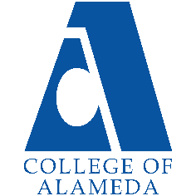
2025-26 Program Review – Instructional –
Library and LIS

Lead Author
Jane McKenna (faculty, Head Librarian)

Program Overview
Please verify the mission statement for your program. If there is no mission statement listed, please add it here.
Library Mission: The College of Alameda Library is a teaching and learning-centered library for a diverse community by providing physical and online access to quality print, electronic, and multi-media resources, services, and instruction. The library faculty and staff promote academic excellence and student success by emphasizing skills in library research, information literacy, and critical thinking.
Library Goals and Objectives:
■ To provide quality services, research materials, technology, facilities, and instructional programs that support the college curricula, information literacy, and research needs. (Maps to ILOs #1, #2, #3, #4, and #5)
■ To provide students with access to information resources that support their learning processes, teach information literacy, and satisfy their intellectual needs. (Maps to ILOs #1, #2, #3, #4, and #5)
■ To provide timely, appropriate, current, and knowledgeable responses to student and faculty requests for information in print, electronic and web-based formats. (Maps to ILOs #2 and #3)
■ To provide a comfortable, safe, clean and quiet learning environment for all students. (Maps to ILOs #3 and #5)
■ To administer fair and objective service policies that maintain ethical information use guidelines and respect an individual’s right to privacy. (Maps to ILOs #4 and #5)
Library Service Outcomes:
- Library provides sufficient resources to meet the information needs of the curriculum.
- Library provides sufficient access to Library resources.
- Students will be able to effectively, efficiently, and ethically access and use needed information.

List your faculty and/or Staff, and indicate whether they are full-time or part-time.
Ann Buchalter (faculty)
Jane McKenna (faculty)
Josh Rose (faculty)
Joan Bewley (classified staff – Senior Library Technician - eResources/Periodicals)
Megan Gorham (classified staff – Principal Library Technician)
Senior Library Tech (vacant)
Senior Library Tech (vacant)

Program Goal | That at least 50% of the Library collection has a publication date  Post 2010.  Justification: Accreditation requires we have a current and high quality collection. There is a connection between library materials and student success rates. Campus data shows that students checking out print books have higher GPA and success rates than the college average ... this is also seen when broken out by at risk groups and equity challenged groups. Full data on this is located on the Library website under Planning Documents.
Status: In-Progress or Complete? If complete, give a brief description of how you measured the goal completion. | In-Progress.  The Library’s age of collection data for 2024-2025 indicates that 38% of the collection was published post 2010. This represents a 5% improvement in currency of the collection based on the 2023-2024 Age of Collection. Due to unstable funds for library materials, the Library has not been able to acquire funds to purchase books in the numbers necessary to update the collection significantly and so has engaged in an aggressive weeding project to increase currency of the collection in years when budget limits purchasing. The Library continues to advocate for a stable budget to provide current books for student’s information needs.
Which college or district goal is aligned with your program goal? | Aligns to the following College Goal:  Increase retention and persistence rates  District Goal: Advance Student Access, Equity, and Success

Program Goal | Provide library orientations for 60% of all English 1A and 100% of all English1AS sections.  Justification: Campus data shows that students receiving library orientations have a higher success rates than other sections of the course not receiving orientations (see the Library Planning webpage for this study).
Status: In-Progress or Complete? If complete, give a brief description of how you measured the goal completion. | In Progress:  In Fall 2024, there were nine (9) ENGL 1A courses and two (2) ENGL 1AS courses. For library  orientations in Fall 2024, there were no ENGL 1A orientations offered and there were four  (4) total ENGL 1AS orientations offered to two (2) ENGL 1AS sections (40751 & 40757).  Percentage of one or more library orientations offered to ENGL 1A courses: 0%  Percentage of one or more library orientations offered to ENGL 1AS courses: 100%  In Spring 2025, there were eight (8) ENGL 1A courses and two (2) ENGL 1AS courses. For  library orientations in Spring 2025, there were two (2) library orientations offered for two  ENGL 1A courses (ENGL 1A (20820) and ENGL 1A (20821)). There were two (2) library  orientations offered to one ENGL 1AS (20729) course.  Percentage of one or more library orientations offered to available ENGL 1A courses: 25%  Percentage of one or more library orientations offered to available ENGL 1AS courses: 50%
Which college or district goal is aligned with your program goal? | Aligns to the following College Goal:  Increase retention and persistence rates.  District Goal: Advance Student Access, Equity, and Success

Program Goal | Implement and Train on all modules of the new Library Integrated System called Alma/Primo from ExLibris.
Status: In-Progress or Complete? If complete, give a brief description of how you measured the goal completion. | COMPLETE
Which college or district goal is aligned with your program goal? | Aligns to Following College Goal:  Increase community and educational partnerships  District Goal: Advance Student Access, Equity, and Succes

Program Goal | Ensure equitable and reliable student access to library services by maintaining stable and consistent staffing schedules and restoring classified positions that are vacant.  Action: Hire 2 vacant full-time Senior Library Technicians (both currently vacant). The Library has gone from 4 classified staff in 2024-2025 to only 2 classified staff in 2024-2025. If pressure is placed to increase library opening hours to restore pre-covid hours, then staffing levels must be restored as well.
Status: In-Progress or Complete? If complete, give a brief description of how you measured the goal completion. | In-Progress. The Library has adjusted their open hours of the Library to the following: Mon. – Thurs from 10am-6pm in order to allow for some evening hours while also recognizing that internal usage data (circ and ref) and assessment process shows that 8am-10am are very slow times at our service desks and also recognizing that the Library has had to absorb a 50% reduction in classified staff for their area. They have also prioritized overlapping schedules for the two remaining techs to ensure that when one is out, the library hours are not impacted. The Library continues to plan and schedule in ways that ensure continuous access during open hours and prioritize predictable hours over superficially extended ones. We continue to advocate for the hire of at least one of the two currently vacant tech positions to balance workloads and sustain essential behind the scenes work previously handled by 4 classified staff and now being done by just 2 classified staff. The Library will continue to advocate for operations to remain stable, dependable, equitable and that they are aligned with accreditation standards, job descriptions, contracts and Ed Code standards.
Which college or district goal is aligned with your program goal? | District Goal: Advance Student Access, Equity, and Success

Describe your current utilization of facilities, including labs and other space
The COA Library has approximately 20,748 gross square feet as assignable
space on the first floor of the L Building and an additional 2,521
square feet of study space on the 2nd floor of the L Building. The
space on the first floor includes seating for more than 200 students,
book stacks, four group study rooms, a quiet study room, book displays,
Chromebooks, Circulation Desk, Reserve Desk, Reference Desk, periodical
display/browsing area, study tables and carrels, copiers/scanner, printing, an
archive, computers for researching (14 workstations), 2 print stations
cataloging/processing service areas, library staff/faculty
offices, and an open classroom for library instruction sessions.

Enrollment Trends
LIS
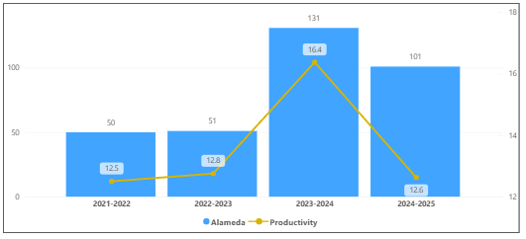
OVERALL
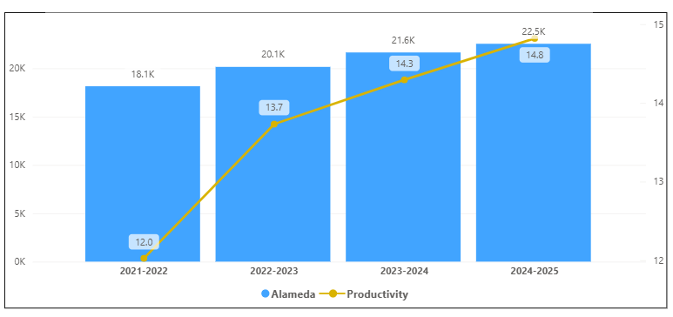
Discuss enrollment trends over the past four years.
LIS Enrollment had an increase from 21-22 to 23-24 but decreased 24-25. LIS Productivity increased from 2021-2022 to 2023-2024 then decreased in 2024-2025. This program did not follow the overall trend of the college because of the decline in 2024-2025. This may be due to an issue with many fake students that were identified by the District and removed from the 2024-2025 semester of LIS classes.

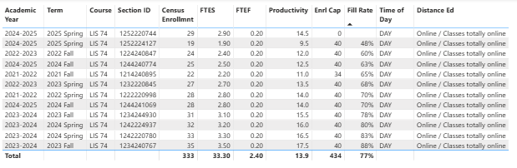
The list of course sections in your area is sorted from lowest fill rate to the highest fill rate for the last four years. Consider and discuss whether the course offers meet the needs of our students.
LIS74 is CSU/UC transferable as an elective and is being added as an elective option on the local degree lists. It is also included in the pathways for many programs. Students surveyed at the end of the course indicate high levels of satisfaction with the course and express that they found the skills taught in it were beneficial to their success in other classes.

Discuss any action plan to better meet student needs and demands.
The Library has updated LIS74 and will be submitting it this year for State approval to meet Cal-igetc. The Library has also created a new course, LIS20, that we are also submitting to the state to meet Cal-igetc. In addition, we have developed a new Certificate of Achievement in Digital Literacy and Critical Inquiry.

Describe effective and innovative teaching strategies used by faculty to increase student learning and engagement.
LIS courses emphasize hands-on research practice, guiding students through real information-seeking scenarios that build confidence in evaluating sources, using databases, and citing ethically. Assignments are designed to connect directly to students’ academic and personal interests, reinforcing relevance and engagement.
Librarians collaborate with discipline faculty to embed research instruction into Canvas courses and classroom assignments. Through interactive workshops, discussion forums, and online research modules, students learn to navigate information in context supporting both equity and retention.
All LIS courses use OER materials, allowing faculty to tailor diverse, inclusive content while removing financial barriers. Students engage with multimedia readings, tutorials, and case studies that reflect varied perspectives and learning styles.
Faculty integrate emerging technologies including critical evaluation of AI tools into lessons on ethical information use. These activities prepare students for responsible participation in academic and professional environments shaped by digital change.

Faculty incorporate diverse examples, student choice, and reflective journaling to promote inclusivity and connection. These practices create learning environments where students see their identities and experiences valued, supporting deeper engagement and persistence.

How is technology used by the discipline department?
Technology is central to every aspect of the Library’s operations, instruction, and service delivery. The Library integrates multiple digital systems and platforms to support equitable access to information, enhance student learning, and streamline internal workflows.
The Library operates within the Peralta Community College District’s shared ExLibris Alma/Primo integrated library system, which provides students and faculty seamless access to print and electronic collections across all four PCCD colleges. This system supports cataloging, circulation, acquisitions, and resource sharing, and gives students a consistent research experience aligned with that of California State University libraries, facilitating smoother transfer and research skill continuity.
Students have 24/7 remote access to the Library’s extensive collection of databases, eBooks, and streaming media. Through the Library’s website and Canvas integration, users can access more than 40 databases, including scholarly journals, eBooks, and multimedia resources such as Kanopy and Overdrive. The Library also provides online chat reference (“Ask a Librarian”), research guides, and self-paced tutorials, ensuring equitable service for both in-person and distance learners.
The Library’s instructional area is equipped with projection, computer, and whiteboard technology that supports in-person information literacy sessions. Librarians also use Canvas shells and roles to embed directly into online courses offering live or asynchronous orientations, discussion boards, and digital research guidance. LIS courses (e.g., LIS 74 and LIS 85) use Canvas to deliver Zero Textbook Cost (ZTC) instruction, integrating open educational resources (OERs) and teaching students how to navigate digital information ethically and effectively.
The Library provides student access to technology on site, including computers, scanners, ADA-compliant workstations, Wi-Fi, and GoPrint services. Responding to Math faculty feedback, the Library expanded its circulation services to offer graphing calculators for checkout. The Library is also working with IT to pilot a Bring Your Own Device (BYOD) printing solution, which would make College of Alameda the first in the district to implement this system.
Library faculty use technology extensively for assessment and data-driven planning. Librarians track and analyze statistics on database use, gate counts, circulation, and instruction sessions to guide scheduling, collection development and inform resource allocation. The Library’s assessment results are stored in CurriQunet Meta, ensuring alignment between Service Area Outcomes (SAOs), Student Learning Outcomes (SLOs), and institutional goals.
The LIS program itself models effective technology use as part of its curriculum. Students learn to evaluate, navigate, and ethically use digital information tools such as academic databases, online catalogs, AI research assistants, and citation management software. Through assignments emphasizing digital literacy and online research skills, the LIS program reinforces the College’s mission of preparing students for success in academic, workplace, and civic contexts shaped by technology.

How does the discipline, department, or program maintain the integrity and consistency of academic standards with all methods of delivery, including face to face, hybrid, and Distance Education courses?
The Library and Library and Information Studies (LIS) program ensure academic integrity and consistent learning outcomes across all modes of instruction such as face-to-face, hybrid, and fully online through intentional course design, shared instructional resources, and continuous assessment aligned with institutional outcomes.
All LIS courses are developed and taught by faculty librarians who apply consistent course outlines, learning outcomes, and assessment methods regardless of modality. Each course undergoes Curriculum Committee review and adheres to Title 5 and DE Addendum requirements for distance education. Regular updates to course outlines ensure alignment with current information literacy frameworks, research ethics standards, and technological trends that affect student learning.
The LIS program uses Canvas as the official learning management system to deliver both online and hybrid courses. This ensures a uniform structure, consistent communication channels, and equitable access to materials. All LIS courses are Zero Textbook Cost (ZTC) and integrate Open Educational Resources (OER), guaranteeing identical content and academic rigor across modalities. Librarians maintain the same standards for assignments, grading rubrics, and research instruction whether students participate in person or remotely.
For instruction sessions, librarians collaborate closely with classroom faculty to tailor sessions to course-level learning outcomes while maintaining consistent expectations for research quality and academic integrity. Librarians embed into online Canvas courses to provide synchronous and asynchronous orientations, research tutorials, and discussions that mirror in-person experiences. This embedded model supports the same student learning outcomes particularly in evaluating sources, citing ethically, and applying critical information literacy skills across all delivery modes.
The Library regularly assesses both Student Learning Outcomes (SLOs) and Service Area Outcomes (SAOs) through direct measures (coursework, surveys, usage data) and reflective dialogue. Results are documented in CurriQunet Meta, where each outcome is mapped to institutional learning outcomes and reviewed at least once every three years. These assessment cycles help ensure consistent academic standards across instructional modes while identifying needed improvements in technology, access, or pedagogy.
Academic integrity is emphasized in all LIS instruction through units on ethical information use, citation practices, and avoiding plagiarism. The program also integrates discussions of AI and digital ethics, ensuring that students apply these principles consistently regardless of delivery method. By maintaining identical learning outcomes, equitable access to digital resources, and shared instructional rubrics, the Library and LIS program uphold the same academic standards for all students, in all formats.

Curriculum
CurriQunet Meta
If necessary, use the CurriQunet META link to review the details of curriculum. Some summary information is provided below.
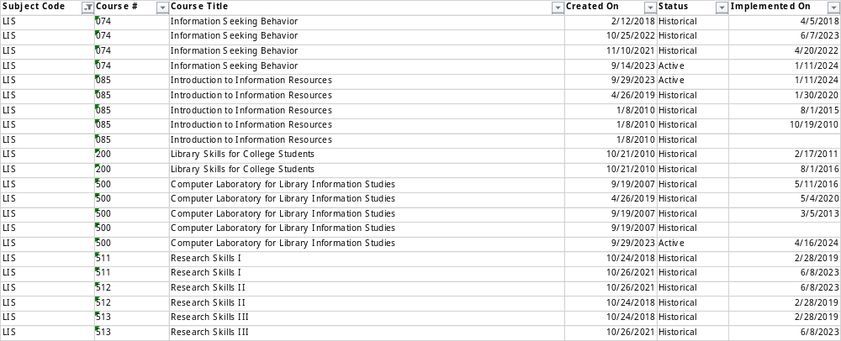
Please review your course outlines of record in CurriQunet META to determine if they have been updated in the past four years. Specify when your department will update, or deactivate, each one, within the next four years.
All LIS outlines have been updated in the last 3 years.

Please summarize the Discipline, Department or program of study plans for curriculum plans for improvement. Below, please provide details for individual course improvement. Add plans for new courses here.
The Library has updated LIS74 and will be submitting it this year for State approval to meet Cal-igetc. We have also created a new course, LIS20, that we are also submitting to the state to meet Cal-igetc. In addition, we have developed a Certificate of Achievement in Digital Literacy and Critical Inquiry that develops students’ research, communication, and critical thinking skills essential for CSU and UC transfer. Students completing this certificate will demonstrate mastery of information literacy, digital research, and humanities-based inquiry. This program emphasizes information evaluation, communication skills, psychology, and human values, preparing students for success across disciplines and transfer pathways.

How is your program meeting the needs of students and/or articulation with four-year institutions?
LIS courses and Library orientations directly supports the Vision for Success and AB 928 (Cal-GETC) mandates by embedding LIS into transfer preparation and providing students with skills in research, communication, and ethical information use. It is particularly well-suited for dual enrollment and first-year students, who need early guidance in navigating AI and digital tools responsibly.

Assessment – Instructional
Student Learning Outcomes Assessment
Your Student Learning Outcomes for active courses are listed below. Please review and note any corrections or planned changes.
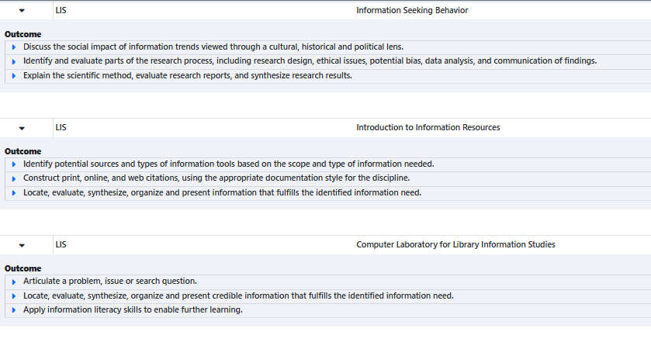

The existing SLOs are adequate and currently not in need of updating..

Please provide a high-level summary and your program’s interpretation of your SLO findings over the past year.
SLO and SAO assessment results entered into Maverick all indicate high levels of achievement in student success for Library SLOs and SAOs.

Subject | SLO or SAO | Assessed Date | Status
LIS | LIS74 SLO 1 | Spring 2025 | In Review
LIS | LIS74 SLO 2 | Spring 2025 | In Review
LIS | LIS74 SLO 3 | Spring 2025 | In Review
LIS | LIS500 SLO 1 | Fall 2025 | TBD
LIS | LIS500 SLO 2 | Fall 2025 | TBD
LIS | LIS500 SLO 3 | Fall 2025 | TBD
LIS | LIS85 SLO 1-5 | Fall 2023 | Not offered since 2023
Library | Library SAO 1 | Fall 2025 | In Review
Library | Library SAO 2 | Fall 2025 | In Review
Library | Library SAO 3 | Fall 2025 | In Review

What were the most important things your department learned from assessment? Did implementation of your action plans result in better student learning?
The Library has assessed all SLOs and SAOs in the last 3 years except for LIS85. LIS85 has not been taught since 2023. We have created a new certificate that includes LIS85. We plan to offer and assess LIS85 within the next year.
All the SLOs for all of the LIS courses (that have been offered) have been assessed within the last 3 years and entered within Meta. For the LIS course assessment results indicate that students are 90% or above in meeting the outcomes for the courses.
In addition, all of the Library service outcomes have been assessed within the last 3 years and entered within Meta. The service-learning outcomes data for library services is also analyzed at the Dept. level and utilized when developing budget priorities and staffing schedules for the area. Service area data compiled and analyzed includes library orientation assessment results, library student surveys, faculty surveys, library usage statistics (reference by the hour, hourly head counts), as well as studies done in collaboration with the campus researcher that analyze the demographic data, GPA / success rates of Library users. Many of these assessment results are also posted on the Library webpage under For Librarians -> Planning Documents.
A detailed description of the Library’s internal assessment process can be found on the Library Webpage under For Librarians -> Planning Documents.

Listed below are your programs (degrees and certificates) and the program learning outcomes (PLOs) for each. Please share your reflections on the PLOs and support from the college needed in assessing the PLOs over the next four years.

[LIS does not have degrees or certificates.]

College of Alameda Institutional Learning Outcomes (ILOs) were created to guide educational programs and services. They include:
- Problem Solving: Solve problems and make decisions in life and work using critical thinking, quantitative reasoning, community resources, and civil engagement.
- Communication and Technology: Use technology and written and oral communication to discover, develop, and relate critical ideas in multiple environments.
- Creativity: Exhibit aesthetic reflection to promote, participate and contribute to human development, expression, creativity, and curiosity.
- Diversity: Engage in respectful interpersonal communications, acknowledging ideas and values of diverse individuals that represent different ethnic, racial, cultural, and gender expressions.
- Civic Responsibility: Accept personal, civic, social and environmental responsibility in order to become a productive local and global community member.
How does your program participate in assessing the Institutional Learning Outcomes (ILOs)? If your program has not participated, how will you plan to incorporate these outcomes within your program?
The Library and the Library and Information Studies (LIS) program are deeply engaged in assessing and aligning student learning with the College of Alameda’s Institutional Learning Outcomes (ILOs). Both Library instruction and LIS courses are intentionally designed to advance core competencies in communication, critical thinking, information and technology literacy, and civic and global awareness—directly mapping to the College’s ILO framework.

Each LIS course and Library instructional session includes Student Learning Outcomes (SLOs) that are explicitly mapped to relevant ILOs within CurriQunet Meta, the College’s assessment management system. Librarians assess these outcomes regularly, at least once every three years, as part of the institutional outcomes cycle.
Beyond formal courses, the Library also contributes to ILO assessment through Service Area Outcomes (SAOs) related to equitable access, collections, and instruction. These outcomes such as improving student confidence in finding academic sources or increasing database usage reflect the Library’s role in supporting Information Competency and Lifelong Learning. SAO results are analyzed annually and inform both Library operations and broader campus planning documents.
Assessment results are discussed by the librarians, summarized in annual program updates, and shared with the College IEC Committee to contribute to campuswide ILO assessment cycles. The program continues to refine its mapping of SLOs and SAOs to ILOs, ensuring that Library and LIS instruction reflects emerging institutional priorities such as equity, information competency and digital literacy.
In upcoming cycles, the Library plans to expand data collection on how Library instruction sessions contribute to student success and retention. This will further demonstrate the Library’s integral role in achieving the College’s institutional goals.

Course Completion
Consider your course completion rates over the past four years (% of student who earned a grade of "C" or better).
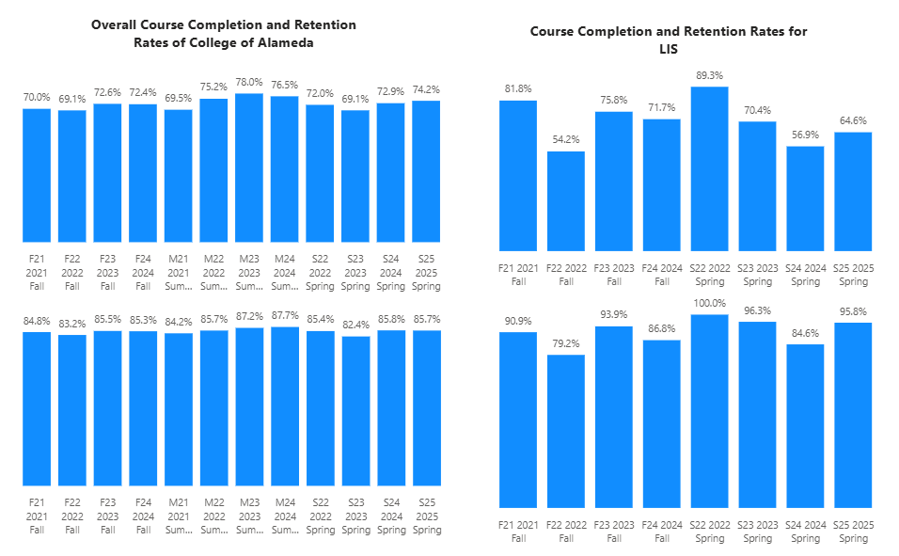

How does the course completion rate for your program or discipline compared to your college’s Institutional Set Standard for course completion (70% with stretch goal of 78%)? Also discuss the retention rate for your program or discipline, compared to the college average shown in data below.
The course completion for LIS is above the College of Alameda’s completion rate for that term except for Fall 2022, Fall 2024, Spring 24 and Spring 25. LIS is also above the set standard of 70% for the completion rate for all terms, except for Fall 2022, Spring 2024 and Spring 2025. For retention, LIS is above the College of Alameda’s retention for that term Fall 2022 and Spring 2024. LIS is above the average of 85% for retention rate for all terms except Fall 2022 and Spring 2024.

What has the discipline, department, or program done to improve course completion and retention rates?
LIS courses are Zero-Textbook-Cost (ZTC) and integrate Open Educational Resources (OER) to make learning materials more inclusive and affordable. Faculty use project-based assignments that let students apply research skills to real-world topics, increasing engagement and persistence.
Library assessment data show that students who participate in multiple library instruction sessions have higher success rates and GPAs than peers who do not. This finding has led to deeper collaboration with English, ESOL, and Learning Communities to integrate library instruction into gateway courses that historically show equity gaps.
Faculty and librarians incorporate diverse resources and reflective assignments to foster belonging and motivation among disproportionately impacted students. Efforts such as the Latinx Collection and thematic displays promote cultural connection and engagement, contributing to retention and academic success.

The Library’s circulating collection, providing textbooks, circulating books, Chromebooks, graphing calculators, ZTC Class Textbook sets, directly addresses access barriers that can hinder course completion. Librarians also extend research and reference support through embedded Canvas modules and online chat ensuring students receive help when and how they need it.

Equity Analysis
College of Alameda continues to focus on access, equity, and success. The goal is to create an inclusive environment where all students can thrive and meet their education and career goals.
Following is a brief description of equity data analysis, examining success rates of different ethnic groups (Asian, Black/African American, Hispanic/Latino, “Two or More”, “Unknown/NR”, White), age range, gender (Female, Male, Unknown Gender), and special population groups (Foster Youth, Veterans, College, SAS).
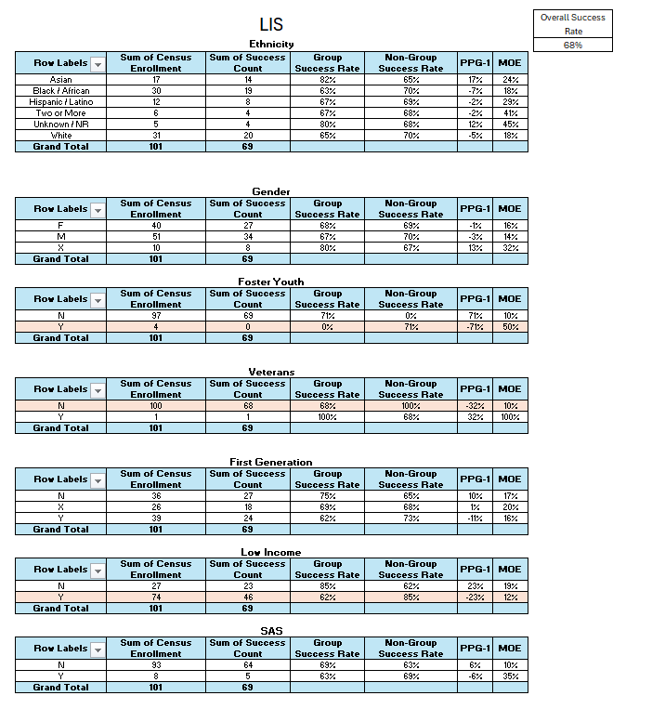

Success rate data in LIS for AY2024-25 was analyzed using the PPG-1 (percentage point gap minus 1) method, comparing the success rate of the given group against the success rate of everyone else. The success rate of the following groups falls significantly below the overall success rate of 68% for LIS 74 outside the statistical margin of error:

- Not Veterans 68%
- Foster Youth 0%
- Low Income 62%

While there are other groups whose success rates fall below the overall success rate for LIS 74, either the percentage point gap difference is small or, because of the small sample size, a reliable conclusion cannot be drawn.

What can your discipline, department, or program do to improve course completion for disproportionately impacted groups?
The Library and Library and Information Studies (LIS) program play a critical role in advancing equitable student success by addressing barriers that disproportionately impact historically underrepresented students. Both areas emphasize inclusive access to learning materials, culturally responsive instruction, and intentional support for digital and information literacy development, skills that strongly correlate with persistence and course completion.
Many students who struggle with course completion cite lack of reliable technology or access to course materials as primary barriers. The Library directly addresses this through its Chromebook lending program, offering Chromebooks and charging equipment for checkout. This program has been very successful and aligns with local schools that also loan Chromebooks to their students. Chromebooks are now considered a collection standard for CA Community College Libraries but the Library struggles with obtaining funding to support the refresh of these Chromebooks as they go out of date. All Chromebooks in the Library were purchased with Covid relief funding in 2020 and need replacement.

In response to student feedback, the Library is also developing a Bring Your Own Device (BYOD) printing system to make academic technology more accessible to all students.

In 2024–25, the Library implemented a 10-year amnesty for lost materials, clearing outstanding fines from student accounts. This action aligns with the College’s equity goals by removing punitive barriers to library use and student success.

LIS courses teach students how to locate, evaluate, and ethically use information. These skills help reduce equity gaps by empowering students to navigate research assignments with confidence. Survey data consistently shows that LIS students report increased self-efficacy and academic confidence after completing our LIS74 course. Expanding outreach to learning communities, dual enrollment programs, and Career Education cohorts will help ensure that disproportionately impacted students benefit from these transferable academic skills earlier in their college experience.
Librarians collaborate with faculty across disciplines to integrate Library instruction into gateway and transfer-level courses where equity gaps are most pronounced. Data from the campus researcher has shown that students who participate in multiple library instruction sessions demonstrate higher success rates and GPAs than those who do not. Scaling this model, especially through embedded Canvas support in online course, can improve outcomes for students who might otherwise be disconnected from campus resources.
The Library and LIS program are working with the campus researcher to analyze Library use and course success data by student demographic categories. Prior analyses revealed that equity-impacted groups actually check out books at higher rates than their overall enrollment proportion which is an encouraging sign that the Library is a trusted and accessible space. Building on this, future plans include identifying patterns in resource use, engagement, and course completion to target additional outreach and culturally responsive programming.
Visible representation in Library collections, displays, and instruction helps students see their identities and communities reflected in academic spaces. Continued development of the Latinx Collection (funded through the HSI grant), expansion of diverse content, and thematic Library programming (e.g., cultural heritage months) will further build belonging and persistence for disproportionately impacted students.

Space below is provided for additional discussion of equity-impacting factors not discussed above, including those that affect dual enrollment courses and/or online/hybrid courses.
Dual enrollment students often identify with both their high school and the college but may not have full awareness or access to college-level resources. The Library is working to build orientation materials and Canvas-based research tutorials specifically for dual enrollment classes to ensure these students can benefit from the same digital collections, research tools, and librarian support as regularly enrolled college students. Every Fall, the Library offers a section of LIS500 that is reserved for ASTI classes. This is arranged as contract ed and provides ASTI students with instruction and access to library research.
Online and hybrid courses in LIS maintain consistent standards, but students with lower digital literacy or limited access to quiet study spaces may face additional barriers. To address this, faculty librarians design courses with low-bandwidth options, asynchronous flexibility, and universal design principles, ensuring materials are mobile-friendly and accessible for students with disabilities. The Library also has created an extreme quiet zone within the Library space that provides those that need complete silence to study a place for that.
Equity in online learning also extends to visibility and representation. The Library’s virtual presence through its website, Canvas modules, and online displays seeks to mirror the inclusive atmosphere of the physical library. Ongoing efforts include, highlighting diverse authors and voices, and linking to instructional resources that reflect a range of cultural and linguistic perspectives.

Degrees & Certificates Conferred
Does your program offer any degree/certificate programs? If your program does not, skip this section and continue to Engagement.
What has the discipline, department, or program done to improve the number of degrees and certificates awarded? Below data shows the number of degrees and certificates awarded by year, for the past four years.
[LIS does not have degrees or certificates.]

Increasing the number of students who complete a certificate or degree is a shared goal across CoA’s Ed Master Plan Goals, PCCD Goals, the Chancellor’s Office Vision for Success, the Student-Centered Funding Formula, and Guided Pathways. What is planned for the next 3 years to increase the number of certificates and degrees awarded?
[LIS does not have degrees or certificates.]

Engagement
Discuss how faculty and staff have engaged in institutional efforts such as committees, presentations, and departmental activities. Please list the committees that full-time faculty participate in.
Librarians participate on a variety of campus and District committees such as Curriculum, Budget, District Head Librarians, union meetings, Dept Chair meetings, ZTC Taskforce Meetings, hiring committees, and led flex day presentations on topics related to the Library.

Discuss how faculty and staff have engaged in community activities, partnerships and/or collaborations.
The Library has partnered with multiple departments such as Art and Fashion to display student art in the Library. The Library provides embedded instruction and orientations for all disciplines. Faculty recommendations are actively solicited for collection development. The Library has worked closely with the ZTC Grant Coordinators to develop a process and special collection for ZTC Class Textbook sets. Librarians participate on a variety of state-wide groups such as CCCL Alma Systems and Cataloging Workgroups, Chief Council of Head Librarians, and Community College League of California – Library and Technology Consortium.

Discuss how adjunct faculty members are included in departmental training, discussions, and decision-making.
Adjunct librarians and LIS instructors are fully included in departmental communication, training, and decision-making. They receive orientation on library systems, policies, and equity-minded teaching practices, and are invited to participate in all departmental planning. Their input is incorporated into program review discussions, resource requests, and service planning, ensuring that decisions reflect the full instructional team’s experience.
The Library fosters an inclusive, collaborative culture in which adjunct contributions are valued. Their perspectives inform improvements in access, collections and instructional support for students.

Prioritized Resource Requests Summary
In the boxes below, please add resource requests for your program. If there are no resource requested, leave the boxes blank.
Resource Category | Description/Justification | Full-Time Equivalent Percentage | Salary Grade (if applicable)
Personnel: Classified Staff | 2 Full-time Senior Library Technician vacancies need to be filled in order to extend library hours back to pre-covid levels. In 2025-2026, the Library is currently staffed at 50% of where we were the previous year. | 2.0
Personnel: Student Worker

Personnel: Part Time Faculty | The Library needs adjunct librarian hours to provide instruction and reference support for students at the Reference Desk. | .5
Personnel: Full Time Faculty

Personnel: Full Time Faculty, future anticipated need

Resource Category | Description/Justification | Total Estimated Cost
Professional Development: Department wide PD needed

Professional Development: Personal/Individual PD needed

Prioritized Resource Requests Summary - Continued

Resource Category | Description/Justification | Total Estimated Cost
Supplies: Software | - Public Web Browser (annual subscription) - $250  - Alma –Digital – a add-on for ExLibris that facilitates checking out digital copies of reserve materials - $2000 | $1,750
Supplies: Books, Magazines, and/or Periodicals | - Reserve Textbooks - $4,000  - Flipster Periodical database and print periodicals - $5,000 (annual subscriptions)  - Articles/ebooks/videos databases - $40,000 (annual subscriptions)  - Circulating Books - $20,000 (number based on estimate of what it takes to update the age of collection) | $69,000
Supplies: Instructional Supplies | - Instruction supplies for student use, materials processing, non-book/magazine materials for checkout to students (headphones, keyboards, mice, graphing calculators, charging cords, etc), – $3,600 | $3,600
Supplies: Non-Instructional Supplies | - Tattle tape, barcodes, book covers, labels and cataloging supplies – $2,000  - Office supplies for Library staff – $1,000 | $3,000
Supplies: Library Collections | See sections above called Supplies: Books, Magazines, and/or Periodicals and Supplies: Instructional Supplies

Resource Category | Description/Justification | Total Estimated Cost
Technology & Equipment: New | Replace Computers next to the Reference Desk that students use for research. These computers are over 10 years old. | Total $20,000 (for 10 computers)
Technology & Equipment: Replacement | The Library has Chromebooks for our instructional area and also for students to checkout through our Chromebook Lending Program. All of the library’s Chromebooks were bought by the District in 2020 with Covid relief funds and these are now past their shelf life and do not hold a charge. The Library needs to replace both their department Chromebooks, used for library instructions sessions, and also the Chromebooks checked out to students for the semester. Circulation statistics and a research study on who are checking out the COA Library Chromebooks demonstrate this is a popular program that supports our equity impacted students.  GoPrint Wireless Print Stations - tbd  Refresh student computers – tbd  Emergency Phones and panic buttons – tbd  Building Announcement System – tbd | Total= $21,000 (for quantity of 60 Chromebooks at $300 each)

Prioritized Resource Requests Summary - Continued

Resource Category | Description/Justification | Total Estimated Cost
Facilities: Classrooms | Library storage area on 2nd floor.  A dedicated space for Library Instruction within the L Building 2nd floor.  Library - Lighting upgrade  Library - New roof  Library - Electrical upgrade  Library - HVAC upgrade
Facilities: Offices

Facilities: Labs

Facilities: Other | Custodian schedule for L building should be to pick-up trash after we close not before we open because trash sitting overnight or over the weekends leads to mice and bugs. Before Fall 2025, the L building was on a evening custodian’s schedule and then in Fall 2025 the schedule was changed to a day custodian and this has led to an increase in ants and mice in the building. The Library has requested multiple times to return to the evening custodian’s schedule and that request keeps getting denied.

Resource Category | Description/Justification | Total Estimated Cost
Library: Library materials | See section above called Supplies: Books, Magazines, and/or Periodicals
Library: Library collections | See section above called Supplies: Books, Magazines, and/or Periodicals

Resource Category | Description/Justification | Total Estimated Cost
OTHER | CCLC Dues and Membership - $150 (annual, provides discount pricing for databases)  Biliotheca Security Gates (service contract - annual, alarm system for books, required by Accred.) - $2,886 | $3,036

