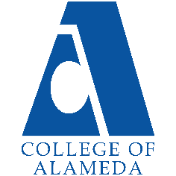
2025-26 Program Review – Instructional –
CHEM

Lead Author
Peter Olds

Program Overview
Please verify the mission statement for your program. If there is no mission statement listed, please add it here.
COA chemistry offers general chemistry (Chem 1A/1B) for science majors, and introductory general chemistry (Chem 30A/30B) for allied-health career track students. COA chemistry is a small program with one full time and three part time instructors. Demand for chemistry courses is high since these are prerequisites for almost any career in the sciences or healthcare industry.

Program Learning Outcomes (PLOs):
1. Demonstrate understanding of chemical processes to solve real-world problems
2. Collect and interpret analytical data using techniques in general chemistry.
3. Demonstrate the ability to perform basic calculations related to preparation of solutions and quantitative and qualitative analyses commonly used in experiments in chemistry.

List your faculty and/or Staff, and indicate whether they are full-time or part-time.
Full Time – Peter Olds
Part Time – Eileen Clifford, Alex Madonik

Program Goal | Bring laboratory management and oversight up to minimum standards. Mitigate the historical lack of safety regulatory compliance in COA labs  -Implement a Chemical Hygiene Plan (CHP) in COA science labs. Turn lab management and oversight over to technically qualified staff capable of maintaining safety regulatory compliance.
Status: In-Progress or Complete?  If complete, give a brief description of how you measured the goal completion. | Update Progress
Which college or district goal is aligned with your program goal? | Advance student access, equity and success.

Program Goal | Resume offering Chem 30B – Introduction to organic and biochemistry for allied health students.
Status: In-Progress or Complete?  If complete, give a brief description of how you measured the goal completion. | Update Progress
Which college or district goal is aligned with your program goal? | Advance COA teaching and learning. Build programs of distinction.

Program Goal | Refurbish and bring up to satisfactory standards the abandoned D-109 main campus chemistry lab plus associated storage and prep areas:  This involved reinstallation of hoods and a complete plumbing upgrade. As of 9-26-2017 three hoods and bench faucets had been reinstalled in D-109. Another hood is requested for the D-105 Chem/Demo prep area in addition to lipped shelving and lab bench re-installation.  Dry chemical storage area (location TBD) requires lipped earthquake-proof shelving. Balance room (D-108 or D-109?) needs stone tables replaced.  It is also requested to refurbish and bring up to satisfactory standards for demos the D-119 lectern (gas and water) and D119 chem demo prep area. (D-119 is the CHEM lecture room.)  Quotes for the above work should be obtained ASAP from Thermo-Fisher, VWR and other laboratory furnishing companies.
Status: In-Progress or Complete?  If complete, give a brief description of how you measured the goal completion. | Update Progress
Which college or district goal is aligned with your program goal? | Advance student access, equity and success.

Describe your current utilization of facilities, including labs and other space
Update Paragraph Below

Pre-pandemic: One chemistry laboratory, Room 150 at the Science annex, (with four chemical hoods) can reasonably accommodate 25 students. This single lab is presently used for all chemistry courses offered at COA. Several Science Annex rooms including 110 and 160 are used for chemistry classes. Room D-119 on the main campus is also used for Chem 1A/1B lectures and chemistry demonstrations. The partially refurbished D-109 chemistry lab is still not practically functional, though we are hopeful functionality will be restored for Spring 2024 Chem 30A. During the pandemic: Chemistry faculty were teaching from home online with Zoom plus various online academic and virtual lab platforms since late March 2020. Since the Fall 2022 semester, Chem 1A, Chem 1B and one Chem 30A section are have resumed as in-person on the main campus using D-119 and 860 Atlantic rooms 110 and 160. In person labs have resumed in Room 150 at 860 Atlantic, currently the only available lab space for all chemistry courses.

Enrollment Trends
CHEM
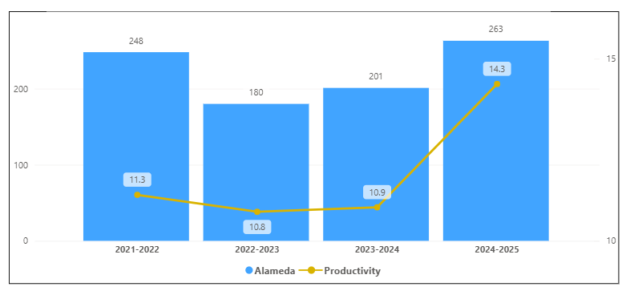
OVERALL
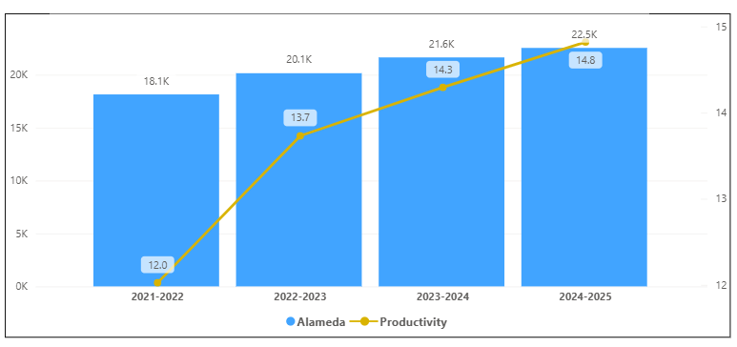
Discuss enrollment trends over the past four years.
CHEM Enrollment decreased from 2021-2022 to 2022-2023 but had an increase in both 2023-2024 and 2024-2025. Productivity decreased from 2021-2022 to 2022-2023 but had an increase in 2024-2025 of 3.4.

This program did not follow the overall trend of the college except for the last two years.

Discuss any reason for decrease/increase in enrollment

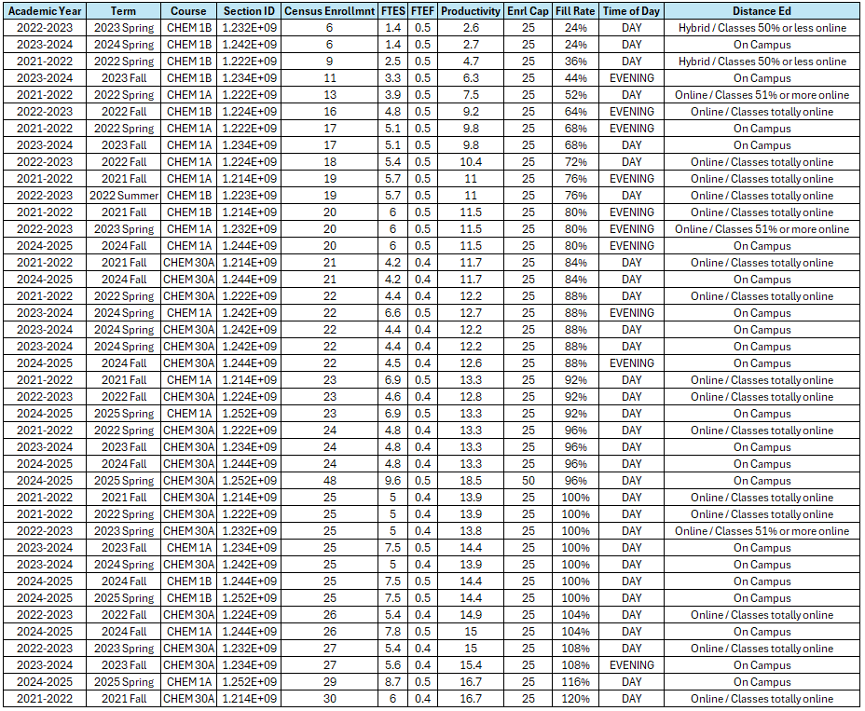
The list of course sections in your area is sorted from lowest fill rate to the highest fill rate for the last four years. Consider and discuss whether the course offers meet the needs of our students.
Discuss Here

Discuss any action plan to better meet student needs and demands.
Discuss Here

Describe effective and innovative teaching strategies used by faculty to increase student learning and engagement.
Describe Here

How is technology used by the discipline department?
Discuss Here

How does the discipline, department, or program maintain the integrity and consistency of academic standards with all methods of delivery, including face to face, hybrid, and Distance Education courses?
Discuss Here

Curriculum
CurriQunet Meta
If necessary, use the CurriQunet META link to review the details of curriculum. Some summary information is provided below.

Please review your course outlines of record in CurriQunet META to determine if they have been updated in the past four years. Specify when your department will update, or deactivate, each one, within the next four years.
Discuss Here

Please summarize the Discipline, Department or program of study plans for curriculum plans for improvement. Below, please provide details for individual course improvement. Add plans for new courses here.
Discuss Here

How is your program meeting the needs of students and/or articulation with four-year institutions?
Discuss Here

Assessment – Instructional
Student Learning Outcomes Assessment
Your Student Learning Outcomes for active courses are listed below. Please review and note any corrections or planned changes.
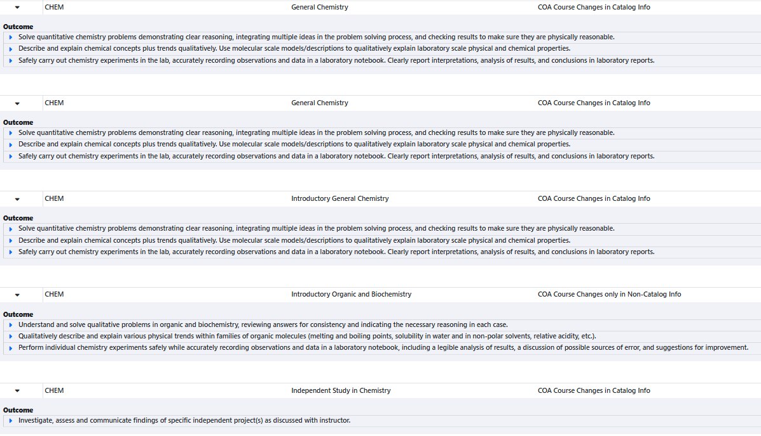
Discuss Here

Please provide a high-level summary and your program’s interpretation of your SLO findings over the past year.
Discuss Here
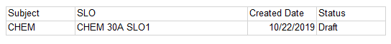
What were the most important things your department learned from assessment? Did implementation of your action plans result in better student learning?
There has been zero SLO assessments completed by CHEM for this SLO cycle.
Discuss Here

Listed below are your programs (degrees and certificates) and the program learning outcomes (PLOs) for each. Please share your reflections on the PLOs and support from the college needed in assessing the PLOs over the next four years.
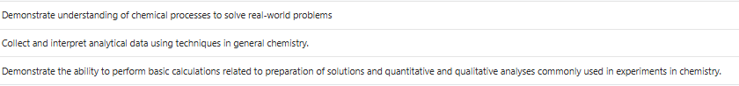
Discuss Here

College of Alameda Institutional Learning Outcomes (ILOs) were created to guide educational programs and services. They include:
- Problem Solving: Solve problems and make decisions in life and work using critical thinking, quantitative reasoning, community resources, and civil engagement.
- Communication and Technology: Use technology and written and oral communication to discover, develop, and relate critical ideas in multiple environments.
- Creativity: Exhibit aesthetic reflection to promote, participate and contribute to human development, expression, creativity, and curiosity.
- Diversity: Engage in respectful interpersonal communications, acknowledging ideas and values of diverse individuals that represent different ethnic, racial, cultural, and gender expressions.
- Civic Responsibility: Accept personal, civic, social and environmental responsibility in order to become a productive local and global community member.
How does your program participate in assessing the Institutional Learning Outcomes (ILOs)? If your program has not participated, how will you plan to incorporate these outcomes within your program?
Discuss Here

Course Completion
Consider your course completion rates over the past four years (% of student who earned a grade of "C" or better).

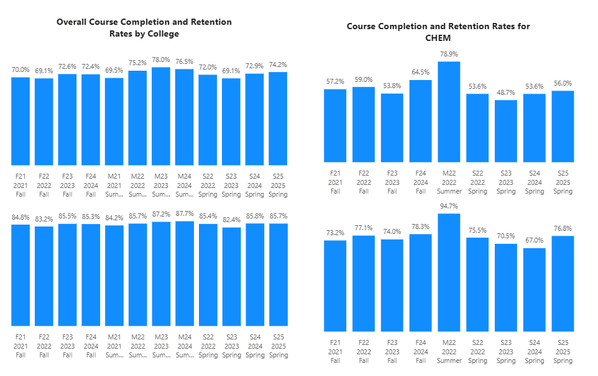
How does the course completion rate for your program or discipline compared to your college’s Institutional Set Standard for course completion (70% with stretch goal of 78%)? Also discuss the retention rate for your program or discipline, compared to the college average shown in data below.
The course completion for CHEM is below the College of Alameda’s completion rate for that term except for summer 2022. CHEM is also below the set standard of 70% for the completion rate for all terms except for summer 2022. For retention, CHEM is below the College of Alameda’s retention for that term except summer 2022. CHEM is below the average of 85% for retention rate for all terms except summer 2022.

What has the discipline, department, or program done to improve course completion and retention rates?
Discuss Here

Equity Analysis
College of Alameda continues to focus on access, equity, and success. The goal is to create an inclusive environment where all students can thrive and meet their education and career goals.
Following is a brief description of equity data analysis, examining success rates of different ethnic groups (Asian, Black/African American, Hispanic/Latino, “Two or More”, “Unknown/NR”, White), age range, gender (Female, Male, Unknown Gender), and special population groups (Foster Youth, Veterans, College, SAS).
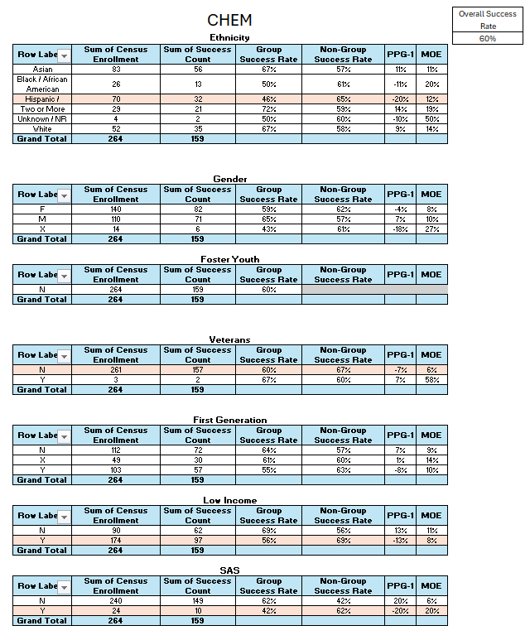
Success rate data in CHEM for AY2024-25 was analyzed using the PPG-1 (percentage point gap minus 1) method, comparing the success rate of the given group against the success rate of everyone else. The success rate of the following groups falls significantly below the overall success rate of 60% for CHEM outside the statistical margin of error:

- Ethnicity Hispanic/Latinx 46%
- Not Veterans 60%
- Low Income 56%
- SAS 42%

While there are other groups whose success rates fall below the overall success rate for CHEM, either the percentage point gap difference is small or, because of the small sample size, a reliable conclusion cannot be drawn.

What can your discipline, department, or program do to improve course completion for disproportionately impacted groups?
Discuss Here

Space below is provided for additional discussion of equity-impacting factors not discussed above, including those that affect dual enrollment courses and/or online/hybrid courses.
Discuss Here

Degrees & Certificates Conferred
Does your program offer any degree/certificate programs? If your program does not, skip this section and continue to Engagement.
What has the discipline, department, or program done to improve the number of degrees and certificates awarded? Below data shows the number of degrees and certificates awarded by year, for the past four years.
No Chem Degrees and Certificates awarded in the last 4 years.
Discuss Here

Increasing the number of students who complete a certificate or degree is a shared goal across CoA’s Ed Master Plan Goals, PCCD Goals, the Chancellor’s Office Vision for Success, the Student-Centered Funding Formula, and Guided Pathways. What is planned for the next 3 years to increase the number of certificates and degrees awarded?
Discuss Here

Engagement
Discuss how faculty and staff have engaged in institutional efforts such as committees, presentations, and departmental activities. Please list the committees that full-time faculty participate in.
Discuss Here

Discuss how faculty and staff have engaged in community activities, partnerships and/or collaborations.
Discuss Here

Discuss how adjunct faculty members are included in departmental training, discussions, and decision-making.
Discuss Here

Prioritized Resource Requests Summary
In the boxes below, please add resource requests for your program. If there are no resource requested, leave the boxes blank.
Resource Category | Description/Justification | Full-Time Equivalent Percentage | Salary Grade (if applicable)
Personnel: Classified Staff

Personnel: Student Worker

Personnel: Part Time Faculty

Personnel: Full Time Faculty

Personnel: Full Time Faculty, future anticipated need

Resource Category | Description/Justification | Total Estimated Cost
Professional Development: Department wide PD needed

Professional Development: Personal/Individual PD needed

Prioritized Resource Requests Summary - Continued

Resource Category | Description/Justification | Total Estimated Cost
Supplies: Software

Supplies: Books, Magazines, and/or Periodicals

Supplies: Instructional Supplies

Supplies: Non-Instructional Supplies

Supplies: Library Collections

Resource Category | Description/Justification | Total Estimated Cost
Technology & Equipment: New

Technology & Equipment: Replacement

Prioritized Resource Requests Summary - Continued

Resource Category | Description/Justification | Total Estimated Cost
Facilities: Classrooms

Facilities: Offices

Facilities: Labs

Facilities: Other

Resource Category | Description/Justification | Total Estimated Cost
Library: Library materials

Library: Library collections

Resource Category | Description/Justification | Total Estimated Cost
OTHER

