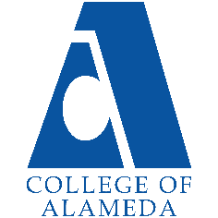
2025-26 Program Review – Instructional –
CSI

Lead Author
Anthony VILLEGAS (AV)

Program Overview
Please verify the mission statement for your program. If there is no mission statement listed, please add it here.
Mission Statement
In fulfillment of the mission of College of Alameda to serve the educational needs of our community
by providing comprehensive and flexible programs and resources that empower students to achieve
their goals, Computer Information Systems (CIS) is committed to supporting our faculty and to
empowering our students in developing global technology skills through our CIS degree, certificates
and special programs in Programming, Desktop Support, Web Publishing, Information Technology and
Big Data Analytics.

List your faculty and/or Staff, and indicate whether they are full-time or part-time.
Anthony VILLEGAS – Full Time
JoAnne Strickland – Full Time
James Kennedy- Part Time
Barbara Collin- Part Time
Marilyn VARNADO- Part Time
Jesse NORMAN- Part Time

Program Goal | Increase Student Enrollment in CIS classes
Status: In-Progress or Complete? If complete, give a brief description of how you measured the goal completion. | Update Progress
Which college or district goal is aligned with your program goal? | COA Goal #1 – Advance COA Teaching and Learning PCCD Goal #1 – Advance Student Access, Equity, and Success Vision for Success – Goal 1: Over the next five years, we will work on increasing 10% per year the number of graduates with CIS degrees and certificates to prepare students for High Tech jobs.

Program Goal | Increase Student Completion in CIS classes
Status: In-Progress or Complete? If complete, give a brief description of how you measured the goal completion. | Update Progress
Which college or district goal is aligned with your program goal? | . COA Goal #2 – Increase retention and persistence rates PCCD Goal #2 – Engage and Leverage Partners Vision for Success – Goal 2: Over five years, increase by 10 percent the number of COA students transferring annually to a UC or CSU.

Program Goal | NEW GOAL
Status: In-Progress or Complete? If complete, give a brief description of how you measured the goal completion. | Update Progress
Which college or district goal is aligned with your program goal?

Describe your current utilization of facilities, including labs and other space
Update Paragraph Below

COA H108 is our new computer lecture and lab room which replaced our previous D114 lab since we returned to vis-à-vis classes in 2022. Our previous D114 filing cabinets and drawers were removed without fair warning. Their contents e.g. instructor manuals, exam keys, student projects, USB drives an no longer be replace. We need new filing drawers in H108 for our CIS instructors. Previous A224, A228, A231 classrooms have not been used. 202D open labs is used when library is open
Enrollment Trends
CIS
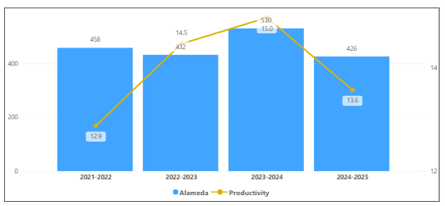
OVERALL
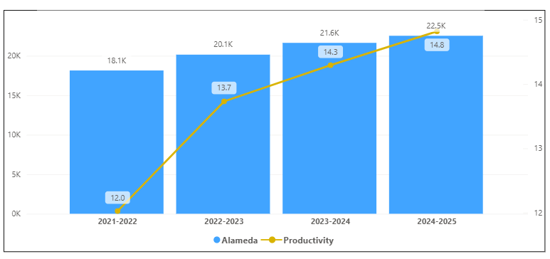
Discuss enrollment trends over the past four years.
CIS Enrollment had a decrease from 21-22 to 22-23 and an increase from 22-23 to 23-24. Then in 2024-2025 there was another decrease in enrolment. CIS Productivity increased from 2021-2022 to 2023-2024. Then in 2024-2025 it had a decrease. This program did not follow the overall trend of the college because of it decreases in enrollment and productivity.

Discuss any reason for decrease/increase in enrollment

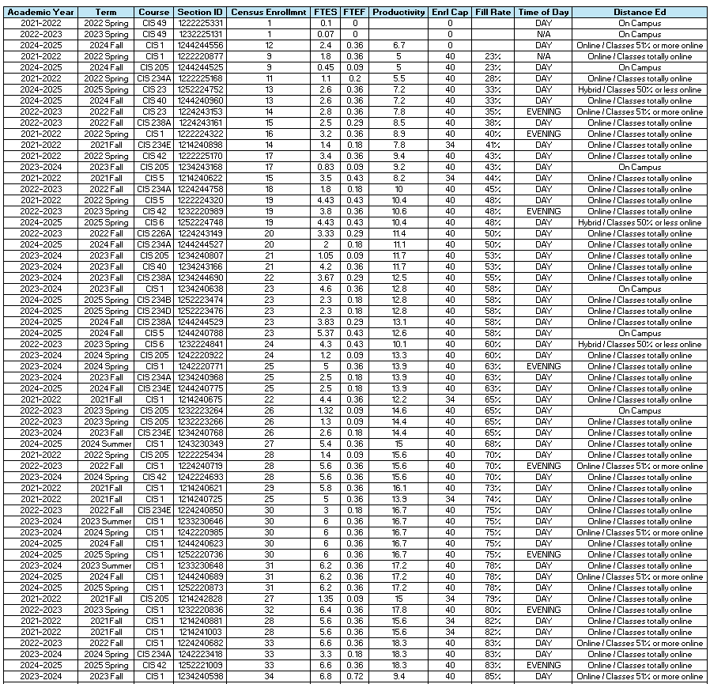
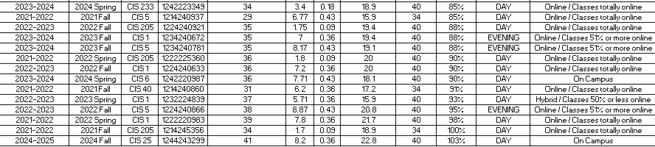
The list of course sections in your area is sorted from lowest fill rate to the highest fill rate for the last four years. Consider and discuss whether the course offers meet the needs of our students.
Discuss Here

Discuss any action plan to better meet student needs and demands.
Discuss Here

Describe effective and innovative teaching strategies used by faculty to increase student learning and engagement.
Describe Here

How is technology used by the discipline department?
Discuss Here

How does the discipline, department, or program maintain the integrity and consistency of academic standards with all methods of delivery, including face to face, hybrid, and Distance Education courses?
Discuss Here

Curriculum
CurriQunet Meta
If necessary, use the CurriQunet META link to review the details of curriculum. Some summary information is provided below.

Please review your course outlines of record in CurriQunet META to determine if they have been updated in the past four years. Specify when your department will update, or deactivate, each one, within the next four years.
Discuss Here

Please summarize the Discipline, Department or program of study plans for curriculum plans for improvement. Below, please provide details for individual course improvement. Add plans for new courses here.
Discuss Here

How is your program meeting the needs of students and/or articulation with four-year institutions?
Discuss Here

Assessment – Instructional
Student Learning Outcomes Assessment
Your Student Learning Outcomes for active courses are listed below. Please review and note any corrections or planned changes.
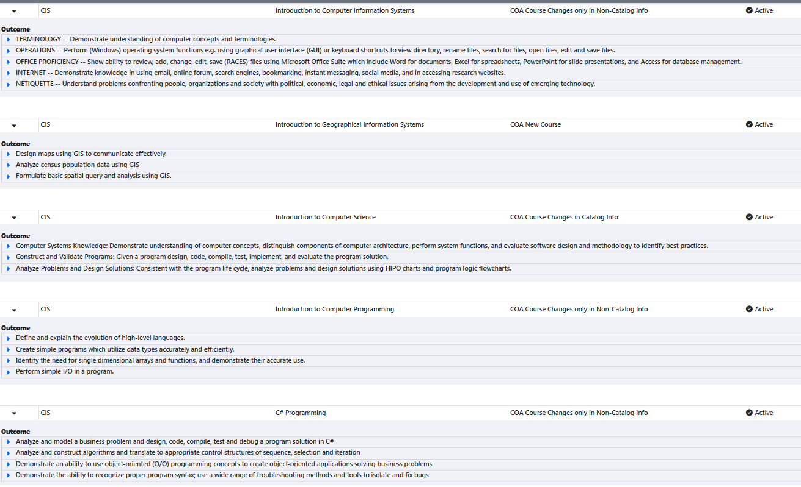
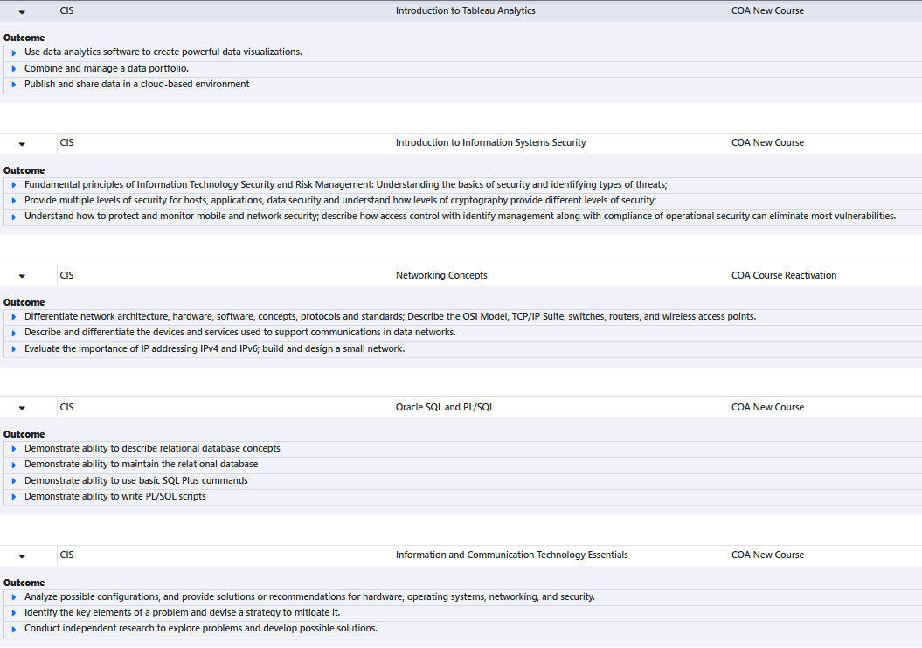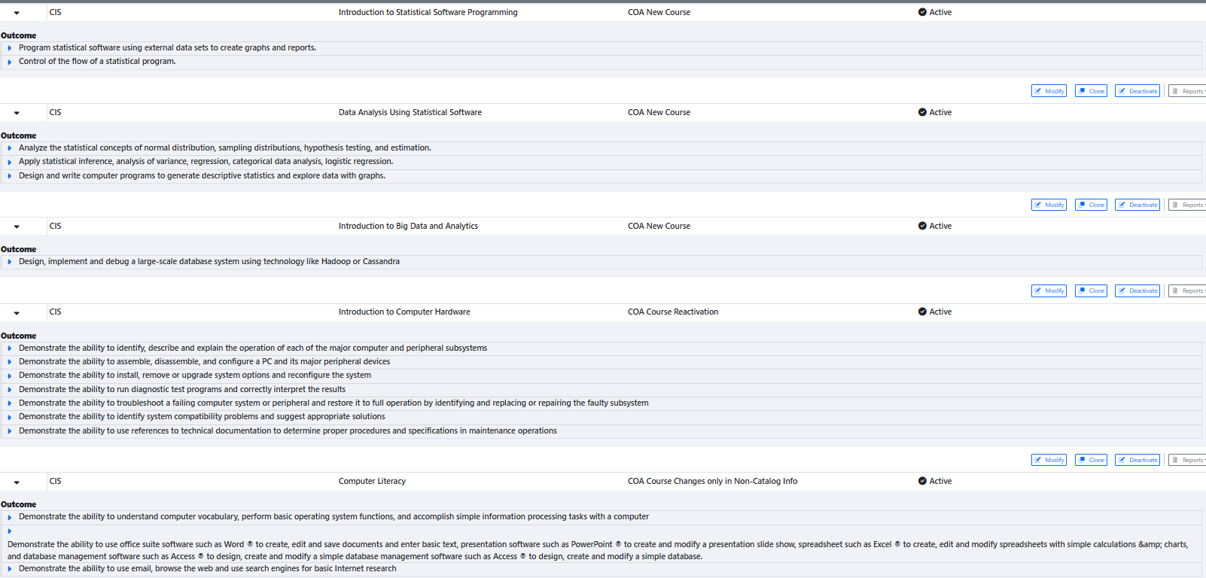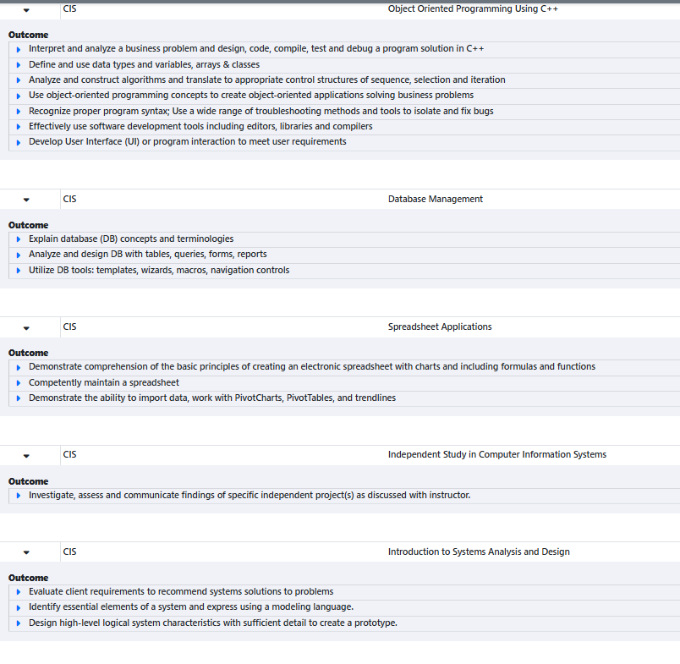
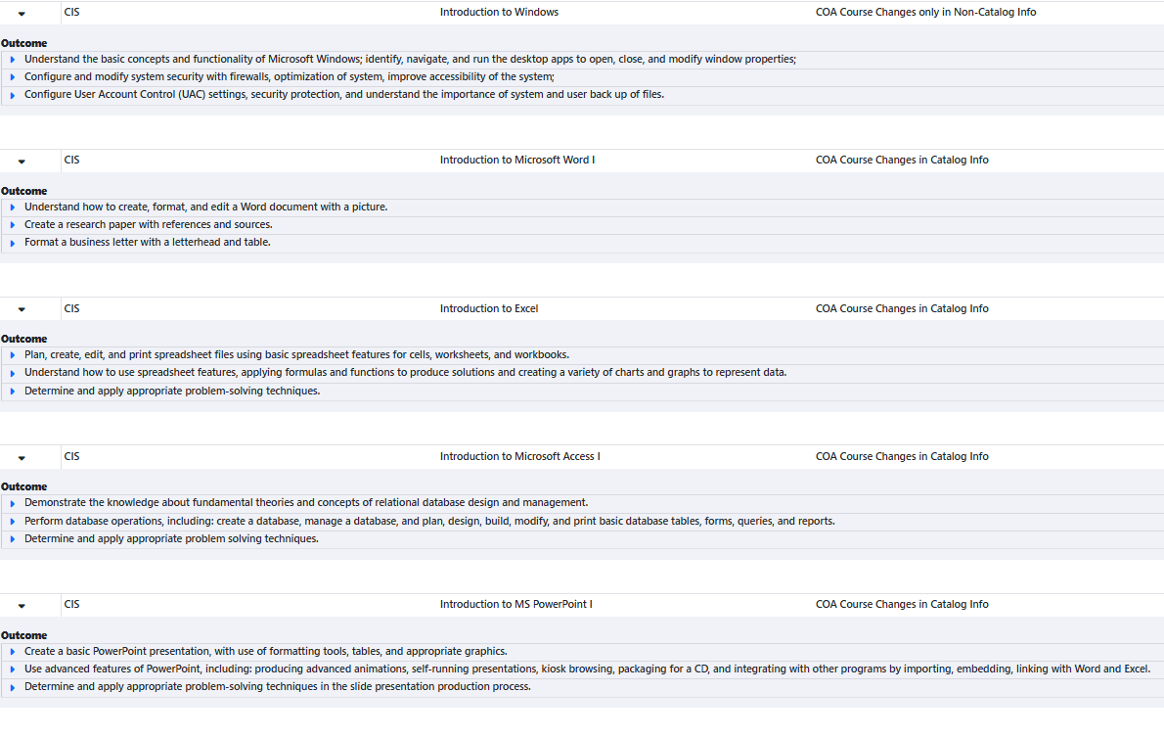
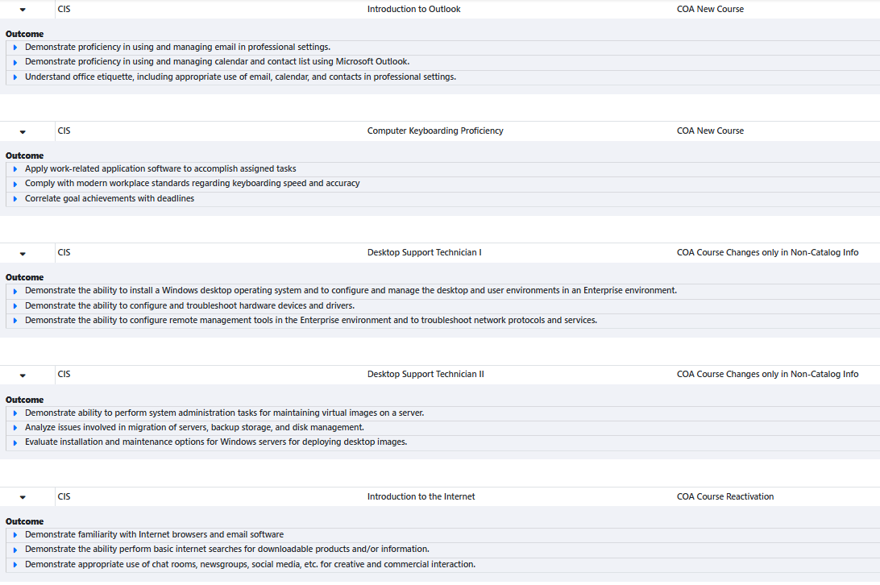
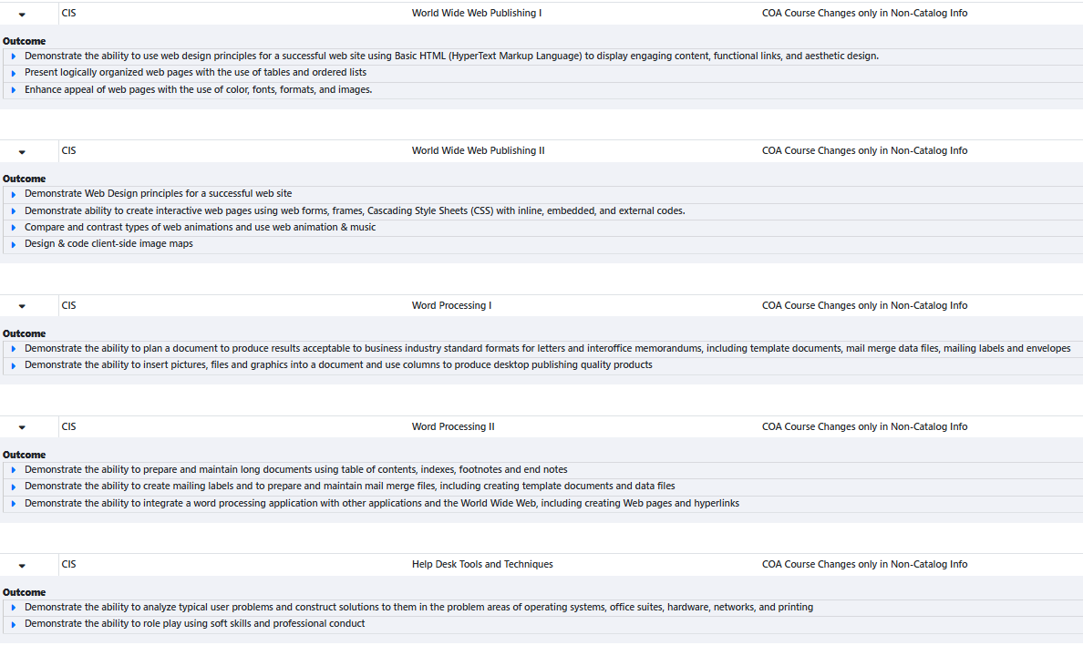
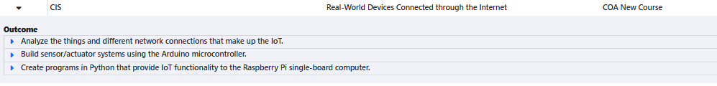
Discuss Here

Please provide a high-level summary and your program’s interpretation of your SLO findings over the past year.
Discuss Here
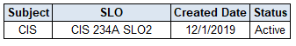
What were the most important things your department learned from assessment? Did implementation of your action plans result in better student learning?
CIS has completed zero SLOs for this SLO Cycle.

Discuss Here

Listed below are your programs (degrees and certificates) and the program learning outcomes (PLOs) for each. Please share your reflections on the PLOs and support from the college needed in assessing the PLOs over the next four years.
PLOs:
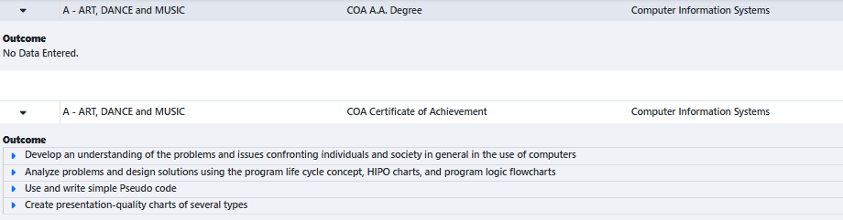
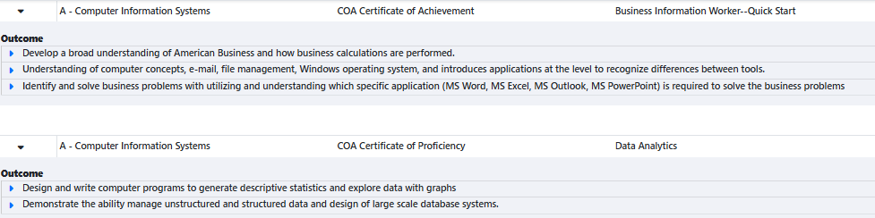

Discuss Here

College of Alameda Institutional Learning Outcomes (ILOs) were created to guide educational programs and services. They include:
- Problem Solving: Solve problems and make decisions in life and work using critical thinking, quantitative reasoning, community resources, and civil engagement.
- Communication and Technology: Use technology and written and oral communication to discover, develop, and relate critical ideas in multiple environments.
- Creativity: Exhibit aesthetic reflection to promote, participate and contribute to human development, expression, creativity, and curiosity.
- Diversity: Engage in respectful interpersonal communications, acknowledging ideas and values of diverse individuals that represent different ethnic, racial, cultural, and gender expressions.
- Civic Responsibility: Accept personal, civic, social and environmental responsibility in order to become a productive local and global community member.
How does your program participate in assessing the Institutional Learning Outcomes (ILOs)? If your program has not participated, how will you plan to incorporate these outcomes within your program?
Discuss Here

Course Completion
Consider your course completion rates over the past four years (% of student who earned a grade of "C" or better).
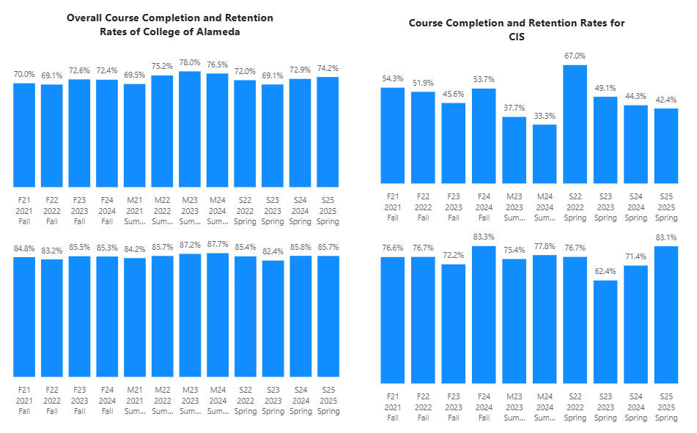
How does the course completion rate for your program or discipline compared to your college’s Institutional Set Standard for course completion (70% with stretch goal of 78%)? Also discuss the retention rate for your program or discipline, compared to the college average shown in data below.
The course completion for CIS is below the College of Alameda’s completion rate for that term. CIS is also below the set standard of 70% for the completion rate for all terms. All of terms are below the stretch goal. These completions are well below the college average success rate and the set standard of the college.

For retention, CIS is below the College of Alameda’s retention for that term. CIS is below the average of 85% for retention rate for all terms.

What has the discipline, department, or program done to improve course completion and retention rates?
Discuss Here

Equity Analysis
College of Alameda continues to focus on access, equity, and success. The goal is to create an inclusive environment where all students can thrive and meet their education and career goals.
Following is a brief description of equity data analysis, examining success rates of different ethnic groups (Asian, Black/African American, Hispanic/Latino, “Two or More”, “Unknown/NR”, White), age range, gender (Female, Male, Unknown Gender), and special population groups (Foster Youth, Veterans, College, SAS).

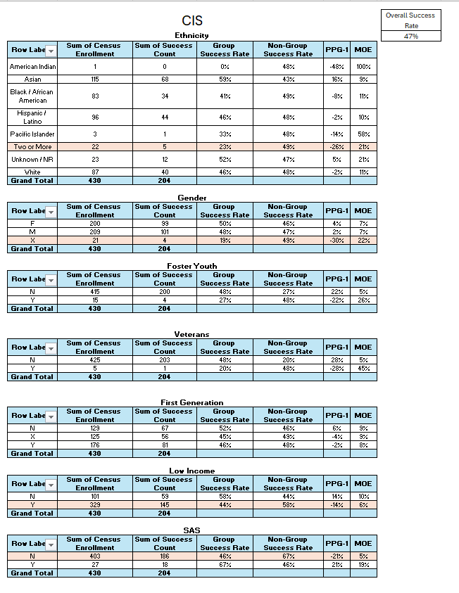
Success rate data in CIS for AY2024-25 was analyzed using the PPG-1 (percentage point gap minus 1) method, comparing the success rate of the given group against the success rate of everyone else. The success rate of the following groups falls significantly below the overall success rate of 47% for CIS outside the statistical margin of error:

- Ethnicity Two or More 23%
- Not Reported Gender 19%
- Low Income 44%
- Not SAS 46%

While there are other groups whose success rates fall below the overall success rate for CIS, either the percentage point gap difference is small or, because of the small sample size, a reliable conclusion cannot be drawn.

What can your discipline, department, or program do to improve course completion for disproportionately impacted groups?
Discuss Here

Space below is provided for additional discussion of equity-impacting factors not discussed above, including those that affect dual enrollment courses and/or online/hybrid courses.
Discuss Here

Degrees & Certificates Conferred
Does your program offer any degree/certificate programs? If your program does not, skip this section and continue to Engagement.
What has the discipline, department, or program done to improve the number of degrees and certificates awarded? Below data shows the number of degrees and certificates awarded by year, for the past four years.
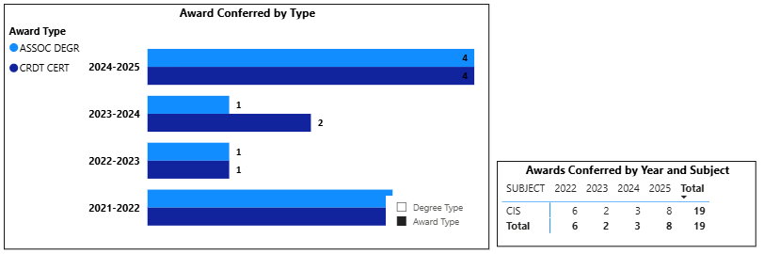
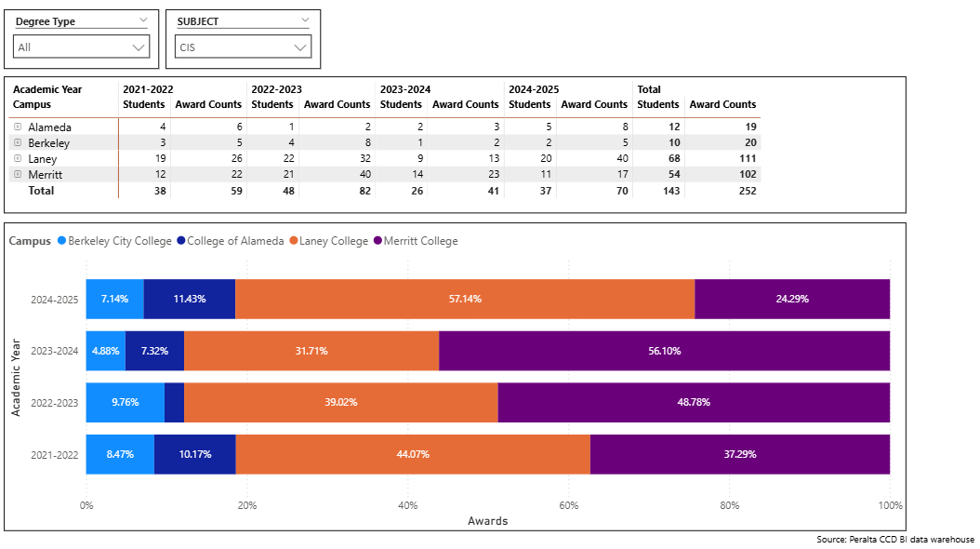
We have increased the number of degrees and certificates in the last 4 years. We are not the top in CIS in the district for these degrees and certificates.
Discuss Here

Increasing the number of students who complete a certificate or degree is a shared goal across CoA’s Ed Master Plan Goals, PCCD Goals, the Chancellor’s Office Vision for Success, the Student-Centered Funding Formula, and Guided Pathways. What is planned for the next 3 years to increase the number of certificates and degrees awarded?
Discuss Here

Engagement
Discuss how faculty and staff have engaged in institutional efforts such as committees, presentations, and departmental activities. Please list the committees that full-time faculty participate in.
Discuss Here

Discuss how faculty and staff have engaged in community activities, partnerships and/or collaborations.
Discuss Here

Discuss how adjunct faculty members are included in departmental training, discussions, and decision-making.
Discuss Here

Prioritized Resource Requests Summary
In the boxes below, please add resource requests for your program. If there are no resource requested, leave the boxes blank.
Resource Category | Description/Justification | Full-Time Equivalent Percentage | Salary Grade (if applicable)
Personnel: Classified Staff

Personnel: Student Worker

Personnel: Part Time Faculty

Personnel: Full Time Faculty

Personnel: Full Time Faculty, future anticipated need

Resource Category | Description/Justification | Total Estimated Cost
Professional Development: Department wide PD needed

Professional Development: Personal/Individual PD needed

Prioritized Resource Requests Summary - Continued

Resource Category | Description/Justification | Total Estimated Cost
Supplies: Software

Supplies: Books, Magazines, and/or Periodicals

Supplies: Instructional Supplies

Supplies: Non-Instructional Supplies

Supplies: Library Collections

Resource Category | Description/Justification | Total Estimated Cost
Technology & Equipment: New

Technology & Equipment: Replacement

Prioritized Resource Requests Summary - Continued

Resource Category | Description/Justification | Total Estimated Cost
Facilities: Classrooms

Facilities: Offices

Facilities: Labs

Facilities: Other

Resource Category | Description/Justification | Total Estimated Cost
Library: Library materials

Library: Library collections

Resource Category | Description/Justification | Total Estimated Cost
OTHER

