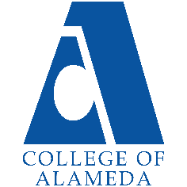
2025-26 Program Review – Instructional –
WLANG

Lead Author
Update Lead Author

Program Overview
Please verify the mission statement for your program. If there is no mission statement listed, please add it here.
Mission Statement
The Mission of the World Languages department at College of Alameda that consists of Spanish, Vietnamese, Cantonese, and German is to help students develop communicative and cultural competence in these languages and the countries in which they are spoken. Students work on developing proficiency in listening, speaking, wring, and reading in the target language, in addition to developing cultural knowledge of the speaking countries and communities. Courses are conducted in the target language and much class time is dedicated to task-based, communicative activities.

[No Degrees or Certificates are on record for World Languages – Spanish, Vietnamese, Cantonese, or German]

List your faculty and/or Staff, and indicate whether they are full-time or part-time.
Anna Rodas, Adjunct Faculty Spanish
Allen Tam, Adjunct Faculty- Chinese (Cantonese)
John D. Nguyen, Adjunct Faculty- Vietnamese

Program Goal | Ensuring all students that have enrolled in a world language course can complete a certificate, degree or transfer to a four-year university
Status: In-Progress or Complete?  If complete, give a brief description of how you measured the goal completion. | Update Progress
Which college or district goal is aligned with your program goal? | College Goal: Increase retention and persistence rates  District Goal: Advance Student Access, Equity, and Success

Program Goal | New Goal
Status: In-Progress or Complete?
If complete, give a brief description of how you measured the goal completion.
Which college or district goal is aligned with your program goal?

Program Goal | New Goal
Status: In-Progress or Complete?
If complete, give a brief description of how you measured the goal completion.
Which college or district goal is aligned with your program goal?

Describe your current utilization of facilities, including labs and other space
Update Paragraph Below

Spanish, Chinese or Vietnamese classes do not have labs and most of the classes are taking place in in smart classrooms which have every imaginable educational technology, including access to internet. Currently, all the Vietnamese and Chinese classes are online with scheduled Zoom meetings and Spanish classes are fully in-person.

Enrollment Trends
WLANG
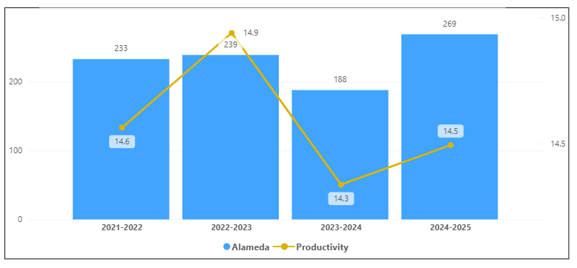
OVERALL
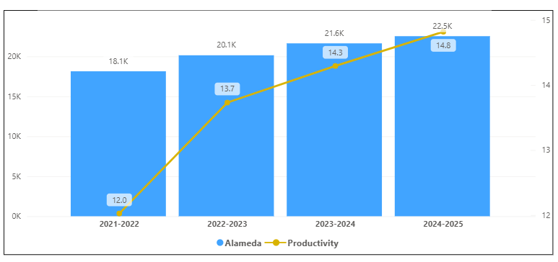
Discuss enrollment trends over the past four years.
WLANG Enrollment increased from 2021-2022 to 2022-2023 then had decreased in 2023-2024. Then WLANG increased in 2024-2025. WLANG Productivity increased from 2021-2022 to 2022-2023 then decreased in 2023-2024. Productivity had an increase in 2024-2025 of 0.2.

This program did not follow the overall trend of the college because of the decline in 2023-2024.

Discuss any reason for decrease/increase in enrollment

The list of course sections in your area is sorted from lowest fill rate to the highest fill rate for the last four years. Consider and discuss whether the course offers meet the needs of our students.
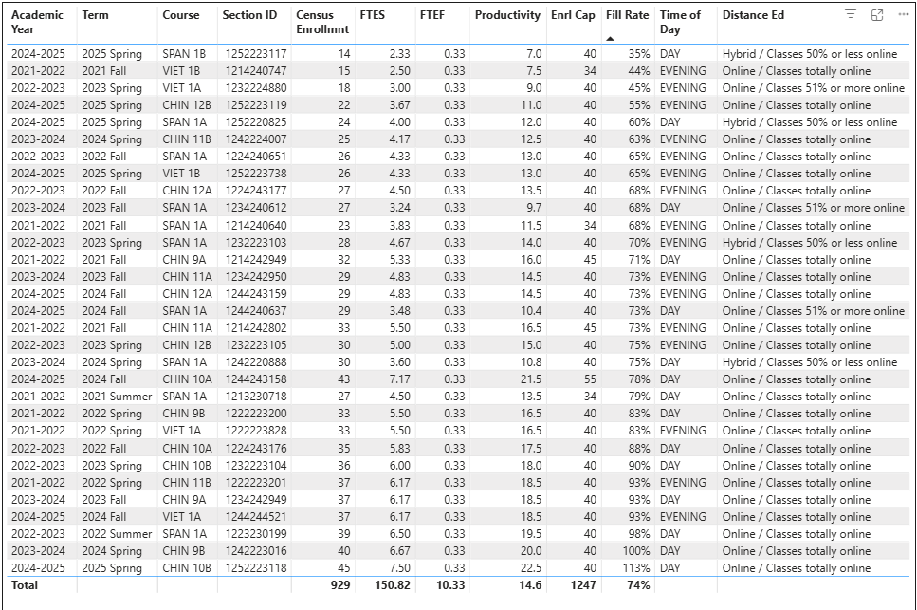
Discuss Here

Discuss any action plan to better meet student needs and demands.
Discuss Here

Describe effective and innovative teaching strategies used by faculty to increase student learning and engagement.
Describe Here

How is technology used by the discipline department?
Discuss Here

How does the discipline, department, or program maintain the integrity and consistency of academic standards with all methods of delivery, including face to face, hybrid, and Distance Education courses?
Discuss Here

Curriculum
CurriQunet Meta
If necessary, use the CurriQunet META link to review the details of curriculum. Some summary information is provided below.

Please review your course outlines of record in CurriQunet META to determine if they have been updated in the past four years. Specify when your department will update, or deactivate, each one, within the next four years.
Discuss Here

Please summarize the Discipline, Department or program of study plans for curriculum plans for improvement. Below, please provide details for individual course improvement. Add plans for new courses here.
Discuss Here

How is your program meeting the needs of students and/or articulation with four-year institutions?
Discuss Here

Assessment – Instructional
Student Learning Outcomes Assessment
Your Student Learning Outcomes for active courses are listed below. Please review and note any corrections or planned changes.
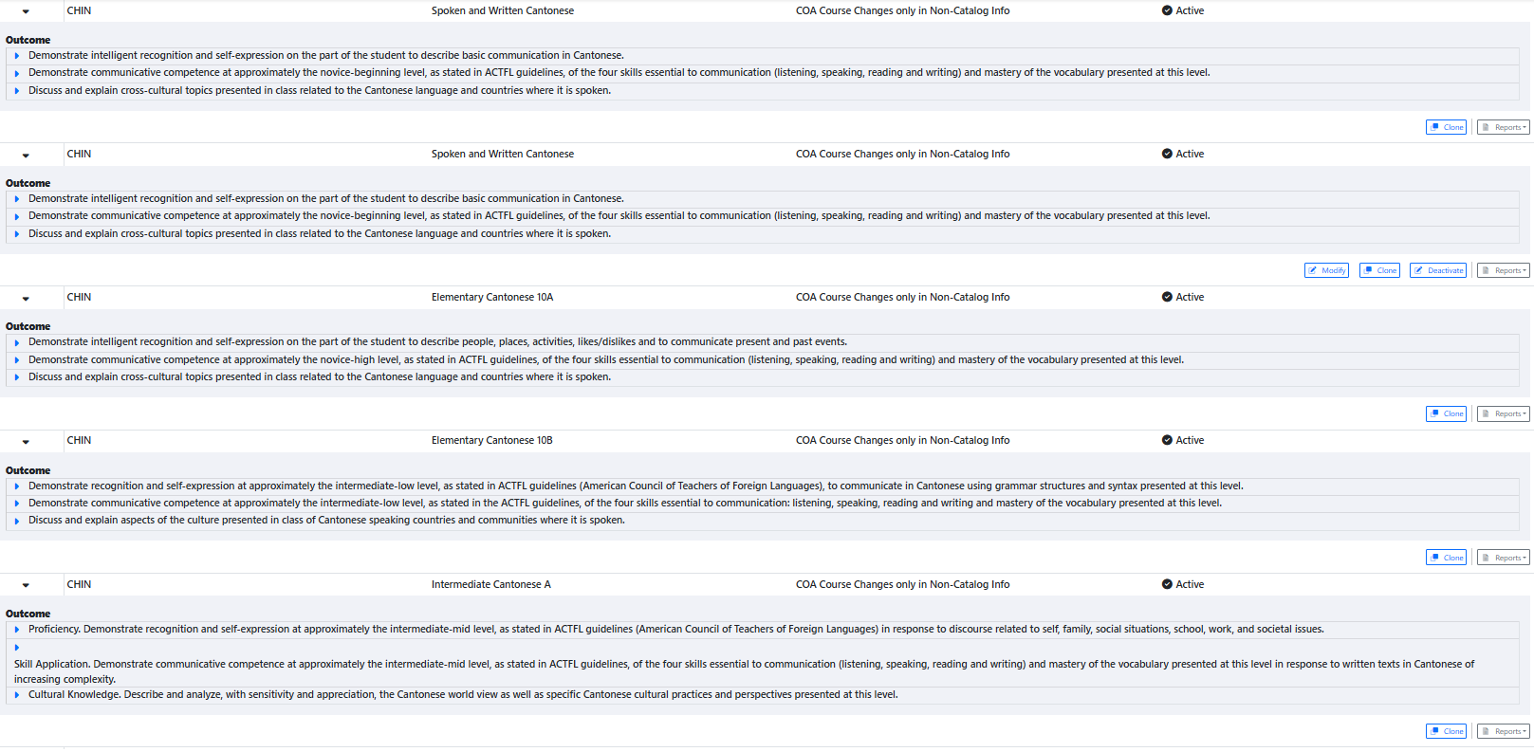
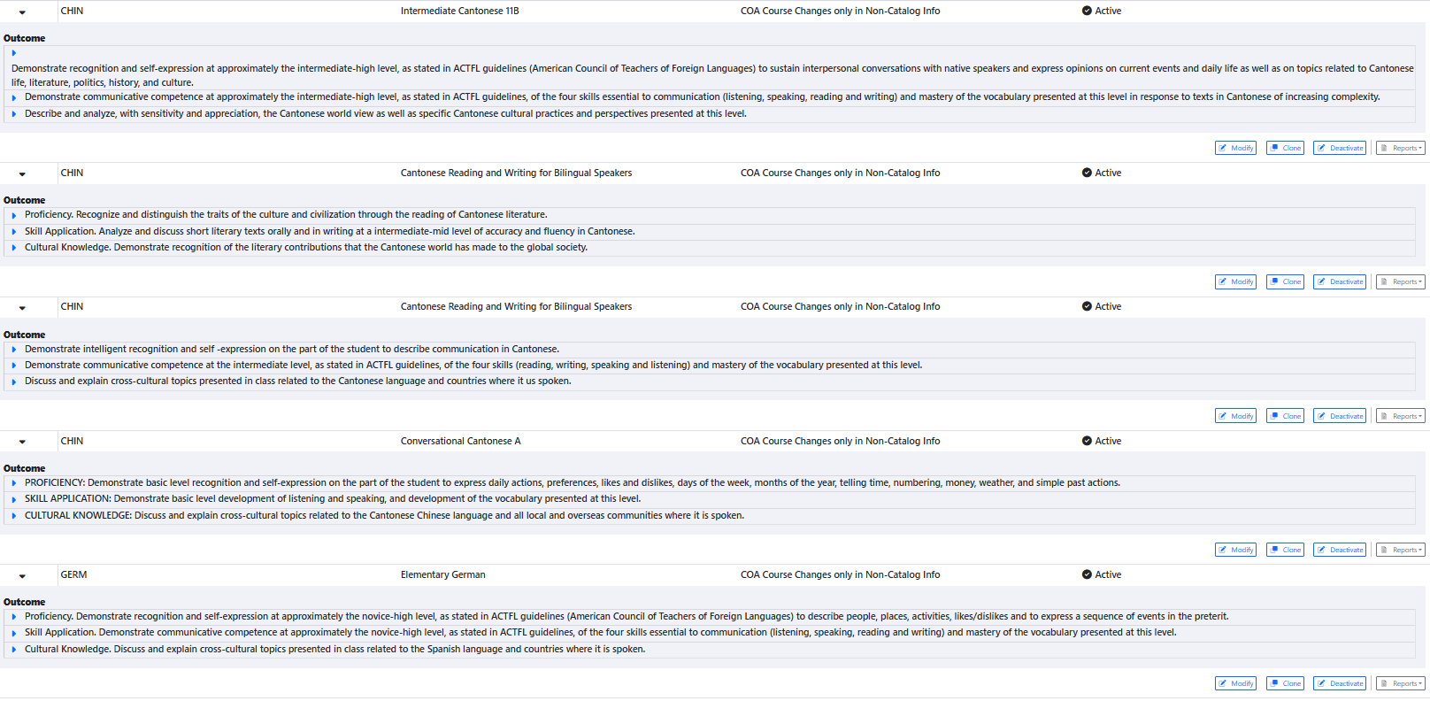
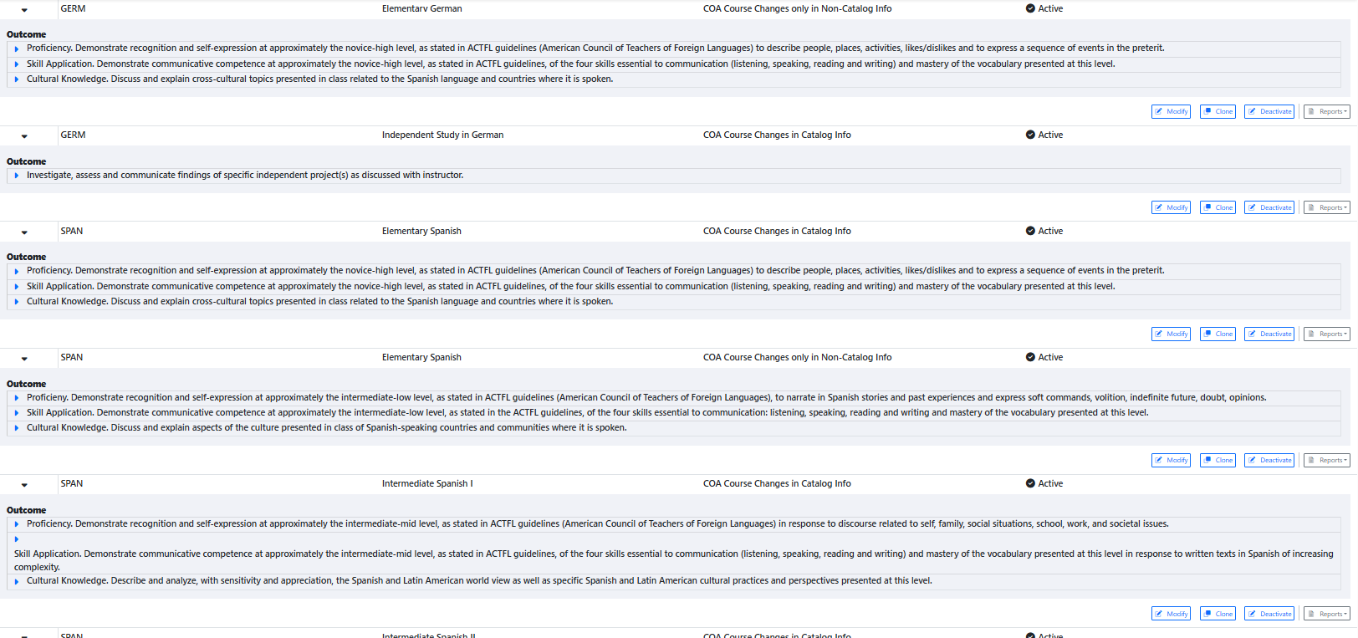
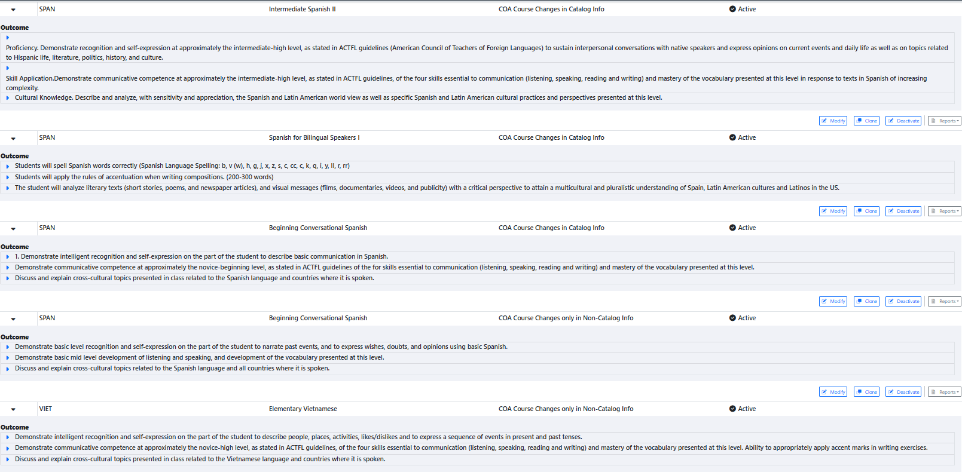
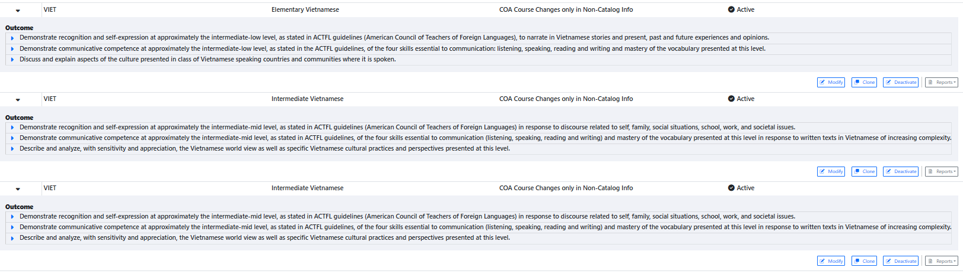
Discuss Here

Please provide a high-level summary and your program’s interpretation of your SLO findings over the past year.
Discuss Here
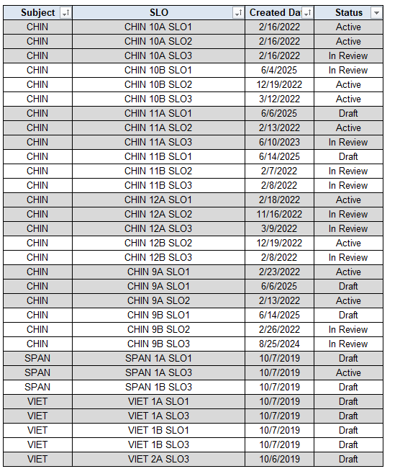
What were the most important things your department learned from assessment? Did implementation of your action plans result in better student learning?
There have been five SLOs completed by WLANG in this SLO Cycle. Not all courses have all SLOs completed. There is a bunch of drafts that are not submitted yet and a bunch that are in review.

Discuss Here

Listed below are your programs (degrees and certificates) and the program learning outcomes (PLOs) for each. Please share your reflections on the PLOs and support from the college needed in assessing the PLOs over the next four years.
[No Degrees or Certificates are on record for World Languages – Spanish, Vietnamese, Cantonese, or German]

College of Alameda Institutional Learning Outcomes (ILOs) were created to guide educational programs and services. They include:
- Problem Solving: Solve problems and make decisions in life and work using critical thinking, quantitative reasoning, community resources, and civil engagement.
- Communication and Technology: Use technology and written and oral communication to discover, develop, and relate critical ideas in multiple environments.
- Creativity: Exhibit aesthetic reflection to promote, participate and contribute to human development, expression, creativity, and curiosity.
- Diversity: Engage in respectful interpersonal communications, acknowledging ideas and values of diverse individuals that represent different ethnic, racial, cultural, and gender expressions.
- Civic Responsibility: Accept personal, civic, social and environmental responsibility in order to become a productive local and global community member.
How does your program participate in assessing the Institutional Learning Outcomes (ILOs)? If your program has not participated, how will you plan to incorporate these outcomes within your program?
Discuss Here

Course Completion
Consider your course completion rates over the past four years (% of student who earned a grade of "C" or better).
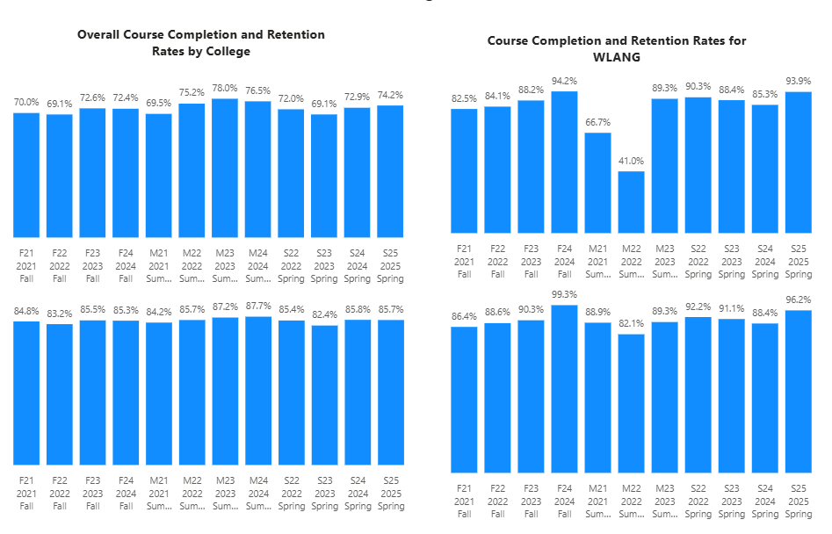

How does the course completion rate for your program or discipline compared to your college’s Institutional Set Standard for course completion (70% with stretch goal of 78%)? Also discuss the retention rate for your program or discipline, compared to the college average shown in data below.
The course completion for WLANG is above the College of Alameda’s completion rate for that term except for summer 2021 and 2022. WLANG is also above the set standard and stretch goals of 70% for the completion rate for all terms except for summer 2021 and summer 2022. For retention, WLANG is above the College of Alameda’s retention for that term except summer 2022. WLANG is above the average of 85% for retention rate for all terms except summer 2022.

What has the discipline, department, or program done to improve course completion and retention rates?
Discuss Here

Equity Analysis
College of Alameda continues to focus on access, equity, and success. The goal is to create an inclusive environment where all students can thrive and meet their education and career goals.
Following is a brief description of equity data analysis, examining success rates of different ethnic groups (Asian, Black/African American, Hispanic/Latino, “Two or More”, “Unknown/NR”, White), age range, gender (Female, Male, Unknown Gender), and special population groups (Foster Youth, Veterans, College, SAS).
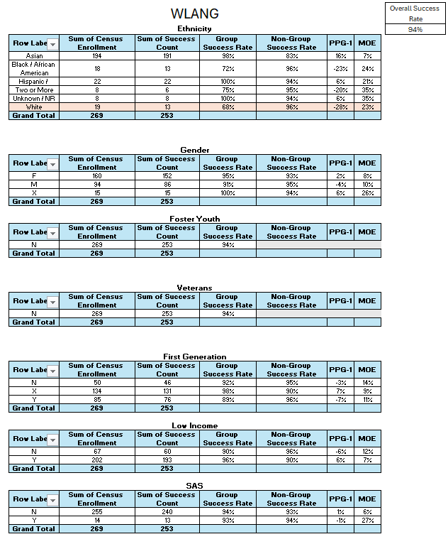
Success rate data in WLANG for AY2024-25 was analyzed using the PPG-1 (percentage point gap minus 1) method, comparing the success rate of the given group against the success rate of everyone else. The success rate of the following groups falls significantly below the overall success rate of 94% for WLANG outside the statistical margin of error:

- Ethnicity White 68%

While there are other groups whose success rates fall below the overall success rate for WLANG, either the percentage point gap difference is small or, because of the small sample size, a reliable conclusion cannot be drawn.

What can your discipline, department, or program do to improve course completion for disproportionately impacted groups?
Discuss Here

Space below is provided for additional discussion of equity-impacting factors not discussed above, including those that affect dual enrollment courses and/or online/hybrid courses.
Discuss Here

Degrees & Certificates Conferred
Does your program offer any degree/certificate programs? If your program does not, skip this section and continue to Engagement.
What has the discipline, department, or program done to improve the number of degrees and certificates awarded? Below data shows the number of degrees and certificates awarded by year, for the past four years.
[No Degrees or Certificates are on record for World Languages – Spanish, Vietnamese, Cantonese, or German]

Increasing the number of students who complete a certificate or degree is a shared goal across CoA’s Ed Master Plan Goals, PCCD Goals, the Chancellor’s Office Vision for Success, the Student-Centered Funding Formula, and Guided Pathways. What is planned for the next 3 years to increase the number of certificates and degrees awarded?
[No Degrees or Certificates are on record for World Languages – Spanish, Vietnamese, Cantonese, or German]

Engagement
Discuss how faculty and staff have engaged in institutional efforts such as committees, presentations, and departmental activities. Please list the committees that full-time faculty participate in.
Discuss Here

Discuss how faculty and staff have engaged in community activities, partnerships and/or collaborations.
Discuss Here

Discuss how adjunct faculty members are included in departmental training, discussions, and decision-making.
Discuss Here

Prioritized Resource Requests Summary
In the boxes below, please add resource requests for your program. If there are no resource requested, leave the boxes blank.
Resource Category | Description/Justification | Full-Time Equivalent Percentage | Salary Grade (if applicable)
Personnel: Classified Staff

Personnel: Student Worker

Personnel: Part Time Faculty

Personnel: Full Time Faculty

Personnel: Full Time Faculty, future anticipated need

Resource Category | Description/Justification | Total Estimated Cost
Professional Development: Department wide PD needed

Professional Development: Personal/Individual PD needed

Prioritized Resource Requests Summary - Continued

Resource Category | Description/Justification | Total Estimated Cost
Supplies: Software

Supplies: Books, Magazines, and/or Periodicals

Supplies: Instructional Supplies

Supplies: Non-Instructional Supplies

Supplies: Library Collections

Resource Category | Description/Justification | Total Estimated Cost
Technology & Equipment: New

Technology & Equipment: Replacement

Prioritized Resource Requests Summary - Continued

Resource Category | Description/Justification | Total Estimated Cost
Facilities: Classrooms

Facilities: Offices

Facilities: Labs

Facilities: Other

Resource Category | Description/Justification | Total Estimated Cost
Library: Library materials

Library: Library collections

Resource Category | Description/Justification | Total Estimated Cost
OTHER

