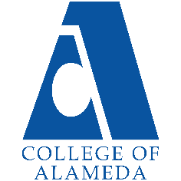
2024-25 Annual Program Update -
Library and LIS

Program Overview
Please verify your program’s mission statement and program’s learning outcomes below, and make any corrections necessary.
Mission Statement
The College of Alameda Library is a teaching and learning-centered library for a diverse community by providing physical and online access to quality print, electronic, and multi-media resources, services, and instruction. The library faculty and staff promote academic excellence and student success by emphasizing skills in library research, information literacy, and critical thinking.

List your program faculty and/or staff, and indicate whether they are full-time or part-time.

Full Time:
Ann Buchalter (faculty)
Jane McKenna (faculty)
Josh Rose (faculty)
Caitlin Gilbert (staff)
Joan Bewley (staff)
Senior Library Tech (vacant)
Senior Library Tech (Evening/vacant)

Describe your current utilization of facilities, including labs and other space.
The COA Library has approximately 20,748 gross square feet as assignable
space on the first floor of the L Building and an additional 2,521
square feet of study space on the 2nd floor of the L Building. The
space on the first floor includes seating for more than 200 students,
book stacks, four group study rooms, a quiet study room, book displays,
Chromebooks, Circulation Desk, Reserve Desk, Reference Desk, periodical
display/browsing area, study tables and carrels, copiers/scanner, printing, an
archive, computers for researching (14 workstations), 2 print stations
cataloging/processing service areas, library staff/faculty
offices, and an open classroom for instruction.

The Program Goals below are from your most recent Program Review or APU. If none are listed, please add your most recent program goals. Then, indicate the status of this goal, and which College and District goal your program goal aligns to. If your goal has been completed, please answer the follow up question regarding how you measured the achievement of this goal.
Program Goal | That at least 40% of the Library collection has a publication date  Post 2010.  Justification: Accreditation requires we have a current and high quality collection. There is a connection between library materials and student success rates. Campus data shows that students checking out print books have higher GPA and success rates than the college average ... this is also seen when broken out by at risk groups and equity challenged groups. Full data on this is located on the Library website under Planning Documents.
Status: In-Progress or Complete? If complete, give a brief description of how you measured the goal completion. | In-Progress.  The Library’s age of collection data for 2023 indicates that 33% of the collection was published post 2010. This represents a 4% improvement in currency of the collection based on the 2022 Age of Collection when only 29% of the collection was published post 2010. Due to unstable funds for library materials, the Library has not been able to acquire funds to purchase books in the numbers necessary to update the collection significantly and so has engaged in an aggressive weeding project to increase currency of the collection in years when budget limits purchasing. The Library continues to advocate for a stable budget to provide current books for student’s information needs.
Which college or district goal is aligned with your program goal? | Aligns to the following College Goal:  Increase retention and persistence rates  District Goal: Advance Student Access, Equity, and Success
Program Goal | Provide library orientations for 60% of all English 1A and 100% of all English1AS sections.  Justification: Campus data shows that students receiving library orientations have a higher success rates than other sections of the course not receiving orientations (see the Library Planning webpage for this study).
Status: In-Progress or Complete? If complete, give a brief description of how you measured the goal completion. | In progress. In 2023-2024, there were a total of 21 ENGL 1A classes (13 in Fall 2023; 8 in Spring 2024). There were also 5 ENGL 1AS classes (3 in Fall 2023; 2 in Spring 2024), according to Campus Solutions.  Below are the percentage of ENGL courses that had at least one library session in Fall 2023 and Spring 2024:  ENGL 1A - Fall 2023: 8% (1/13)  ENGL 1AS - Fall 2023: 33% (1/3)  ENGL 1A - Spring 2024: 25% (2/8)  ENGL 1AS - Spring 2024: 100% (2/2)
Which college or district goal is aligned with your program goal? | Aligns to the following College Goal:  Increase retention and persistence rates.  District Goal: Advance Student Access, Equity, and Success
Program Goal | Implement and Train on all modules of the new Library Integrated System called Alma/Primo from ExLibris.
Status: In-Progress or Complete? If complete, give a brief description of how you measured the goal completion. | In-Progress.  The Library has migrated to the new system but we continue to train and trouble-shoot. This year, the Library implemented Alma-digital. Ongoing training is required since the system is always updating.
Which college or district goal is aligned with your program goal? | Aligns to Following College Goal:  Increase community and educational partnerships  District Goal: Advance Student Access, Equity, and Success
Program Goal | Hire a full-time Senior Library Technician (Evening/Reserves) to replace for a recent Retirement.  Justification: It is critical that the Library hire a Senior Library Tech as soon as possible. This need is urgent. This position is critical to provide adequate staffing to reopen the building in the evenings.
Status: In-Progress or Complete? If complete, give a brief description of how you measured the goal completion. | In-Progress.  The position was filled and then went vacant again.  The Library continues to advocate for the replacement of this critical position that is instrumental in meeting our Library Service Outcomes.
Which college or district goal is aligned with your program goal? | District Goal: Advance Student Access, Equity, and Success

Program Update – Enrollment Trends, Success Rates, and Degrees & Certificates
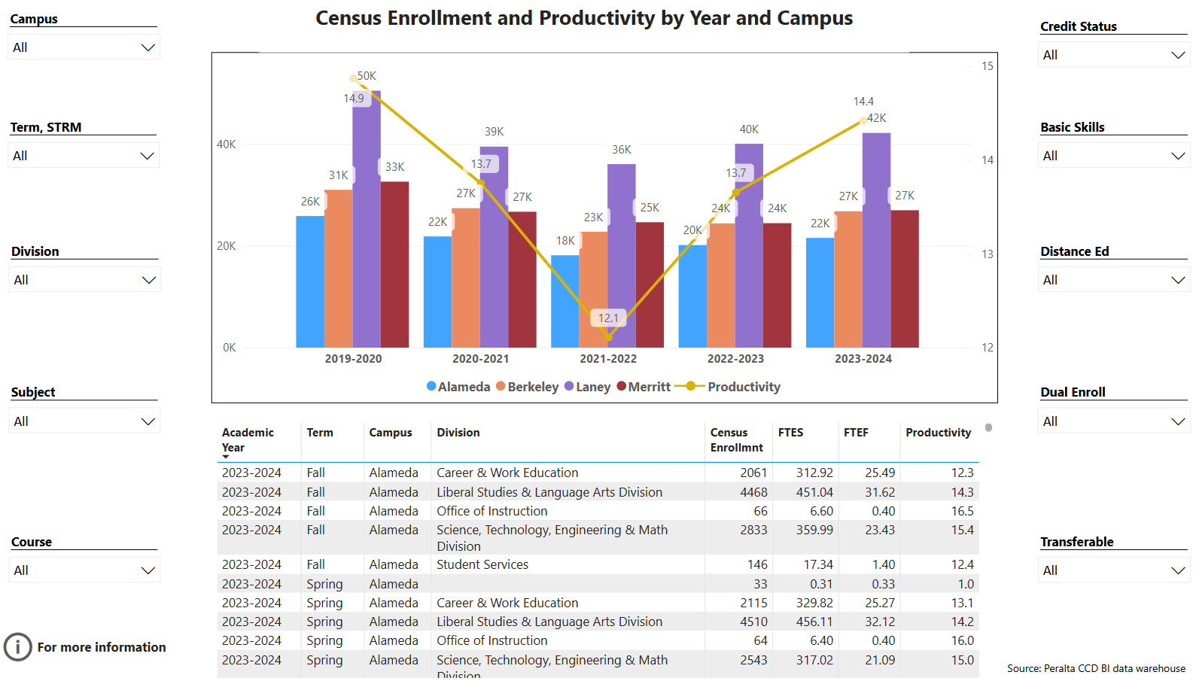
Enrollment Trends Power BI dashboard
Note: Please consider the most recent years when answering the questions below. Data with default filter is provided below. Use the link above to explore the data further.
Discuss recent enrollment trends. District-wide enrollment trends are shown above for comparison.
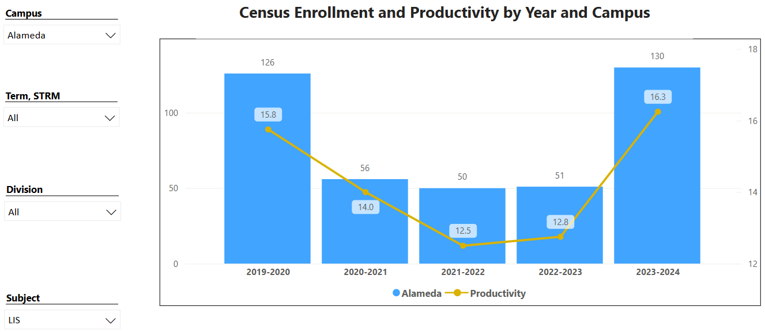
Enrollment numbers for LIS74 took a dip in previous years but have now come back to pre-covid levels.

Course Completion Power BI Dashboard #1
Course Completion Power BI Dashboard #2
Institutional Set Standards
Consider your course completion rates in recent years (% of student who earned a grade of "C" or better). Data with default filter is provided below. Use the link above to explore the data further.
How does the course completion rate for your program or discipline compare to your college’s Institutional Set Standard for course completion (70% with stretch goal of 77%)? Also discuss the retention rate for your program or discipline, compared to the college average shown in data below, as well as what the discipline, department, or program has done to improve course completion and retention rates.
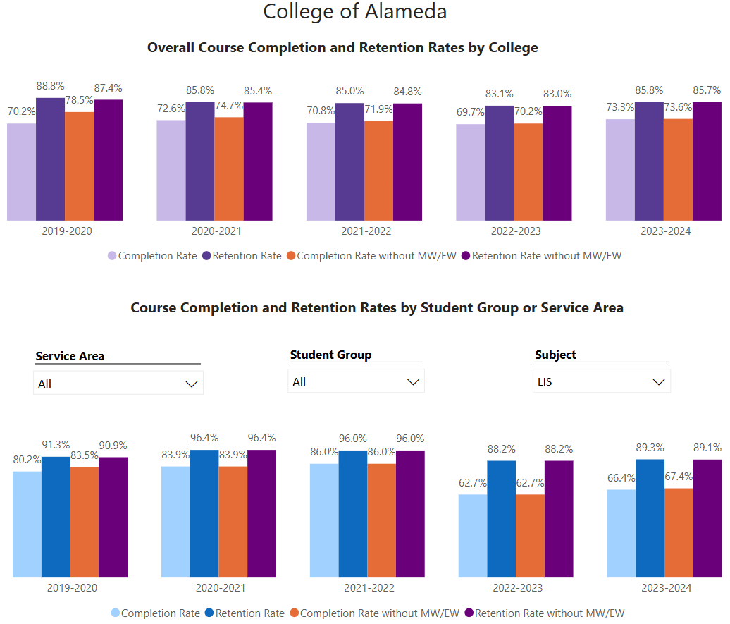
The completion rate is average for the LIS students with an average completion rate of 70%. The numbers are consistent across most categories and population groups.

The retention rate is strong for the LIS students with an average retention rate of 83%. This rate is in line with the college average for retention.

Degrees & Certificates Power BI dashboard
Please provide an update on the degrees and certificates offered by the discipline, department, or program. Below data shows the number of degrees and certificates awarded by year, for the past three years. Use the link above to explore the data further.
[LIS does not have degrees or certificates.]

Describe any significant changes in the recent years and discuss what the changes mean to your program.
Enrollment decline in LIS is due to a cut in the sections offered. In the past, the LIS program offered one section for every session run at the College (Fall, Winter Intersession, Spring, Spring Intersession, and Summer). As cuts were made across all departments to discipline allocations, the LIS program reduced their offering to only one section in the Fall and one section in the Spring. This accounts for the large drop in enrollment for LIS that is evident when comparing pre 2019-2020 and post 2019-2022 enrollment. The Library hopes to return to previous levels of discipline allocation when the budget allows.

Describe the department's progress on Student Learning Outcomes (SLOs) and/or Service Area Outcomes (SAOs) since the last Program Review/APU.
All the SLOs for all of the LIS courses (that have been offered) have been assessed within the last 3 years and entered within Meta. For the LIS course assessment results indicate that students are 90% or above in meeting the outcomes for the courses.
In addition, all of the Library service outcomes have been assessed within the last 3 years and entered within Meta. The service-learning outcomes data for library services is also analyzed at the Dept. level and utilized when developing budget priorities for the area. Service area data compiled and analyzed includes library orientation assessment results, library student surveys, faculty surveys, library usage statistics, as well as studies that analyze the demographic data, GPA / success rates of Library users. Many of these assessment results are also posted on the Library webpage under For Librarians -> Planning Documents.
In addition, a detailed description of the Library’s internal assessment process can be found on the Library Webpage under For Librarians -> Planning Documents.

Describe the outcomes and accomplishments from previous year’s funded resource allocation request. If your program did not receive any allocations, leave the boxes blank.
Brief description of funded request | Source (any additional award outside your base allocation) | Total Award Amount | Outcome/Accomplishment
The Library has a large number of regular bills that are required to maintain a basic level of library services and resources. The Library does not receive these funds as a base allocation (even though they are annual subscriptions) and instead must advocate / help identify funds for these even though these funding requests/expenditures are stable annual needs that we are contractually required to pay. These bills include annual service/subscription agreements for article databases, library systems, periodical subscriptions, security gates contract, reference chat software subscription, reserve textbooks, and circulating collection books (only funding expenditure that has some flexibility in terms of whether we order). The Library continues to advocate for a baseline budget from the general fund for annual baseline Library expenses that do not change from year to year. |  | $131,237 | See the Library Planning Documents webpage for in-depth usage and collection statistics including: circulation numbers, textbook usage, database usage, orientation sessions, material cataloged, study room usage, withdrawn materials, etc. Recent data shows that article database usage has gone up significantly (60% increase in searches from the previous year). Over 300 Chromebooks were checked with an additional 180 renewals of Chromebooks. Books for the Latinx Collection were purchased using HSI grant funds. Age of the collection improved currency by 6% from previous year. Group study room bookings served 846 students. Reference questions increased by 60% from the previous year. Circulation transactions doubled compared to the previous year.

Prioritized Resource Requests Summary
In the boxes below, please add resource requests for your program. If there are no resource requested, leave the boxes blank.
Resource Category | Description/Justification | Full-Time Equivalent Percentage | Salary Grade (if applicable)
Personnel: Classified Staff | Full-time Senior Library Technician (Circulation) – need to fill this vacancy in order to provide regular evening hours for the Library.
Personnel: Student Worker | Funds for student workers to assist at the Circulation Desk | 5,000
Personnel: Part Time Faculty | Continue to fund adjunct librarian hours at previous year levels in order to give the F/T Reference Librarian time off-desk and to cover evening hours. | See parcel plan for current levels of adjunct librarian support that we request continue annually.
Personnel: Full Time Faculty

Personnel: Full Time Faculty, future anticipated need

Resource Category | Description/Justification | Total Estimated Cost
Professional Development: Department wide PD needed

Professional Development: Personal/Individual PD needed

Prioritized Resource Requests Summary – Continued

Resource Category | Description/Justification | Total Estimated Cost
Professional Development: Department wide PD needed
Professional Development: Personal/Individual PD needed
Supplies: Software | Public Web Browser (annual subscription) - $250  Alma –Digital – a add-on for ExLibris that facilitates checking out digital copies of reserve materials - $1500 | $1,750
Supplies: Books, Magazines, and/or Periodicals | Reserve Textbooks - $2,000  Reference Books – $2,000  Periodicals – $2,000 (print subscriptions)  Flipster Periodical database - $4,000  Articles/ebooks/videos databases - ($36,275) (annual subscriptions)  Circulating Books - $55,000 (number based on estimate of what it takes to update the age of collection over the course of 10 years) | $101,275
Supplies: Instructional Supplies | Instruction supplies, student printer supplies and cataloging supplies – $3,600 | $3,600
Supplies: Non-Instructional Supplies | Office supplies for Library staff – $1,000 | $1,000
Supplies: Library Collections | See sections above called Supplies: Books, Magazines, and/or Periodicals and Supplies: Instructional Supplies
Technology & Equipment | GoPrint Wireless Print Stations - tbd  Updated Circulation Shelving – tbd  Library Lounge Seating (upholstered chairs are cracking/tearing) – tbd  Refresh staff computers – tbd  Refresh student computers – tbd  Emergency Phones and panic buttons – tbd  Building Announcement System – tbd  New whiteboards for study rooms - tbd  Presentation equip for study rooms – tbd | TBD
Library: Library materials/collections | See section above called Supplies: Books, Magazines, and/or Periodicals
Facilities: Classrooms/Labs | Library - Lighting upgrade  Library - New roof  Library - Electrical upgrade  Library - HVAC upgrade | tbd
Facilities: Offices

Other | CCLC Dues and Membership - $150 (annual, provides discount pricing for databases)  Biliotheca Security Gates (service contract - annual, alarm system for books, required by Accred.) - $2,886 | $3,036

