College of Alameda Library
Program Review
Fall 2012

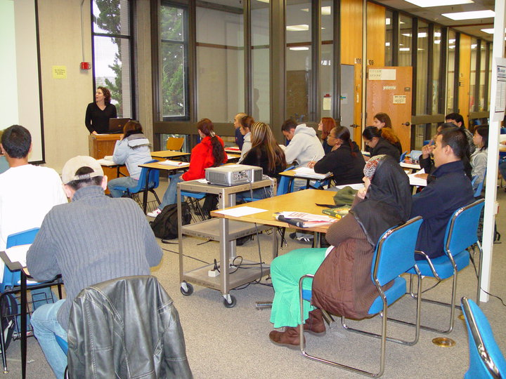 |  | 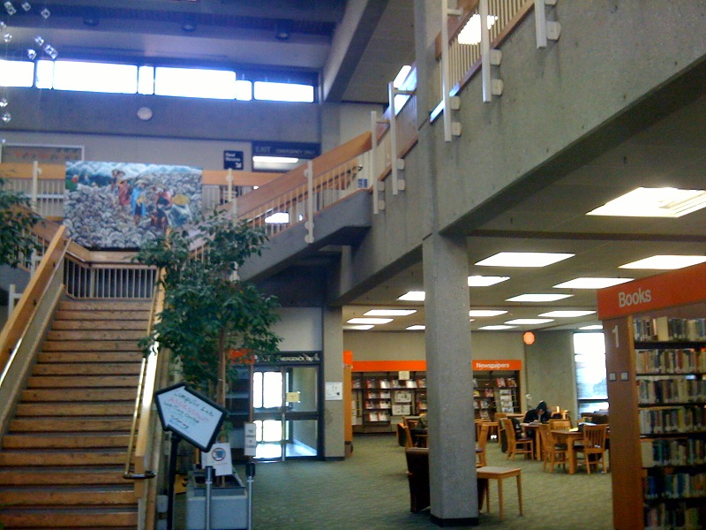
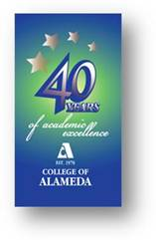 | 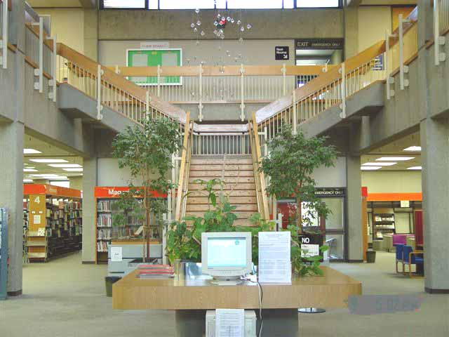
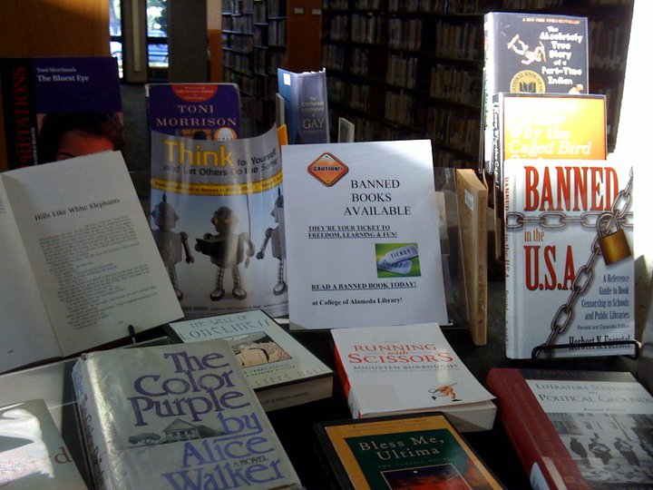 |  | 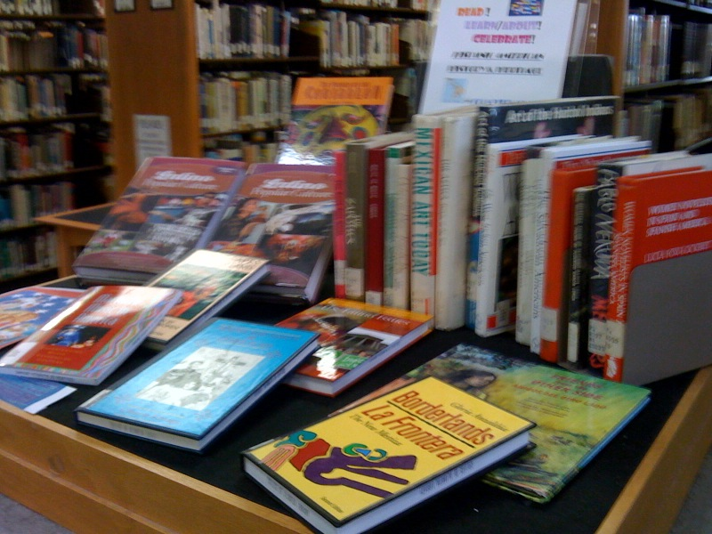

Fall 2012
COA Library Program Review Narrative Report

1. College: College of Alameda
Discipline, Department or Program: LIBRARY: Services and Instruction (LIS)
Date: FALL 2012
Members of the Library Program Review Team:

Library Faculty:  ▪ Steve Gerstle, Reference & Instruction  ▪ Jane McKenna, Public Access Services  ▪ David H. Sparks, Head Librarian, Technical Processing & Library IT Systems | ▪ Regular Adjuncts: (Reference/Instruction)  Barbara Fields,  Anna-Marie Basso | Library Technicians (Contract)  ▪ Lili Tavassoli, Senior Library Tech/Circulation  ▪ Glenda Gardner, Senior Library Tech/Periodicals  ▪ Caitlin Gilbert, Principle Library Tech  ▪ Paulette Brewer (90 day temp), Library Tech II, Evening & Reserve  ▪ Vacant, Library Tech I Cataloging & Processing
________________________________________________________________________
2. Narrative Description of the Discipline, Department or Program:

Please provide a general statement of primary goals and objectives of the discipline, department or program. Include any unique characteristics, degrees and certificates the program or department currently offers, concerns or trends affecting the discipline, department or program, and any significant changes or needs anticipated in the next three years.

MISSION STATEMENT:

The College of Alameda Library strives to be a teaching and learning-centered library for a diverse community by providing physical and online access to quality print, electronic, and multi-media resources, services, and instruction. The library faculty and staff strive to promote academic excellence and student success by emphasizing skills in library research, information literacy, and critical thinking. As a result of encouraging intellectual curiosity, independent thinking, and lifelong learning the library helps students, faculty, and staff achieve success in their individual educational, occupational, and life goals.

Goals and Objectives:

■ To provide quality services, research materials, technology, facilities, and instructional programs that support the college curricula, information literacy, and research needs
■ To provide students with access to information resources that support their learning processes, teach information literacy, and satisfies their intellectual need
■ To provide timely, appropriate, current, and knowledgeable responses to students and faculty requests for information needs in print, electronic and web-based formats

■ To provide professionally qualified librarians and a skilled technical staff to support the use of library resources and technology (including audio-visual/multi-media) to support academic, administrative, collegial, and organizational needs
■ To provide assistance and access to persons with special needs, and ensure a comfortable, safe, and clean learning environment for all students
■ To administer fair and objective service policies
■ To protect each individual’s right to privacy with respect to information requested and materials consulted
■ To affirm the mission and vision of College of Alameda, and the Peralta Community College District

Since the last program review in Fall 2006, library resources, services, and instructional programs have, despite state, district, and college funding cuts, continued to maintain, if not improve library services and instruction. Towards our mission of more hands-on teaching, librarians have continued to innovate in student’s learning of information literacy skills, and due to Measure A funding the project of “weeding” library collections (withdrawing outdated, unused materials according to a set rubric) and acquiring more appropriate, more current research and reading materials either by instructor recommendation or librarian research, has proceeded gradually. All with COA Student Services, COA Library is unique as a campus program that provides resources, services and instruction for all other programs, all students, faculty and staff. In light of COA Library progress in accreditation recommendations, we received an Commendation from the exiting Accreditation Team in March 2009.

Reductions in library open hours have been made incrementally between 2006 and 2012 totaling a 23% cut. Library usage (visits, circulation and instruction) reflect similar decreases. Library circulation services are automated, providing access to an integrated library system of a “union” catalog of all district library resources. Also part of our electronic/online resources are internet-based recommended sites and other numerous electronic resources including online periodical subscription databases. This now includes, as of 2012, a STEM (Science, Technology, Engineering, Mathematics, plus Environmental and Computer Science) focused eBook collection. Library Instruction operates in both online and “brick and mortar” environments and resources. Instruction in library research occurs individually, in groups at the Reference area Research Workstations, and in the classroom (LIS85, LIS 200, LIS500, and Non-FTE Orientations).

A continued decline in services and instruction reflects the recent 30% cuts by the college of total class sections and decline in head count, the latter used in calculation in actual staffing needed to adequately serve the student body. But, while similar decline in Reference is found over the long term, individual and group instruction at the Reference desk seems to fluctuate, declining between 2010 and 2012 only about 10%. As detailed below overall circulation and web-resource usage continues to increase by smaller margin. This overall in-house decline reflects national trends for all academic libraries. However, circulation of research and reading materials continues to improve from a ten year high in 2010-11 of 22,502, to a 2011-12 decline of only 12%. This is due to several facts and projects including:

- The college commitment to upgrade (currency, curricular needs, etc.) and improve the library collections (print and online) – a annual average of $30,000 over 10 years. This is, however, only approximately 25% of the projected 2.5 million to totally upgrade our neglected collections.
- The Weeding Project that removes outdated, underused materials, making better and more recently acquired research and reading materials more visible and accessible.
- Outreach to faculty for a more integrated approach to library class sessions, including multiple session for one class/instructor. This outreach includes consultations with faculty in two important ways: a. creation of more successful library lessons and assignments tailored for the assignment at hand; b. meeting with instructors proposing new courses in order to acquire new research and reading materials that reflect new curriculum development. Librarians have met with instructors for an average of 12 meetings, excluding curriculum approvals, annually since 2008. In 2011-12 the number of meetings rose to 14. Anecdotally, curriculum (course outline) approvals also average about another dozen or more.
- Creation of two new collections: EZ Reading (for Basic Skills & ESL students) and Bestsellers (to encourage general reading and, as a result, greater literacy)

Allocations from Measure A have almost totally replaced annual general funds from the college for annual operational costs (Maintenance Of Effort Budget). All state funding from the State’s Instructional Equipment and Library Materials fund has also been cut that had provided almost exclusive funding for the improvement of library collections. After the cut of the state TTIP funding of $38,000 for each CC library the libraries in 2010-11 received approval for district-wide general educational funding for subscription to online periodical databases. At this writing this local funding is in jeopardy, due to several factors including redirection of identified funds for other needs including library systems maintenance and categorical funds for databases as direct resources to students.

However, other operational costs for purchase of library materials (annual print periodical subscriptions, reserve textbooks, and Reference standing orders, also have no stable funding. Measure A, a finite bond measure, has covered funding for all library expenditures except office and cataloging supplies and security gate maintenance. Measure A has been used for purchasing new computers, other instructional equipment and, most importantly, the upgrade project for library collections -- an accreditation issue due to COA’s out-of-date and irrelevant resources for current curricular needs. The funding has allowed the library to maintain and improve collections and computer access to resources for students since 2006.

The library continues to rely on support from the college’s IT Team for proxy server support and maintenance of library computers for faculty, staff and student use. This server helps provide remote access (off-campus) to all students. All district libraries also rely on the District Data Center for maintenance and upgrades to the district servers and services that support the library’s automated catalog. In 2011, the Chancellor approved the recommendation of the District Planning and Budget Council to allocate $400,000 from Measure A for the purchase of and migration to a new library system. The District Data Center will need to actively work with the librarians to support the completion of the migration process, ongoing maintenance and other necessary database functions that include universal remote authentication (a more efficient way to allow students to access library electronic resources off campus and for online classes). In order to keep up with heavy use by staff and students, as well as steadily evolving technology needs, the library computers should be replaced regularly on a 5-year refresh cycle recently adopted by the District Technology Committee.

Although the library is automated, the need for traditional print reading material remains, especially for Basic Skills and ESL students who comprise a large percentage of COA’s student body. For example, the library needs hard copy versions of magazines and journals for students to examine for critical thinking and media literacy assignments. Additionally, students need to examine periodicals, encyclopedias and other reference sources to learn about different types of information tools critical for academic success. Students also continue to need access to books with current information that they can check-out. The library needs an adequate, reliable line-item budget to provide essential support for the library’s collections: research and reading materials, including books, periodicals, electronic resources and non-print media.

With only three contract library faculty, the library struggles to support the complications of an increasing demand and necessity for instruction in information literacy. Managing our more complex automated library environment with increased media services needs of the college and coordination of access to the growing collection of electronic resources is also more and more time-consuming.

Library & Information Studies (LIS) courses will become more important as the California state and others institutions of higher learning continue to move towards an information competency requirement. PCCD Librarians plan to continue to support a district-wide requirement. The library currently offers one online short-term library course (LIS 85--2 unit, that is UC/CSU transferrable) and 1 unit, Basic Skills Library course (LIS 200). Librarians plan to continue to offer these courses each semester. LIS200 plans to be linked formally to various basic skills classes and in Fall 2013 to one learning community. However, if the college implements an information competency requirement the library’s course offerings will need to expand and include new online LIS courses. Additional library faculty will be required to meet the needs of this expansion.

FOR ADDITIONAL DETAILS IN LIBRARY STATISTICS AND DATA SEE THE LIBRARY WEBPAGE/PLANNING DOCUMENTS –

http://alameda.peralta.edu/library/library-handouts/library-planning-documents/
________________________________________________________________________

3. Curriculum:

- Is the curriculum current and effective? Have course outlines been updated within the last three years? If not, what plans are in place to remedy this?

CURRENCY:
[Non-FTE instruction] Orientations -- Individual class session for library instruction:
Instruction and classroom activities and lessons are aligned to assignments and information need to increase student’s motivation as well as to demonstrate application of skills and concepts that successfully provide their immediate information needs. Lesson are constructed in collaboration with individual instructors to address both a broad understanding of academic library and the information needs of the specific assignment.

LIS 85: Introduction to Information Resources:
LIS 85 course was updated Spring 2011. In updating the outlines, the library will consider all applicable areas of the course verification checklist for currency.

LIS 200: Library Skills for College Students
This class was first offered Spring 2012. In updating the outlines, the library will consider all applicable areas of the course verification checklist for currency.

LIS500 Computer Laboratory for Library Information Studies
LIS 500 course outline was updated Fall 2012. In updating the outlines, the library will consider all applicable areas of the course verification checklist for currency.

Effectiveness
Student Survey Spring 2012: Comments from students throughout the course and in student evaluations and surveys validated the relevancy and importance of using the library as a place of study, learning in individuals and groups. Having a quiet space to study was often mentioned in the Spring 2012 survey. Students also seem confident in their ability to find information they needs for course work and in approaching a librarians for help.

Specifically the survey shows that 71% of students responding felt confident in using library services. Nearly 50% of student said that library staff was helpful and 54% said that library policies and rules were adequately explained. According to survey responses, 62% of students use the library to access Reserve Textbooks and nearly 30% said that they check out general circulation books.

These indicators, together with a 70% student success rate in finding information for their assignment, indicates that students are successful in knowing how to ask questions in the library to get the services and information they need. This also demonstrates that library staff and librarians provide good access to service use details and to collaboration/consultation with librarians.

- Has your department conducted a curriculum review of course outlines? If not, what are the plans to remedy this?

Yes. See the Currency section above.

- What are the department’s plans for curriculum improvement (i.e., courses to be developed, updated, enhanced, or deactivated)? Have prerequisites, co-requisites, and advisories been validated? Is the date of validation on the course outline?

CURRICULUM IMPROVEMENT (See TaskStream document below for more details)

LIS85: Introduction to Information Resources: Annual assessments via class survey and analysis of success, retention and productivity have led to several revisions in assignments and approach.

LIS 200: Library Skills for College Students: As a newly developed course in light of annual assessment via class survey and analysis of success, retention and productivity, the lesson plans for this class has been revised adding new assignments that assess learning in a more complete way. In class workshop style and group study has also been adopted.

LIS 500: Computer Laboratory for Library Information Studies: This positive attendance course has been under continual revision. First used for a series of three progressive open workshops in information literacy, it is also now used as a format for two progressive classes for ASTI (Alameda Science and Technical Institute), the college’s secondary special school. Adjunct librarian, Mrs. Fields, a credentialed secondary school librarian, has to develop a specific curriculum and lesson plan for this level of learning. Additional plans for revision of the three workshop series on ongoing, including outreach to the Alameda community’s information needs via city organizations including the Alameda Free Library and the Alameda Multicultural Center. Plans are to be ready with appropriate workshops and training in information literacy for these kinds of venues by Fall 2013.

[Non-FTE instruction] Orientations -- Individual class session for library instruction: Development and innovation in these classes is also ongoing due to the nature of the instruction as each class lesson developed in collaboration with the instructor. In particular, great strides have been made to develop appropriate lessons, especially group work and hands-on assignments for ESL and basic skills students. See below a summary of innovations and improvement to teaching and learning for Basic Skills students as foundational skills for college success applied to LIS200, Orientations/Individual Class Sessions, and ASTI classes.

In Spring 2008 ASCCC adopted Information Literacy as a Basic Skill that incorporate appropriate library activities into the assessment tool and effective practices portion of any future editions of Basic Skills as a Foundation for Student Success in California Community Colleges. Workshops and course-integrated instruction/learning communities serve the needs of this population more effectively. The library has either already integrated, or is exploring instructional practices that relate to those listed for programs in the Basic Skills Initiative including:

- Application of current learning theory in information competency;
- Tailoring orientations to specific disciplines, assignments, and needs of instructor/student;
- Uses a variety of teaching methods (audio, visual, small groups, etc.) to address holistic development of all students (social, emotional, class, and cultural experience), also providing public access to research materials on campus for student without such resources
- Creation of new testing and assessment tools for evaluating skill sets for Basic Skills via library assignments
- Orientations and workshop are presented in a highly structured environment physically in the library to orient student to facilities and resources;
- Works with English basic skills, ESL, DSPS, other student success, basic skills and learning community programs, instructors sharing and developing library instruction and resources for student in these programs; the library has created a new special collection for ESL materials and purchased recommended resources for EMOJA, APASS, and ADELANTE
- Has begun a series of assessment tests to help access instruction and monitor student performance including: bibliographic assignments, critical thinking assignments – “What is your assignment?” What is the research process?” “Assignment topic as search strategy.” Pre/post tests.
- At COA, librarians attend Basic Skills workshops and keep undated concerning the Basic Skills & Student Success/ Enrollment Management Committee, now called CLASS

Tutor Training (Instructional Support)
Librarians have coordinated with faculty and coordinator of tutoring and the writing center to plan and to deliver information competency training sessions (Fall 2012) to tutors enrolled in the LRNRE 30: Tutor Training Course.

Prerequisites, co-requisites validated. Date of validation

LIS 85: Recommended Preps, only – (validated 2011) LIS 200: Recommended Preps, only—2011. LIS 500: N/A.

- What steps has the department taken to incorporate student learning outcomes in the curriculum? Are outcomes set for each course? If not, which courses do not have outcomes?

All LIS courses have SLOs which reflect professional, teaching and learning standards set by the American Library Association and the 2001 the State Academic Senate recommendations for Information Competency for community college students.

- LIS 85 (Updated SLOs Spring 2011): Course materials, quizzes, and the final project (Annotated Bibliography) are constructed to guide students through an understanding of library research and the relevance and evaluation of resources using evaluative criteria; formulation and understanding of research topics and search techniques appropriate for online catalog, database and World Wide Web searches. The final project demonstrates the students’ ability and understanding of constructions of all media citations and appropriate documentation style.

- LIS 200 (Updated SLOs Spring 2011): Course materials, in-class individual and group workshops, and the final project (a short annotated bibliography consisting of 5 types of media) are constructed to guide basic skills and ESL students through an awareness of COA Library’s, or an academic libraries resources, how to behave and function in an academic library environment to fulfill information needs, an understanding basic library research skills including how to find books, scholarly articles and websites appropriate for college level assignments of library research and the relevance and evaluation of resources using evaluative criteria to select quality, information sources, and organize information.

- LIS 500 (Updated SLOs Fall 2012): One-time instructional session (or orientation) introduces the student to using an academic library; to identify appropriate resources to meet specific information needs; formulate search strategies and conduct effective searches using computer-based information resources, including the online catalog, databases and the internet. Specifically developed lessons for ASTI high school students, using the “Big 6” approach, relating information seeking to everyday tasks, is demonstrated. Special assignment that assesses the students understanding of using an academic library and how to evaluate information are revised each semester to relate to particular class objectives.

Student Data (Library Information Studies)Quantitative Assessments (academic year) See narrative above for explanation of nos.
LIS85

By Academic Year
ACTIVITY
LIS85 Course (h)  A  B  C  Pass  D  F  INC,NC,NP  W  Retention (i)  Success (j) | Fa11  15  7  2  0  1  3  0  4  86%  24/32  =  75% | Sp12  11  2  2  2  2  7  0  3  90%  17/29  =  58% |  | Su12  9  4  0  0  0  0  0  1  93%  13/14  =  93% | Fa10  11  4  5  0  1  6  0  0  100%  20/27  =  74% | Sp11  9  4  8  0  0  8  2  2  94%  21/33  =  64% |  | Su11  8  4  4  1  1  3  1  0  100%  17/22  =  77% | Fa09  7  5  2  1  2  7  0  0  100%  15/24=  63% |  | Sp10  13  3  1  1  1  2  1  0  100%  18/22= 82% | Su10  15  5  2  0  0  2  0  0  100%  22/24  =  92% | Fa08  8  3  2  0  1  3  0  5  77%  13/22=  59% |  | Sp09  3  3  3  1  1  10  0  0  100%  10/21  =  48% | Su09  15  3  0  1  0  1  0  0  100%  19/20=  95%

LIS200
Enrollment (LIS200) | Spring 2012  1st semester offererd | Fall 2013
Census Enrollment (duplicated) | 32 | N.A.
Sections (master sections) | 1
Total FTES | 1.11
Total FTEF | 0.07
FTES/FTEF | 15.8
Retention
Enrolled | 14
Retained | 18
% Retained | 56.25%
Success
Total Graded | 18
Success | 16
% Success | 53.33%

Orientations & LIS500 Workshops | 2011-12 | 2010-11 | 2009-10 | 2008-09  (Sp & Fall) | 2007-08
- Enrollment -- No. of Orientations | 45 | 49 | 59 | 78 | 62
- Orientations:  Students Attended /Average Class Size | 1258 | 1460 | 1689/28 | 1442/18 | 1466/ 22
- Enrollment – No. of Workshops/Attendance/Average | 0 –  Pending redesign | 0 –Pending redesign | 0 –Pending redesign | 25/47/ 1.9 student per wksht | 24/10/ .42  student per wksht
REFERENCE DESK Instruction  One-on-one* | 4274 | 4879 | 5342 | 5701 | 5843
SUMMER INSTRUCTION | 2012 | 2011 | 2010 | 2009 | 2008
SESSIONS | 8 | Not Funded | 6 | 7 | 7
STUDENTS ATTENDING: Total/Session | 273 / 31 | Not Funded | 226 / 38 | 300 | 232

- Describe the efforts to develop outcomes at the program level. In which ways do these outcomes align with the institutional outcomes?

Strategic Planning & Mapping to ILOs -- Which of these college goals do you intend to fulfill and how?

The library has mapped SLOs and PLOs to ILOs and District Goals. Those most relevant to learning information literacy skills are COA-ILOs nos. 1 and 2; DWSG nos. 1, 2, 4. Library Services Learning Outcomes support COA-ILOs nos. 1, 2, 4, 5; DWSG nos. 1, 2, 3, 4. See below a listing more specific curricula, pedagogies, and projects shaped by these outcomes. See TaskStream documents below for more details in exact mappings.

COA LIBRARY PROGRAM LEARNING OUTCOMES:

- Information Need: Articulate a problem, issue, or search question.
- Identify Tools and Resources: Identify potential sources and types of information tools based on the scope and type of information needed.
- Search Strategies: Develop successful search strategies appropriate for specific tools.
- Search Results: Locate, evaluate, synthesize, organize and present credible information that fulfills the identified information need.
- Ethical and Legal Issues: Identify ethical and legal issues that affect information and documentation.
- Further Learning: Apply information literacy skills to enable further learning.

COA INSTITUTIONAL LEARNING OUTCOMES:
- Solve problems and make decisions in life and work using critical thinking, quantitative reasoning, community resources, and civil engagement.
- Use technology and written and oral communication to discover, develop, and relate critical ideas in multiple environments.
- Exhibit aesthetic reflection to promote, participate and contribute to human development, expression, creativity, and curiosity.
- Engage in respectful interpersonal communications, acknowledging ideas and values of diverse individuals that represent different ethnic, racial, cultural, and gender expressions.
- Accept personal, civic, social and environmental responsibility in order to become a productive local and global community member
DISTRICT-WIDE STRATEGIC GOALS:

- Advance Student Access, Success and Equity
- Build Programs of Distinction and Create a Culture of Innovation and collaboration
- Engage Our Communities and Partners
- Develop Resources to Advance and Sustain our Mission

COA LIBRARY RESPONSE TO COA AND DISTRICT OUTCOMES AND GOALS

- Overall success – State wide studies, and COA surveys and anecdotal data demonstrate a general overall increase in student success measures for students exposed to information literacy instruction.
- Persistence/Retention – In the 2004 Statistic Report persistence of students taking library instruction was positively affected. Our 2008 Report suggests that that the retention rate is higher for Eng. 1A students that have full exposure to library instruction.
- Changed methodologies to address skills levels in reading and library class activities. Resulted in difference approaches (assignments, lectures, hands-on, group work, and other classroom activities) for LRC classes developed in conjunction with Counseling, and ESL Faculty
- Development of EZ Reading Collection – prioritizing acquisition of Basic Skills reading materials
- Libraries have historically addressed those patrons who are economically at-risk by providing free and easy access to library materials. Here, via 14 OPAC (Public Access Terminals), free instruction via Reference Desk One-on-One sessions and orientations.
- Upgrade for Library Integrated Catalogue System – with enhanced web 2.0 capabilities including relevance searching (Internet search engine-like), Resource integration (one search pulls resources from local print collections, internet, and online databases), district-wide remote access to library materials, possibility of blogging and social networking via library homepage, and electronic reserve
- Active assessment of library program and course SLOs; continued development of new testing/assignment materials and methods of gathering data for library instruction (e.g. integrated library activates with written assignment results, new approaches to and assessment of Basic Skills students and ASTI High School.
- Started gathering data on expanded collaboration with faculty such as resource recommendations via email and in person; development of new subject research materials
- Updated and revised Library Webpages: development and maintenance of extensive resources on the Library webpages, including extensive development of Library Tutorial links
- One year experiment with VIRTUAL REFERENCE. A one-to-one private chat freeware to allow reference to assist online students and students off-campus with the research needs. Fairly successful, however company was sold to Google who discontinued the product. Currently researching another freeware utility to reinstate by Spring 2013.
- MOE Budget: Continue to advocate, with the support of College administration and Budget Committee the development of a Maintenance Of Effort budget for annual library expenditures – concept not yet adopted by college.
- EMP Inclusion: Introduced to the Accreditation/Planning Committee the reinstatement of a Library section for programs and courses into the Education Master Plan. This section was removed by district consultants in 2008 revision of format.

- Recommendations and priorities.

Instruction and Related Resources
- MOU for stable funding for annual library expenses for resources: Periodical subscriptions, Reserve Textbooks, Annual Reference updates (standing orders)
- Continue to fund online/electronic and print collections upgrade project
- Develop and reinstate workshop series in collaboration with community agents: Alameda Free Library and Alameda Multicultural Center
- In collaboration with district librarians, develop a 1 or 2 unit, short term/online UC/CSU college transferrable information competency course. It is hoped that this one unit class will eventually become a graduation requirement.
- Offer additional sections of new Basic Library Skills (LIS200) class linked with Eng 269/201 & Learning Communities as needed.

- STAFFING: Complete the hiring of the Library II Technician (Reserve, Evening
- Hire an Library II Technician (Cataloging/Processing) to replace retirement
- Replace librarians and staff as vacancies occur
- Continue to hire Instructional Aide to assist librarians (20 hrs. wk.)
  - Includes, Information/directional station, and/or processing, and/or circulation backup, and/or circulation for Listening and Viewing Center Stations.
- Part-time dedicated IT technician for library IT

Research & Technology
- Coordinate with Office of Research (District) to track library LIS85 graduation/transfer data.
- Coordinate with Office of Research (District) to track students (retention and success) who take library instruction vs. those who do not; similar to our 2005 report.
- Coordinate library IT to develop a plan for the systematic upgrading of computer hardware and software for staff and student computer workstations. Inclusion of library faculty, staff computers in campus IT refresh. Refresh OPACs (student use library research computers) with other computer labs
- Update Library Technology Plan included in the COA plan to project need out for 3-5 years.

4. Instruction:
- Describe effective and innovative strategies used by faculty to involve students in the learning process. How has new technology been used by the department to improve student learning?

SUMMARY OF INNOVATIVE STRATEGIES: (See attached Taskstream docs below for additional details; click on document for access): In general the library has been a leader on campus of using advanced information technology. The automation of the College of Alameda Library over the last 5 years has drastically changed access to services and resources. The library launched it web pages in 2000. It was the first COA department to have a working homepage of instructional and informational resources.

Bibliographic instruction via classes and at the reference desk has also changed with the use of information technology that includes full use of our “smart classroom” installed 2010 in our open classroom space. While improvement has occurred by including library services and instruction in more strategic planning, difficulties remain in allocating stable funding for library annual “maintenance of effort” budget necessary for stabilization and growth of library facilities and equipment as well as direct electronic and print resources and services for students. Access to resources for student use and student learning has improved due to remote access to electronic article databases, the library’s union catalog. Student learning of information competency has improved, especially in number of students involved, by continued emphasis on teaching research skill via traditional courses, workshops and “orientation” at a greater level of depth and using a wider variety of multimedia approaches to accommodate different learning styles.

SUMMARY OF INSTRUCTIONAL METHODOLOGIES

LIS85 and Orientations (non-FTE instruction) use a variety of instructional modes (lecture, web tutorials, multimedia instructional tools such as videos and power point presentations, discussion, online classroom, group assignments, etc.) appropriate for different content and learning styles, and active learning techniques (problem-solving, discussion, presentations, evaluation, online quizzes with feedback) for classroom and outside assignments. Librarians regularly use web-authoring software to create and update library web pages with pertinent information regarding library courses and handouts

LIS 200: Library Skills for College Students -- Address basic-skills students and was created in response to the number of students who were being directed to LIS 85 but were unprepared or underprepared for a college level/transferrable class. The class starts with print resources and hands on class work and transition into online/electronic resources (online testing, in-class use of computers, etc.) with the goal of getting students prepared for the online as well as introducing this population to college libraries, beginning research methods, and online learning.

SEE APPENDIX A FOR TASKSTREAM PDFs FOR FURTHER ANALYSIS OF COURSES

- How does the department maintain the integrity and consistency of academic standards within the discipline?

All academic libraries in the U.S. use state and profession ACRL Information Literacy standards and program guidelines below to maintain integrity and consistency in program and course content. The CSU and CCC system have collaborated to produce a checklist of competencies "to facilitate inter-segmental cooperation".

- ACRL (Association of College and Research Libraries)
- Information Literacy Competency Standards for Higher Education (2000)
- Guidelines for Instruction Programs in Academic Libraries (2003)
- Information Competencies Checklist for Lower Division and Upper Division Students--CSU and CCC Systems
- Title 5 Standards

- Discuss the enrollment trends of your department. What is the student demand for specific courses? How do you know? What do you think are the salient trends affecting enrollments?

Enrollment continues to either maintain or increase, the latter due to the addition of LIS200 offered each semester. We hope to offer these classes on a continuing basis. Student demand for online classes is reflected in good enrollment for LIS85, whose census numbers (between 2009-2012) remain consistent, within only a relative 10% variation between semesters. Retention and success rates of student are good for LIS85 are 85% retention and 74% for successful completion

SEE DISCUSSION OF LIBRARY SERVICES TREND IN SECTION BELOW

- Recommendations and priorities.

See Recommendation & Priorities table in section 3 above.

5. Student Success:

- Describe student retention and program completion (degrees, certificates, persistence
rates) and trends in the department. What initiatives can the department take to improve
retention and completion rates?

See Taskstream documents in Appendix A for analysis of student success and previous charts of grading, retention, and success percentages.

ACCESS SERVICES, ACQUISITIONS & CATALOGING

- What are the key needs of students that affect their learning? What services are needed for these students to improve their learning? Describe the department’s efforts to access these services. What are your department’s instructional support needs?

The Library is both an instructional program and a student service. Librarians and library staff enthusiastically agree with our overall mission and goal of continuing to transform into a teaching and learning library that is consistent with 21st century pedagogy and librarianship. Library information technology seeks support from the COA IT Team which is currently understaffed. The Library supports the current hiring of additional IT Team staff. The library has also has shown the need for a part-time library technician (or IT Team member partly dedicated) to assist the Library Systems and Online Resources Librarians with the installation and maintenance of Library-related technology, especially mindful of the increasing complexity of library technology and electronic services and resources.

LIBRARY SERVICES LEARNING OUTCOMES

ACCESS SERVICES:

1. Service-related Information Needs : Students will be able to demonstrate and communicate their service-related information needs using appropriate self-advocacy skill with librarians and staff.
2. Check-out : Students will be able to complete the circulation/checkout process and procedure from appropriate service desks
3. Social Responsibility: Student will demonstrate social responsibility by proper behavior, use of library equipment, and library policies
4. Online Access Skills: Student will be aware of online and remotely accessible resources and demonstrate ability to access these resources.

COLLECTIONS:

1. Curricular Needs: Library Faculty will research and select library materials using professional methodologies and sources to accommodate ongoing development of library collections that provide current and appropriate resources for the college's curricular needs.
2. Research and Life-Time Learning: Library Faculty will research and select library materials using professional methodologies and sources to stimulate faculty research and a life time love of learning and libraries.
3. Outreach and collaboration: Librarians will engage in outreach to faculty, individually, in department meetings, and the Curriculum Committee process in order to collaborate on selection and development of library materials that reflect current needs and desires for course development

TECHNOLOGY

- Providing quality Library technology
- Providing quality services and access to library technology (hardware, software and networks) that supports educational needs for the college community
- Technological expertise
- Providing professional, technically skilled library faculty and staff to support the use of all local and remote library technology and resources
- Timely and appropriate results
- Provide timely, appropriate, current, and knowledgeable responses to students and faculty requests for information needs using print, electronic and web-based formats
- Access to Library Resources for Special Needs Users
- Provide access to adaptive technologies that assure access to library resources for persons with special needs to ensure a comfortable, safe, clean, and technologically appropriate learning environment

NARRATIVE SUMMARY (SERVICES): Includes Service Area data such as: number of students served by the program, circulation statistics, building use statistics, cataloging and process statistics.
Student/Patron use of the L Building, and Library specifically, continued to generally increase in 2009-10 despite cut back an 11% cut back in hours over the last review period. From 2010 to 2012 a decrease of building users averaged about 10%, less than the decrease in FTE, probably due to headcount (numbers of actual student using college resources). Interestingly enough, during this same time period, use of the Library webpages increased by 9% confirming anecdotal evidence that online use of library resources has increased, especially as online instructors increasingly require library research.

COLLECTIONS (ANALYSIS OF CIRCULATION & HOLDINGS)

Reflective of the overall decrease (30% approximate) of college FTE, all circulation transactions (reserve, general, in-house use) declined between 2010-11 and 2011-12 after increases in reserve (48%) and general circulation (17% ) between 2009-10 and 2010-11. Since our last (and first ever) Program Review in 2006 and despite the recent decline in circulation, these figures represent a 25% increase in total materials circulated between 2006 and 2012. This increase demonstrates the positive effects of automation of library services and materials available online, but especially the continued upgrading of in-house collections and ebooks for currency and relevance to curriculum. A new focus, due to three years of funding from Basic Skills, has been on acquiring Basic Skills/ESL reading/research materials resulting in a new collection/area – EZ Reading.

ANALYSIS OF COLLECTIONS/HOLDINGS:
Due to Measure A funding, 2,718 new titles were added to the general circulating and reference collections. If combined with new donations this represents a 25% increase in materials cataloged since 2006. Total print book titles held is 37,714 of which 81% were published 25 years or more ago, and under the recommended standard of 40,000. This percentage is down from an estimated 90% in 2006. More current publications 1990- 2012 represent 19% of the collections, and an improvement of the 2006 estimate of only 10%. Clearly the ability to fund collection development for more current and appropriate reading and research materials for students is helping improve the collections.
The acquisition of the Springer ebook collections, due to a Green Grant from the Office of Instruction in Spring 2012 help increase the value of collections (currency, curricular need, etc.). About 27,000 titles, primarily in the hard sciences, social sciences, ecological studies, green and electronic technologies/industries, business, and mathematics, published between 2005-2012 were added with costs of about $2.50 each. When the new age of collections report is done Spring 2012, the library will be closer to achieving our goal of excellence.
CCCLC Standards (2004) for purchase cost per FTE student is a minimum $15.00 with $37.00 being “excellent.” From 2006 to 2010 total budgets for purchase revealed a range of funds spent per student from $1.86, but within the last two years an increased average of $12.00 was spend per FTE. At this writing the estimate for 2012 will increase again to $13.06, still $24 under that recommend excellence for expenditures per FTE. The average cost of a general academic book in 2008 was $99.86, up 33% from 2007. In 2010 the average cost of a textbook was $107.94 and the average cost of an academic books rose to $116.25, or 13.7% increase from 2009. Estimates for 2011 are an additional 5.54% increase to the costs of academic books.
All regular funding for reserve textbook, standing orders for reference, and periodical has been cut. Funding, since the last program review (2006) has been from one-time grants and bonds. Sources include: Basic Skills grants for special collections, a one-time Chancellor grant, Peralta Foundation donations, and COA Academic Senate donations. The majority of the funds spent have come from Measure A. This year textbook costs rose to $5,387 with only 71% of class sections requiring a textbook having either a current or older edition on reserve. Of this 71%, about 30% are older editions than are required by the instructor for the current semester.

PRINT AND ONLINE PERIODICALS: HOLDINGS & BUDGET
Profession and Title 5 standards recommend holdings for our size library and college FTE, with 400 periodical titles. The print periodical collection is also without stable funding. It recent years allocations have come almost exclusively from Measure A. Since 2006 spending has increased for periodicals, including annual cost increases of 2-5% per year. After the 2003 budget cuts that restricted Fund 1 allocations to the library the average of 175 current subscriptions was reduced to 12. Since 2009-10, the number of subscription has increased from 18 (2009) to 43 current subscriptions, still 140 short of the COA 2003 standard and 357 short of recommended professional standards. In an informal survey of Bay Area CC Libraries, we find an average of 150 current print periodical subscriptions owned by libraries. The total cost of periodicals for 2011-12 was $7,203, down from the 2002-03 high of $12,744.
Electronic periodicals are accessed through the online article databases located on the Library webpages. These essential resources also, despite recent efforts of librarians and district strategic planning committees, continue to have unstable funding. Costing from $35,000 to $40,000 in annual subscription and hosting costs, these critical resources are used by both campus and distance education students. One of the requirement for accreditation in the standard for libraries concerns off-campus/remote access to library materials.
After the state cuts the TTIP funding of $38,000 to each community college library, PCCD libraries got approval from district committee, approved by the Chancellor, to replace state funding with local funding for each campus. This agreement is not in jeopardy, due to district decisions on redirection of funding sources that now impact college funding. The original agreement was to minimize any cost impact on the colleges. The issue of local funding must be resolved before the 2013 self-study and new accreditation cycle.
In 2011 an agreement was made by state librarians to receive funding for one academic database free to each community college. COA takes advantage of this free databases as well as another funded by the California Community College Library Consortium.
Use of online article databases continues to increase, especially via remote/off-campus access. In 2011-12 this was a 15% increase. Statistics reported remain tentative as access to our proxy server’s reports is not available, a report that would probably increase the numbers of users/searches

AV/Multimedia Services & Collections:

COA Library does not own any multimedia materials, nor provides circulation services for them. However CCCLC Standard call for a collection of approximately 400-750 items (CDs, DVDs, etc.). Faculty Media Reserves has been traditionally operated by AV personnel, positions which have been vacant for several years. The Media Reserve Collection consisted mainly of illegal video and tape copies of various course materials owned by faculty, but faculty stopped using this service since our last review. As a result the library has officially stopped supporting or circulating the existing collection. The head librarian plans to review materials left for possible use in a revived Media Collection supported by the development of both a Listening/Viewing Center & useful Faculty Media Reserves to come up to recommend standard for a media collections of 400 items. This has been proposed for several years in unit plans and program reviews without being funded. Part of this study will be to finalize and implement the COA Library draft of a revised copyright policy

Listening Viewing Center Project equipment and multimedia collection development; assess standards and costs for collection and new processing.

  - Collections: Funding support for library materials to research, select, and processes a new MultiMedia Collection (including captioned VHF, video disks, DVDs, and CDs, for use by entire campus community as required by professional standards and Title V Ed. Code.
  - Estimated collections funding $10,000. with annual allocation for acquisitions.
  - Formal establishment of Circulation Services for AV/Listening.
  - STAFFING: Hiring 1.0 FTE Student Assistant for AV/LISTENING Center Circulation, and adequate staffing and supplies to realize this project
  - New media players and earphones (6) for already established carrels on 2nd floor.

►Baseline data collected and analyzed: Prepared by COA Librarians & Library Specialist Technicians

SERVICE STATISTICS
By Academic Year ACTIVITY | 2011-2012 | 2010-2011 | 2009-2010 | 2008-2009 | 2007-2008
FTE: First Census | 4049 | 4291 | 4613 | 4,062 | 3,433
Gate Count (entrances and exits) | Su11  335,706  Fa11 11  487,578  Sp12  626,558  TOTAL:  314,112 | Su10  160,445  Fa10  150,789(n)  Sp11  312,446  TOTAL:  344,224 | Su09  772,266  Fa09  955,320  Sp10  132,459 (l.)  TOTAL:  358,867 | Su08  346,981  Fa08  552,406  Sp09  728,912  TOTAL:  382,812 | Su07  NotAvai  Fa07 178,314  Sp08  346,100  TOTAL:  346, 100
Hours Open per Week (F & Sp only) | 52 | 52 | Fall 54, (k)  Spring 52 | 56 | 62

Webpage Hits | 31,956 | 28,442 | 28, 819 | NA | NA
Study Rooms (# of Bookings) | 691  Average/Day  4.19 | NA | NA | NA | NA
Transactions – Circulating | 3,984 | 4,245 | 3,879 | 3,008 | 3,068
Transactions – Reserve | 24,458 | 36,024 | 36,160 | 24,360 | 22,172
Transactions –  In House Usage | 5,810 | 4,735 | 4,112 | 3,806 | NA
By Academic Year (b)  ACTIVITY | 2011-2012 | 2010-2011 | 2009-2010 | 2008-2009 | 2007-2008
TOTAL CIRCULATION | ►34,392 | 45,004 | 44,151 | 31,174 | 25,240
►Baseline data collected and analyzed: Prepared by COA Librarians & Library Specialist Technicians. Total Circulation data recorded tentatively due to recent change to new bibliographic utility (digital/online catalog) for our library services.

ONLINE PERIODICAL DATABASE USAGE: REFERENCE-RELATED

ONLINE ACCESS**  Librarians have only begun to collect this data Sept. 2008 and should be viewed as incomplete. | 2011-12 | 2010-11
Library Web page “HITS” | 31,414 | 28,442
ONLINE DATABASES TOTAL USAGE | 79,088 | 67,310
BREAKDOWN of Selected Dtbs
Academic Search Premier EBSCO HOST (Multiple, & Sciences, Social Sciences, GREEN File, Government Docs | 47,458 | 36,064
COLLEGESOURCE | 209 | 223
COUNTRYWATCH | 201 | 864
CQ RESEARCHER (Hot Topics) | 1,644 | 1,418
DISCOVERING Collection (Basic Skills & ASTI) | 508 | 893
All GALE- Literary Research Center, Infotrac | 21,973 | 20,683
LEXIS-NEXIS -- ACADEMIC UNINVERSE (Law, National Newspapers, Business, Economics) | 1,741 | 2,617
OXFORD-Dictionary of ART; Dictionary of Music & Musicians | 571 | 509
SIRS Reference Suite (4 Dtbs including government publications & webpage resources) | 4,276 | 4594

- Student Success:
- Describe student retention and program completion (degrees, certificates, persistence rate) tends in the department. What initiatives can the department take to improve retention and completion rates.

See above narratives and Taskstream documents for discussion of much of this. However, the main “initiative” that the library could take, in conjunction with administration, continues to be the stabilization of the library budget on which all instruction, resources, and equipment depends. A library cannot operate and remain accredited without continually updating its collections. The library currently offers no degree program or certificates.

- Describe the department’s effort to assess student learning at the course level. Describe the efforts to assess student learning at the program level. In which ways has the department used student learning assessment results for improvement?
See documents below.
- Describe the department’s effort to assess student learning at the course level. Describe the efforts to assess student learning at the program level. In which ways has the department used student learning assessment results for improvement?

SEE APPENDIX B FOR TASKSTREAM PDFs for SERVICES SLO ANALYSIS

- Recommendations and priorities.

See page 12 above; annually revise and continue activities listed in the Library Unit Plan.

6. Human and Physical Resources (including equipment and facilities)

- Describe your current level of staff, including full-time and part-time faculty, classified staff, and other categories of employment.

Current Library staffing is as follows:

- 3.0 Contract Librarians
- 0.6 Adjunct Librarians
- 0.2 P.T (Temporary) Cataloging Librarian Assistant
- 3.8 TOTAL (79% Contact Librarians to Total)

- 3.0 permanent Classified Library Technician (one position is in the hiring process)
- 1.0 Temporary (90 day) Classified, Evening Library Technician
- 3,478.5 Work Study hours for 13 students in 2011-12

- Describe your current utilization of facilities and equipment.

The Library is open five days a week during the academic year for a total of 58 hours (this is 13 hours cut from 2006.)

Monday – Thursday 8:00am – 7:00pm
Friday 8:00am – 4:00pm
Saturday/Sunday Closed

Whenever the library is open students and faculty have access to librarians, printed book collections, 13 research workstations (1 with adaptive software; currently not functioning) that access the on-line catalog, electronic databases, the Internet, the group study rooms, 1 extra quiet study room with 5 carrels, 22 single seat carrels (including one ADA compliant), three open study spaces (with one ADA compliant table), a periodical browsing area, and 1 open classroom (seating for 31)

Since the establishment, via new security gates technology, to collect these statistics, there continue to be over 300,000 “visits” to the Library/LRC, illustrating increased usage despite declining hours The annual statistics also demonstrate that the library is one of the most highly used facilities on campus.

See appendices for a more detailed comparison of library statistics between 2006 and 2012.

- Are the human and physical resources, including equipment and location, adequate for all the courses offered by your department (or program)? What are your key staffing and facilities needs for the next three years? Why?

Current Levels of Staffing

- Based on California Academic Senate & TITLE V Ed. Code Standards for staffing, the COA library currently meets minimal staffing for estimated FTES.

FTE Student | Faculty Librarian | Support Staff | TOTAL
According to Ed. Code Guidelines for: 1,000-3,000 | 4.0 | 7.5 | 11. 5
Current COA Library Staffing | 3.6 | 4.0 | 7.6

FTE Students | Admin | Faculty |  | Techs |  | Other  Staff*** |  | Total Staff
 | Min & Excel | Min | Excel | Min | Excel | Min | Excel | Min | Excel
ACRL Guidelines for  1,000-2,999 FTE | 1 | 3 | 5 | 3 | 6 | 3 | 6 | 10 | 18
Current COA Staffing | 0 | 3.6 |  | 4 |  | .1 |  | 7.7

- Based on ACRL PROFESSIONAL standards for staffing, the COA Library is currently understaffed by approximately 24% (min. standards) to 50% (excellent standards).
- ACRL STANDARDS also advise that additional Staff will be needed if enrollment is 50% greater than FTE as it does at COA. Minimum standards also include one full-time administrator who is a certified librarian.
Completing the hiring process for a replacement library technician will help to stabilize the library staff and stabilize evening open hours. Four library technicians, besides being just below recommended staffing for our size college, allows for covering any possible disruption in services that might result in absences (illness, vacation, required furlough days, etc.). As library services and instruction are housed in a large public space for both adequate levels services and safety concerns, the current staffing should be maintained, and the vacant Library Technician II (Cataloging/Processing) be reinstated. The COA library has approximately 20,768 gross square feet as assignable space on the first floor, with seating for more than 200 students, as well as book stacks, a periodical display/browsing area, study tables and carrels, circulation, cataloging and process services areas, an archive, library faculty and staff offices, and the open classroom for instruction. There is also approximately 2,521 gross square feet as library assignable space on the second floor to house the Audio-Visual Reserve Collection and Multi-Media circulation services, including additional study areas and carrels
Our current minimum of three contract librarians are needed to current levels of teaching information competency, and support for acquisitions, and the technological needs of the library. These Librarians (Public Access Librarian, Reference/Instruction Librarian, Cataloging/Systems, and Adjunct (Evening) Librarians also cooperate and assist each other in providing instruction in information literacy; assist in providing effective reference and circulation services to students, faculty, and staff; and in helping to generate FTES in the Library Information Studies courses; and if Information Competency becomes a required course for graduation in Peralta, will assist in teaching the classes. In addition, the Cataloging/Systems and Public Access Librarians maintain, coordinate upgrades, and train district library staff in using the District automated library system. In addition to contract librarians and staff, hourly librarians and student assistants are needed to maintain the current level of services and instruction hours of operation, maintenance of shelves, and overall studious, academic environment of the library.

Library Collections (Print/Online Research and Reading Resources) are also considered “resources” in the same sense and meaning of this section. In this case the question, “Are resources adequate for all the courses offered by your department (or program), includes all disciplines, all college courses and program. As mention above library collection remain outdated, except for the recent acquisition of STEM-related ebooks (2005-2012), 81% publish 25 years, or more, ago. The remaining 19% are more currently published (1990-2012), an improvement of the 2006 estimate of only 10%.

Library Equipment and Technology: Library computer for faculty, staff and student use should be on the same refresh cycle as other college departments and lab. The Student Research Workstations constitute the library’s “lab.” We would like to continue our project/research to replace these workstations with Thin Client computers for ease of maintaining and updating. The library has one proxy server that is well maintained by the IT Team, but also will need “refreshing” within the next 3-5 years. Other library IT equipment is not as well maintained. The library ordered, but never received 6 new Listening-Viewing Workstation computers for students to use Reserve CDs and DVDs. See above project for additional details. Other non-high tech library equipment ( binding and repair, laminating, magnetic De/Reactivation stations as well as low-tech book trucks, replacement shelving, book shelve organizer and book holder have not been replaced or updated in 30 years.

Recommendations and priorities: For all Library Funding (Instructional, Service, Technology

- DISTRICT-WIDE: IT assistance in maintaining PCCD libraries’ IT servers and system housed at the district; installation of additions modules related to the new catalog system.
- Continued district-wide support of PCCD libraries equipment and resource needs for student success

- BUDGET & PLANNING: Maintenance of Effort (MOE) Annual Costs Library Budget – MOU with Managers to fund minimum/maintenance of effort budget each year, regardless of funding source; establishment of detailed maintenance budget at the line item level for annual costs and expenses.
  - Databases – Continue regular funding recommended by district wide planning and budgeting for library research electronic online: $35,000-$40,000.
  - Post Measure A Planning: Promote growth and development of programs and services by including library in Regular and New Money funding, not just Measure A as has become the district practice
  - Educational Master Plan: Inclusion of Library Services and Instruction section.
  - Adopt regular funding of extra sessions (Intercessions, Summer) including Instructional Librarian.

- MAINTAIN LIS Instructional Program: Library Instruction – Increased demand shown since 2002 – Until faculty/staffing increased in proportion to increased demand; analysis has shown (see above) this contributes to Student Success by reflecting an 81% persistence rate.

- Continuing offering LIS85 and LIS200 each semester
- Feasibility study of developing Workshop series (LIS500) in conjunction with Alameda Free Library and other community organizations
- Online Reference: Evaluation of experiment and survey of Virtual Reference services

- SLOs: Ongoing assessment of analysis and revision of teaching methods in Taskstream

- MARKETING NEEDS:

- Community Outreach to Alameda Public for collaboration on a literacy event
- Feasibility of having Information Literacy Workshops (LIS500) at Alameda Public and/or advertise LIS85
- Funding for printing Library Pamphlets about: Regular services and instruction. Specialty pamphlets titled: “How a book gets on the library’s shelves,” and “What do librarians do?” Library Bookmark with services and hours

7. EQUIPMENT/IT (software, hardware) NEEDS:

- Replacement of Library OPACs for student use with Thin Client or regular tower (12) units, refreshed with all campus computers on the 5 year cycle.
- Purchase Library CD/DVD Server – i.e. TurboPlus/Kintronics
- Annual 3 M security gates maintenance contract; replace within 5 years.
- Bi-annual renewal fee for Public Web Browser
- Receipt Printers, barcode scanner – replace on needed basis. Required for Check-out receipts: Improved student access, record-keeping and transparency.
- L Bldg Lighting Project: Replace AND/OR repair L Bldg exit/emergency lights, lobby lighten, other ceiling lighting for Folio collection, and replace lighting units under the stairs for copy machines and Bestsellers Collection. Requested since 2006 Program Review.
- SIGNAGE ORDER (request from 2010) – replace an augment library-related signage.
- STUDY CARREL (WHEELCHAIR ACCESS) – Purchase addition carrel for Extra-Quiet Study room that is ADA compliant.
- Replace all 12 staff office chairs -- 8-10 years old, some broken and torn; ergonomic and durable.

8. COLLECTION DEVELOPMENT: LIBRARY MATERIALS (READING & RESEARCH RESOURCES FOR STUDENT USE

- Online Databases: Continue analysis of student use and curricular need; continued emphasis on Basic Skills and ESL materials
- Continued Upgrade of collections based special funding. Bring COA up to accreditation standards (volumes, currency, and curricular appropriateness) research materials for student needs. Complete the collection upgrade within ten years first with Measure A funds, then applying annual funding to accomplish the goal.
- Periodicals: Stabilize budget allocations for periodical collection. Begin revision of collection development policy statement for periodicals. Weed collection.
- Reserve Textbooks: Develop additional sources for funding Reserve Books (Book Store, Student Government funds, President, development of E-Reserve – copyright issues).
- Stable budget for annual Standing Orders for Reference Collection
- Multimedia Collection: Funding support for library materials to research, select, and processes including cataloging and security supplies to process.
- EBOOKS: continue to acquire and update on a stable platform for campus and remote access.
- College Archive: Extra service and/or release time for cataloging and organization of College Archive. Based on supplies already ordered, plan for future equipment and supplies for archive.
- Continue Collection Review and Development Project for specific subject area crucially needing updating
- Review and acquisitions that has an impact on staffing, including: research for new resources, contact time with teaching faculty for recommendations, refinement of weeding process in technical processing.
- Review cataloging/processing ordering and outsourcing processing.

9. STAFFING NEEDS:

- FILL CURRENT VACANT POSITION FOR LIBRARY TECHNICIAN (CATALOGING/PROCESSING)
- Monitor hiring process for completion and successful hire of Evening Technician
- Continue to hire P.T. Cataloger/Processor until hiring of above
- Funding for student assistant (Obj. Code 2453) to assist with increase work flow in technical services, acquisitions, and public services.
- Funding for work study or student assistant for floating position (cross-trained)
- Replace faculty and staff as vacancies occur.

____________________________________________________________________________

7. Community Outreach and Articulation

- Annual Spring Creative Writing Reader that includes faculty, staff, and students – more outreach to community is planned if budget for publicity is allowed. Some free publicity is available as reading is during National Library Week which the library also promotes.
- Plans for revision of the three workshop series are on ongoing, including outreach to the Alameda community’s information needs via city organizations including the Alameda Free Library and the Alameda Multicultural Center. Plans are to be ready with appropriate workshops and training in information literacy for these kinds of venues by Fall 2013.
- Plans drafted for a college/community online book club to promote literacy as well as promoting the campus.

For transfer programs:

- Describe the department’s efforts in meeting with and collaborating with local 4-year institutions. Is the program adequately preparing students for upper division course work? How do you know?

See response to # 4. Instruction. LIS85 is transferable to CSUs and UCs

For all instructional programs:
- Describe the department’s effort to ensure that the curriculum responds to the needs of the constituencies that it serves.

Librarians represent the department on the following campus committees: Curriculum, Student Success Committee, College Council, Facilities Committee, Educational Master Plan, Technology Committee), participates in Staff Development activities related to curriculum reform and faculty-oriented workshops, and deliver/plan additional instruction for identified needs of various constituencies such as Learning Communities, ESL.

Also librarians participate in local and state meetings including CCLC workshop, State Curriculum Institute, annual conferences of the American Library Association and related committees and research section like: Distance Learning; Instruction and Reference, Users Services Association, Collection Development Association, Association of Community and Junior College Libraries, and the state Deans and Directors of Libraries annual meeting in Sacramento.

Calculated by Librarians. District numbers are not accurate due to errors in tabulating drops to the “Late Start” status. The District does not in reality consider statistics for PCCD libraries, but we recommend a recalculation for LIS85 based on a “Late Start” census date.
Used PBI Tool numbers, but District numbers are not accurate due to errors in tabulating drops to the “Late Start” status. The District does not in reality consider statistics for PCCD libraries, but we recommend a recalculation based on a “Late Start” census date.
Library Utility calculates both check-out and check-out. Both necessitate action/time by staff so is a useful number.
Not all databases are included in the breakdown due to technical issues with reporting use. Also numbers do not reflect remote access also due to technical proxy server issues.
In 2001 the State Academic Senate recommended to the Board of Governors that Information Competency become a requirement for the AA/AS degree

