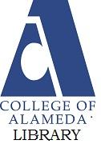
For Librarians:

How To Become an Embedded Librarian Within Canvas
The COA Library encourages faculty to embed Reference/Instructional Librarians within their class Canvas shell for ease and efficiency of student-librarian communication.

Benefits of Embedding
How does the embedded librarian experience differ from the traditional librarian relationship with a class? Any workshops that you present to the class will remain the same, however the Canvas presence allows the librarian to provide supplemental materials and an additional point of contact with the students.
As an embedded librarian you will have the opportunity to:
- Understand the Class Content - You will receive all Announcements from the class instructor and have access to the upcoming assignments and the rubrics used to grade them. Should students seek assistance from you, you have the ability to look at the assignment instructions and see what the instructor is actually asking for. Library workshops may be tailored to the class content and themes studied.
- Create Announcements - You may send Announcements to the entire class reminding the students of upcoming workshops and provide links to recordings (Zoom lectures or other videos of interest).
  - Note that any videos embedded within Announcements will be stripped out when emailed to the student. The embedded video is only visible within the Canvas application. Therefore, include the video link for increased accessibility.
- Create Discussions - A library-specific Discussion group allows students to get their questions answered quickly. Questions may range from lecture clarification to citation practices. By posting the questions/answers in a public space, classmates may utilize the group as a resource as well.
- Increase Opportunities for Communication - Students may easily contact you through the Canvas Communications Inbox.
- Provide Supplemental Materials - You may provide links to library resources, additional information literacy content, and research guides.
- Edit Pages Within Modules - You have the ability to add content to existing Module Pages. This, however, should not be done without explicit permission from the course instructor.
- Collaborate With Instruction - The course instructor may choose to utilize you as a resource for information literacy content within formative and summative assessments. Although you should not be responsible for grading, you may provide ideas for questions and exercises.
- Develop Relationships With Students - As the embedded librarian within a class, students will grow comfortable interacting with, or hearing from you via zooms, announcements, emails and recordings. You represent the “face of the library” to these students and it is not uncommon for students to specifically seek you out for research assistance even after the original course is completed.

Limitations
In the interest of preserving the Canvas site in the format set up by the instructor, you are limited in what you may add or alter. While you may create Pages, you may not add any Pages to a Module. If you would like your Page or Discussion added to a specific Module, you will need to ask the course instructor to move it for you. To protect student privacy, you will not have access to student grades or their assignment submissions.

STEP 1: Getting the Class Instructor on Board
Many instructors schedule multiple library workshops for each class. These classes are ideal candidates for an embedded librarian presence. At the time in which the request for library instruction is made, respond with the suggestion that they consider embedding the librarian within the course Canvas environment. An example of such a response might look something like:
“Thank you for scheduling your library workshops! We have you on the calendar for the dates and times you have requested. We are encouraging faculty to embed the instructional librarian within the class Canvas shell. Embedded librarians allow for efficient student-librarian communication through Discussion Groups and the Canvas Inbox while providing added awareness of class-appropriate library resources. If you are interested in pursuing this, please contact our Head Librarian, Jane McKenna (jmckenna@peralta.edu), for further details.”
Once contacted, Jane will check whether you have enough time in your schedule to add the duties of an embedded librarian and will reply to the class instructor, confirming your assignment.

STEP 2: Adding the Librarian Role to Canvas
After your availability is confirmed, the instructor will be required to submit a District Help Desk Ticket to add you to Canvas (Figure 1). The Head Librarian will send the course instructor the following instructions:
- Login to your Portal
- Select ‘Peralta Help Desk’ and login
- For ‘Request Type’ choose ‘Canvas’
- For the second drop down under ‘Request Type’ (won't appear till you fill in the first drop down with Canvas) choose ‘ADD TA/Tutor/Observer/DE Coordinator/Librarian.’ This will open up a new screen with additional choices.
- For ‘Campus’ select ‘COA’
- Fill in the ‘Name of your Class’ and the 5-Digit course code
- For ‘Please Add to My Class’ select ‘Librarian’
- For ‘Names’ and ‘Peralta email’ fill in the name of the Librarian and the Librarian’s peralta.edu email address
- Mark ‘YES’ for Currently Employed
- Skip the Notes Field
- For ‘Carbon Copy’ Field, send a copy to the Head Librarian, jmckenna@peralta.edu
- Click the ‘Save’ button
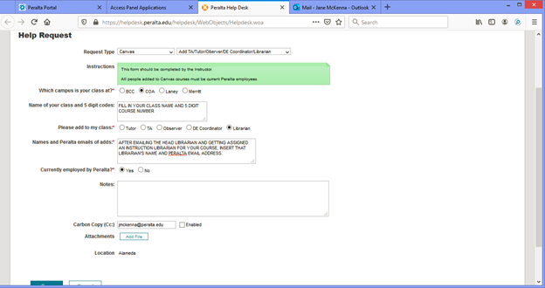
Figure 1: Submit a District Help Desk Ticket to add a Librarian role to the class.

Once the ticket has been sent you will, generally within a day or two, receive an email invitation to join the class. This invitation will also show up at the top of your Canvas dashboard. You will need to accept the invitation to join and complete the process.

STEP 3: Determining the Class Canvas Format
A prime benefit of being an embedded librarian is student engagement; the key to engagement is findability. Students will engage with you more frequently and consistently if your Canvas presence is obvious and content is proactively supplied in multiple locations. The course instructor will likely have the class Canvas already set-up in a format that works best for them. Get familiar with the site and figure out where you might place library content. Remember that the Canvas site is the instructor’s “classroom.” Changes or additions should not be made without their permission.
Potential options for your content location might include:
A Library Module - This would be a one-stop shop for all of your content. All Discussions, FAQs, resources, etc. would be posted within this module, ideally located at the top, before the class content modules.
Class Resources Module - Many instructors allocate their first few modules for introductions and semester-long class resources. Library resource pages may be included within other class resources and collected within this module.
Dispersed Within Modules and Discussions - Some instructors prefer that library content be presented within Canvas modules chronologically or thematically (e.g. library resource pages on annotated bibliographies inserted in whichever module the students happened to be in at the time you gave a workshop on them, or resources on MLA citation practices being saved near an assignment in which MLA format will be used).
Each of these formats have benefits, however the dispersed format makes it more challenging for students to go back and refer to the resources in later modules; they have to search for the resources within all of the class pages and modules. If you are given the choice, a standalone Library Research module may be the easiest, most efficient means of providing information.

STEP 4: Creating Your Content
Canvas allows you to provide content in a variety of ways. As an embedded librarian, you might want to consider offering a selection of the following:
Introduction - The class instructor will likely introduce you to the class however, even prior to your first library workshop, it’s helpful for the students to get to know you. Create an Introduction page (“Meet Your Librarian!”) with preferred means of contact (Canvas Inbox? Peralta email?), working hours, and expected response times. To “put a face to the name” it’s good practice to include a short (around 2 minutes) video of yourself in which you chat about your background, your hobbies, or whatever you would like the students to know about you. Don’t forget to provide accurate closed captions to all of your videos; you’ll likely need to edit any automatically generated captions.
Discussion Groups - A frequently utilized feature is an “Ask the Librarian” Discussion page. This proves to be a great way to get simple questions answered quickly. If one student has a question, it is likely that others do as well; posting the questions and answers publicly benefits the class. Students may ask any questions related to research or the library (e.g. tricky citation formats or appropriate database suggestions). Make sure to clarify how quickly students should expect to hear from you. If students require a rapid response, direct them to the Reference Librarian contact information, particularly the chat feature.
Private Instruction - Occasionally students require more assistance than may be provided through email or Discussion Groups. For example, a student may receive feedback from a graded assignment instructing them to “discuss this with our librarian.” Many times, the student has misunderstood citation formats or how to correctly assemble a Works Cited/References page. In such situations, the student may contact you for further assistance. If you are offering this service, you may inform the class within an Announcement and/or on one of your Canvas Pages. Arrange a mutually agreed upon time to meet online and provide a Zoom link. Prior to the meeting, review the assignment and grading rubric as assigned by the instructor and, if possible, obtain a copy from the student of the work completed thus far (such as a paper) so that you may prepare resources. If you are meeting the student online, make sure that you both have the ability to Share Screens. You will be sharing resources for them to use and you can confirm they are implementing the suggestions correctly. Note that if you can not find a time to meet during your work hours, you should direct the student to the COA Reference Librarians. After you have met with the student, send an email to the Reference Librarian so that they may include your consultation time in the daily Reference tally.
Library Resources - Embedded librarians have the ability to know what the class is working on and which library resources might be the most useful. For example, if a class was working with the theme “Everyday Heroes,” you might supply them a page of library resources designed to support their research (where to find biographies, autobiographies, news articles, appropriate databases, etc.). In addition to supplementing class projects and assignments, it is worthwhile to provide a Page of basic library information such as hours, location, contact information and links to curbside pickup.
Many of the above suggestions may be provided as a designed Page within a module or, alternatively, as an Canvas Announcement. If creating a Page, you will need to work with the instructor as you will not have permission to include your Page within a Module. You may, however, create the Page and then ask the instructor to move the Page to the appropriate spot.
Note that some instructors may assume that your content provided may be reused in future classes. While this may be true for some things, it is worth mentioning to the class instructor that hyperlinks may change over time and your materials are frequently updated and tailored to specific class needs.

Content Development Considerations
Video Development - Videos are useful for a variety of purposes within an online classroom. Short videos may provide an introduction to you or the library services while instructional workshops may be contained within longer videos. There are many free or paid video recording services available that will allow you to screen capture. Some of the more popular services include Screencast-o-matic, Screencastify, Vimeo, and Panopto. Another option is Canvas Studio which has the benefit of direct integration into the Canvas classroom.
Accessibility - All content must be accessible to those with alternative learning accommodations. If you will be developing content on Canvas frequently, it is recommended to take one of the many educational courses on designing for accessibility. These courses are offered by Peralta, @ONE, and other sources. The COA Library webpage also provides accessibility resources and tips for online materials.
Some accessible design features to include are:
- Headings - Utilize the Canvas Rich Text Editor to distinguish Headings from Paragraph Text. Use the Heading numbers appropriately and consecutively to assist screen readers. Any documents created in non-Canvas word processors should also use properly assigned Headings. Microsoft provides Heading formatting guidance for Word and Google offers similar Heading formatting tips for Docs.
- Hyperlinks - Create descriptive hyperlinks rather than including the entire URL to prevent screen readers from reading lengthy links aloud. For example, you might suggest visiting the COA LIbrary Website rather than visiting http://www.alameda.peralta.edu/library. Descriptive hyperlinks should indicate the purpose and location of the link.
- Colors - Colors should be of comparatively high contrast and should not be the only sole means to convey difference. Rather, color should be used to supplement additional indicators of change (Figure 2).


A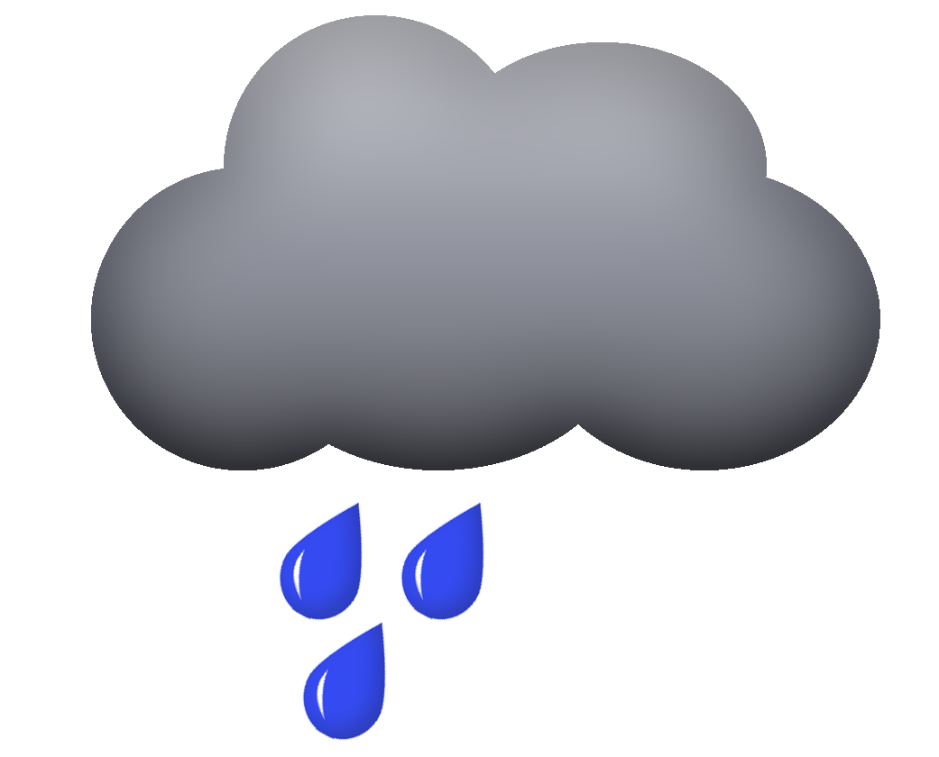 |     B

Figure 2: The weather forecast is illustrated in a more accessible format in Panel A. Panel B only uses color differences to signify difference. Panel A uses color and shape.

- Alternative Text- Descriptive alternative text should be included with every embedded or inserted image. The text will provide context for learners with visual impairments or screen readers. Canvas provides instructions for alternative text development.
- Captioning - In general, captions are required for all videos you produce. Captions may be generated using a provided written transcript or be automatically generated by video editing software. Automatic speech-to-text captioning generation is provided by YouTube or through the Deluxe Screencast-o-Matic plans, among others. Captioning should be accurate and be shown with accurate timing. Automatically generated captions often require significant editing for spelling, capitalization and punctuation. A variety of online tutorials are available to assist you with editing and creating YouTube captions and adding captions to your Screencast-o-Matic videos.

STEP 5: Ongoing Maintenance
Your Canvas presence will require ongoing upkeep throughout the semester. Within Canvas, go to Account and then Notifications (Figure 3) to confirm that you will receive notifications from students. In particular, you want to set Immediate Notification when students post in your Discussions (Figure 4).

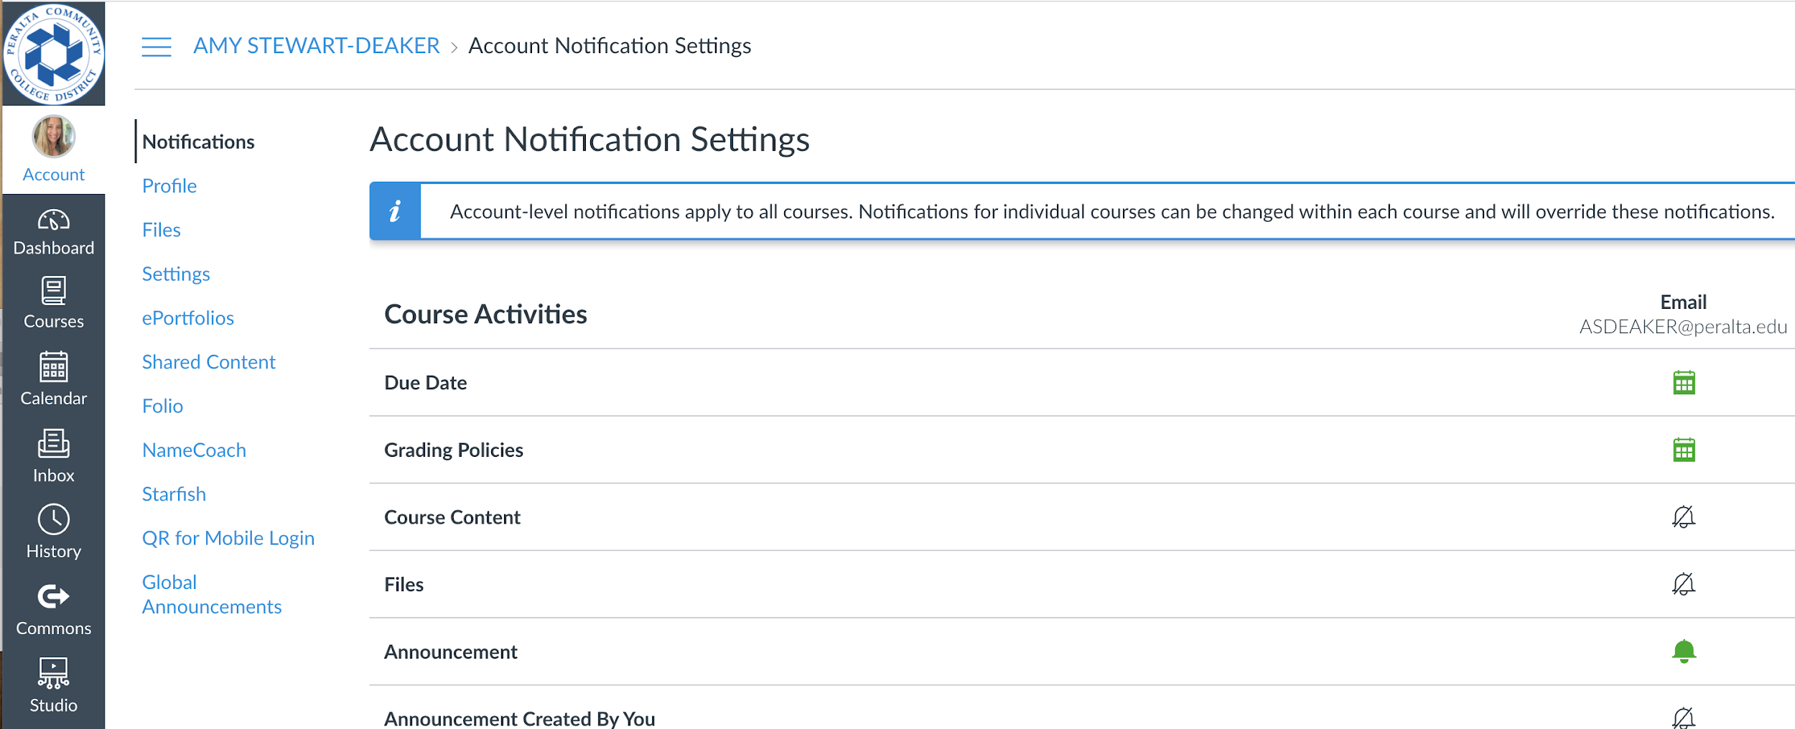
Figure 3: Adjust your Canvas Notifications within the Account settings.

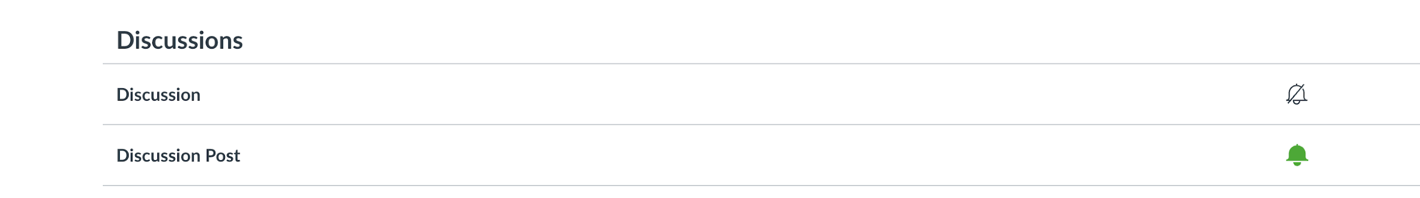
Figure 4: Set Discussion Post notifications to “Notify Immediately” (the green bell icon). Change by clicking on the icon.

In your class Introduction it is good practice to set communication expectations. How quickly should the students expect to hear from you? Be clear regarding your working days and hours so that students do not feel like you are ignoring them. If your Canvas messages are being forwarded to your Peralta Outlook email, note that you are able to reply directly to the emails from Outlook. Even if you have set up notifications sent to your email, it is still useful to occasionally scroll through the class Canvas Discussion boards and Inbox to confirm that you have not missed any student questions.
Keep an eye on the class assignments; as the deadlines for larger projects get closer, students will likely require more research assistance. Some well-timed Announcements from you, reminding students how to contact and to set up Zoom sessions with you will be appreciated.
At the close of the semester, evaluate your class presence; which means of communication worked most effectively? If students were not taking advantage of your Discussion groups or other opportunities, can you figure out why? A reflection on successful and unsuccessful practices will aid you and the students you work with in the future.

