
Getting Started With Library Zoom Instruction

Online library instruction has proven to be a necessary endeavor during the global pandemic crisis, yet may also be a valuable means of instruction at any time. Zoom is frequently utilized as the host for online instruction. Frequently, an instructor will request a librarian to join the class’s previously scheduled zoom, in which case entry to the class is as simple as clicking a link. However, you may be asked to create your own zoom session. This document provides a guide to creation and implementation of a zoom workshop.
Step 1: Scheduling
Work with the CoA faculty member to figure out a date and time for your workshop. Keep in mind that, although in-person library instruction may be scheduled for up to two hours, your zoom instruction should be considerably shorter. It’s hard to keep students’ attention and engagement when you are interacting through a screen. You will likely be lecturing and demonstrating research techniques without the benefit of the in-class, student hands-on activities which we include when we lecture in person. Try to keep your lecture to under an hour.
Examine the topics which the faculty member is asking you to cover. Should it be broken into multiple sessions, in the interest of keeping your lecture shorter?
Option: Do the topics lend themselves to short, pre-recorded videos? If these are topics that you think you will be repeatedly covering AND if you think that the students won’t have any questions, consider creating a short (less than 10 minutes)video in Screen-o-matic or your favorite video-creation tool. You may supplement your live Zoom video with these pre-recorded videos. Send the videos to the faculty member, who may choose to upload them to their course canvas site.

Step 2: Creating a Zoom Meeting Invite
You will need a ConferZoom account to create your meeting invitation. If you do not yet have a ConferZoom account set up, go to http://conferzoom.org/ConferZoom/SignUp and use your Peralta email to obtain your Educator account. The Educator account will allow you to have longer meetings with a greater number of participants than are allowed through personal accounts.
On the ConferZoom site, click on the Meetings link and then click on Schedule a New Meeting (Figure 1).
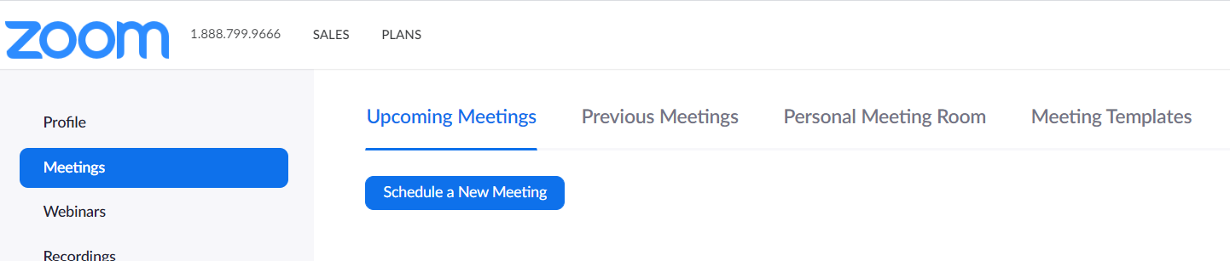
Figure 1: Scheduling a New Meeting in Zoom

The key items to fill in are:
Topic - change the meeting title to something appropriate to the course, such as “ENG 1A Library Instruction”
When - Input the scheduled date and time
Duration - Always set for longer than you think it will actually go, just in case. Use the official class duration time as a guide (e.g. two hours). Many times the course teacher will take over the class after you finish your library instruction. Making the class exit your zoom and then re-enter another zoom loses many of the students so some teachers will want to use your zoom to lecture or hold Q & A’s for the class.
Time Zone - Should automatically be set for Pacific Time, but always good to check.
Meeting Password - Check the box to require a password. Zoom will then automatically generate a password for you. You also have the opportunity to create your own password if you do not wish to use the generated one. It is recommended to use meeting passwords in an effort to keep out uninvited malicious and distracting “zoombombers.”
Video - Consider who needs to have their video on. Likely you will, in which case confirm that the box is checked on for the host. Unless necessary for the participants to have their screen on, you may leave the box for participant’s video unchecked. The participant will have the option to turn on their video at a later time, during the zoom, should they feel comfortable doing so.
Audio - check the box for Both
Meeting Options - check the following boxes: Enable Join Before Host and Mute Participants Upon Entry (note, you don’t have to do this but this lets the students log on before you and turns their microphones off. They can always turn them on again themselves, but it reminds them to keep them off to eliminate background noise).
Now save the meeting by selecting the Save button.
A Note About Recordings: Zoom provides cloud-based recording services for all meetings; the default is to not record the meeting. Should you wish to record the entire meeting, within Meeting Options (as you are creating the meeting) select the “Record the meeting automatically in the cloud” box. To change the recording options (e.g. what is saved and for how long), go to the Settings link on the left side of the page and click on the Recording tab. Cloud storage is limited to 0.5 GB (Educational accounts) or up to 1 GB (Professional accounts). Section 508 of the Rehabilitation Act requires that all recordings provided to the students include closed-captioning or be accompanied by a transcript. Confirm compliance with Section 508 by ensuring that the Audio Transcript box is checked within the Settings>Recording page.

Step 3: Sending the Invitations
After you have saved your meeting, the next screen shows a summary of the meeting (Figure 2). You can also access this summary by going to Meetings and clicking on the appropriate meeting (note that you can also Edit your meeting by scrolling to the bottom of the meeting summary screen to select Edit This Meeting...for example if you forgot to require a password). The summary page includes a clickable option to upload the meeting to your personal calendar (Google, Outlook or Yahoo). Within the summary you will see the link to the meeting as well as the password required to enter the meeting. That is the information that you need to send the class teacher to distribute to their students. Suggest to the teacher that the meeting link and password be copied into an appropriate (password protected) location within the class Canvas shell (such as the class ConferZoom tab). An easy way for you to copy all relevant information is to click on Copy the Invitation (located near the meeting URL) and paste all of that information into an email.
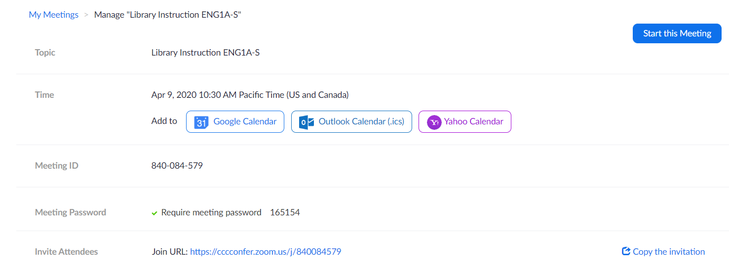
Figure 2: Summary page for scheduled Zoom meetings
“Copy the Invitation” provides phone numbers if the students choose to phone in. It provides many options for access so it is helpful to highlight/bold the URL and password when you email it to the teacher.

Step 4: Your Zoom Meeting
Depending on what you are presenting, have your Google Slides or Powerpoint presentation pulled up on your screen before the meeting starts. If you are using multiple websites, it’s handy to have them loaded up in separate browser tabs. Even if you are not planning on having a slide presentation, it’s still nice to have an opening screen (perhaps just a title slide) that reassures students they are in the right place when they enter the meeting. As mentioned previously, your meeting title, set up when you created the invite, should also clearly state the purpose of the meeting. It is also a good idea to turn off or snooze all computer notifications during your meeting, particularly if you are planning on sharing your screen. Try to be the first person in your meeting. To join your pre-scheduled meeting, go to your ConferZoom page, click on Meetings and then click on Start or Join meeting, next to the appropriate meeting.
Share your screen with the class by clicking the green Share Screen button at the bottom of your Zoom screen (Figure 3). You can choose if you are just sharing a single application or sharing your entire screen (easier if you are using multiple applications).

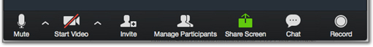
Figure 3: The Share Screen button (in green) allows you to share your full or partial screen
As soon as the teacher of the class joins, make her/him a Co-Host of the meeting. To do that, hover over their video screen, click on the three dots, and select Make Co-Host (Figure 4).
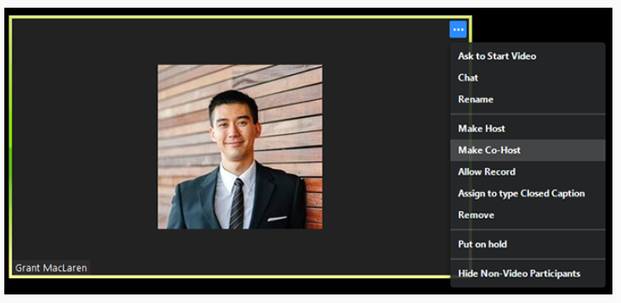
Figure 4: Use the three dots in a participant's video image to assign a Co-Host. Image from https://support.zoom.us/
Alternatively, you can go to the bottom of your Zoom screen and select Manage Participants, go to the teacher’s name, and make them Co-Host from there. It is very useful to have a Co-Host to manage the participants. The teachers know who is supposed to be in the class and can monitor the behavior of the participants. Should a zoombomber show up in class, a student becomes disruptive, or if someone forgets to turn their microphone off, the Co-Host can remove or mute participants without you needing to break from your lecture. Discuss Co-Hosting with your faculty member prior to your Zoom meeting so that they are prepared to assist you with any disruptions. Zoom provides more information about Co-Hosts at https://support.zoom.us/hc/en-us/articles/206330935-Enabling-and-Adding-a-Co-Host
The instructor, as teacher of record, is required to attend your zoom meeting. Just as we require faculty members to attend our in-person library instruction, so is faculty presence required in online meetings. If the faculty member takes issue with this policy, please have them contact the Head Librarian. That said, if your faculty member is unable to attend and you are, therefore, unable to have a co-host, you can prevent zoombomber entrance by using the Waiting Room feature. To use the Waiting Room, when you are setting up your meeting (Step 2), under Meeting Options, click “Enable Waiting Room.” When participants attempt to enter your meeting, they will be held in the Waiting Room; you have the ability to admit or deny participation by clicking Manage Participants at the bottom of your screen. To effectively use the Waiting Room you will need the class name list so you know who to expect and who to admit to the meeting. It is helpful to have a co-host (the class instructor, if present) monitor the Waiting Room for the duration of your workshop so that you do not need to break your flow to let students in. For more information on Waiting Rooms refer to https://support.zoom.us/hc/en-us/articles/115000332726-Waiting-Room
Zoombombers who manage to enter the class (or disruptive students) may be handled by muting and removing them from the zoom session. To mute a participant, click on the three dots on their video screen (refer back to Figure 4) and then select Mute. Alternatively, you may click on Participants in the Zoom toolbar, and select Mute next to their name. You may also remove students from the Zoom using the same methods; click on the three dots in their video screen and select Remove or click on Participants, hover near their name, select More and then Remove. Another easy way to remove students is to use the Security button on your Zoom toolbar. From there, you may select to mute or remove attendees. If you are sure that the legitimate students are all present and that no more are planning on attending the session, you might want to lock the meeting from further entry. To do so, select Participants, click on More and then Lock Meeting (Figure 5). To unlock the meeting, you’ll follow the same steps, and simply deselect Lock Meeting.
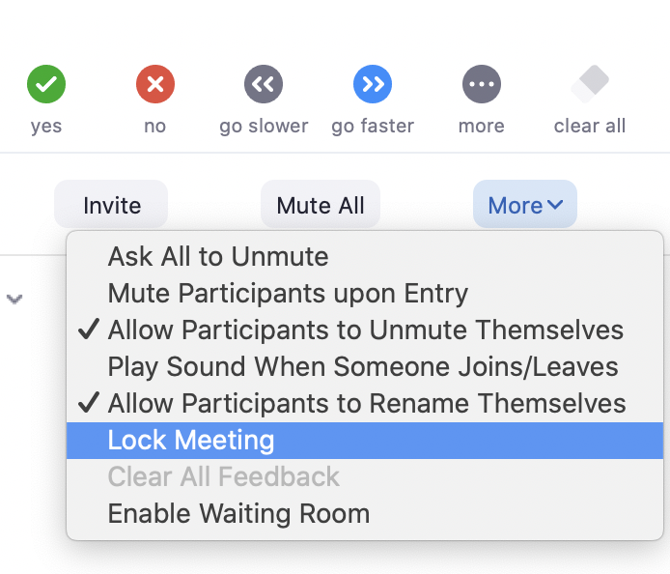
Figure 5: Lock the Meeting by using the Participants button in the toolbar.
If you would like to record all (or part of) your meeting and did not set up automatic cloud-based recordings (refer to Step 2 of this document), you may manually turn on recordings after your meeting has started. Use the controls at the base of your screen (Figure 6) to turn on/off the recording. Pressing the Record button initiates cloud-based recording and audibly alerts the meeting participants that the meeting is now being recorded.
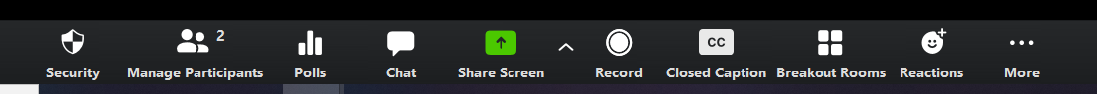
Figure 6: To manually record the meeting, press the Record button.

The Zoom Chat feature is a way for muted students to ask questions. Your Co-Host may be able to answer some of them but it’s a good idea to scan the chat log occasionally to see if there are any questions directed at you. If you are sharing your full screen, you will probably have the participant video screens (and the chat log) minimized in a corner of the screen. Note that the Present Mode in many slideshows (such as Google Slides) expands to fill the entire screen and you will not be able to see the Zoom Chat until you exist the presentation. To discreetly monitor the chat log, one workaround is to log into the meeting on your smartphone or ipad using a personal zoom account and keep the chat window up there, answering questions verbally. Ideally, you will be able to create space on your computer screen; keeping the chat window open there will ensure that you are aware of all comments and questions as they occur.
After your lesson is completed, tell students that they are welcome to turn their mics back on to ask questions or to use the chat feature. If the course instructor desires to continue his/her lesson after your instruction, turn off your mic and video. It’s useful to keep the audio on, however, in case more questions crop up.
Using the Class Instructor’s Zoom Meeting:
Frequently the course instructors will ask you to join the regularly scheduled class Zoom meeting, rather than having the class log into your Zoom. This is particularly useful when the instructors are planning on lecturing before or after the library workshop; keeping the students in one place increases attendance in both lectures. If you will be logging into the class Zoom, you will need to obtain the link. If the instructor has disabled screen sharing for participants, ask the instructor to make you a co-host so that you may share your screen.
Step 5: Follow Up
Go into ConferZoom, select Meetings and then click on Usage (highlighted in yellow in Figure 7). This will take you to Reports on each of your previously held meetings. Input the date of the meeting into the calendar if you don’t see it show up automatically.
Attendance: The resulting meeting log (Figure 8) provides a record of how many participants were at your meeting. Keep in mind that two of the participants included in this log are yourself and the teacher of record. Select the attendance number to view the names of the participants, if desired. Record the number of students and input that value into the “Green Sheet” (COA Library Instructional Request form). Scan or take a photo of the sheet and email it to Caitlin. If you are attending the class Zoom, rather than one in which you are the host, you will not have access to the post-meeting attendance statistics. To obtain the information needed for Caitlin’s records, email the instructor and ask for the attendance count. If the Zoom was recorded and all students have access to the recording, you may use the class enrollment number as the count for attendance.
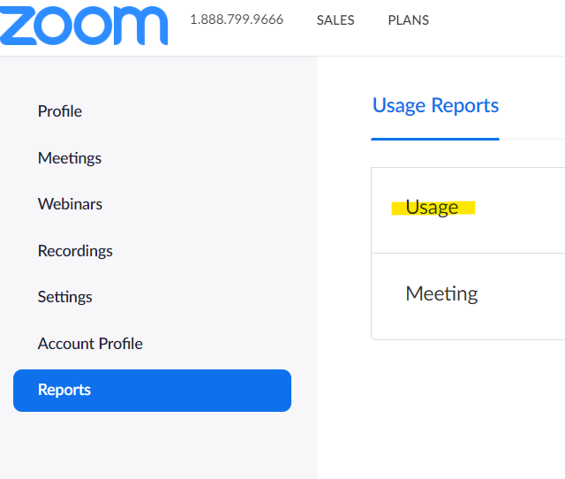
Figure 7: Access the Usage Reports to determine the number of participants

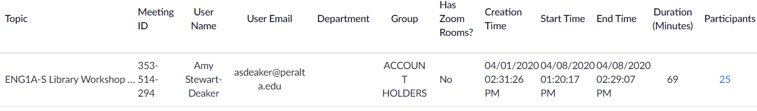
Figure 8: The Usage Report provides a record of meeting duration and attendance.
Recordings: You will receive an email from Zoom with a link to the recorded meeting and a separate email letting you know that the audio transcript is complete. Note that the audio transcript is saved as a .vtt file and will require a text editor to view outside of ConferZoom. To access any recordings within ConferZoom; click on the Recordings link and select the appropriate recording. You will then have the option to download your recording to your computer or copy a sharable link (Figure 9). To trim the playback range of the video (if you don’t want to share the entire video, just a portion of it), play the video and click on the scissors at the bottom of the video. For additional information on changing the playback range, refer to https://support.zoom.us/hc/en-us/articles/115003001383. To change the viewability settings for the Shared recording link (e.g. requiring a password to access) click the Share button.
The audio transcript will appear next to the video recording when you play the recording in ConferZoom. You may also view the transcribed audio by using the Closed Captioning (CC) button underneath the video. Prior to sharing the video, confirm that the automated transcript is correct. If editing is required, use the Pencil icon next to each recorded phrase to change the wording. Make sure you save any changes.
Provide the class instructor with the recording link and, if you provide the class with online materials on your Peralta web page or Canvas shell, share the link there as well.
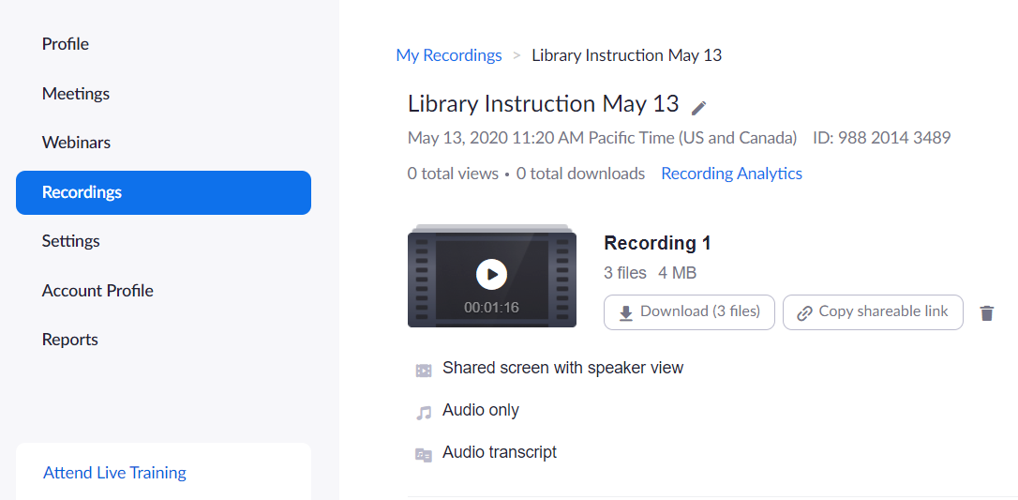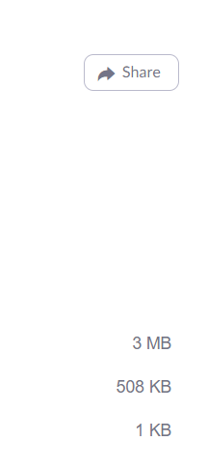

Figure 9: The recording may be downloaded or shared. To change the viewability settings, use the Share button.

Recognize that Zoom cloud storage is not recommended as a permanent storage solution. Saving the recordings on your personal computing device is an option, but is often memory intensive. Therefore, Peralta suggests judiciously curating and transferring your recordings to external cloud-based storage such as YouTube or Google drive. Refer to Peralta’s Options For Permanent Storage for additional guidance.
Notes on Instructional Content:
Library closure necessitates a focus on online content (article databases) rather than the catalog. For first-year students, a brief introduction to OneSearch is still helpful, as they will eventually be able to fully utilize the circulated collection, however a thorough exploration of our online resources is more useful in the short term.
Until the library fully reopens, it’s worth adding the following information to most presentations:
- How to arrange Curbside Pickup for circulating books
- How to borrow Chromebooks
- How to get in touch with library staff. How to chat with us for Reference help and what hours we are working.
It’s handy to have a copy of your presentation and any appropriate handouts (e.g. Citation Handouts) uploaded to your Peralta webpage prior to your zoom meeting. At the close of your meeting, show the students how to get to your page and how they may download the materials.

