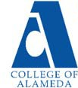

2025-26 Program Review – Instructional – Automotive Technology

Lead Author
Rick Greenspan

Program Overview

Please verify the mission statement for your program. If there is no mission statement listed, please add it here.

Mission Statement
[Update Mission Statement if needed]
The Automotive Technology curriculum is designed to prepare students for employment as apprentice auto mechanics or to allow students to continue toward a Baccalaureate degree in other advanced schools of technology in preparation for future management and teaching careers in the automotive industry.

The College of Alameda ATECH program is certified by the National Automotive Technicians Education Foundation (NATEF), NATEF certification guidelines and procedures are attached (Appendix D1 and D2) The program also works with the Apprentice program to meet their training needs, as well as with the Calif Bureau of Automotive Repair (BAR) in supplying required update programs for certified California Smog Mechanics and including in the regular curriculum the material required for Calif State Smog Licenses (as well as Calif State Lamp and Brake licenses)

Automotive Electronics Specialist – A.S. Degree Program Learning Outcomes
- Be ‘lifelong learners’ in the field of automotive technology, keeping up with changes in vehicles, in diagnostics and in repair procedures through a commitment to continual learning and training.
- Communicate effectively with customers, supervisors and co-workers.
- Apply critical thinking and problem-solving skills in the process of diagnosing and repairing vehicles.
- Competently perform industry standard automotive repair procedures, using proper tools, procedures and diagnostic techniques, as specified in the NATEF program certification process.

Automotive Electronics Specialist - Certificate of Achievement Program Learning Outcomes
- Be ‘lifelong learners’ in the field of automotive technology, keeping up with changes in vehicles, in diagnostics and in repair procedures through a commitment to continual learning and training.
- Communicate effectively with customers, supervisors and co-workers.
- Apply critical thinking and problem-solving skills in the process of diagnosing and repairing vehicles.
- Competently perform industry standard automotive repair procedures, using proper tools, procedures and diagnostic techniques, as specified in the NATEF program certification process.

Chassis and Drivetrain – A.S. Degree Program Learning Outcomes
- Be ‘lifelong learners’ in the field of automotive technology, keeping up with changes in vehicles, in diagnostics and in repair procedures through a commitment to continual learning and training.
- Communicate effectively with customers, supervisors and co-workers.
- Apply critical thinking and problem-solving skills in the process of diagnosing and repairing vehicles.
- Competently perform industry standard automotive repair procedures, using proper tools, procedures and diagnostic techniques, as specified in the NATEF program certification process.

Chassis and Drivetrain - Certificate of Achievement Program Learning Outcomes
- Be ‘lifelong learners’ in the field of automotive technology, keeping up with changes in vehicles, in diagnostics and in repair procedures through a commitment to continual learning and training.
- Communicate effectively with customers, supervisors and co-workers.
- Apply critical thinking and problem-solving skills in the process of diagnosing and repairing vehicles.
- Competently perform industry standard automotive repair procedures, using proper tools, procedures and diagnostic techniques, as specified in the NATEF program certification process.

Chassis Specialist – A.S. Degree Program Learning Outcomes
- Be ‘lifelong learners’ in the field of automotive technology, keeping up with changes in vehicles, in diagnostics and in repair procedures through a commitment to continual learning and training.
- Communicate effectively with customers, supervisors and co-workers.
- Apply critical thinking and problem-solving skills in the process of diagnosing and repairing vehicles.
- Competently perform industry standard automotive repair procedures, using proper tools, procedures and diagnostic techniques, as specified in the NATEF program certification process.

Chassis Specialist - Certificate of Achievement Program Learning Outcomes
- Be ‘lifelong learners’ in the field of automotive technology, keeping up with changes in vehicles, in diagnostics and in repair procedures through a commitment to continual learning and training.
- Communicate effectively with customers, supervisors and co-workers.
- Apply critical thinking and problem-solving skills in the process of diagnosing and repairing vehicles.
- Competently perform industry standard automotive repair procedures, using proper tools, procedures and diagnostic techniques, as specified in the NATEF program certification process.

Drivetrain Specialist – A.S. Degree Program Learning Outcomes
- Be ‘lifelong learners’ in the field of automotive technology, keeping up with changes in vehicles, in diagnostics and in repair procedures through a commitment to continual learning and training.
- Communicate effectively with customers, supervisors and co-workers.
- Apply critical thinking and problem-solving skills in the process of diagnosing and repairing vehicles.
- Competently perform industry standard automotive repair procedures, using proper tools, procedures and diagnostic techniques, as specified in the NATEF program certification process.

Drivetrain Specialist - Certificate of Achievement Program Learning Outcomes
- Be ‘lifelong learners’ in the field of automotive technology, keeping up with changes in vehicles, in diagnostics and in repair procedures through a commitment to continual learning and training.
- Communicate effectively with customers, supervisors and co-workers.
- Apply critical thinking and problem-solving skills in the process of diagnosing and repairing vehicles.
- Competently perform industry standard automotive repair procedures, using proper tools, procedures and diagnostic techniques, as specified in the NATEF program certification process.

Engine Performance – A.S. Degree Program Learning Outcomes
- Be ‘lifelong learners’ in the field of automotive technology, keeping up with changes in vehicles, in diagnostics and in repair procedures through a commitment to continual learning and training.
- Communicate effectively with customers, supervisors and co-workers.
- Apply critical thinking and problem-solving skills in the process of diagnosing and repairing vehicles.
- Competently perform industry standard automotive repair procedures, using proper tools, procedures and diagnostic techniques, as specified in the NATEF program certification process.

Engine Performance - Certificate of Achievement Program Learning Outcomes
- Be ‘lifelong learners’ in the field of automotive technology, keeping up with changes in vehicles, in diagnostics and in repair procedures through a commitment to continual learning and training.
- Communicate effectively with customers, supervisors and co-workers.
- Apply critical thinking and problem-solving skills in the process of diagnosing and repairing vehicles.
- Competently perform industry standard automotive repair procedures, using proper tools, procedures and diagnostic techniques, as specified in the NATEF program certification process.

Engine Repair Specialist – A.S. Degree Program Learning Outcomes
- Be ‘lifelong learners’ in the field of automotive technology, keeping up with changes in vehicles, in diagnostics and in repair procedures through a commitment to continual learning and training.
- Communicate effectively with customers, supervisors and co-workers.
- Apply critical thinking and problem-solving skills in the process of diagnosing and repairing vehicles.
- Competently perform industry standard automotive repair procedures, using proper tools, procedures and diagnostic techniques, as specified in the NATEF program certification process.

Engine Repair Specialist - Certificate of Achievement Program Learning Outcomes
- Be ‘lifelong learners’ in the field of automotive technology, keeping up with changes in vehicles, in diagnostics and in repair procedures through a commitment to continual learning and training.
- Communicate effectively with customers, supervisors and co-workers.
- Apply critical thinking and problem-solving skills in the process of diagnosing and repairing vehicles.
- Competently perform industry standard automotive repair procedures, using proper tools, procedures and diagnostic techniques, as specified in the NATEF program certification process.

Light-duty Auto Repair - Certificate of Achievement Program Learning Outcomes
- Be ‘lifelong learners’ in the field of automotive technology, keeping up with changes in vehicles, in diagnostics and in repair procedures through a commitment to continual learning and training.
- Communicate effectively with customers, supervisors and co-workers.
- Apply critical thinking and problem-solving skills in the process of diagnosing and repairing vehicles.
- Competently perform industry standard automotive repair procedures, using proper tools, procedures and diagnostic techniques, as specified in the NATEF program certification process.

List your Faculty and/or Staff, and indicate whether they are full-time or part-time.
[Update list of personnel]
Rufino Ramos, John Peterson, Wayne Fung, Rick Greenspan (full time)
Mark Christensen, Patrick Dong (part-time)

The Program Goals below are from your most recent Program Review or APU. If none are listed, please add your most recent program goals. Then, indicate the status of this goal, and which College and District goal your program goal aligns to. If your goal has been completed, please answer the follow up question regarding how you measured the achievement of this goal.
Program Goal | Maintain quality of program
Status: In-Progress or Complete?  If complete, give a brief description of how you measured the goal completion. | Always in progress
Which college or district goal is aligned with your program goal? | Advance Student Success  District Goal: Build Programs of Distinction
Program Goal | Keep up with changes in industry
Status: In-Progress or Complete?  If complete, give a brief description of how you measured the goal completion. | Always in progress
Which college or district goal is aligned with your program goal? | Advance Student Success  District Goal: Build Programs of Distinction

Program Goal | Professional development for faculty
Status: In-Progress or Complete?  If complete, give a brief description of how you measured the goal completion. | Always in progress
Which college or district goal is aligned with your program goal? | Advance COA teaching and learning

Program Goal | Continue to maintain NATEF (ASE Educational Foundation) Master Level program certification status
Status: In-Progress or Complete? | Always in progress
Which college or district goal is aligned with your program goal? | Build Programs of Distinction  Advance COA teaching and learning

Program Goal | Update equipment, such as hybrid, direct injection, electric and fuel cell vehicles, for student labs
Status: In-Progress or Complete?  If complete, give a brief description of how you measured the goal completion. | Always in progress
Which college or district goal is aligned with your program goal? | District Goal: Build Programs of Distinction

Program Goal | Update diagnostic equipment to match industry standards
Status: In-Progress or Complete?  If complete, give a brief description of how you measured the goal completion. | Always in progress
Which college or district goal is aligned with your program goal? | District Goal: Build Programs of Distinction

Describe your current utilization of facilities, including labs and other space
Atech shares B Building with Auto Body/paint, but each program has separate lecture and lab space. Atech utilizes lecture and lab space Monday-Friday, from 8 am until 10 pm.

A new building is under construction, with completion date expected Fall 2025

Career Education

What are the employment rates for students that have exited your program for the past three years?

https://datamart.cccco.edu/Perkins/Core_Indicator_Reports/Core_PerformanceTrendReport_College.aspx

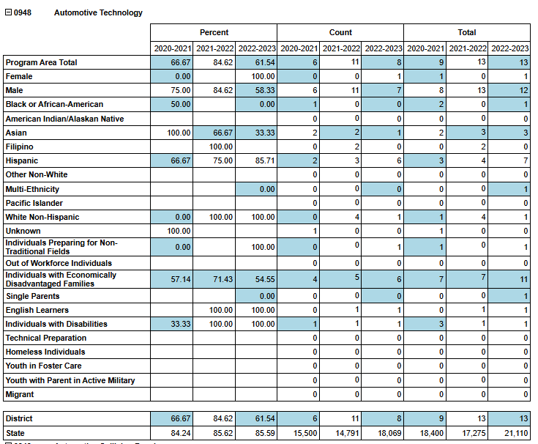

What are the projected job openings in your discipline for the next 8 years?
California
Bay Area

https://data.ca.gov/dataset/long-term-occupational-employment-projections/resource/274e273c-d18c-4d84-b8df-49b4d13c14ce

For Long Term 2023-33, there are projected 63,510 job openings in California and 4,570 job openings in Alameda County

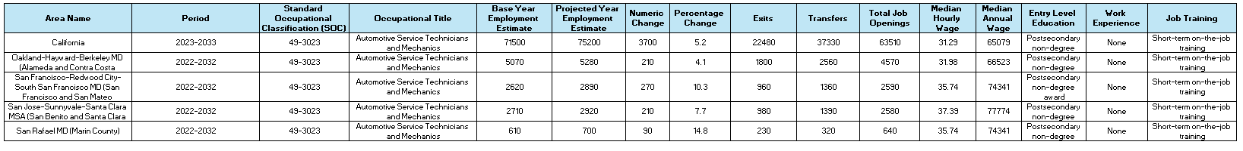

How is your discipline or program responding regarding changes in labor market demand?
Discuss Here

Do you have an industry advisory board in place? If so list, your board members.
Discuss Here

Has your industry advisory board met regularly (at least once per quarter or semester)?
Discuss Here

Please describe the number of activities and recommendations resulting from advisory committee meetings that have occurred in the past three years. What information was presented that required changes to be made to your program?
Discuss Here

Does your program require state or national licensing? If yes, are there substantial differences with the set standard pass rate for this exam or license and the percentage of students passing this exam?

Discuss Here

Do your students participate in other third-party certifications? If yes, are there substantial differences with the standard pass rate and the percent of students getting successfully certified?
Discuss Here

What programs similar to yours exist in the surrounding area or at nearby East Bay colleges? In which ways is your program collaborating with other community colleges in the region?
Discuss Here

Enrollment Trends

ATECH
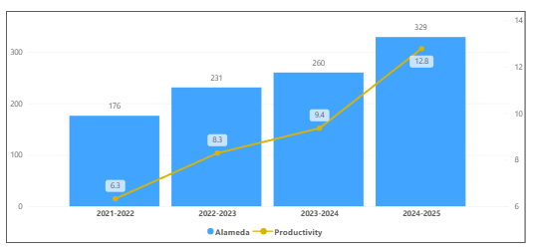
OVERALL
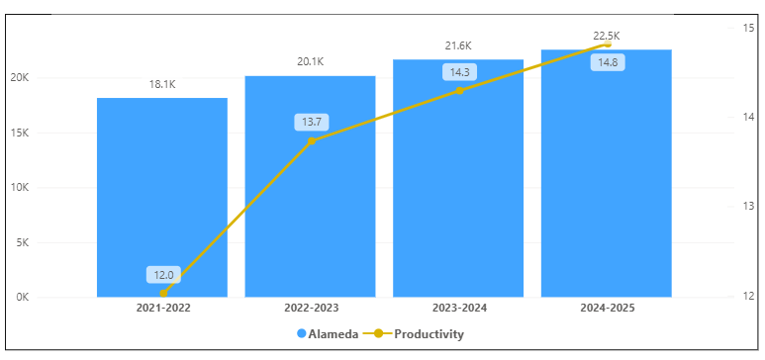
Discuss enrollment trends over the past four years.

ATECH Enrollment increased from 2021-2022 to 2024-2025. Productivity increased from 2021-2022 to 2024-2025. It had the biggest increase in productivity in 2024-2025 of 3.4. ATECH percentage increase of 26.5% students which is bigger than the overall college percentage increase of 4.2 % students.

This program did follow the overall trend of the college.

Discuss any reason for decrease/increase in enrollment

The link below shows list of course sections in your area sorted from lowest fill rate to the highest fill rate for the last three years.
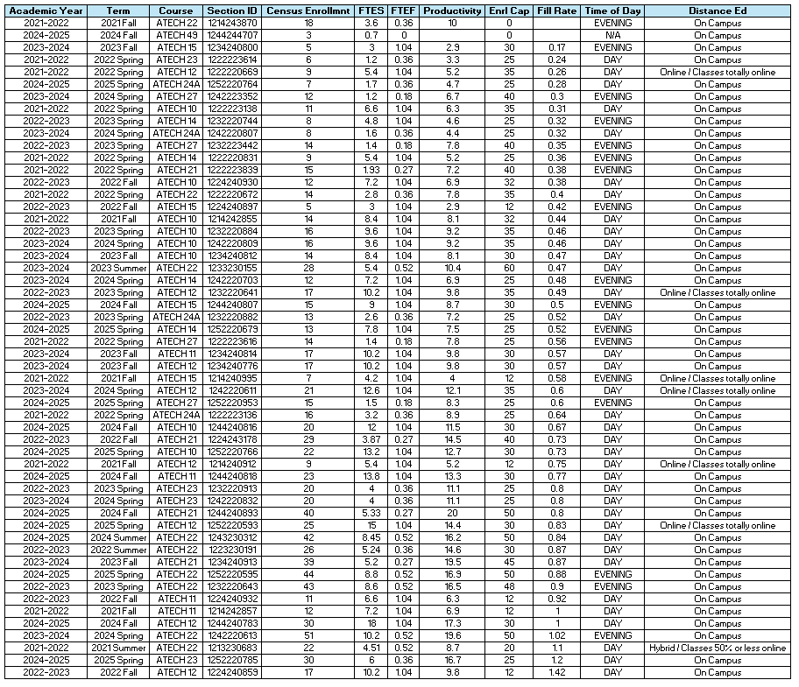

Consider and discuss whether the course offerings meet the needs of our students.

Discuss Here

Discuss any action plan to better meet student needs and demands.

Discuss Here

Describe effective and innovative teaching strategies used by faculty to increase student learning and engagement.

Discuss Here

How is technology used by the discipline department?
Discuss Here

How does the discipline, department, or program maintain the integrity and consistency of academic standards with all methods of delivery, including face to face, hybrid, and Distance Education courses?
Discuss Here

Curriculum

CurriQunet Meta
If necessary, use the CurriQunet META link to review the details of the curriculum. Some summary information is provided below. Please review your course outlines of record in CurriQunet META to determine if they have been updated in the past 4 years.
Specify when your department will update, or deactivate, each one, within the next 4 years.
Discuss Here

Please summarize the Discipline, Department or program of study plans for curriculum plans for improvement. Below, please provide details for individual course improvement. Add plans for new courses here.
Discuss Here

How is your program meeting the needs of students and/or articulation with four-year institutions?
Discuss Here

Assessment – Instructional
Student Learning Outcomes Assessment
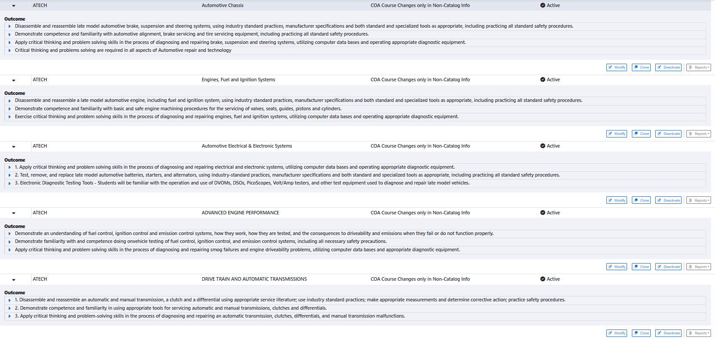

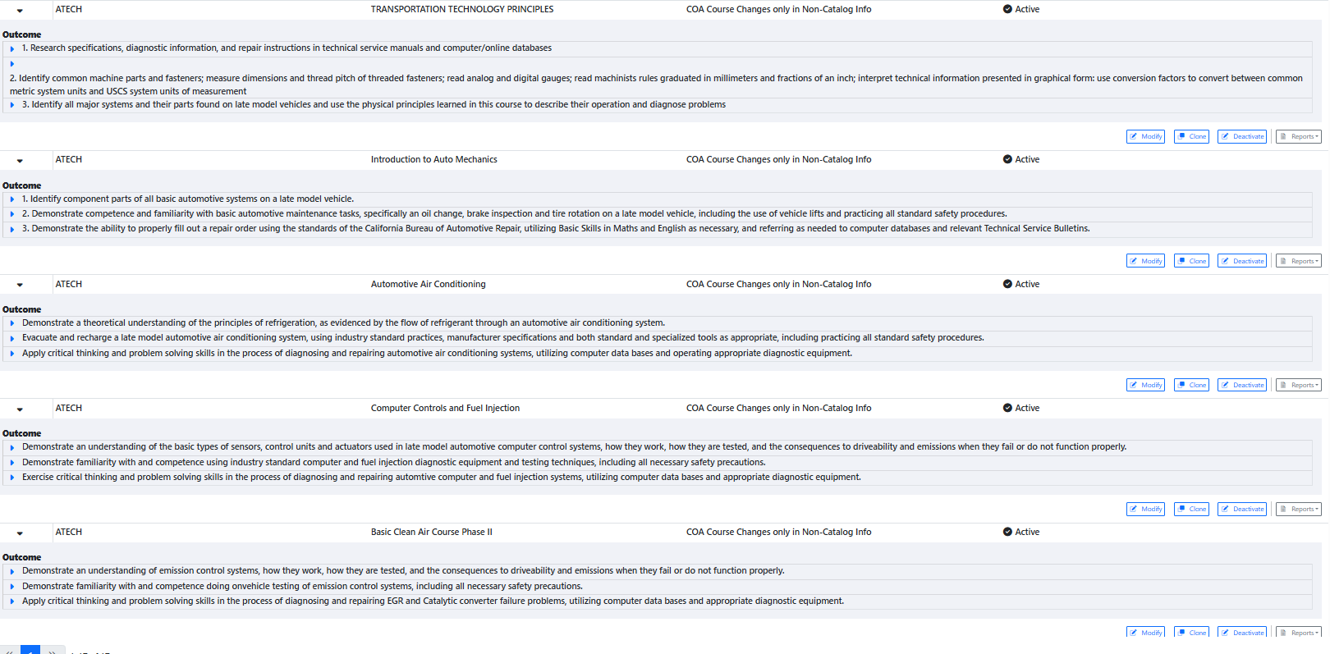
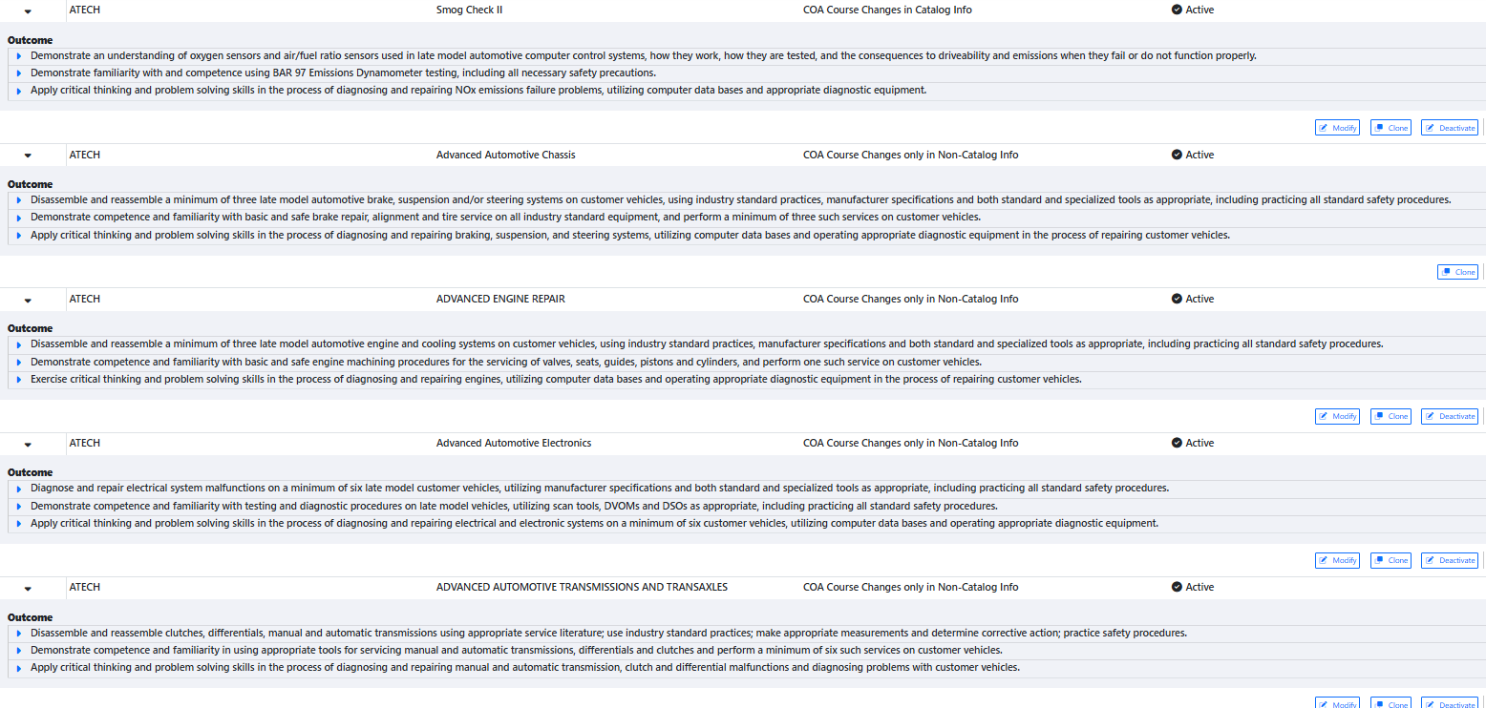
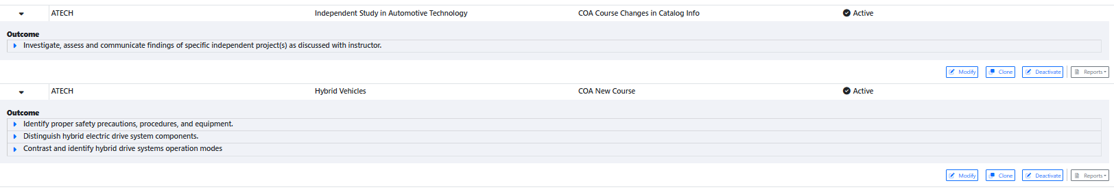

Your Student Learning Outcomes for active courses are listed below. Please review and note any corrections or planned changes.
Discuss Here

Please provide a high-level summary and your program’s interpretation of your SLO findings over the past year.
Discuss Here

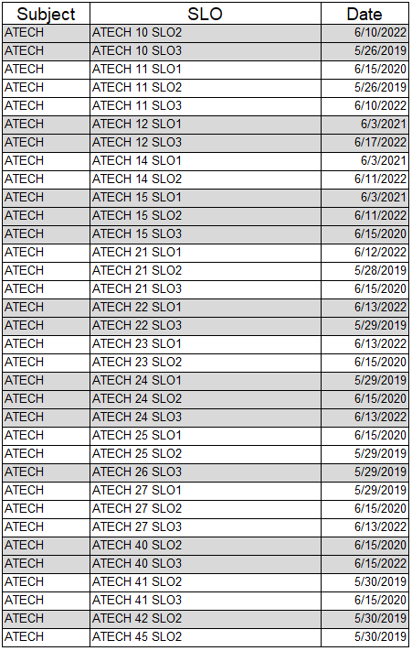

What were the most important things your department learned from assessment? Did implementation of your action plans result in better student learning?
Discuss Here
All SLO assessments were completed for previous cycle, but zero have been completed for this SLO assessment cycle.

Listed below are your programs (degrees and certificates) and the program learning outcomes (PLOs) for each. Please share your reflections on the PLOs and support from the college needed in assessing the PLOs over the next 4 years.

Automotive Electronics Specialist – A.S. Degree Program Learning Outcomes
- Be ‘lifelong learners’ in the field of automotive technology, keeping up with changes in vehicles, in diagnostics and in repair procedures through a commitment to continual learning and training.
- Communicate effectively with customers, supervisors and co-workers.
- Apply critical thinking and problem-solving skills in the process of diagnosing and repairing vehicles.
- Competently perform industry standard automotive repair procedures, using proper tools, procedures and diagnostic techniques, as specified in the NATEF program certification process.

Automotive Electronics Specialist - Certificate of Achievement Program Learning Outcomes
- Be ‘lifelong learners’ in the field of automotive technology, keeping up with changes in vehicles, in diagnostics and in repair procedures through a commitment to continual learning and training.
- Communicate effectively with customers, supervisors and co-workers.
- Apply critical thinking and problem-solving skills in the process of diagnosing and repairing vehicles.
- Competently perform industry standard automotive repair procedures, using proper tools, procedures and diagnostic techniques, as specified in the NATEF program certification process.

Chassis and Drivetrain – A.S. Degree Program Learning Outcomes
- Be ‘lifelong learners’ in the field of automotive technology, keeping up with changes in vehicles, in diagnostics and in repair procedures through a commitment to continual learning and training.
- Communicate effectively with customers, supervisors and co-workers.
- Apply critical thinking and problem-solving skills in the process of diagnosing and repairing vehicles.
- Competently perform industry standard automotive repair procedures, using proper tools, procedures and diagnostic techniques, as specified in the NATEF program certification process.

Chassis and Drivetrain - Certificate of Achievement Program Learning Outcomes
- Be ‘lifelong learners’ in the field of automotive technology, keeping up with changes in vehicles, in diagnostics and in repair procedures through a commitment to continual learning and training.
- Communicate effectively with customers, supervisors and co-workers.
- Apply critical thinking and problem-solving skills in the process of diagnosing and repairing vehicles.
- Competently perform industry standard automotive repair procedures, using proper tools, procedures and diagnostic techniques, as specified in the NATEF program certification process.

Chassis Specialist – A.S. Degree Program Learning Outcomes
- Be ‘lifelong learners’ in the field of automotive technology, keeping up with changes in vehicles, in diagnostics and in repair procedures through a commitment to continual learning and training.
- Communicate effectively with customers, supervisors and co-workers.
- Apply critical thinking and problem-solving skills in the process of diagnosing and repairing vehicles.
- Competently perform industry standard automotive repair procedures, using proper tools, procedures and diagnostic techniques, as specified in the NATEF program certification process.

Chassis Specialist - Certificate of Achievement Program Learning Outcomes
- Be ‘lifelong learners’ in the field of automotive technology, keeping up with changes in vehicles, in diagnostics and in repair procedures through a commitment to continual learning and training.
- Communicate effectively with customers, supervisors and co-workers.
- Apply critical thinking and problem-solving skills in the process of diagnosing and repairing vehicles.
- Competently perform industry standard automotive repair procedures, using proper tools, procedures and diagnostic techniques, as specified in the NATEF program certification process.

Drivetrain Specialist – A.S. Degree Program Learning Outcomes
- Be ‘lifelong learners’ in the field of automotive technology, keeping up with changes in vehicles, in diagnostics and in repair procedures through a commitment to continual learning and training.
- Communicate effectively with customers, supervisors and co-workers.
- Apply critical thinking and problem-solving skills in the process of diagnosing and repairing vehicles.
- Competently perform industry standard automotive repair procedures, using proper tools, procedures and diagnostic techniques, as specified in the NATEF program certification process.

Drivetrain Specialist - Certificate of Achievement Program Learning Outcomes
- Be ‘lifelong learners’ in the field of automotive technology, keeping up with changes in vehicles, in diagnostics and in repair procedures through a commitment to continual learning and training.
- Communicate effectively with customers, supervisors and co-workers.
- Apply critical thinking and problem-solving skills in the process of diagnosing and repairing vehicles.
- Competently perform industry standard automotive repair procedures, using proper tools, procedures and diagnostic techniques, as specified in the NATEF program certification process.

Engine Performance – A.S. Degree Program Learning Outcomes
- Be ‘lifelong learners’ in the field of automotive technology, keeping up with changes in vehicles, in diagnostics and in repair procedures through a commitment to continual learning and training.
- Communicate effectively with customers, supervisors and co-workers.
- Apply critical thinking and problem-solving skills in the process of diagnosing and repairing vehicles.
- Competently perform industry standard automotive repair procedures, using proper tools, procedures and diagnostic techniques, as specified in the NATEF program certification process.

Engine Performance - Certificate of Achievement Program Learning Outcomes
- Be ‘lifelong learners’ in the field of automotive technology, keeping up with changes in vehicles, in diagnostics and in repair procedures through a commitment to continual learning and training.
- Communicate effectively with customers, supervisors and co-workers.
- Apply critical thinking and problem-solving skills in the process of diagnosing and repairing vehicles.
- Competently perform industry standard automotive repair procedures, using proper tools, procedures and diagnostic techniques, as specified in the NATEF program certification process.

Engine Repair Specialist – A.S. Degree Program Learning Outcomes
- Be ‘lifelong learners’ in the field of automotive technology, keeping up with changes in vehicles, in diagnostics and in repair procedures through a commitment to continual learning and training.
- Communicate effectively with customers, supervisors and co-workers.
- Apply critical thinking and problem-solving skills in the process of diagnosing and repairing vehicles.
- Competently perform industry standard automotive repair procedures, using proper tools, procedures and diagnostic techniques, as specified in the NATEF program certification process.

Engine Repair Specialist - Certificate of Achievement Program Learning Outcomes
- Be ‘lifelong learners’ in the field of automotive technology, keeping up with changes in vehicles, in diagnostics and in repair procedures through a commitment to continual learning and training.
- Communicate effectively with customers, supervisors and co-workers.
- Apply critical thinking and problem-solving skills in the process of diagnosing and repairing vehicles.
- Competently perform industry standard automotive repair procedures, using proper tools, procedures and diagnostic techniques, as specified in the NATEF program certification process.

Light-duty Auto Repair - Certificate of Achievement Program Learning Outcomes
- Be ‘lifelong learners’ in the field of automotive technology, keeping up with changes in vehicles, in diagnostics and in repair procedures through a commitment to continual learning and training.
- Communicate effectively with customers, supervisors and co-workers.
- Apply critical thinking and problem-solving skills in the process of diagnosing and repairing vehicles.
Competently perform industry standard automotive repair procedures, using proper tools, procedures and diagnostic techniques, as specified in the NATEF program certification process.

College of Alameda Institutional Learning Outcomes (ILOs) were created to guide educational programs and services. They include:
- Problem Solving: Solve problems and make decisions in life and work using critical thinking, quantitative reasoning, community resources, and civil engagement.
- Communication and Technology: Use technology and written and oral communication to discover, develop, and relate critical ideas in multiple environments.
- Creativity: Exhibit aesthetic reflection to promote, participate and contribute to human development, expression, creativity, and curiosity.
- Diversity: Engage in respectful interpersonal communications, acknowledging ideas and values of diverse individuals that represent different ethnic, racial, cultural, and gender expressions.
- Civic Responsibility: Accept personal, civic, social and environmental responsibility in order to become a productive local and global community member.
How does your program participate in assessing Institutional Learning Outcomes (ILOs)? If your program has not participated, how will you plan to incorporate these outcomes within your program?
Discuss Here

Course Completion
Consider your course completion rates over the past three years (% of students who earned a grade of "C" or better). Data with default filter is provided below. Use the link above to explore the data further.
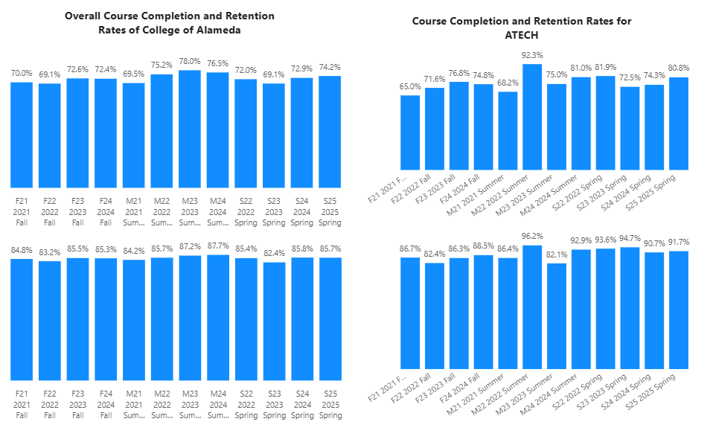
How is the course completion rate for your program or discipline compared to your college’s Institutional Set Standard for course completion (70% with stretch goal of 78%)? Also discuss the retention rate for your program or discipline, compared to the college average shown in data below.
The course completion for ATECH is above the College of Alameda’s completion rate for that term except for summer 2021, summer 2023 and Fall 2021. ATECH is also above the set standard of 70% for the completion rate for all terms except for Fall 2021 and Summer 2021. For retention, ATECH is above the College of Alameda’s retention for that term except Fall 2022 and Summer 2023. ATECH is below the average of 85% for retention rate for all terms except Fall 2022 and Summer 2022.

What has the discipline, department, or program done to improve course completion and retention rates?
Discuss Here

Equity Analysis
College of Alameda continues to focus on access, equity, and success. The goal is to create an inclusive environment where all students can thrive and meet their education and career goals.
Following is a brief description of equity data analysis, examining success rates of different ethnic groups (Asian, Black/African American, Hispanic/Latino, “Two or More”, “Unknown/NR”, White), age range, gender (Female, Male, Unknown Gender), and special population groups (Foster Youth, First Gen College, SAS).
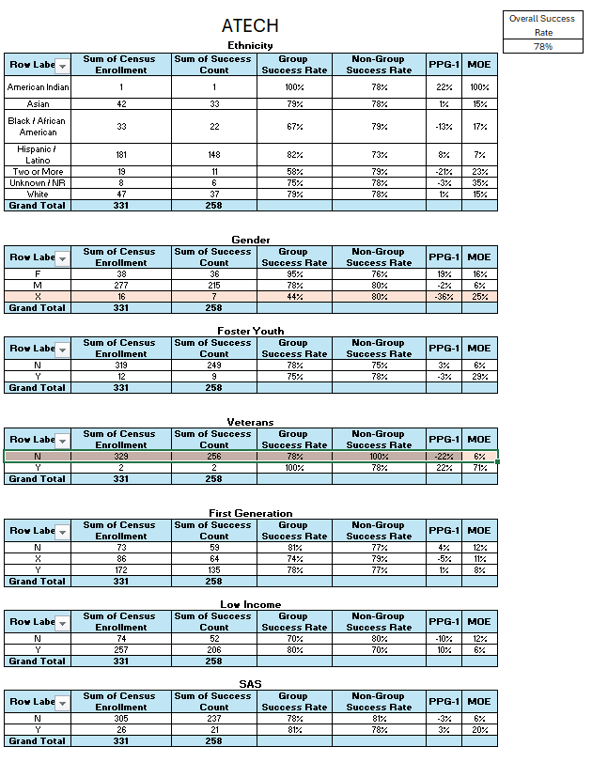
Success rate data in ATECH for AY2024-25 was analyzed using the PPG-1 (percentage point gap minus 1) method, comparing the success rate of the given group against the success rate of everyone else. The success rate of the following groups falls significantly below the overall success rate of 78% for ATECH, outside the statistical margin of error:

- Unreported Gender 44%
- Not Veterans 78%

While there are other groups whose success rates fall below the overall success rate for ATECH, either the percentage point gap difference is small or, because of the small sample size, a reliable conclusion cannot be drawn.

What can your discipline, department, or program do to improve course completion for disproportionately impacted groups?
Discuss Here

Space below is provided for additional discussion of equity-impacting factors not discussed above, including those that affect dual enrollment courses and/or online/hybrid courses.
Discuss Here

Degrees & Certificates Conferred
Does your program offer any degree/certificate programs? If your program does not, skip this section and continue to Engagement.
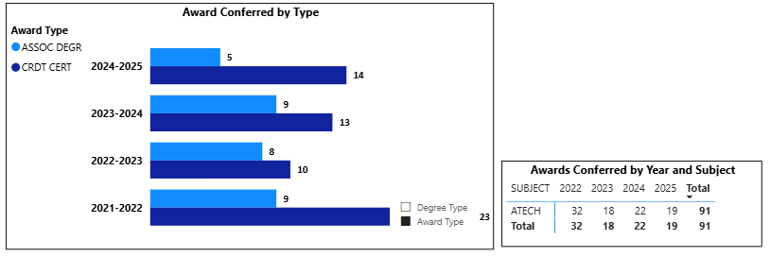
What has the discipline, department, or program done to improve the number of degrees and certificates awarded? Below data shows the number of degrees and certificates awarded by year, for the past three years. Use the link above to explore the data further.
Associate degrees have decrease in the last four years. Certificates have also decreased in the last four years. We average around 23 degrees in ATECH for the last 4 years.

Discuss Here

Increasing the number of students who complete a certificate or degree is a shared goal across CoA’s Ed Master Plan Goals, PCCD Goals, the Chancellor’s Office Vision for Success, the Student-Centered Funding Formula, and Guided Pathways. What is planned for the next 3 years to increase the number of certificates and degrees awarded?
Discuss Here

Engagement
Discuss how faculty and staff have engaged in institutional efforts such as committees, presentations, and departmental activities. Please list the committees that full-time faculty participate in.
Discuss Here
.

Discuss how faculty and staff have engaged in community activities, partnerships and/or collaborations.
Discuss Here

Discuss how adjunct faculty members are included in departmental training, discussions, and decision- making.
Discuss Here

Prioritized Resource Requests Summary
In the boxes below, please add resource requests for your program. If there are no resources requested, leave the boxes blank.

Resource Category | Description/Justification | Full-Time Equivalent  Percentage | Salary Grade (if  applicable)
Personnel: Classified Staff
Personnel: Student Worker
Personnel: Part Time Faculty
Personnel: Full Time Faculty
Personnel: Full Time Faculty, future anticipated need

Resource Category | Description/Justification | Total Estimated Cost
Professional Development: Department wide PD needed

Professional Development: Personal/Individual PD needed

Prioritized Resource Requests Summary - Continued

Resource Category | Description/Justification | Total Estimated  Cost
Supplies: Software
Supplies: Books, Magazines, and/or Periodicals
Supplies: Instructional Supplies
Supplies: Non-Instructional Supplies
Supplies: Library Collections

Resource Category | Description/Justification | Total Estimated  Cost
Technology & Equipment: New
Technology & Equipment: Replacement

Prioritized Resource Requests Summary - Continued

Resource Category | Description/Justification | Total Estimated Cost
Facilities: Classrooms
Facilities: Offices
Facilities: Labs
Facilities: Other

Resource Category | Description/Justification | Total  Estimated Cost
Library: Library materials
Library: Library collections

Resource Category | Description/Justification | Total Estimated  Cost
OTHER

