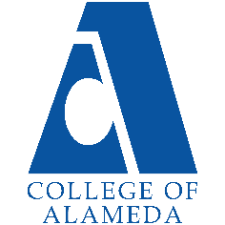
College of Alameda
2025-26 Abbreviated Program Review (2 Years) – Student Life and Basic Needs

Program Overview
Please provide your program’s mission statement and program’s learning outcomes
The mission of Student Activities and Campus Life is to improve student persistence, retention and completion rates by offering opportunities and experiences beyond the classroom that encourage learning and student success.

List your program faculty and/or staff.
[Update list of personnel goes here]
Natalie Rodriguez, Director of Student Activities & Campus Life
Jeremy Simmons, Basic Needs Coordinator

Describe your current utilization of facilities, including labs and other space.
[Update list goes here]

The Office of Student Activities and Campus Life and Basic Needs Center currently use the following rooms and spaces in the F Building (Student Center):
F109 - Reflection Room
F107 - ASCOA Storage Room
F122 - One Stop Shop
F Pit
F105 – Basic Needs Suite
F105A - Basic Needs Coordinator Office
F105B - Storage (former nurse's office)
F202 – Storage
F212 - ASCOA Offices
F212A - ASCOA Executive Office
F212B - ASCOA Executive Office
F215 - ASCOA Closet
F216 - ASCOA Conference Room
F217 - Director of Student Activities Office
Mamava Lactation Pod (2nd Floor)
We are also currently in the process of reclaiming the following spaces:
F108 – Currently used as instruction storage space.
F121 – Currently used by engineers. Former Police office.
F203 – Kitchen. Non-operational
List your program goals from your most recent Program Review or APU. Then, provide an update on the status of the goal. Has your program achieved the goal? Have any of your goals been revised or are any still in progress? Lastly, make sure to discuss which College or District goal your program goal aligns to.
If no program goals exist or if this is your first program review, work to create 2-3 goals and align them with a college or District goal.

Program Goal | Implement a comprehensive leadership program for ASCOA student leaders.
Status: In-Progress or Complete? | [Update Progress]
Which college or district goal is aligned with your program goal? | College Goal – Increase retention and persistence rates District Goal – Advance Student Access, Equity and Success

Program Goal
Status: In-Progress or Complete?
Which college or district goal is aligned with your program goal?

Program Goal
Status: In-Progress or Complete?
Which college or district goal is aligned with your program goal?

Program Update
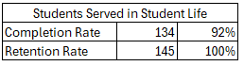
Course Completion and Retention Rates (Datamart Success Rates and Retention Rates)
For Basic Needs, the terms Spring 2024, Fall 2024, Spring 2025 all completion rates and retention rates were higher than the overall College. However, Summer 2024 completion rates and retention rates were lower by a lot compared to the overall population.

Fo Student Government, the Last Year the completion rate and retention of the students were higher the stretch goal of 78% and the retention average of 85%.

(Explain what you have been doing to help with Completion Rates and Retention Rates and Explain reasons for declines/increases)

Enrollment Trends (Datamart Student Headcount)
There was a 26% increase in the student headcount for students who were served in the basic needs center. This a big increase from the previous year. There was only a 4 % increase in the student population for the college overall. So, it was a much bigger increase in the students served in the basic needs. In 2023-2024, 3% of the student population was getting basic needs service. In 2024-2025, 5% of the student population was getting basic needs services. A 2% increase in the percentage of the population served.

There is 14 Students in the Student Government. This is an increase because there was 0 the year before.

(Explain what you have been doing to help Enrollments and Explain reasons for declines/increases)

Degrees and Certificates
The degrees and certificates in Datamart are not updated until September 2025. So, we looked at the two previous years of students who got basic needs services and their awards. We see that there was an increase in the overall population for the degrees. However, the group of students who got services in basic needs decreased. This decrease could be because in 2023-2024 there was a decline in the student headcount of who was being served. Because the percentage of degree per student population is the same for both years. Whereas the overall population went up by 1% for degrees and certs per student count. So, it did not follow the overall college trend.

There were 3 students in Student Government that got degrees this year. It was a total of 4 degrees and certificates. This is an increase from last year because there was zero.

(Explain what you have been doing to help Degree and Certificates and Explain reasons for declines/increases)

Describe any significant changes and discuss what the changes mean to your program. Consider whether performance gaps exist for disproportionality impacted students by using filters to disaggregate the data. Focus upon the most recent year and/or the years since your last comprehensive program review. Cite data points to support your reflection.
Basic Needs Last 2 Years Student Populations (Datamart)
Overall Student Population (Power BI)
2023-2024 2024-2025
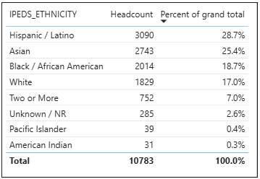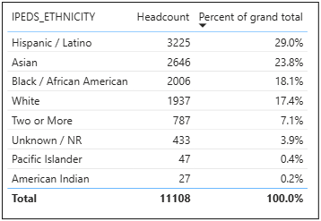
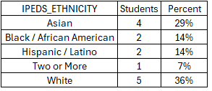
If you look at the population of students of basic needs, we can see that it is not the same as overall student population demographics. It looks like basic needs support more Asian than the overall population percentage. It is also seen helping less Black/African Americans and Hispanics than the overall population percentage. Hispanics having a - 2% to -5% different from overall population and Black/ African American having a -1% to - 3% difference from the overall population. Asian was the biggest group supported by basic needs with ~30% to 33% which is a 8% to 10% difference from the overall population percentage.

For the Student Government, there is a higher percent of white and Asian students. There is no Pacific Islanders and American Indians. See if we can get all representation.

[Explain Equity Gaps and If there were changes in the program]
Describe the department's progress on Student Learning Outcomes (SLOs) and/or Service Area Outcomes (SAOs) since the last Program Review/APU.
[Describe what you are going to do to assess SLO and/ or SAO for future terms]

Student Activities
Last Assessed on Spring 2022
SAO 1: Analyze obstacles to community college student success and examine strategies and resources to overcome obstacles 84.6%

Last Assessed on Spring 2023
SAO 2: Increase the persistence and retention rates of student government leaders. 62.5%

Last Draft on Spring 2024
SAO 3: Celebrate cultural backgrounds and examine the relationship of cultural experiences and educational attainment. 75%

Describe the outcomes and accomplishments from previous year’s funded resource allocation request. If your program did not receive any allocations, leave the boxes blank.
Brief description of funded request | Source (any additional award outside your base allocation) | Total Award Amount | Outcome/Accomplishment

Prioritized Resource Requests Summary
In the boxes below, please add resource requests for your program. If there are no resources requested, leave the boxes blank.
Resource Category | Description/Justification | Total Estimated Cost
Personnel: Student Worker

Personnel: Part Time Faculty
Personnel: Full Time Faculty

Resource Category | Description/Justification | Total Estimated Cost
Professional Development: Department wide PD needed
Professional Development: Personal/Individual PD needed
Supplies: Software

Supplies: Books, Magazines, and/or Periodicals

Supplies: Instructional Supplies

Supplies: Non-Instructional Supplies

Supplies: Library Collections

Technology & Equipment

Library: Library materials/collections

Facilities: Classrooms/Labs

Facilities: Offices

Other

