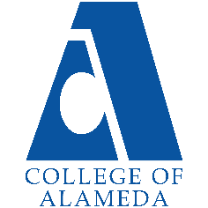
College of Alameda
2025-26 Program Review Template – Transfer Center

Lead Author:
[Your Name Here]

Program Overview
Provide your service area’s mission statement. If your service area does not have a mission statement, what is your timeline for creating a mission statement?
[Your Mission Here]
The mission of the College of Alameda’s Transfer Program is to increase the student transfer rates from COA to four-year colleges/universities. To accomplish this goal, the Transfer Program’s primary function is to ensure that all students have access to necessary transfer information and provide programs and services needed for a successful transition to the receiving institutions. An area of responsibility for the Transfer Program is to assist underrepresented, low-income, disabled, and first-generation college students through outreach programs and services to increase their awareness of the opportunities and resources available to achieve student success and transfer

List your program faculty and/or staff.
[List of personnel goes here]
Danna Chavez Baquero – Coordinator/ Counselor
Alisi Ika – Clerical I
Wendy Odath – Staff Assistant

List the essential functions of your department, program or unit and provide a description of how the unit aligns with the college mission.
[Your Essential Functions Here]
Following the Transfer Center Guidelines set by the California Community College Transfer Center Directors and the California Community Colleges Chancellor's Office the Transfer Counselor works to engage with the college community in the following areas:
1. Serving as the primary contact person for inquiries from community college administrators, faculty, staff, students and the community concerning the college's transfer programs and services.
2. Serving as a liaison between the community college and baccalaureate-level universities in regards to admission policies and transfer requirements.
3. Working with campus faculty and administration to ensure that the transfer function i s clearly identified as a primary mission of the college
4. Working with college administrators to coordinate the activities of the Transfer Center with other instructional and student services programs on campus and to encourage cooperative working relationships.
5. Chairing the Transfer Center Advisory Committee developed to assist in supporting and strengthening transfer activities on campus.
6. Working with the campus articulation officer to monitor and encourage the development of articulation agreements and campus participation in articulation efforts.
7. Providing ongoing information and training to counselors regarding new transfer options, changing requirements, university selection criteria, ASSIST and university application procedures to ensure that accurate and up-to-date information is being conveyed to students.
8. In conjunction with the Counseling Department, provide transfer counseling that includes handling complex transfer cases referred to the Transfer Center by counselors, administrators or instructional faculty; the evaluation of independent and out-of-state transcripts for transfer to UC, CSU or other baccalaureate-level colleges or universities; research regarding transfer requirements to independent or out-of-state universities; or advocacy for students who believe their denial of admission from a baccalaureate-level university is unfair or incorrect.
9. Receiving daily California Community College and university updates through the statewide Transfer Center Director’ s distribution list

List your program goals from your most recent Program Review or APU (Annual Program Update). Then, provide an update on the status of the goal. Has your program achieved the goal? Have any of your goals been revised or are any still in progress? Lastly, make sure to discuss which College or District goal your program goal aligns with.
If no program goals exist or if this is your first program review, create 2-3 goals and align them with a college or District goal.
Program Goal | Implement fall 2024 and spring 2025 transfer fairs
Status: In-Progress or Complete? | [Update Progress]
Which college or district goal is aligned with your program goal? | A. Advance Student Access, Equity, and Success  B. Engage and Leverage Partners  C. Build Programs of Distinction  D. Strengthen Accountability, Innovation and Collaboration

Program Goal | Conduct ongoing transfer workshops
Status: In-Progress or Complete? | [Update Progress]
Which college or district goal is aligned with your program goal? | A. Advance Student Access, Equity, and Success  C. Build Programs of Distinction

Program Goal | Increase the visibility of on-campus and online transfer representatives
Status: In-Progress or Complete? | [Update Progress]
Which college or district goal is aligned with your program goal? | A. Advance Student Access, Equity, and Success  B. Engage and Leverage Partners  C. Build Programs of Distinction

Program Goal | Conduct university campus tours
Status: In-Progress or Complete? | [Update Progress]
Which college or district goal is aligned with your program goal? | A. Advance Student Access, Equity, and Success  B. Engage and Leverage Partners  C. Build Programs of Distinction  D. Strengthen Accountability, Innovation and Collaboration

Students served in conexED in Transfer Center Overall College of Alameda
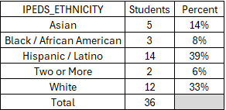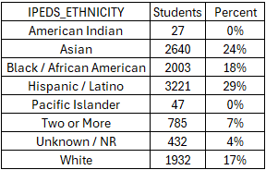
Do the students served by your service area differ from the College's overall student population? If so, elaborate on how the service area is identifying and addressing the needs of the student population.
Yes, the transfer center served a student that differed from the college’s overall student population. The transfer center by percent serviced more Hispanics and White’s ethnicities than the overall population. The transfer center did not serve one American Indian or Pacific Islander. However, the transfer did serve more men per the population they served compared to overall college’s population.

[Students’ Demographics discussion goes here]

Which groups of students are underrepresented among those who received services, particularly by race/ethnicity and gender?
Pacific Islanders and American Indian were not served by the transfer center. Also, Black/ African Americans had a very small percent of students served by the transfer center.

[Students’ Demographics discussion goes here]

Describe how external factors such as advisory board recommendations, federal or state mandates, changing demographics, and/or COVID-19 has impacted the support services your program or administrative unit provides.
How has your program addressed these changes or challenges to ensure students are supported and can continue to work towards meeting their educational goals?
[Changes and Challenges discussion goes here]

Data Analysis
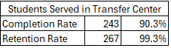
How does the course completion rate for your program compare to your college's College-Set Standard for course completion of 70% and the stretch goal of 78%?

The students who were served in the Transfer Center have higher rate of completion compared to the overall population of the campus. Also, it is above the set standard of 70% and the stretch goal of 78% at 90 % completion for student served at the transfer center.

[College Completion Rates discussion here: how will transfer center increase student completion rate]

On average the course retention rate (number of students are retained in the course) for College of Alameda has been 85% for the past three years. Examine the course retention rates for your program over the last three years. How does your program course retention rate compare to the college?
The students who were served in the Transfer Center have higher rate of retention compared to the overall population of the campus. Also, it is above the average of 85% at 99% retention rate of the student who were served at the transfer center.

[College Retention Rates discussion here: how will transfer center increase student retention rate]

Equity
College of Alameda continues to focus on access, equity, and success. The goal is to create an inclusive environment where all students can thrive and meet their education and career goals. As pertaining student equity data from Student Equity Plan 2022-2025, how could your program help increase the number of students reaching each of these metrics.
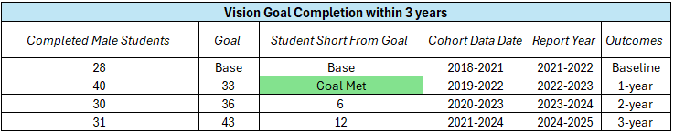
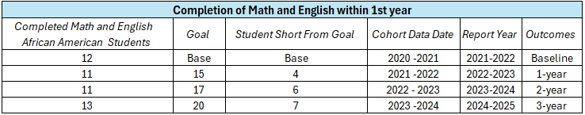
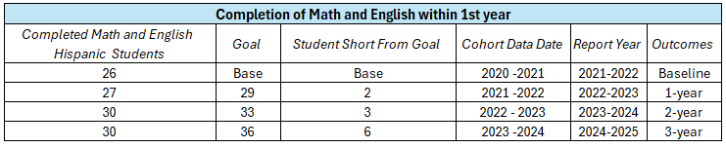
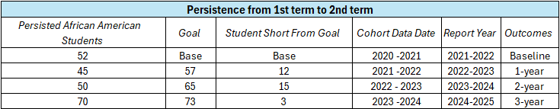
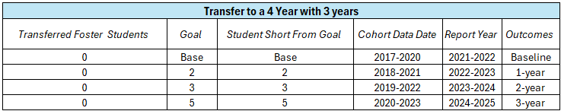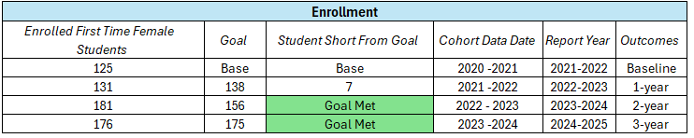

Discuss how your program has worked to address these equity gaps. Incorporate examples of your program data where applicable.
When looking at the different goals from the SEP, Transfer to a 4 Year most pertains to the Transfer Center. In the 36 Student Served by the Transfer Center last year 0 were Foster Youth. This is an equity gap that the Transfer Center could help with the SEP Goals. Also, Black/ African American is in two different SEP Goals and if we look at your population of students served this group is underrepresented. Another Equity Gap to investigate. Hispanic with their completion of transfer English and Math in their first year is also something transfer center can help with because if the students are following the guided pathways, they should be taking Math and English in their first year. With many of the transfer center students being Hispanic, the paths should be discussed in their transfer paths, so this number increases, and we reach our goals.

[Further Equity discussion here]

Student Learning Outcomes Assessment
List your Service Area Outcomes (SAOs) and/or Student Learning Outcomes (SLOs)
[Please list the other two SAOs]

Last Assessed Spring 2022
SAO 1: Students who utilize the Transfer Center’s services, events, and programs will demonstrate the ability to access, utilize, and integrate new transfer information learned into their transfer planning.

Never Assessed
SAO 2: Students who utilize the Transfer Center’s services and resources, and participate in the center’s events, will demonstrate an increased level of confidence in their transfer knowledge.

Please provide a high-level summary and your program’s interpretation of your SAO/SLO findings over the past year.
SAO 1 has not been assessed since Spring 2022 and other SAO have not been assessed at all.
[Please discuss assessments of SAOs in the last 2 years]

What were the most important things your department learned from assessment? Did implementation of your action plans result in better student learning?
[Please respond with plan on how to assess the SAOs in the future]

Degrees & Certificates Conferred
Increasing the number of students who complete a certificate or degree is a shared goal across CoA’s Ed Master Plan Goals, PCCD (Peralta Community College District) Goals, the Chancellor’s Office Vision for Success, the Student-Centered Funding Formula, and Guided Pathways.
How can your program contribute to increasing the number of certificates and degrees awarded over the next three years?
CSU GE Breadth and IGETC Counts
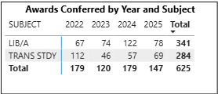
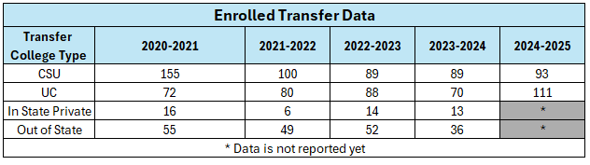
We had an increase in IGETC in the last two years. With the CSU GE it went up in 2024 but declined in 2025. This is also seen in the enrolled students from college of alameda in the transfer school. We have had a large increase in UC enrollment. We have had a decline in the CSU enrollment.

[CSU GE and IGETC Certification Discussion on the increases and decreases.]

Engagement
How has your department participated in college wide efforts such as committees, presentations, and departmental activities?
[Engagement Discussion]
The Transfer Center promotes transfer through the annual College Transfer Fair and end of year transfer celebration. The Transfer Center acts as a liaison between college and university undergraduate admissions representatives.

How has your department engaged in community activities, partnerships and/or collaborations?
[Collaborations Discussion]
The Transfer Center works with college and university undergraduate admission representatives, inviting representatives to counseling meetings, scheduling one on one student appointments, and promoting transfer programs.

Prioritized Resource Requests Summary
In the boxes below, please add resource requests for your program. If there are no resources requested, leave the boxes blank.
Resource Category | Description/Justification | Total Estimated Cost
Personnel: Classified Staff
Personnel: Student Worker
Personnel: Part Time Faculty
Personnel: Full Time Faculty

Resource Category | Description/Justification | Total Estimated Cost
Professional Development: Department wide PD (Professional Development) needed
Professional Development: Personal/Individual PD needed
Supplies: Software
Supplies: Books, Magazines, and/or Periodicals
Supplies: Instructional
Supplies: Non-Instructional
Supplies: Library Collections
Technology & Equipment
Library materials/collections
Facilities: Classrooms/Labs
Facilities: Offices
Other

