College of Alameda
L Building Second Floor Map
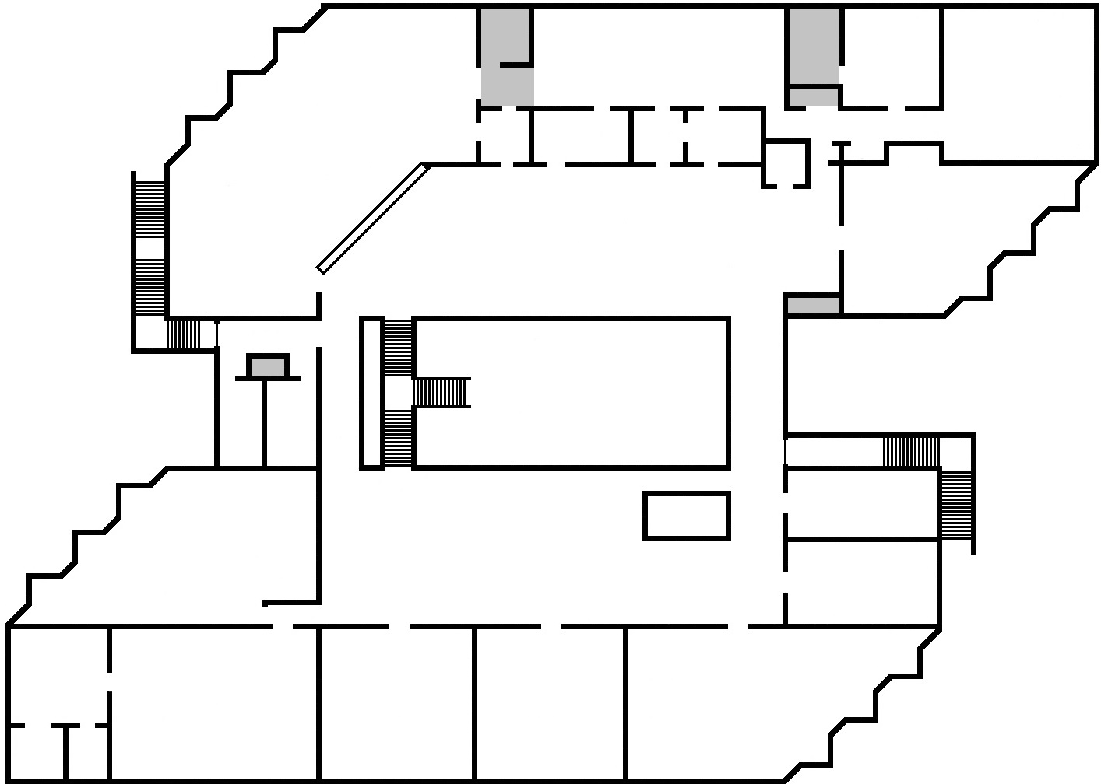
Faculty/Staff Offices:
L204
L226
L227
L229
L230
L235
L236


L
2
3
6
Adult Education

L223
LRC Classroom
L234
L235
L226
LRC Front Desk
Stryker Chair
Math Lab
L202-D
Computer/ Open Lab
L202-E
Writing Lab
L207
UMOJA
L215
L202-C
L204
L227
Emergency Exit
OPEN AREA
Learning Skills
L210
Community Room
L237
L231

Accounting Lab
L230
L229

L228
Emergency Exit
IT
L224

