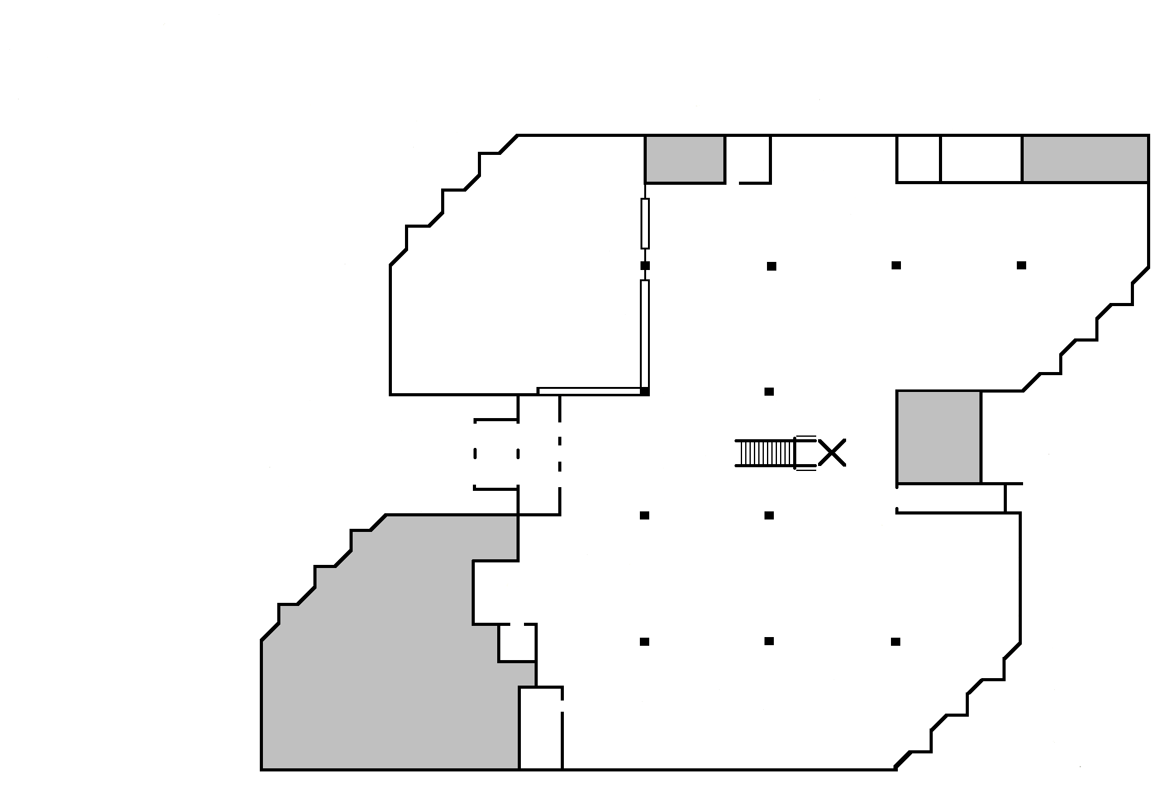


EZ
Readers
New
Books
Latinx
Circulation Desk
Young
Adult
Graphic
Novels
Staff Picks
Stacks 1 - 17

17 16 15 14 13 12 11 10 9 8
1 2 3 4 5 6 7
Best
Sellers
Reference
Monthly Book
Display
Study Room
110

} Tables
} &
} Furniture
Reserve
Desk

Fashion
Emergency
Exit
Library
Instruction
Study
Room
108

Periodicals stored
(Older Magazines, Journals & Newspapers)
-------------------
Quiet
Study
Room
Defibrillator& First Aid Kit
Entrance
Study
Room
109

Study Carrels

Computers
Reserve Textbooks

Reference Desk
Lib. Office 106
Li

Study
Room
107
Library
Offices

College of Alameda
Library Map
(Downstairs)

Study
Room
108

