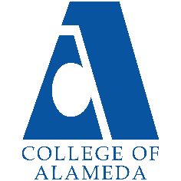
College of Alameda
2020-21 Annual Program Update – Library and LIS

Program Overview
Please provide your program’s mission statement.
Mission:
The College of Alameda Library is a teaching and learning-centered
library for a diverse community by providing physical and online access
to quality print, electronic, and multi-media resources, services, and
instruction. The library faculty and staff promote academic excellence
and student success by emphasizing skills in library research,
information literacy, and critical thinking.

Goals and Objectives:
- To provide quality services, research materials, technology,
facilities, and instructional programs that support the college
curricula, information literacy, and research needs. (Maps to ILOs #1,
#2, #3, #4, and #5)
- To provide students with access to information resources that
support their learning processes, teach information literacy, and
satisfy their intellectual needs. (Maps to ILOs #1, #2, #3, #4, and #5)
- To provide timely, appropriate, current, and knowledgeable
responses to student and faculty requests for information in print,
electronic and web-based formats. (Maps to ILOs #2 and #3)
- To provide a comfortable, safe, clean and quiet learning environment for all students. (Maps to ILOs #3 and #5)
- To administer fair and objective service policies that maintain ethical information use guidelines and respect an individual's right to privacy. (Maps to ILOs #4 and #5)

Library Service Area Outcomes:
- Library provides sufficient resources to meet the information needs
of the curriculum. (maps to ILO #1 and #2)
- Library provides sufficient access to Library resources. (maps to
ILO #1 and #5)
- Students will be able to effectively, efficiently, and ethically
access and use needed information. (maps to ILO #1, #4 and #5)

List your program faculty and/or staff

Full Time:
Ann Buchalter (faculty)
Jane McKenna (faculty)
Caitlin Gilbert (staff)
Glenda Gardner (staff)
Cheryl Peel (staff)
Instruction / Reference Librarian (vacant)
Senior Library Tech (vacant)

Part Time:
Mary Poeck (adjunct faculty)
Barbara Fields (adjunct faculty)
Amy Stewart-Deaker (adjunct faculty)
Adam Mann (adjunct faculty)
Claire Sue (adjunct faculty)

List your program goals from your most recent Program Review or APU.
Then, provide an update on the status of the goal. Has your program achieved the goal? Have any of your goals been revised or any still in progress?
Lastly, make sure to discuss which College or District goal your program goal aligns to.
If no program goals exist or if this is your first program review, work to create 2-3 goals and align them with a College or District goal.
Program Goal 1 | Hire a full-time Instruction and Reference Librarian to replace a recent retirement.
Status: In-Progress or Complete? | In-Progress.  The Library continues to advocate for the replacement for this critical position instrumental in meeting our Library Service Outcomes.
Which college or district goal is aligned with your program goal? | Justification: The full-time Instructional/Reference Librarian retired in Spring 2019 and this position has not yet been replaced. This request is to fill for a retirement vacancy and is not a new position. It is critical for the Library to replace this position. We are the only campus in the District to be without such a position. The Library is extremely low staffed for a Library of our size. Library standards recommend 4 f/t librarians for a college of our size and yet we only have 2 f/t librarians (Head Librarian and Systems/Cataloging Librarian). The lack of an Instruction/Reference Librarian is an accreditation issue and negatively impacts student success. Campus data shows that students in sections receiving COA Library orientations have a higher success (90%) rate than students in sections that do not receive Library instruction (70%). During the Covid closure, demands for Zoom library instruction sessions, OER resources, custom library skills videos and embedded librarians for Canvas have increased significantly. Library database usage has also doubled indicating a need for additional online librarian support for students researching remotely. The Library is struggling to meet this new demand with no full-time librarian responsible for instruction and reference. Replacing this position represents a position that would impact every student/faculty on the entire campus … across all disciplines, rather than only one department.  It is critical that the Library hire an Instruction  Librarian as soon as possible. This need is urgent. Failure to hire will place the college out of compliance with Ed. Code, risks  accreditation, and leads to significant cutbacks in the number of orientations provided to students which is shown to impact student success rates.  Aligns to the following College Goal:  Increase retention and persistence rates  Aligns to following District Goal:  Advance Student Access, Equity, and Success

Program Goal 2 | That at least 30% of the Library collection has a publication date  within the last 18 years.  Justification: Accreditation requires we have a current and high quality collection. There is a connection between library materials and student success rates. Campus data shows that students checking out print books have higher GPA and success rates than the college average ... this is also seen when broken out by at risk groups and equity challenged groups. Full data on this is located on the Library website under Planning Documents.
Status: In-Progress or Complete? | In-Progress.  Due to unstable funds for library materials, the Library has not been able to acquire funds to purchase books in the numbers necessary to update the collection significantly. The Library is optimistic that the recently passed Measure G will provide additional funds to update the collection in future.
Which college or district goal is aligned with your program goal? | Aligns to the following College Goal:  Increase retention and persistence rates  Aligns to the following District Goal:  Advance Student Access, Equity, and Success

Program Goal 3 | Provide library orientations for 60% of all English 1A and 100% of all English1AS sections.
Status: In-Progress or Complete? | In-Progress
Which college or district goal is aligned with your program goal? | Justification: Campus data shows that students receiving 2 or more library orientations per section have a higher success rates than other sections of the course not receiving orientations (see the Library Planning webpage for this study).  Aligns to the following College Goal:  Increase retention and persistence rates  Aligns to the following District Goal:  Advance Student Access, Equity, and Success

Program Goal 4 | Plan for, train and implement the State-wide migration to a new Library Integrated System called Alma/Primo from ExLibris.
Status: In-Progress or Complete? | In-Progress.  The Library has migrated to the new system but we continue to train and trouble-shoot. We also need to resolve student load/sign-in issues that require District IT coordination and support. We also still need to implement the Discovery feature for the system.
Which college or district goal is aligned with your program goal? | Aligns to Following College Goal:  Increase community and educational partnerships  Aligns to Following District Goal:  Advance Student Access, Equity, and Success

Program Goal 5 | Hire a full-time Senior Library Technician to replace a recent  retirement.
Status: In-Progress or Complete? | In-Progress.  The Library continues to advocate for the replacement for this critical position instrumental in meeting our Library Service Outcomes.
Which college or district goal is aligned with your program goal? | Justification: It is critical that the Library hire a Senior Library Tech as soon as possible. This need is urgent. The Library needs to fill the Senior Library Tech position that went vacant in the 2020-2021 year. This position is critical to provide adequate staffing to reopen the building. Without this position, the Library may need to cut their open hours when we return to in-person.  Aligns to the following College Goal:  Increase retention and persistence rates  Aligns to following District Goal:  Advance Student Access, Equity, and Success

Describe your current utilization of facilities, including labs and other space
The COA Library has approximately 20,748 gross square feet as assignable
space on the first floor of the L Building and an additional 2,521
square feet of study space on the 2nd floor of the L Building. The
space on the first floor includes seating for more than 200 students,
book stacks, four group study rooms, a quiet study room, book displays,
Circulation Desk, Reserve Desk, Reference Desk, periodical
display/browsing area, study tables and carrels, copiers/scanner, an
archive, computers for researching (14 workstations),
cataloging/processing service areas, an archive, library staff/faculty
offices, and an open classroom for instruction.

Program Update
Using the dashboards, review and reflect upon the data for your program.
Course Completion and Retention Rates – Instructional Dashboard
Course Completion and Retention Rates – Student Services Dashboard
Enrollment Trends and Productivity Dashboard
Degrees and Certificates Dashboard

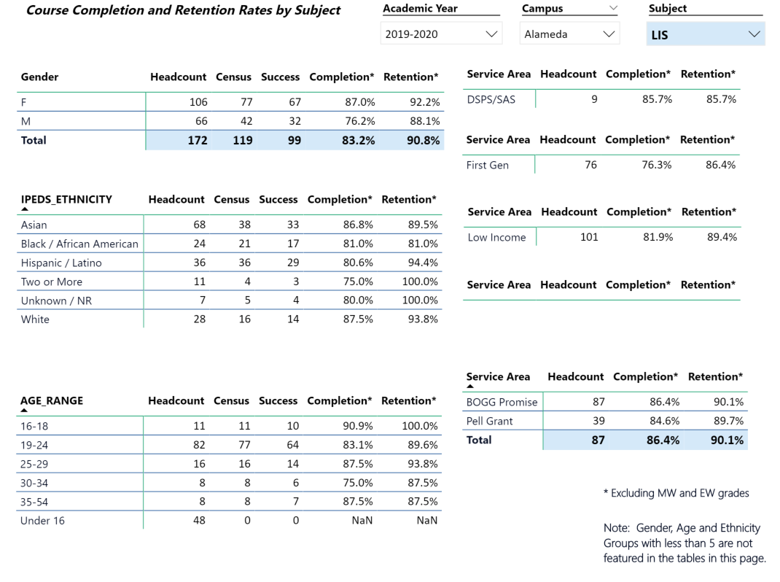

Describe any significant changes and discuss what the changes mean to your program. Consider whether performance gaps exist for disproportionality impacted students by using filters to disaggregate the data. Focus upon the most recent year and/or the years since your last comprehensive program review. Cite data points to support your reflection.
The success and completion rate is strong for the LIS students with an average success rate of 83% and a completion rate of 90%. These numbers are higher than the college average. The numbers are consistent across most categories and population groups. The students in the lower range for success and retention are the first generation students, men and the 30-34 age range.

Describe the department's progress on Student Learning Outcomes (SLOs) and/or Administrative Unit Outcomes (AUOs) since the last Program Review/APU. If your discipline offers a degree or certificate, please describe the department progress on Program Learning Outcomes (PLOs).
All of the SLOs for all of the LIS courses (that have been offered) have been assessed within the last 2 years and entered within Meta. For the LIS74 course, assessment results indicate that students are 90% or above in meeting the outcomes for the course. LIS74 is the only course currently being offered in LIS at the College due to lack of a full-time instruction/reference librarian (recent retirement that has not been replaced). The Library has placed this position as a high priority in its Annual Program Update under Goals.
In addition, all of the Library service outcomes have been assessed within the last 2 years and entered within Meta. The service learning outcomes data for library services is also analyzed at librarian meetings and utilized when developing budget priorities. Service area data compiled and analyzed includes library orientation assessment results, library student surveys, faculty surveys, library usage statistics, as well as studies that analyze the demographic data, GPA / success rates of Library users. Many of these assessment results are also posted on the Library webpage under Planning Documents.
In addition, a detailed description of the Library’s internal assessment process can be found on the Library Webpage under Planning Documents.

Describe the outcomes and accomplishments from previous year’s funded resource allocation request.
Brief description of funded request | Source (any additional award outside your base allocation) | Total Award Amount | Outcome/Accomplishment
The Library has a large number of regular bills that are required to maintain a basic level of library services and resources. The Library does not receive these funds as a base allocation (even though they are annual subscriptions) and instead must advocate / help identify funds for these even though these funding requests/expenditures are stable annual needs that we are contractually required to pay. These bills include annual service/subscription agreements for article databases, library systems, periodical subscriptions, security gates contract, reference chat software subscription, reserve textbooks, and circulating collection books (only funding expenditure that has some flexibility in terms of whether we order). The Library continues to advocate for a baseline budget from the general fund for annual baseline Library expenses that do not change from year to year. |  | 96,026  (for 2019-2020, not including District funded Library system expenses) | See the Library Planning Documents webpage for in-depth usage statistics in all of these areas including: circulation numbers, textbook usage, database usage, orientation sessions, material cataloged, study room usage, etc.  The recent data shows that article database usage has gone up significantly (doubled from previous year). This makes sense based on the closure of the campus due to Covid and the shift to online services and resources campus-wide.  Requests for librarians embedding in Canvas shells also increased significantly over the last year.  Last year, the Library cut several databases and cut one adjunct shift due to a lack of stable funds. The only circulating books purchased were possible due to HSI Grant funding.

Prioritized Resource Requests Summary
In the boxes below, please add resource requests for your program. If there are no resource requested, leave the boxes blank.
Resource Category | Description/Justification | Estimated Annual Salary Costs | Estimated Annual Benefits Costs | Total Estimated Cost
Personnel: Classified Staff | The Library needs to fill the Senior Library Tech position that went vacant in the 2020-2021 year. This position is critical to provide adequate staffing to reopen the building. Without this position, the Library may need to cut their open hours when we return to in-person. | 55,000 | 15,000 | 70,000
Personnel: Student Worker

Personnel: Part Time Faculty | The Library requires adjunct reference/instruction librarians to cover the reference desk (chat, email, phone, Zoom orientations, embedded librarian, etc.). Hours are needed to cover vacant position’s responsibilities, evening hours, intersession hours, summer hours, backfill for reduced load and backfill for head librarian. |  |  | 148, 509
Personnel: Full Time Faculty | - The full-time Instructional/Reference Librarian retired in Spring 2019 and this position has not yet been replaced. This request is to fill for a retirement vacancy and is not a new position. It is critical for the Library to replace this position. We are the only campus in the District to be without such a position. The Library is extremely low staffed for a Library of our size. Library standards recommend 4 f/t librarians for a college of our size and yet we only have 2 f/t librarians (Head Librarian and Systems/Cataloging Librarian). The lack of an Instruction/Reference Librarian is an accreditation issue and negatively impacts student success. Campus data shows that students in sections receiving COA Library orientations have a higher success (90%) rate than students in sections that do not receive Library instruction (70%). During the Covid closure, demands for Zoom library instruction sessions, OER resources, custom library skills videos and embedded librarians for Canvas have increased significantly. Library database usage has also doubled indicating a need for additional online librarian support for students researching remotely. The Library is struggling to meet this new demand with no full-time librarian responsible for instruction and reference. Replacing this position represents a position that would impact every student/faculty on the entire campus … across all disciplines, rather than only one department. | 77,000 | 15,000 | 92,000

Resource Category | Description/Justification | Total Estimated Cost
Professional Development: Department wide PD needed

Professional Development: Personal/Individual PD needed

Prioritized Resource Requests Summary - Continued

Resource Category | Description/Justification | Total Estimated Cost
Supplies: Software | Public Web Browser (annual subscription) - $250  ExLibris (Library automated system, annual, fee/cloud hosting) - $5,349  EzProxy (annual, remote authentication / cloud hosting) – $3,502  OCLC (annual, cataloging database) - $1,095 | $10,196
Supplies: Books, Magazines, and/or Periodicals | Reserve Textbooks - $2,000  Reference Books – $2,000  Periodicals – $7,000 (annual subscriptions)  Article/ebook/video databases - $64,000 (annual subscriptions)  Circulating Books - $55,000 (number based on estimate of what it takes to update the age of collection over the course of 10 years) | 130,000
Supplies: Instructional Supplies | Instruction supplies, student printers and cataloging supplies – $3,600 | $3,600
Supplies: Non-Instructional Supplies | Office supplies for Library staff | $1,000
Supplies: Library Collections | See above and below

Resource Category | Description/Justification | Total Estimated Cost
Technology & Equipment: New | Instruction Laptop for Library Classroom - $2,000  Wireless Print Stations - tbd | 2,000
Technology & Equipment: Replacement | Updated Circulation Shelving (24 shelves) – tbd  Library Lounge Seating (upholstered chairs are cracking/tearing) – tbd  Refresh staff computers – tbd  Refresh student computers – tbd  Emergency Phones and panic buttons – tbd  Building Announcement System – tbd  Furniture for new study room – tbd  Presentation equip for study rooms – tbd | tbd

Prioritized Resource Requests Summary - Continued

Resource Category | Description/Justification | Total Estimated Cost
Facilities: Classrooms | Library - Lighting upgrade  Library - New roof  Library - Electrical upgrade  Library - HVAC upgrade | tbd
Facilities: Offices

Facilities: Labs

Facilities: Other

Resource Category | Description/Justification | Total Estimated Cost
Library: Library materials | See above under Supplies
Library: Library collections | See above under Supplies

Resource Category | Description/Justification | Total Estimated Cost
Library – Dues and Memberships | CCLC - $150 (annual, provides discount pricing for databases) | $150
Library Service Contracts | Biliotheca Security Gates (annual, alarm system for books, required by Accred.) - $2,886 | $2,886

