Embedded Librarian Project at College of Alameda – Data Analysis – English 1A – Summer 2018
Summary: In Summer 2018, a librarian attended two meetings of one section of Eng 1A at COA as part of the Embedded Librarian project (funded by the Basic Skills Initiative, Student Equity, Student Success Support Program at COA). The librarian provided instruction on locating, evaluating and citing information sources.
Conclusion: The Eng 1A section that participated in the Embedded Librarian Project had the highest rate of success (76.2%) compared to all of the other Eng 1A sections (average success rate of 64.7%) that were offered that summer at COA.

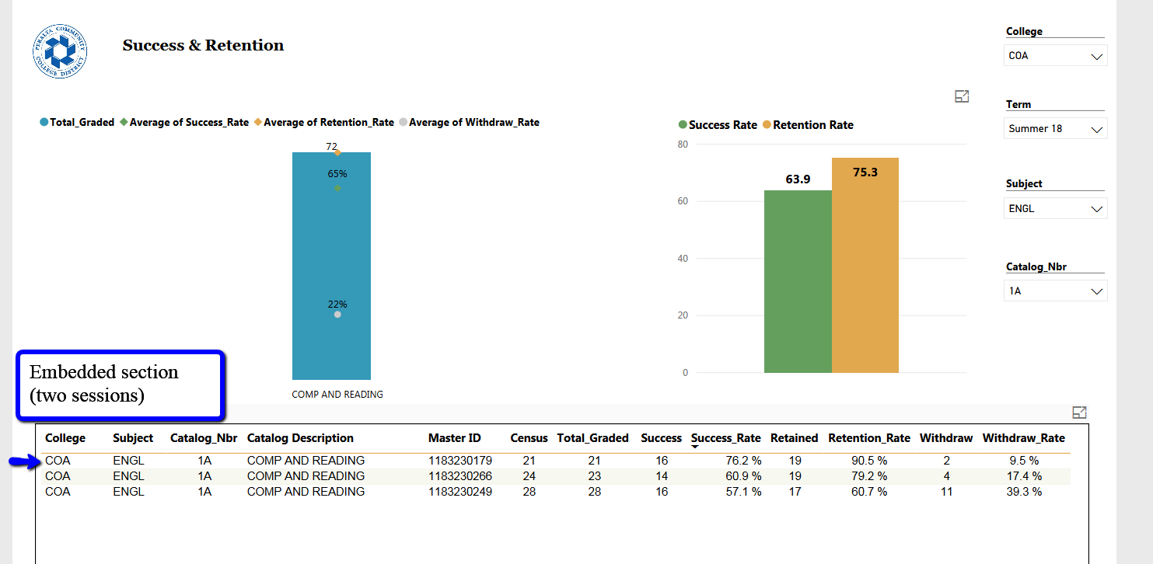
Next Steps: Expand the Embedded Librarian to include additional Engl sections in future. Analyze success rates for future semesters to see if the statistical outcome is repeatable.

