Embedded Librarian Project at College of Alameda – Data Analysis – English 5 – Spring 2018

Summary: In Spring 2018, a librarian attended three meetings of one section of Eng 5 at COA as part of the Embedded Librarian project (funded by the Basic Skills Initiative, Student Equity, Student Success Support Program at COA. The librarian provided instruction on locating, evaluating and citing information sources.
Conclusion: The Eng 5 section that participated in the Embedded Librarian Project had the highest rate of success (90.6%) compared to all of the other Eng 5 sections (average success rate of 70.7%) that were offered that semester at COA.

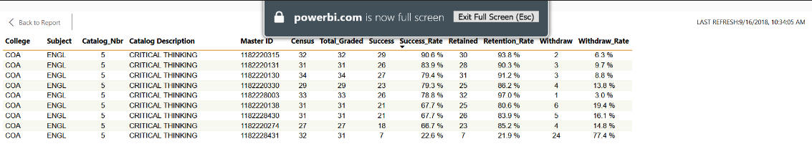

Next Steps: Expand the Embedded Librarian to include additional Engl sections in future. Analyze success rates for future semesters to see if the statistical outcome is repeatable.

