Follow-up Assessment of Eng1A Students – Completed in Fa10
Peralta Fall 09 English 1A Students with follow-up in English 1B or 5 in Spring 10
by Library Instruction
The Library conducted a follow-up study of students who had taken English 1A at the College of Alameda in the fall of 2009. The follow-up study compared two groups of English 1A students: those that had a library instruction session as part of English 1A and those that had not. These students were tracked as to success rates and grades in English 5 and English 1B in the spring of 2010. There were only minor differences between the two groups in success or grades. The results of the study are attached.

There appears to be no long term benefit for English 1A students who attend a single library instruction session. One possibility to consider for future research is to see if increasing the number of library sessions for English 1A students improves success rates or grades in follow-up English courses.

Instruction | Term | Catalog Nbr | Grade | Student ID | %
With Library instruction | Fall 09 | 1A | Non-Success | 71 | 54.2%
 |  |  | Success | 60 | 45.8%
 |  | 1A Total |  | 131
 | Spring 10 | 1B | Non-Success | 4 | 40.0%
 |  |  | Success | 6 | 60.0%
 |  | 1B Total |  | 10
 |  | 5 | Non-Success | 3 | 17.6%
 |  |  | Success | 14 | 82.4%
 |  | 5 Total |  | 17
Without Library instruction | Fall 09 | 1A | Non-Success | 105 | 42.0%
 |  |  | Success | 145 | 58.0%
 |  | 1A Total |  | 250
 | Spring 10 | 1B | Non-Success | 6 | 25.0%
 |  |  | Success | 18 | 75.0%
 |  | 1B Total |  | 24
 |  | 5 | Non-Success | 11 | 15.7%
 |  |  | Success | 59 | 84.3%
 |  | 5 Total |  | 70

Notes:
The cohort students include students who took English 1A in fall 2009 (including the W grade). These students were followed up untill spring 2010 in the courses of English 1B and 5.
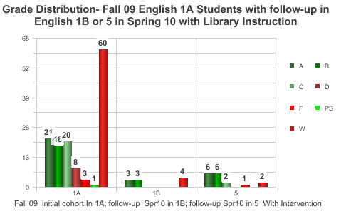

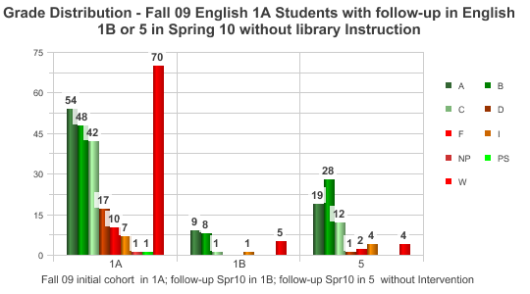
Note:
Green color series represent successful grades; red color series represent non-successful grades.

