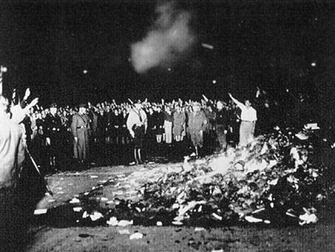 NAZIS BOOK BURNING DURING WWII IN GERMANY

Good Starting Places at the College of Alameda Library
Researching Banned, Prohibited and Challenged Books

Online Databases – Available in the Library’s Reference Area

• Ebsco Host / Academic Search Premier -- Provides full-text for over 4,500 periodicals covering the Social Sciences, Humanities, Sciences, Health, Arts, Business, Sports, Politics, etc. Sample magazine titles: Time, Newsweek, Nation, Mother Jones, National Review, Essence and Business Week

• Infotrac / Expanded Academic ASAP -- Provides full-text coverage of 2,000+ periodicals titles in a wide variety of disciplines including: social science journals, humanities journals, science and technology journals, national news periodicals and general interest magazines.

• Ethnic News Watch -- Full-text database of newspapers and magazines of the ethnic and minority press in America. Good for obtaining alternative viewpoints from the African American, Hispanic American, Arab American, Asian American Jewish American and Native American communities.

Reference Books – Available in the Library’s Reference Area

• Opposing Viewpoints Series (Reference HN 16 .067) -- Series gives pro and con arguments on hot topics; includes a volume on censorship.

Websites – Available with from Open Internet anywhere

• American Library Association (www.ala.org) -- Extensive coverage of banned, prohibited and challenged books. Search within the site on these keywords: banned books, challenged books, prohibited books, censorship.

• Forbidden Library: Banned and Challenged Books (www.forbiddenlibrary.com)

Selected list of challenged and banned books arranged by author and title. Includes a brief note as to why the book was challenged or banned.

