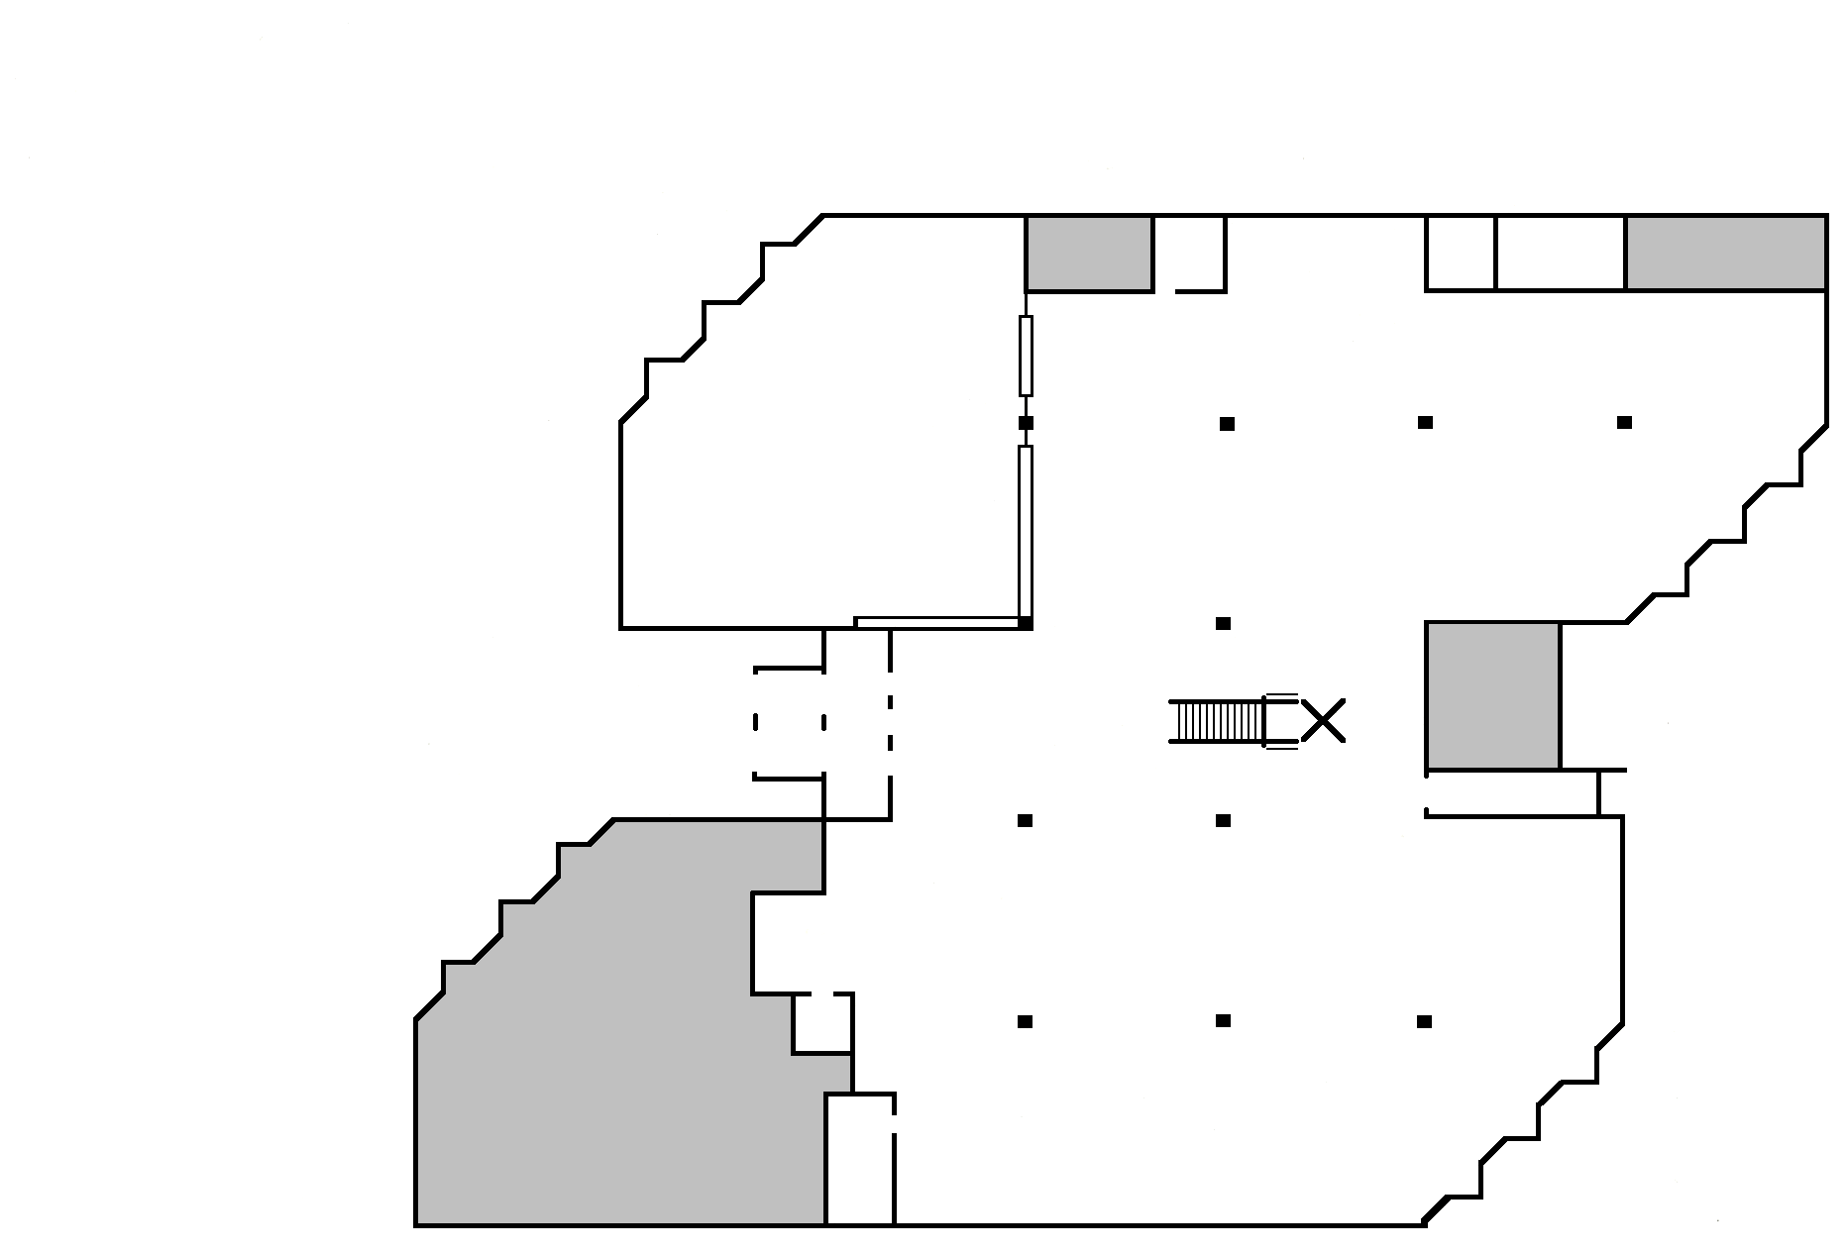

**College of Alameda**

**Library Map**

**L Building First Floor**

} Tables

} &

} Furniture

Scanner

EZ-Readers

Library

Instruction

 



Study

Room

108

**17 16 15 14 13 12 11 10 9 8**

**1 2 3 4 5 6 7**

110A Teacher 110B

offices

Study

Room

109

Study Carrels

Reserve Textbooks

New book

Display

Monthly

Display

Lib. Office 106

Li

Study

Room

107

**Library**

**Offices**

Study

Room

108

Quiet

Study

Room

Newspapers

Stacks 1 - 17

Magazi

n

es

**Emergency Exit**

**Entrance**

Best

Sellers

Photocopy Machines

Reference

**Defibrillator& First Aid Kit**

Periodicals stored

(Older Magazines, Journals & Newspapers)

Reference Desk

Circulation

Desk

Print

Enlarger

Computers

Reserve

Desk

**College of Alameda**

**L Building Second Floor Map**

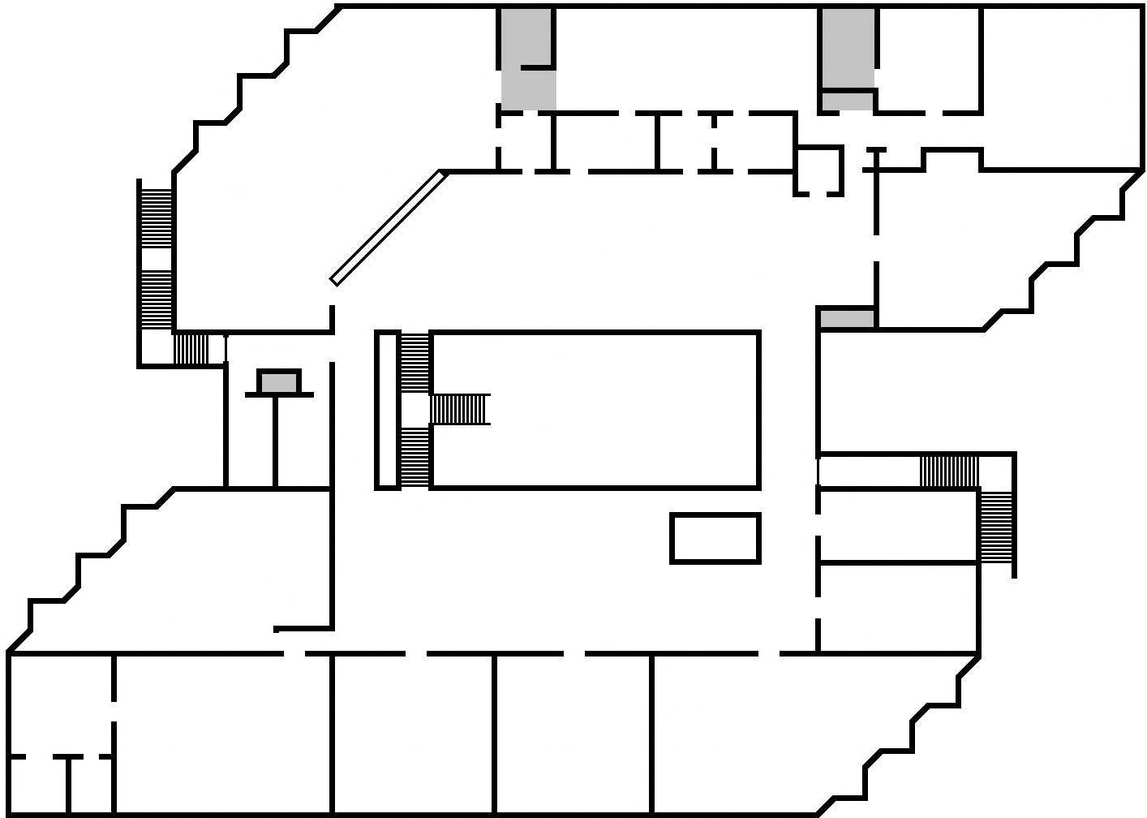

**Library Study Area**

**Emergency Exit**

**Stryker Chair**

**L226**

**LRC Classroom**

**L234**

**Emergency Exit**

**L231**

**Math Lab**

**L202-D**

**Computer/ Open Lab**

**L202-E**

**Writing Lab**

**L207**

**UMOJA**

**L215**

**L202-C**

**LRC Front Desk**

**L204**

**Learning Skills**

**L210**

**OPEN AREA**

**Community Room**

**L237**

**Outreach**

**L235**

**Accounting Lab**

**L228**

**L230**

**L229**

**L227**

**IT**

**L224**

**Adult Education**

**Atlas**

**Dual Enrollment/**

**Academic Dean**

**L223**