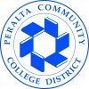
2018-19 Annual Program Update

Program Overview
Please verify the mission statement for your program. If there is no mission statement listed, please add it here.
The mission of the Art Department at the College of Alameda is to provide courses leading to the fulfillment of general education, degrees in art and art history, and successful transfers to UCs and CSUs. The Art Department introduces students to the world of art and promotes lifelong learning.

List your Faculty and/or Staff
Drew Burgess, Maria Guzman, Gabriel Navar, and Susan Leffingwell.

The Program Goals below are from your most recent Program Review or APU. If none are listed, please add your most recent program goals. Then, indicate the status of this goal, and which College and District goal your program goal aligns to. If your goal has been completed, please answer the follow up question regarding how you measured the achievement of this goal.
ASSESSMENT The assessment of courses is ongoing. Individually instructors assess student progress and provide content for TASKSTREAM. Assessment is gathered and aligned with institutional goals. As the system transitions to Curricunet the art department will further develop the assessment of all courses.

Examples of methods for assessment related to specific course and departmental goals:
1) An Instructor’s assessment of courses has been tracked utilizing online surveys at beginning, midterm, and end of semester for courses (ART 1, ART 122, ART 2, and ART 3).
2) An instructor gives a preliminary Art 1 exam and measures students development with a parallel exam later in the semester.
3) An instructor assesses specific Student Learning Outcomes with an analysis of a single midterm question.
4)Portfolios of studio arts students are assessed in relation to Student Learning Outcomes and Institutional goals for drawing and painting classes.
5)Assessment of critiques in studio classes are gathered and utilized in relation to the goals of course outlines including Student Performance Objectives.
6) Singular assignments are assessed in studio classes to reflect upon the relationship of assignments and the goals as stated in the course outline of record.

Guided Pathways
The Art Department will be contributing to the first mapping cohort for the COA Guided Pathways implementation, which focuses on student success. Art Department faculty are participating with and on the Guided Pathways committee. Art faculty serve on the Curriculum Committee and are in communication with the process regarding the structure of pathways.

Counseling Connection
Regarding assessment of courses, faculty are working with a Counseling liaison, in order to better discuss and assess students’ needs.

CURRICULUM/STUDENT SERVICES & EQUITY: The non-credit courses for art have been approved by the state. We now have Art 520 Drawing, 560 Watercolor, 550 Painting, and 590 Mixed Media. These courses will be tied to a certificate. Students can concurrently enroll in our studio classes. This could be a benefit for students who are exploring the college experience and enhancing their creative practice. DSPS students and seniors could also embrace this educational certificate. The additional opportunity could help enrollment. Furthermore, an additional course (ART 122) has been created as a result of faculty support of the Open Educational Resources (OER) project at COA. It is a Zero Textbook Cost (ZTC) format course, which enables students to manage any financial constraints.

CURRICULUM/STUDENT SERVICES & EQUITY: Innovative ideas are addressed by the art department. As leaders, the COA team are the first of the district to offer a studio arts sequence of non-credit courses. Approved by the state and ready for the current catalog, we now have Art 520 Drawing, 560 Watercolor, 550 Painting, and 590 Mixed Media. These courses are tied to a local certificate. Students can concurrently enroll in our studio classes. This could be a benefit for students who are exploring the college experience and enhancing their creative practice. DSPS students and seniors could also embrace this educational certificate. The additional opportunity could help enrollment. This sequence of course was a specific goal of our last review.

Open Educational Resources
Furthermore, an additional course (ART 122) has been refined as a result of faculty support of the Open Educational Resources (OER) project at COA. It is a Zero Textbook Cost (ZTC) format course, which enables students to manage financial constraints.

Student Success
Art history courses and studio arts courses are designed with consideration of the needs of students. Classes are developed with a plan that enables students to access academic materials, art supplies and the tools necessary to succeed.

Updating Course Outlines
The department is in the process of updating courses. In the Fall of 2018 Art 1 and art 122 were updated. District wide coordination will be necessary for some revisions to the language of art courses such as Art 1. Art faculty are working to refine courses in the catalog with updates.

INSTRUCTION/STUDENT SERVICES & EQUITY: The Art Department regards the educational wellbeing of students. ART 2 and ART 3 continue to experience steady enrollment to full capacity. ART 2 has been offered as both fully online and as a hybrid course. In addition, ART 122 has been offered as fully online (Fall 2018) and as a hybrid (Spring 2019). The hybrid courses include monthly visits to Bay Area museums. All museums are public transportation-friendly, very affordable and/or free thanks to the Discover & Go! Program offered by various public libraries.

The collaboration with the COA Fab Lab has been steadily building, and a faculty member is currently conducting professional service as the Maker-in-Residence for the 2018-19 academic year. She is leading the implementation of an interdisciplinary Faculty Maker cohort, which will conduct research at local community college maker spaces as well as create maker curricula. Art Faculty requests include personnel versed in 3D arts and Art History. A Volunteer of Record, student workers, and specialized tutoring efforts are still needed in order to support students in studio courses. Studio courses may have a new relationship with the Fab Lab and Workforce Development as the non-credit sequence evolves.

DSPS
The Art Department has an ongoing relationship with the DSPS office. The studio arts classes serve many students with disabilities. Ideas concerning students, credit and noncredit coursework and career opportunities are evolving.

PROFESSIONAL DEVELOPMENT, INSTITUTIONAL AND PROFESSIONAL ENGAGEMENT, AND PARTNERSHIPS: Recently, several Art Department faculty have planned a department “experience” in an effort to showcase course offerings. The event will dovetail with a STEAM workshop to engage ASTI and promote student success. This event is scheduled to take place on February 1, 2019. Music faculty instructors are collaborating with the Art Department with a live performance. On January 18, the Art Department was represented by several faculty at the campus FLEX Day workshops.

Workshops
The Art department is in conversation with ADAM about a possible collaborative Spring event.

Dance
A long-standing idea has been to collaborate with and create a mural or work of art for the dance department.

Library
In Fall of 2018, the painting class created two works of art for the library.

Presidential Award
The president of the college has awarded students with gift certificates in exchange for works of art that are now a part of a growing collection of student art at COA.

Women’s History Month
The art department is working with the Director of Student Activities to develop a community event.

OTHER PROGRAM IMPROVEMENT OBJECTIVES OR AU OUTCOMES: Completed the non-credit curriculum (Certificate in Art Fundamentals CP3, a certificate of accomplishment). A non-credit certificate in Art History is being considered as an addition to the department’s course programming. The new Liberal Arts building includes a gallery. Noncredit coursework may be beneficial in building a relationship with the community and establishing the College of Alameda as an Arts Center.

Collaboration
Instructors are collaborating on the updates to courses in the art catalog. This includes revising courses and implementing progressive coursework to meet the needs of 21st century students.

OTHER PROGRAM IMPROVEMENT OBJECTIVES OR AU OUTCOMES: Fab Lab projects have been created for both ART 1 and ART 122; they are being assessed and will be further developed over the Spring 2019 semester. Art students access the Fab Lab and participate with new individual projects.

Describe your current utilization of facilities, including labs and other space
The Art Department will change location to the new Liberal Arts Building in Fall of 2019. At present the
studio arts classes take place in the D Building, room D316. Exhibition of student works takes place in
the room. The new facilities will include a gallery that the art department is to oversee for student
exhibitions and shows pertaining to the college disciplines and the community at large. The art department will benefit with a cohesive plan to include faculty in one location. At present the department is divided between two locations. Faculty members will benefit with offices near the studio classroom and lecture rooms of the new building.

The current facilities are outdated in terms of technological delivery. Excessive cords, faulty outlets,
poor lighting hamper educational delivery. Yet, the existing studio room has great charm and is favored
by students. The new facility may benefit as a space if there is a recognition of some of the successful
aspects of the old space.

If the department has positive growth, the ‘old’ room may be of value as a workspace for students. A need for improvement in studio classes is the single sink. Students must wait in line to clean equipment.

Program Update
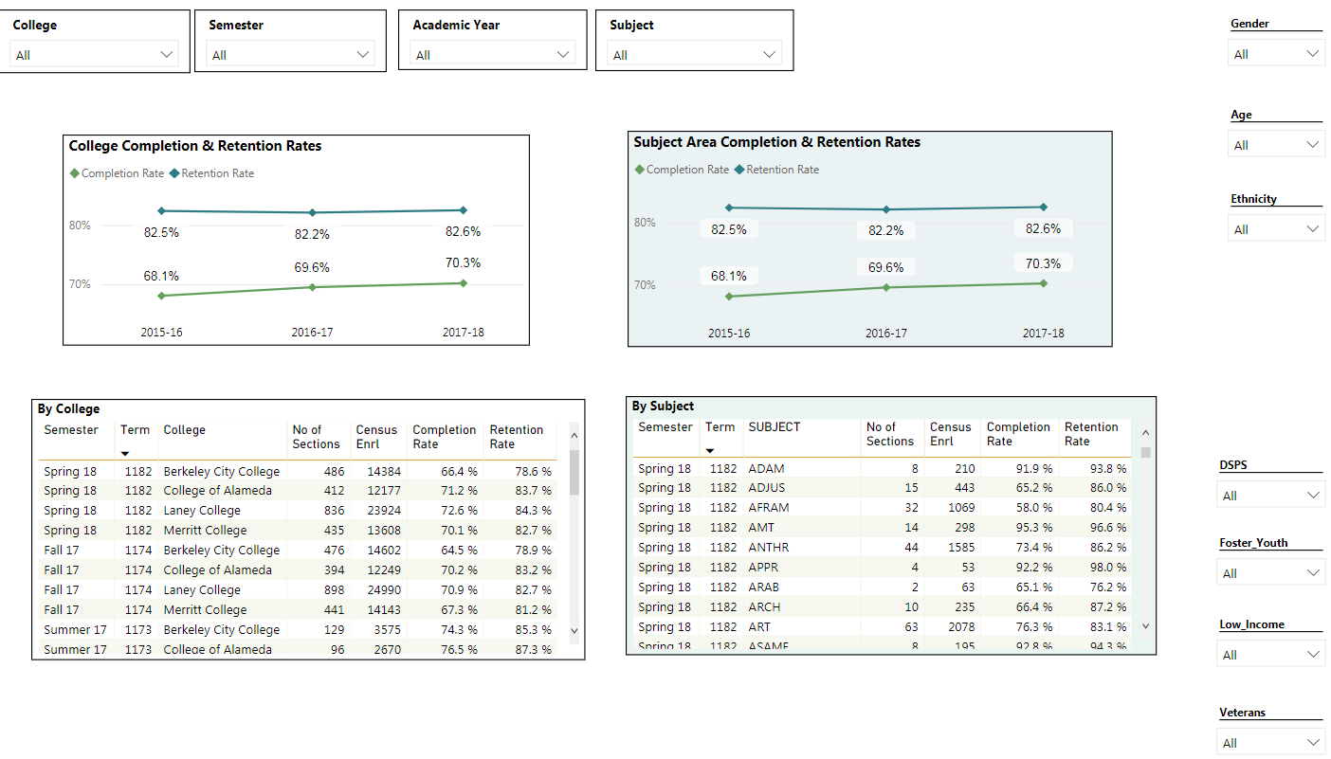
Program Update Power BI dashboard
Using the dashboard, review and reflect upon the data for your program. Describe any significant changes and discuss what the changes mean to your program. Consider whether performance gaps exist for disproportionality impacted students. Focus upon the most recent year and/or the years since your last comprehensive program review. Cite data points from the dashboard to support your answer.
Over the span of the last four years, we have been able to increase the amount of our course offerings.
This includes both studio art and art history courses, and is approximately an average of 3 offerings over
Fall and Spring semesters. In addition, we plan to engage students more during the Summer terms moving forward.

The productivity of the art department has been consistently high in relation to college averages. Completion rates are consistent and in line with the averages of the college. Retention rates indicate that the art department closely follows the averages of the college.

Describe the department's progress on Student Learning Outcomes (SLOs) and/or Administrative Unit Outcomes (AUOs) since the last Program Review/APU. If your discipline offers a degree or certificate, please describe the department progress on Program Learning Outcomes (PLOs).
Regarding Distance Education completion/enrollment, recent updates to previously 100% online courses has involved a hybrid format that requires students to meet at local community museums. This has increased retention rates, writing performances overall, and grades. By actively applying concepts, their ability to recall and contemplate learning materials is enhanced and supported by this group learning activity.

This year, the Art Department received a significantly increased amount of funding for instructional supplies. The Art Department has been working on offering evening and weekend courses. The Fall 2018 ART 1 course on Saturdays was successful, and a Painting course is being offered on Saturdays for the Spring 2019 semester. ART 122 is being offered as a hybrid course on Sundays during the Spring 2019 semester as well.

The department needs to address Program Learning Outcomes. We recognized with the updating of the catalog that revision is needed as well as reflection. The implementation of Guided Pathways intersects with our programs.

Describe the outcomes and accomplishments from previous year’s funded resource allocation request.
Brief description of funded request | Source (any additional award outside your base allocation) | Total Award Amount | Outcome/Accomplishment
Art studio materials and supplies. |  |  | Increased allocation of instructional materials has enhanced student engagement.
Opaque projector |  |  | Previous equipment has included an opaque projector which has been utilized effectively in the painting courses.
Printing Press |  |  | The department has received the press and we plan to utilize it for innovative projects.

Prioritized Resource Requests Summary
In the boxes below, please add resource requests for your program. If there are no resource requested, leave the boxes blank.
Resource Category | Description/Justification | Estimated Annual Salary Costs | Estimated Annual Benefits Costs | Total Estimated Cost
Personnel: Classified Staff | Para professional staff for the facilitation of the new gallery, studio classrooms, lecture classes and special events.
Personnel: Student Worker | 2 Student Workers for Studio courses  As the transition to the new Liberal Arts Building unfolds, the art department will need assistance.  It is expected that the combination of studio work space, gallery space and campus artistic projects will give rise to employment opportunities for students.
Personnel: Part Time Faculty | 1 adjunct instructor who will teach 3-D Design and Mixed Media courses.  The 3-D (Art 47) and Mixed Media(Art 90) courses could be developed within the present studio arts class rooms. These courses strongly relate to painting, sculpture and architecture as well as other disciplines.  Art 590 is the non-credit version of the Mixed Media course.  The Art Department is in a position to support emerging ‘maker’ inquiry. These courses could be taught with a relation to the Fab Lab.
Personnel: Full Time Faculty | 1 Art History Instructor  The College of Alameda will benefit with an Art History Instructor. Art History courses continue to be enrolled to full capacity, and there are discussions to develop specialty courses in the near future.

Resource Category | Description/Justification | Total Estimated Cost
Professional Development: Department wide PD needed | Curriculum Institute Participation | $3,000
Professional Development: Personal/Individual PD needed | $1,000 per faculty – enables faculty to attend either a conference or visit a location for professional research and enrichment. Can also encourages faculty to enhance their own studio practice.  Emerging resources such as OER—The facilitation of OER (stipends to develop courses). | $4,000

Prioritized Resource Requests Summary - Continued

Resource Category | Description/Justification | Total Estimated Cost
Supplies: Software | Photoshop/Illustrator (Adobe Creative Suite) - needed for Maker-in-Residence projects, creating flyers for courses, and potentially, a brochure for the Art Department each semester. This enables the department to promote courses in a uniform and collective manner. | Approximately $20/month
Supplies: Books, Magazines, and/or Periodicals | Art in America | $100
Supplies: Instructional Supplies | Supplies to support Drawing, Painting, and 2D Design | $1500
Supplies: Non-Instructional Supplies | Supplies to support Departmental administration | $800
Supplies: Library Collections | Departmental Art Library, textbooks for student use, and museum passes to assist students in attending site visits/conducting research. | $1,000

Resource Category | Description/Justification | Total Estimated Cost
Technology & Equipment: New | Printer/scanner for home office – enables prompt submission of documents for students/department needs.  Copy (xerox) machine in art studio room | $250-$300 each
Technology & Equipment: Replacement | Speakers | $250

Prioritized Resource Requests Summary - Continued

Resource Category | Description/Justification | Total Estimated Cost
Facilities: Classrooms | Upgrades and transitional coordination with the VPI of instruction and Full time Art Faculty to facilitate the move to the new Liberal Arts Building. | New Building  Budget
Facilities: Offices | Same as above | Same as above
Facilities: Labs | Same as above | Same as above
Facilities: Other | Supplies and equipment to mount exhibits as the new building is complete and the gallery opens. | $2,000

Resource Category | Description/Justification | Total Estimated Cost
Library: Library materials | Textbooks on reserve | $1,000
Library: Library collections | A collection of printed images for art students. | $500

Resource Category | Description/Justification | Total Estimated Cost
OTHER | Supplies to facilitate art events including tables, tents, and exhibition mounting walls. | $1,000

