College of Alameda
Guided Pathways Inquiry Lunch #3
May 7, 2018
MINUTES – draft
Attendees: Trish Nelson, May Chen, Don Miller, Karen Engel, Rachel Goodwin, Rachel Antrobus, Ana McClanahan
Agenda:
- COA Student Pipeline Leaks (aka, pain points)
- COA existing initiatives (mapping)
- COA past initiatives – continued debrief of what worked and didn’t work

Minutes:
COA Student Pipeline Leaks
- Interim Dean Engel presented an initial graphic (in response to the request at the first Inquiry Lunch for a visual representation of what the Guided Pathways framework might look like at COA) of a student “pipeline” and possible locations where the pipe “leaks”. See below.
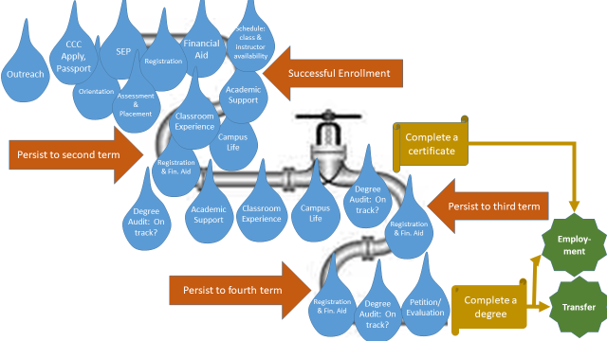
  - See slide deck for additional slides related to this graphic.
  - The visual could be improved by drilling down into each drop – highlighting it via a different color and then indicating a “bucket” of current initiatives or metrics related to that drop (or leak).
  - How can we see who is affecting these initiatives or addressing leaks? Is it Student Services or Instruction? Perhaps we also compile a list.
- The discussion then focused on COA’s existing initiatives related to student supports (the LRC, tutoring, faculty office hours) and do we track how students come to get supported and what happens to them afterwards? Do we have a feedback loop?
  - LRC tracks # of students, which courses they come for help with, and what kind of help they get (eg., open lab, writing lab, math lab)
  - There are faculty who are providing hours of tutoring (such as Leslie Reiman, every Friday) which are not getting logged and we are not getting FTES for them!
  - Many adjuncts do not know what supports are available or how to refer students to them
  - Note: walking students to DSPS or the LRC is very powerful. Although referring them explicitly also helps. Starfish Early Alert should help with this.
- Summer Inquiry project suggested: Inventory all of the student learning supports that are available and review the data (students, courses, types of supports, and, ideally, what happened as a result – course success?). Make this Student Learning Outcome (SLO) based. This could help the LRC determine which types of supports are most effective: non-credit, etc.
  - Shall we map this by degree program? The four Liberal Arts degrees? Look at the SLO’s of each course in the 4 Liberal Arts degrees and look at trends in the SLO’s so we can know how to better provide supports
  - We could “map” the SLO’s to four major student outcomes (critical thinking, writing, quantitative reasoning, communication) (see whiteboard pic below)

  - Question: What is the role of instruction?
  - Question: What are the connections between student services (supports) and instruction (embedded with instruction?)
  - Question: How do we share learning (instruction) across campus/disciplines/majors
  - Hypothesis: What’s best for students is when we create cross-functional (student services and instruction) teams who work together to support students and monitor learning and outomes. [Like Bakersfield’s Completion Teams]
- Generally, how does the College foster cross-functional dialogue re content mastery?
  - This echos Robert Brem’s earlier points about “how we become a Learning College
  - Trish is launching a Community of Practice related to a “Reading Apprenticeship” model where faculty within English and across several departments will discuss and try new ways to align and reinforce reading comprehension mastery across disciplines.
  - How do we sustain/scale this kind of thing? FIGs? (Faculty Inquiry Groups?)
  - Can we look into different models for these cross-functional and inter-departmental teams and how to sustain them over time?
- SLOs and Meta Majors:
  - Perhaps we define Meta Majors on the basis of aligned (across-disciplines) SLO’s
  - If we “map” the SLO’s (per above) it could help the SLO’s mean something (and make PLO’s more feasible)
  - Professional Development could be provided in a more focused manner
  - Cross-functional “completion teams” could begin to look at Starfish data, and SLO data, and learning support data and begin to understand what students need and what interventions are most helpful.
  - If we do this right, students could pick a meta major in the first year and wouldn’t have to pick a major until the second year.
  - We could also look to offer more modular certificates based on competencies or content mastery….a “badge” could be awarded once a student has demonstrated master of a particular SLO for that meta major….and have a “road map” on how and when they will collect all of their badges towards their degree/certificate.
- How can we check our assumptions as we move to a “design” phase?
  - Swirl - do the cons outweigh the pros?
  - COA “home campus” and providing 100% of courses and supports – best for students?
  - We know the primary reasons why students “stop out” – do we build more modular pathways so that it’s easier for them to stop back in?
  - What about their work load? Can we do more with cooped and service learning so they can work towards their core competencies and units for their major – while they are working?
Note: This was the last inquiry lunch for guided pathways for the academic year.

Next Steps: The Summer Institute will be held on June 5 and 6 – please mark your calendars!

