Technology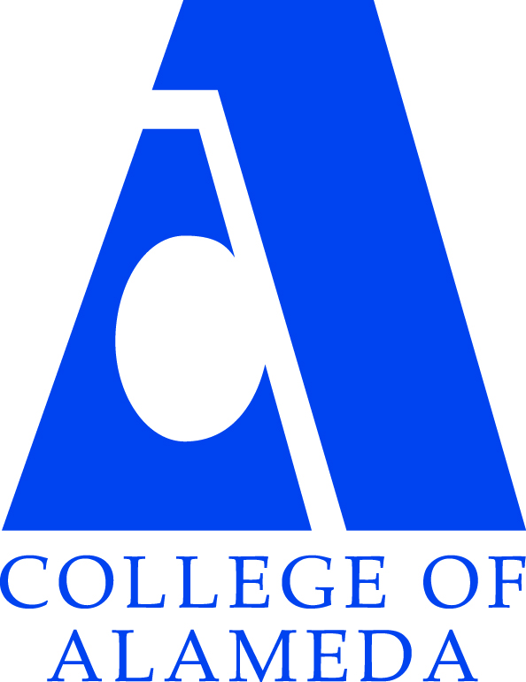 Committee
Meeting AGENDA
Date and Time: October 11, 2017 12:00 – 1:00 p.m.
Meeting Location: A149

Meeting Chair(s): Balamurali Sampathraj (Senior CIS Analyst) and Karen Engel (Interim Dean of Research, Planning & Institutional Effectiveness Recorder: Interim Dean Engel
Topic | Facilitator | Action | Materials
Purpose of Meeting: Discuss college-wide IT-related issues and make to recommendations to President Karas.
- Approval of Minutes & Action Items | Bala |  | Previous Minutes to review.
- Approval of Agenda | Bala
- Discussion Items | Bala | - Laptop survey review  - COA IT updates  - Smart classrooms (Equipment and locations)  - Ideas for upcoming capital bond campaign (2018) | Survey Power Point
- Review of Action Items | Bala
- Future Agenda Items | Bala
- Adjournment | All

