Technology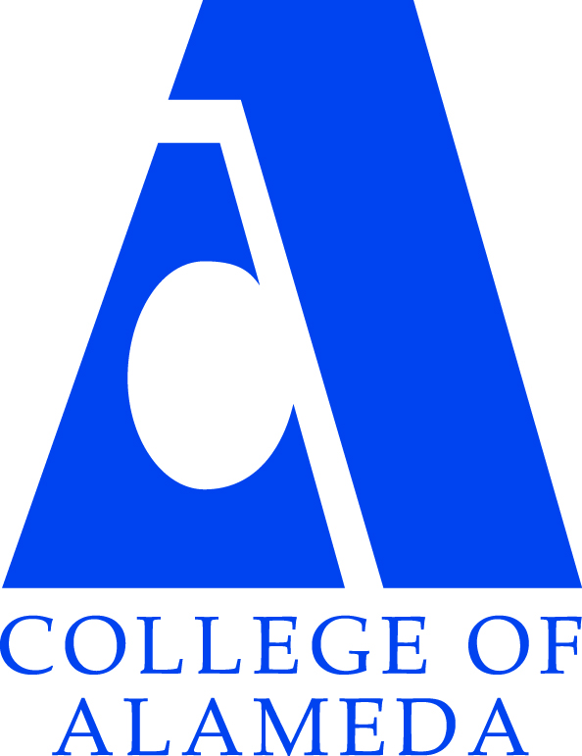 Committee
Meeting AGENDA
Date and Time: Wednesday, May 9, 2018 12:00 – 1:00 p.m.
Meeting Location: L237

Meeting Chair(s): Balamurali Sampathraj and Karen Engel (Interim Dean of Research, Planning & Institutional Effectiveness Recorder: Interim Dean Engel
Topic | Facilitator | Action | Materials
Purpose of Meeting: Discuss college-wide IT-related issues and make to recommendations to the President of COA.
- Approval of Minutes & Action Items | Bala |  | Previous Minutes to review.
- Approval of Agenda | Bala
- Discussion Items | Bala | - Help desk update  - Smart classrooms update  - Merging facilities with technology committee  - Ipad cart update and check out process review  - Ideas for upcoming capital bond campaign (2018)
- Review of Action Items | Bala
- Future Agenda Items | Bala
- Adjournment | All

