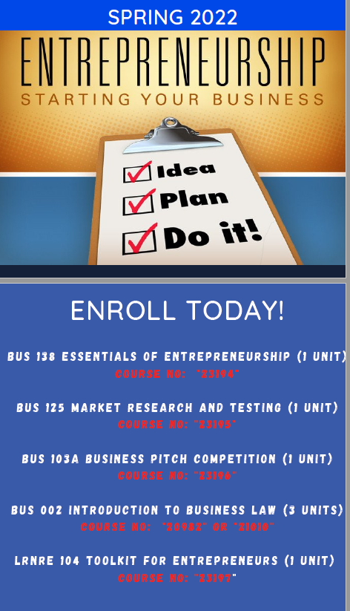

The Entrepreneurship Certificate Program was designed by Professors Rochelle Olive and Carolyn Johnson based on input from students and the business community.
There was a demand for a guided pathway for Entrepreneurship Training which organizes the fundamentals in an easy to follow pathway with courses that build upon and are clearly integrated with each other.
Critically important is the virtual nature of the Certificate program, while embedding opportunities for in person market research and testing. This format democratizes the pathway for working adults, parents, and harder to reach students.
They can select how they engage in the courses while offering a rapid pathway to a certificate. This certificate is necessary proof of success which proves valuable to career and business progression whether the student is learning the business while working for someone else or if they are ready to launch. Funding to support Market Research and Testing and prizes for the Business Pitch competition would make this program more attractive, rewarding, and effective.

Strong Workforce Program (SWP), Perkins, and the Improving Online CTE Pathways grant program have been utilized to support this program.

Program Overview
Overview
The Online Entrepreneurship Certificate prepares students for entrepreneurship through a series of courses, that include hands on and experiential learning opportunities, that will develop their knowledge and skills and serve as a springboard to start, run, or grow their own personal or family-owned business.

The Certificate Courses are:
- BUS 138 Essentials of Entrepreneurship (1 Unit)
Introduction to entrepreneurship for creating personal wealth: Entrepreneurial mindset; innovation and new concept development; entrepreneurial processes for formulating, planning, and implementing new business ventures including market research and testing and start-up financing; and ethics and social responsibility
- BUS 125 Marketing Research and Testing (1 Unit)
Introduction to market research, testing and development for successful entrepreneurial ventures: Concept testing with a range of primary and secondary research; the entrepreneurial market research mindset; concept improvement; preparation for the start-up financing phase; and ethics and social responsibility.
- BUS 103A Business Pitch Competition (1 Unit)
Introduction to financing for entrepreneurial ventures: Opportunities for entrepreneurs and business owners to compete for recognition and financing of their business ventures via pitch, plan and launch competitions.
- LRNRE 104 Toolkit for Entrepreneurs and Managers (1 Unit)
Key interdisciplinary tools and perspectives for entrepreneurial and business management success: Business English, History, Mathematics, Computer Information Systems.
- BUS 002 Introduction to Business Law (3 Units)
General survey of business law: Principles of law on contracts, sales agency, torts, partnerships and corporations, and the uniform commercial code.
.

