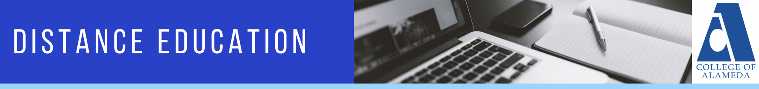

MINUTES
College of Alameda Distance Education Committee
Wednesday, November 17, 2021
12:30pm – 1:30pm
Location: Zoom

Members: Place X in box adjacent to name when present.

X | Brielle Plump, DE Committee Co-Chair | X | Jennifer Fowler, DE Committee Co-Chair | X | Richard Kaeser
X | Nora Mitchell | X | Antonio Villegas | X | Robert Brem

Guests: List full name below. Place X in box adjacent to name when present.

AGENDA ITEM | DISCUSSION | FOLLOW UP ACTION
- Call to order/Approval of Agenda – (5 minutes) |  | Motion to approve the agenda.  Moved by: Robert Brem  Seconded by: Brielle Plump  Motion Passed Unanimously
- District DE Updates – (5 minutes) | - New District DE Coordinator role job description and job search is active, and now includes Edu Tech responsibilities.  - No new LTIs this academic year, learn about it all on the Peralta Faculty Resources Canvas shell.  - Local POCR certification at College of Alameda underway.  - Accessibility consultant to renew in Spring; permanent job description underway.  - Online Equity Training being offered Winter and Spring Session.  - CVC Exchange now posts our Spring 2022 fully online classes.
- Action Items – (20 minutes)
- Approval of minutes from previous meeting |  | Motion to approve minutes from October 27, 2021.  Moved by: Robert Brem  Seconded by: Jennifer Fowler  Motion Passed Unanimously
- Recommendations for Title 5 language for online course types and modalities | New language due to Distance Education Title 5 updates around Regular Substantive Interaction (RSI). | Motion to approve recommended changes.  Moved by: Robert Brem  Seconded by: Richard Kaeser  Motion Passed Unanimously
- Suggested language for online course types and modalities | - New, universal definitions of Online Course types proposed.  - To what degree do/should face to face classes reply on online tools and Canvas, and how/where should we communicate that?  - What are the best ways to articulate when there are proctored exams?  - It should be noted that the nay vote suggested the following four online course type categories and language: 1) live, 2) hybrid, 3) online synch, 4) online async. | Motion to approve new definition.  Moved by: Nora Mitchell  Seconded by: Robert Brem  Motion Passed  Yay: 5  Nay: 1  Abstention: 0
- Discussion Items – (25 Minutes)

- Faculty online attendance survey results | Will discuss in more depth next meeting due to time constraints.
- Classroom observation form for online courses | The current faculty classroom observation is not geared toward the online teaching modality. Faculty shared some challenges they’ve had trying to make it fit for online courses. Some colleges like Diablo Valley College have a unique observation form for online courses. The committee decided to further explore this topic and advocating with PFT to create a faculty evaluation tool that assesses the online teaching modality.
- Announcements – (5 minutes)
- General Announcements | - College of Alameda is due to submit their local POCR certification application this week. Faculty interested in getting a course reviewed for POCR or becoming a POCR reviewer should fill out the POCR Interest Form  - Next DE Committee Meeting: Wednesday 12/15/21 from 12:30pm – 1:30pm: Zoom Link  - Next Community of Practice Meeting: Wednesday 12/3/21 from 12:30pm – 1:30pm: Zoom Link  - Accessibility Drop-In Office Hours open to all faculty and staff through 12/10/21: Fridays from 11:00 – 12:00pm via Zoom: Zoom link
- Next Meeting | December 15, 2021 from 12:30pm – 1:30pm
- Adjournment | Meeting adjourned at 1:28pm

Abbreviations:
- COA – College of Alameda
- DE – Distance Education
- CVC-OEI – California Virtual Campus – Online Education Initiative
- POCR – Peer Online Course Review
- PCCD – Peralta Community College District
- AP – Administrative Procedure
- BP – Board Policy

