**Spring 2022 Welcome Week   
Recap**

We have had a wonderful Welcome Week. On Monday, 01/24, ACCESO/Puente hosted the first virtual event which was Welcome Week Karaoke. We had approximately eight participants. Everyone had a chance to sing and participate. It was great to see everyone cheering each other on and being fully engaged in the different performances. We heard everything from Vicente Fernandez in Spanish; Andrea Bocelli in Italian; and even some new Disney favorites from our staff and administrators who were on the call.

Tuesday, 01/25 we held in person activities. Chancellor Jackson honored us with her presence on campus as we kicked off our morning activities. We provided free Brunch for 150 students, faculty and staff! There were more than nine programs and services tabling with information and giveaways, our regular free produce market, and local radio personality Chuy Gomez as a DJ! Tabling participants included UMOJA, ACCESO, Puente, Student Accessibility Services, Campus Bookstore, Library, Health Services, the Career Center, and Financial Aid. We also had multiple faculty members stay the entire duration of the activities for meet and greets with students and assistance in providing guidance and information.

On Wednesday, 01/26 we also held in person celebrations with free brunch for 100 people, tabling, and 150 meals from Tacos Sinaloa for students who complete a Welcome Week punch card as well as faculty and staff. Students claimed their punch card at the Student Activities table and received stickers from each resource or special program table that they visited. When they had stickers from all of the participating tabling programs, they were able to exchange their card for a meal ticket. The meal included up to five tacos per person with their choice of meat or a vegetarian option and a drink that was either an agua fresca, a canned soda, or a water.

Thursday, 01/27 we wrapped-up our Welcome Week activities with a virtual game of Kahoot. Although attendance was a bit low, the students in attendance had a great time and an opportunity to win some prizes. Thank you to all who supported our Welcome Week efforts!

**Welcome Week Karaoke Screenshots**

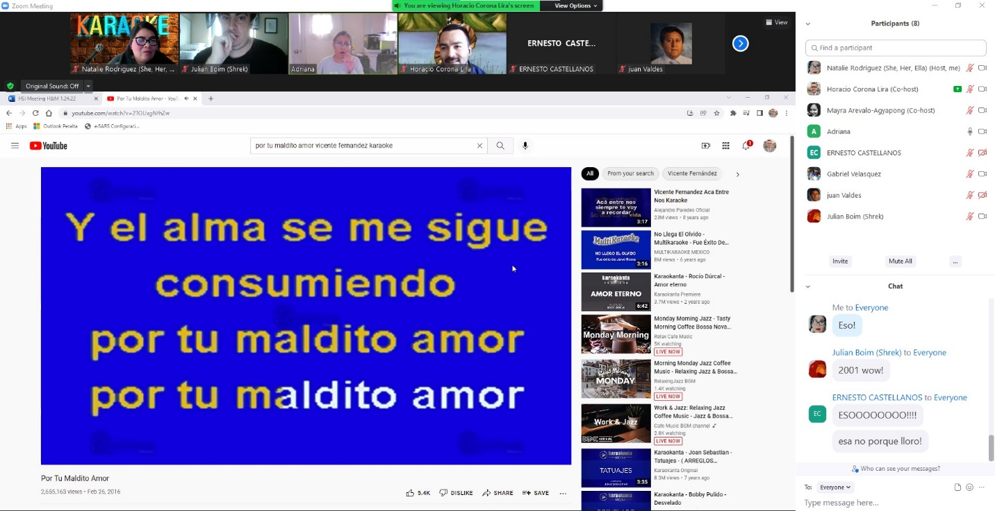

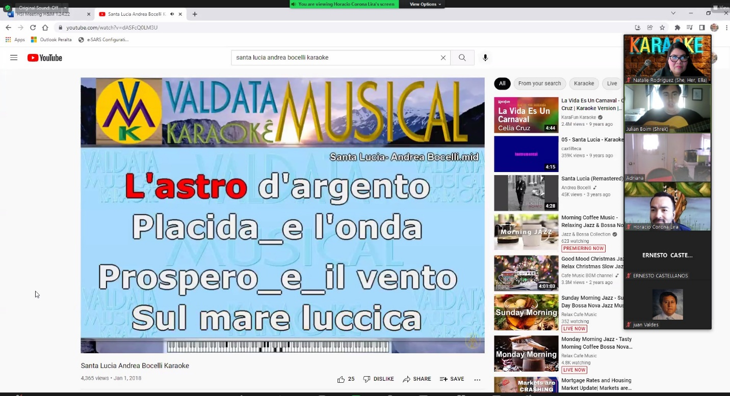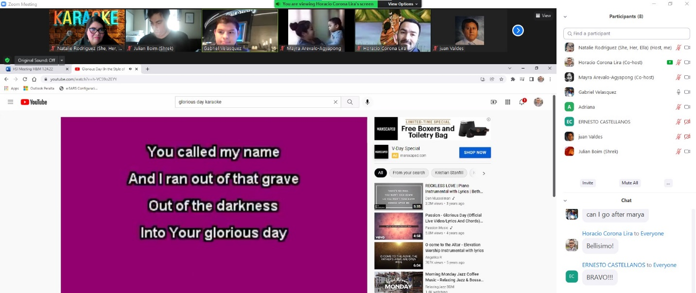

**Welcome Week Photos by Director Horacio Corona Lira**

