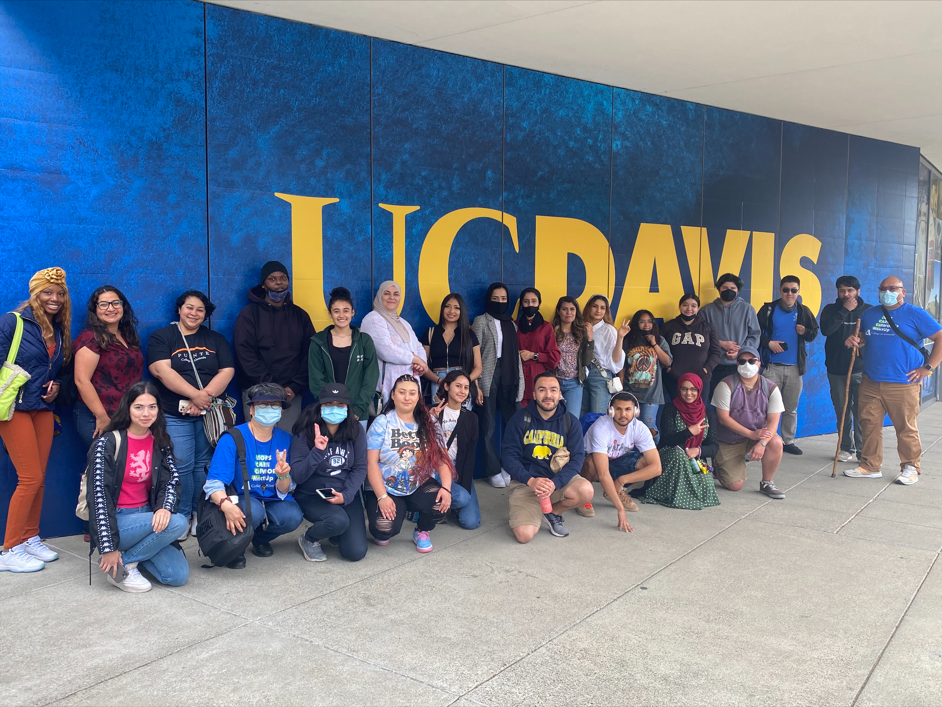

After a hearty breakfast in the fresh air of an early morning start, 24 Peralta students, faculty, and staff departed from College of Alameda to visit California State University, Sacramento and University of California, Davis on May 6th. Although originally organized as an opportunity for College of Alameda EOPS, CARE, CalWORKs, NextUp, ACCESO, and Puente students, the opportunity to join was extended to all Peralta students.

Upon arriving at California State University, Sacramento, students attended an admissions presentation by Charles Cole, Sr., Associate Director of Admissions and Outreach, followed by complimentary beverages. Next on the itinerary was a tour of the lush, green, 305-acre campus. The student tour guide was sure to note the school’s close relationship and proximity to leaders at the California state capitol, which offers many opportunities to explore leadership, law, and policy.

Continuing on to University of California, Davis, students were greeted by Veronica Zendejas, Director of Evaluation in Undergraduate Admissions, and provided lunch. Following the mid-day break, students were given a tour of the expansive 5,300-acre campus. The school’s agricultural focus could be smelled in the air, and environmental awareness permeated the car-free campus covered in seas of bicycles.

Many student participants expressed a shift in mindset over the course of the day. Concerns about how basic needs such as housing, food, transportation, and tuition would be met were displaced, if only for the day, by new possibilities. The prospect of benefiting from student clubs, internships, study abroad, fitness centers, specialized libraries and research facilities, learning communities and cohorts, gave rise to new concerns of how to seize all opportunities. Say yes to leaving your comfort zone, to believing in your potential, to testing new possibilities was the reoccurring theme of the day.

Thanks to all students who participated, and to Fathia Mohamed, Adjunct EOPS and CARE Counselor, for joining. Thanks to the staff who supported the event and helped to make it possible. And special thanks to those who organized and attended the event: Mayra Arevalo- Agyapong, Student Services Specialist, Puente/ACCESO Programs, Horacio Corona Lira, Director, Puente/ACCESO Programs, Louie Martires y McFarland, Project Manager, EOPS/CARE/CalWORKs/NextUp, and Nesi More, Staff Assistant, EOPS/CARE/CalWORKs/NextUp

Reported by Nesi More