College of Alameda

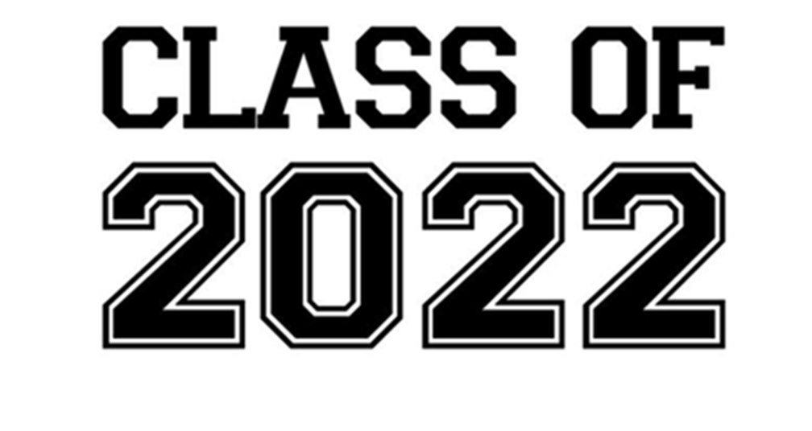

**COA GRADFEST** (In-Person Celebration)

**Please note that campus will be closed and parking will not be available for graduates and their guests. CoA GradFest is a grab-and-go event.**

An **on**–**campus**, **in** **person celebration** **called** **CoA GradFest** will take place on **Friday**, **May** **27**, **2022** **from** **2**:**00** **to** **4**:**00** **p.m**. The in-person celebration **will** **not** **be** **a** **traditional** **graduation** **ceremony**. There will be photo opportunities, activities, and grab-and-go gifts for the graduates.

GradFest will be completely accessible. Graduates will be able to either drive-through or walk-up to participate in the celebration.

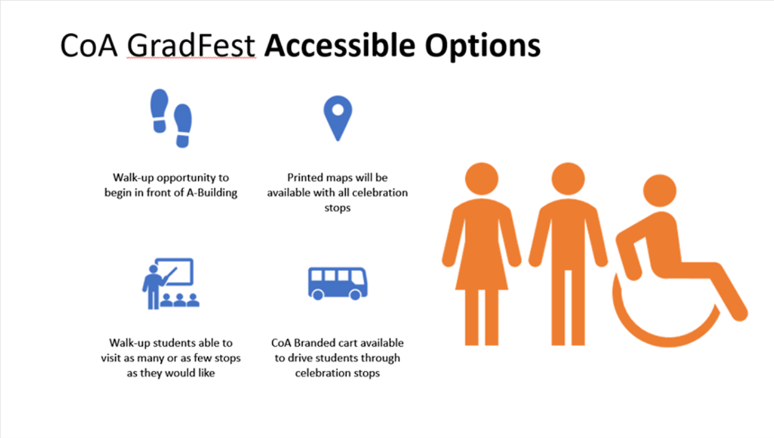

**Entrance:**

**Students driving-through** GradFest will enter through Willie Stargell Ave. **Students who walk-up** will enter through Ralph Appezzato Memorial Parkway (labeled Grand Finale in map below) where we will have a CoA Branded cart available to take graduates to the each of the Celebration Stations.

At each entrance point graduates will be able to pick-up a Commencement Program.

[**Please let us know if you will be participating by drive-through or walk-up here.**](https://forms.gle/nbAwQWoF1QRakRs39)

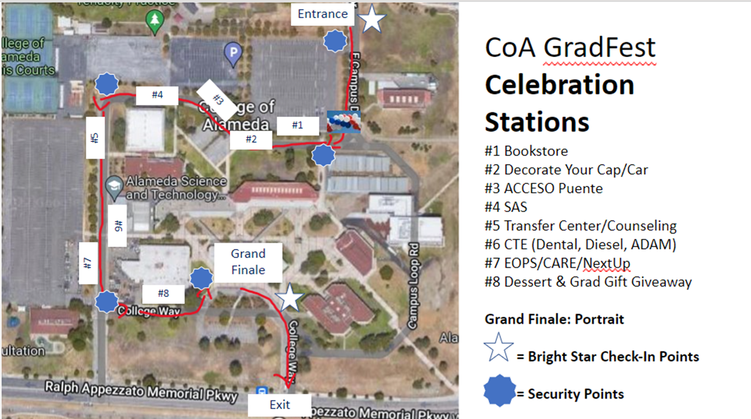

**At the Grand Finale** graduates will be able to pick-up their diploma cover and have the opportunity to take a photograph with the President. **Each participating graduate will receive a free digital portrait if they so choose.**

**COA GRADFEST GUEST POLICY:**

Students will be allowed to bring **no more than two (2) guests** per graduate. Masks must be worn at all times. Students must be prepared to provide clearance through Campus Shield. Guests must be prepared to be screened by BrightStar.

Please follow the directions on this website in order to complete the screening that is being asked for yourself and your guests: <https://safe.peralta.edu/>

### Campus Access

#### **Students should use the Campus Shield app to answer screening questions for campus access. Instructions for the** [**mobile app are available HERE**](http://web.peralta.edu/files/2021/08/Campus-Shield-setup-mobile.pdf) **while instructions for the** [**desktop app are available HERE**](http://web.peralta.edu/files/2021/08/Campus-Shield-set-up-desktop.pdf)**. The** [**screening questions for daily access are available HERE**](https://portal.publicsafetycloud.net/manage-self-assessment/peralta-ccd)**.**

#### **Guests and Vendors on campus need to use the Campus Shield App. For instructions click** [**HERE**](https://static1.squarespace.com/static/5e6145dc0eabf53161c143fa/t/6123bf6a4025626ddd55a7c8/1629732714598/Campus+Shield+FAQs+for+Community+Members+and+Vendors.pdf)[**mobile**](http://web.peralta.edu/files/2021/08/Campus-Shield-setup-mobile.pdf)[**desktop**](http://web.peralta.edu/files/2021/08/Campus-Shield-set-up-desktop.pdf)

**Social Media:**

**Share your GradFest pictures with us using #CoAGradFest2022!**