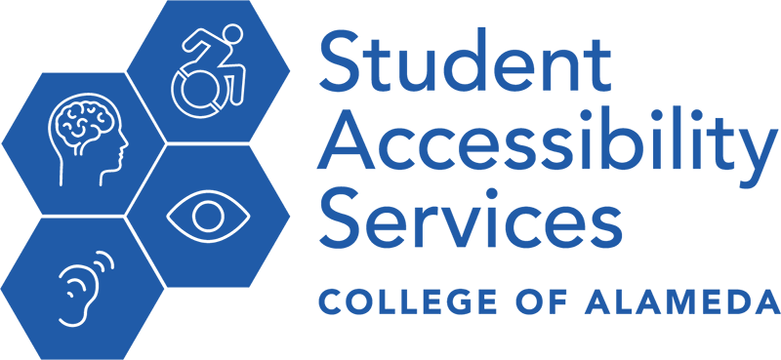

STUDENT RIGHTS AND RESPONSIBILITIES

**As a student with a disability, you have the right to:**

* Participate voluntarily in Student Accessibility Services (SAS);
* Participate in other courses, programs, or activities offered by the college;
* Protection of disclosure of records maintained by SAS;
* All other rights afforded by the Americans with Disabilities Act and Section 504 of the Rehabilitation Act, including equal access and academic accommodation;
* Appeal a decision regarding accommodations through the student grievance process as described in the college catalog.

**As a student with a disability, you have the responsibility to:**

* Comply with the Student Rules of Conduct as adopted by the college and written in the College catalog and all other statutes and regulations related to student conduct;
* Provide professional documentation of disability to the college;
* Request accommodations in a timely manner each semester;
* Be responsible in the use of SAS services and adhere to written service provision policies adopted by SAS;
* Maintain the academic standards of the college and make progress toward the goals established in your Academic Accommodation Plan.