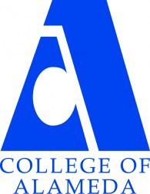
COLLEGE OF ALAMEDA
Institutional Effectiveness Committee
AGENDA

May 13, 2021

2:00 – 3:00 pm
Via ZOOM

https://cccconfer.zoom.us/j/98197987707

Co-Chair - Admin, Dominique Benavides, Director
Co-Chair - Faculty, Andrew Park

1. Approval of the Agenda | Action | Chairs
2. Approval of the Minutes | Action | Chairs
3. Committee Membership for 2021-22 | Informational | Andrew Park
4. SLO Assessment | Informational | Andrew Park
5. 2021 Institutional Research, Planning, and Effectiveness  (IRPE) Summer Institute | Informational | Dominique Benavides
6. Updates on Program Review, EMP taskforce, other IE efforts | Informational | Dominique Benavides
7. Adjournment |  | Chairs
Meetings will resume in Fall 2021 on the 2nd Tuesday, 2-3:30p.m.

Our Mission
The Mission of College of Alameda is to serve the educational needs of its diverse community by providing comprehensive and flexible programs and resources that empower students to achieve their goals.

