COLLEGE OF ALAMEDA
Institutional Effectiveness Committee
MINUTES

April 14, 2022

2:00 – 3:30 pm
Via ZOOM

https://cccconfer.zoom.us/j/94622720807

Co-Chair - Admin, Dominique Benavides, Director
Co-Chair - Faculty, Andrew Park

Committee Members Present: Dominque Benavides, Kawanna Rollins, Frank Nguyen Le, Didem Ekici, Andrew Park (note-taker)

Guests Present: Ava Lee, Jayne Smithson, Jeff Sanceri, Josh Rose

Meeting called to order at 2:04 p.m.

- Approval of the Agenda  Moved by K. Rollins, seconded by D. Ekici. M.S.U. | Action | Chairs
- Approval of the Minutes  - February 10 minutes – shared by D. Benavides. Motion to approve by F. Nguyen Le, seconded by K. Rollins. M.S.U. | Action | Chairs
- Faculty Prioritization  A. Park introduced the discussion topic. The suggestion is to use prior year’s program review, in order to facilitate the faculty hiring prioritization process that occurs in Fall. Using prior year’s program review will allow this process to occur without having to wait for the current year’s program review to be completed.  Jayne Smithson participated in the discussion, and D. Benavides presented some of the data that were used in this year’s prioritization process. A. Park made a comment that using previous year’s program review will allow more time for these quantitative data to be taken into account in prioritization process.  Will try to have a fuller discussion in May meeting, with the VPI present. | Discussion/ Action | Andrew Park
- AB705 Update  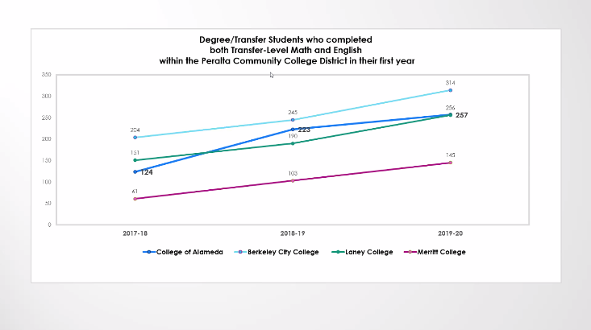  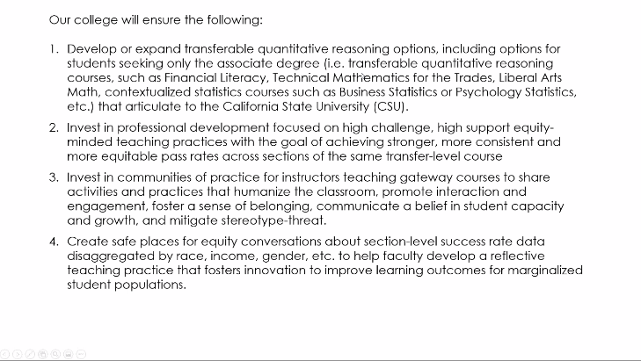  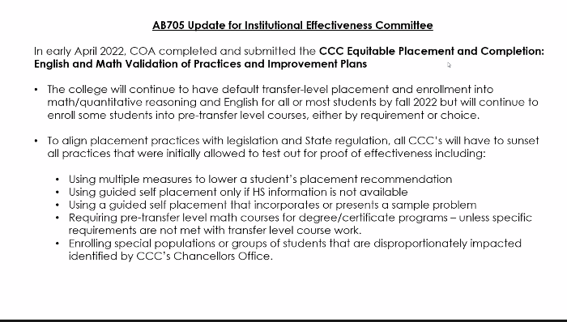  D. Benavides presented on AB 705 update. Some excerpt slides below (summary: making progress; progress looks good).  Also shared information on Equity Leadership Alliance (an effort led out of USC and complementary to a number of efforts at COA; more on next agenda item).  D. Ekici, D. Benavides, F. Nguyen Le, and A. Park participated in the discussion and Q&A. | Informational | Dominique Benavides
5. California Community College Equity Leadership Alliance  5. California Community College Equity Leadership Alliance  A group of 12 courses offered throughout the year; we will be sending 10 people from the college, 3 from the office of instruction, 3 from the student services, 3 from the business office, and 1 from the office of president. The course materials themselves will be available to everyone—reach out to the VPs in respective areas if interested, after the announcement on CCC Equity Alliance goes out.  There was a Q&A about giving incentive to faculty to complete this course (like with Peralta Online Equity training). A note was made that we should add this to next month’s agenda (with the VPI present?) and that Merritt College is going through this process in conjunction with their Guided Pathways process.  A. Park, D. Ekici, and D. Benavides participated in the discussion. | Informational | Dominique Benavides
6. Education Master Plan Update  D. Benavides gave an update. President Jones will hold a town hall (a college-wide meeting) for May 5. An updated plan for EMP update was presented at College Council for a steering committee and 4 sub-groups: planning, analysis, organization, and writing. West Ed will provide the environment scan (they have a district-wide contract).  A. Park and D. Benavides participated in Q&A and discussion.  A. Park noted that May 5 is an academic senate meeting day. | Informational | Dominique Benavides
7. Program Review – Instructional Update  Tabled to next meeting for demo/discussion about CurriQunet program review module. Currently working with VP of Student Services for student services program review.  D. Benavides and F. Nguyen Le participated in the discussion. | Discussion | Dominique Benavides/  Frank Nguyen/  Diana Bajrami
8. Other Items

There was a discussion about the new website at alameda.edu, and how faculty (committee co-chairs, etc.) can get edit access. Advice was to ask Shane Williams.

9. Adjournment  Motion to adjourn by K. Rollins, seconded by F. Nguyen Le. M.S.U. Meeting adjourned at 3:08 p.m. |  | Chairs
Next meeting Thursday, May 12, 2022, 2-3:30p.m.

Our Mission
The Mission of College of Alameda is to serve the educational needs of its diverse community by providing comprehensive and flexible programs and resources that empower students to achieve their goals.

