College of Alameda Library: Logging in to Kanopy
Kanopy is easy to use but requires additional set-up when accessing it for the first time, off campus or when using a mobile device. This document will explain how to log in to Kanopy from a computer off campus (first section). It will also explain how to download and connect to the Kanopy app (second section). For mobile devices and tablets users must download the app in order to access Kanopy content. The app is not necessary if accessing Kanopy on a computer.

Accessing Kanopy From a Computer
- Go to the Article Databases webpage on College of Alameda Library’s website .
- Click on Kanopy (you must use the specific Kanopy link found on the College of Alameda webpage since the link is unique to the College Collection)
- Click on the “Visit the Alameda Collection” orange button on the Kanopy page

- It will take you to Step 3 of 4: Access Kanopy Through your University. Please select “Log in to Alameda” button

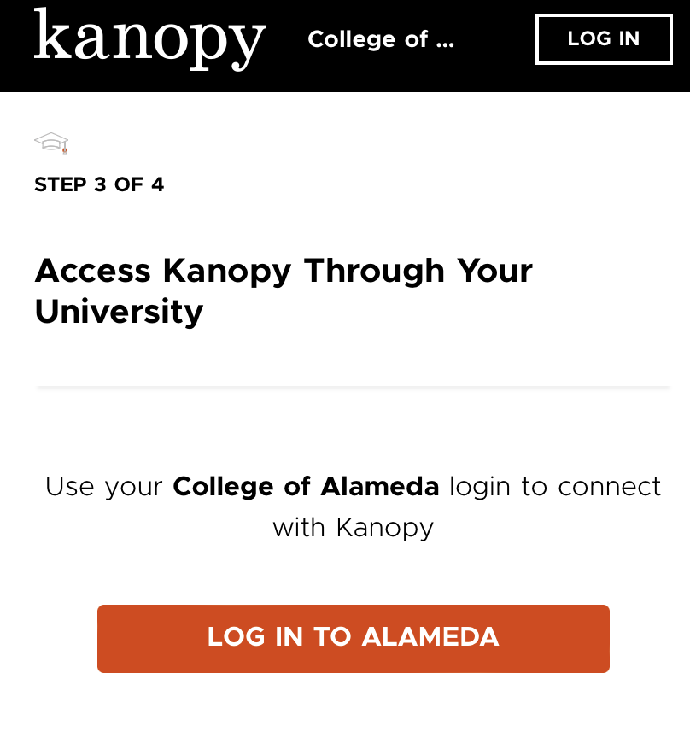

- Now you will see the Peralta Portal login where you will put in your college username and password. This is the same username and password you use to log in to Canvas and Peralta email.
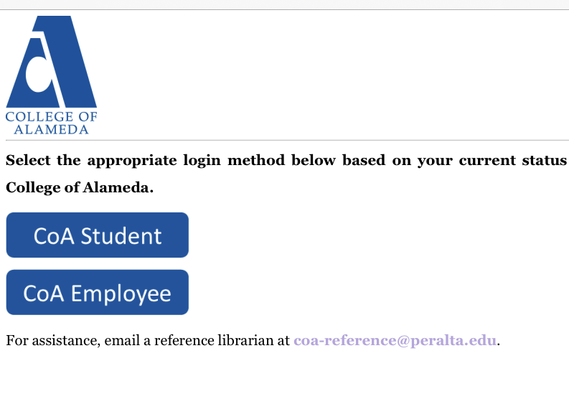

- Congratulations! You are logged into College of Alameda’s Kanopy collection. Scroll through the list of titles to click on the movie title assigned by your instructor.
TROUBLESHOOTING TIP: If you are using a mobile phone or tablet, you will need to follow the additional instructions in the section below to use the Kanopy app to view the videos.

Accessing Kanopy From a Mobile Device or Tablet
- Follow the Steps above for Accessing Kanopy from a computer.
- Then, select the Kanopy link or video that you need to watch. Then select “Get the Free App”
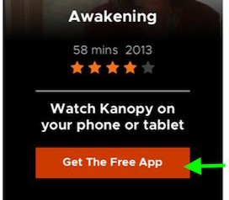
- Please follow the prompts to download the Kanopy app on your mobile device
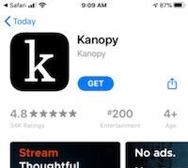
- After the app is installed, select “Get Started” to connect the app to the College of Alameda account
- On the next screen, select “Find University” and search for College of Alameda
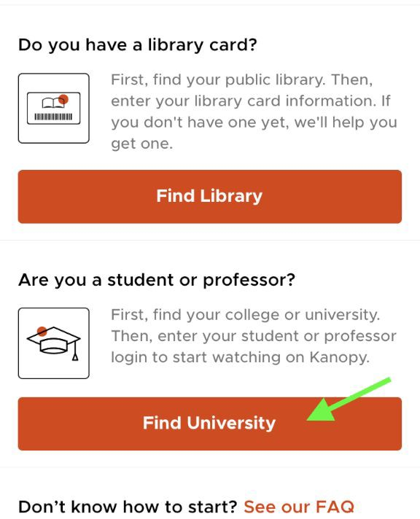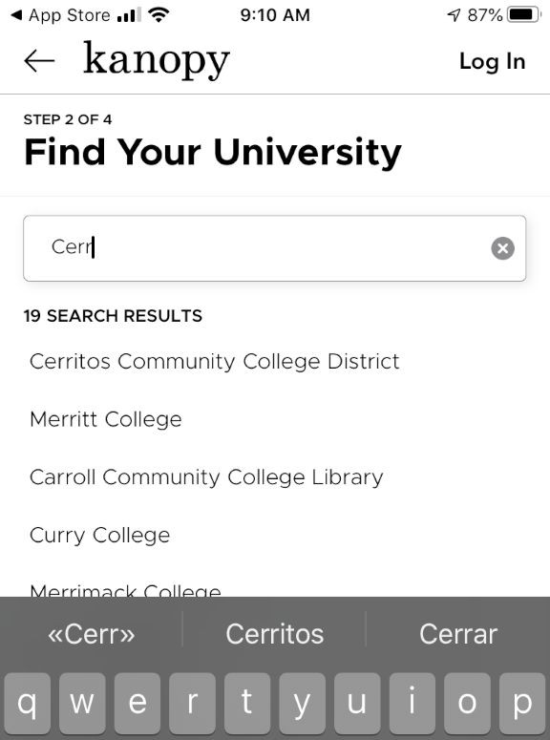
- Now you will see the Peralta Portal login where you select the Student button and enter your Peralta Portal login information. This is the same username and password you use to log in to Canvas and Peralta email.
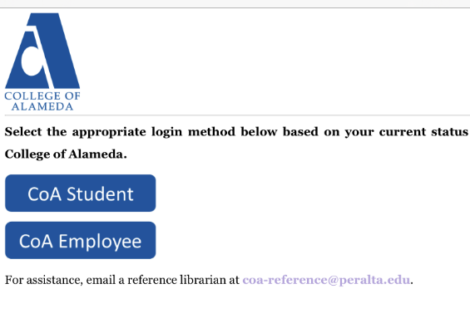
- Kanopy will now ask you to create your own individual user account. If you don’t do this, you won’t be able to view content on the app. We recommend entering your first name, last name, Peralta email and Peralta email password. Then click on Sign Up. You will need to then login to your Peralta email to receive an email from Kanopy requesting verification that you have received that email to complete the sign up.
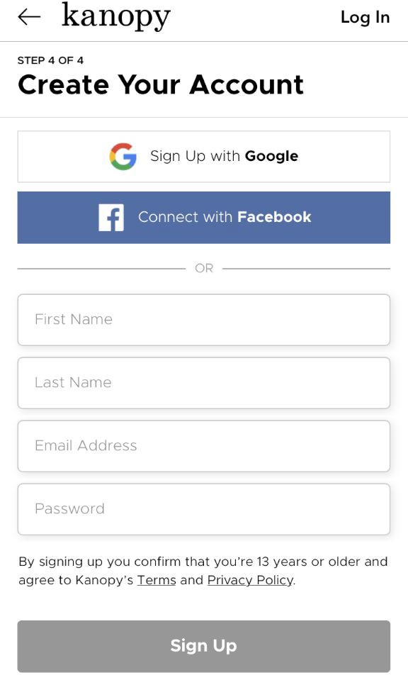

- After verifying your email, you should now be able to use the Kanopy app to view the College of Alameda Kanopy Collection of videos. Click on Search to get started.

For further assistance please contact us by the “Chat with a Librarian” link on the College of Alameda Library webpage.

Jm, 12/2022

