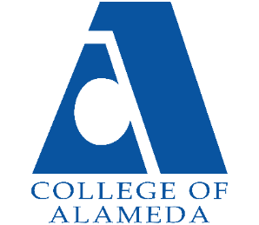

Facilities & Technology Committee AGENDA

Date & Time: Thursday, March 23, at 2:00 PM
Location: Zoom/Conference Room A-149
Full Zoom link: https://us06web.zoom.us/j/81520922840

Topic | Facilitator | Materials | Notes
Purpose of Meeting: Organizational Meeting for COA Facilities & Technology Committee
- Call to Order | Augustine
- Approval of Agenda | All
- Approval of Minutes, February 23 meeting | All
- Update from AECOM | Sharon Serrano |  | AECOM
- Update from District Facilities Meeting | Rachel Goodwin
- 6. Campus facilities update | Shuntel/Augustine
- Update from District Technology Meeting and Campus Update | Saurav Pudasaini
- Open Remarks | All
- Adjournment | Augustine Gill

The Mission of College of Alameda is to serve the educational needs of its diverse community by providing comprehensive and flexible programs and resources that empower students to achieve their goals.

