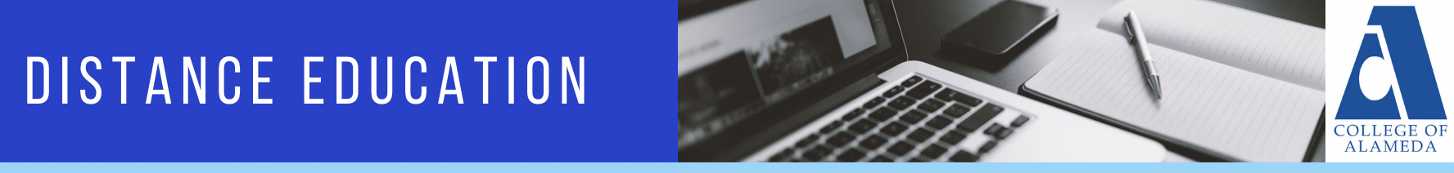

MINUTES
College of Alameda Distance Education Committee
Wednesday, February 15, 2023
12:30p – 1:30p
Location: Zoom

Members: Place X in box adjacent to name when present.

X | Jennifer Fowler |  | Khalilah Beal-Uribe | X | Robert Brem
X | Richard Kaeser |  | Brielle Erike | X | Stefanie Ulrey
 | Anthony Villegas | X | David Leitner

Guests: List full name below. Place X in box adjacent to name when present.

X | Brandon Wu

AGENDA ITEM | DISCUSSION | FOLLOW UP ACTION
- Call to order: Approval of Agenda – (5 minutes) |  | Called to order 12:30pm.  Robert B: motion to approve  Richard K: 2nd motion  Motion Passed Unanimously
- DE Updates – (5 minutes) | - DE meeting past Monday 2/13, Updated CVC exchange about being teaching college, cohort takes a couple months, most likely not teaching college until Fall, cohorts full lucky we got in  - New Title 5 updates impact DE, some simple, some relate to ap 4105 will have to go through gov process, then vetted through pft, looking at rough draft.
- Action Items – (10 minutes)
- Approval of Minutes from 11/16/2022 | Review of minutes from nov 16, 2022  Rob B point of interest, what point do these things get appointed to policy  Steph, pandoras box on this issue | Rob B: move to approve  Steph: 2nd  Motion Passed Unanimously
- Discussion Items (35 minutes)
- In-Progress Committee Goals | Jenn F: came up with goals last semester, monthly POCR practice, working on aligning Canvas shells and hopes to have done by next week, need to work on Goal 2, or encourage full use of learning management system, did Goal 3, Anna O’Neal has money to pay tutors for possible trainings  Rob B: everything should be in Canvas for classes, used to be a non-advocate of online learning, that was until Canvas and now believes it is good and improves quality of education in 2023  Andrew P: Pushing for Faculty handbook and putting something about Canvas in there for instructors  Jenn F: Feature in Newsletter for in person instructors to include material in canvas  Stef: Formalize somehow  Jenn F: Baseline things, encourage as many people as best practice  Rob B: Fears having to make Accessible  Andrew: Place use of LMS in evaluation form  Rob B: Are changes that modality can change what goes on in classroom. Experimenting with hyflex.  Jenn F: Will reach out to Rick Greenspan, newsletter ideas using canvas for all modalities, training for LRC tutors  Rich K: Suggested training LRC tutors more on canvas  Brandon Wu: Students lack information that coming to school has lots of resources, like LRC, only student using LRC in his class,  David L: Having issues with students accessing certain things about Canvas, | Rich K: Reach out to Anna about training tutors  Jenn F: Accessibility and faculty workload for future DE Committee Meeting  Jenn F: Inquire about funding for OTC in summer for faculty
- Title 5 updates to AP 4105 | Jenn F: Updates to title 5 will require updates on our DE, Didem is asking to look at 55204 on instructor cont, section 04,06, 08, def cant change, anything in red writing.  Andrew: District has subscription to AP updates, recommend passing by Jennifer S (PFT), negotiable issue when involves instructor  Jenn F: Recommend run pass Jenn S and Joseph B first. | Jenn F: Asks Committee members to read revised AP4105
- Announcements – (5 minutes)
- Next Community of Practice Meeting: Wednesday 3/1/23 from 12:30pm to 1:30pm
- Next POCR Practice Meeting: Wednesday 3/8/23 from 12:30pm to 1:30pm
- Next DE Committee Meeting: Wednesday 3/15/23 from 12:30pm to 1:30pm
- Adjournment |  | Meeting Adjourned at 1:30pm

Abbreviations:
- COA – College of Alameda
- DE – Distance Education
- CVC-OEI – California Virtual Campus – Online Education Initiative
- POCR – Peer Online Course Review
- PCCD – Peralta Community College District
- AP – Administrative Procedure
- BP – Board Policy

