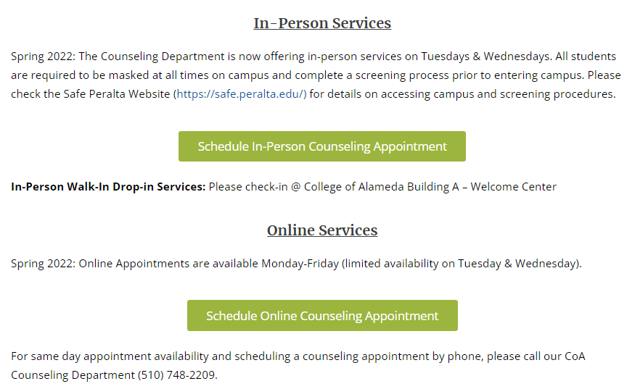

Remove all of the above and replace with the following text:

**In-Person Services**

In addition to telephone and online appointments, the Counseling Department also offers in-person counseling appointments. All students are required to be masked at all times on campus. Please check the Safe Peralta Website (https://safe.peralta.edu/) for additional details and information.

To schedule a counseling appointment by phone, please call our CoA Counseling Department (510) 748-2209.