COA Academic Senate
Meeting Minutes
Thursday, October 19, 2023
Meeting Called To Order at College of Alameda, H 280 & Zoom at 12:20pm
Note: For Virtual attendance, senators indicate their votes in the Zoom Chat
Quorum: 50% + 1
In person Quorum: 7 or more senators (15 seats, 2 vacant)
Senators in Attendance In Person: Jenn Fowler, Sue Altenbach, KL Nadeesha Dias, Rich Kaeser, Andrew Fittingoff, Andrew Park (note-taker), and Jacinda Marshall
Senators in Attendance Online: Cady Carmichael, George Cruz, Kwesi Wilson, Carla Pegues, and Jody Campbell
Guests in attendance: Jayne Smithson, Olga Fish, Jane McKenna, and Linda Dewrance
Agenda Item | Summary | Motion
Agenda Review & Approval for October 19, 2023 | Addition of “ZTC and Low-Cost Materials” to the end of the Discussions agenda. | Motion to approve Agenda October 19, 2023 with the proposed addition  First: S. Altenbach  Second: R. Kaeser  M.S.U.
Review of minutes October 5, 2023 | No changes.  Any grammatical changes can be sent directly to A. Park or J. Fowler. | Motion to approve minutes from October 5, 2023  First: J. Marshall  Second: R. Kaeser  M.S.U.
Action Items  None | N/A | N/A
Discussion Items:  - Updated constitution with bylaws, first reading (A. Park)  - CoA Enrollment Management Taskforce update (A. Park)  - ZTC and Low-Cost materials (O. Fish) | Summary of #1  J. Fowler introduced the agenda item. This is just a first reading with no action being taken today. There are opportunities to continue to offer feedback and suggest changes. There are hardcopies in the room with edits offered by Rochelle Olive.  A. Park walked through the dividing the provisions in previous constitution into the first “Constitution” section and the second “Bylaws” section. Main distinction is constitution is harder to change (requires an up-or-down vote by the whole faculty) and bylaws can be changed by senate action alone. Asking to see if any of the provisions in Bylaws should be moved back into Constitution. If there is consensus on general structure, we will turn on tracking changes and start tracking all the comments and edits from this version and on.  A few highlighted items were discussed:  - “Balloting will not be conducted for uncontested races” language for officer elections—already our practice and this matches existing language for elections of senators.  - Clarification around “Representatives appointed to fill a vacancy shall serve until the next election”; in the past, we treated this as meaning next senate election of any kind, resulting in appointments that are always shorter than 1 year, and unbalancing of how many seats are up for election in a given year. General consensus in the senate to clarify that “next election” here means the next election for the position, so that the appointments last until the next time the seat would have been up for election again (potentially as long as 2 years)  - A. Park: After constitution change, we will need to take action to re-balance the election cycles; some of us up for election this year might have to be elected only for 1 year, so that the year after, it’s not only 3 seats that are up for election again.  - Clarification around “alternate delegates” to DAS and the DAS rep. Eliminate the language around “alternate delegates”.  - J. Fowler: DAS recently voted not to allow proxy voting, so this is consistent with CoA representation at DAS.  - Review of proposed amendment process for bylaws: amendments by a resolution of the Academic Senate, or as part of a constitutional amendment process.  Questions and discussions around corrections and substantive changes:  - Q: How many seats does Student Services have? (A: two full-time positions and one part-time; current language of the constitution doesn’t explicitly mention the part-time position, and to avoid the confusion around “division”, we will add that provision explicitly.)  - Issue of representation of faculty whose position (articulation officer, librarians, and maybe health services faculty) does not fit into either “student services” or instructional “divisions”.  - One proposal: add another line on represented areas about academic senate being empowered to add additional senate seats (maybe capped at a total number of 3)  - Another proposal: add another line that carves out a seat specifically for faculty who do not fit into “one of the areas covered above”  - A related discussion about possibility of adding an additional student services seat.  Participated in discussion: J. Fowler, S. Altenbach, A. Park, G. Cruz, Jane McKenna, … among others.  Summary of #2  J. Fowler introduced the agenda item, with a short introduction of the enrollment management taskforce, which met 3 or 4 times so far since its formation last spring.  Slide 6 of the “Data Coaching Session 1” presentation was shared.  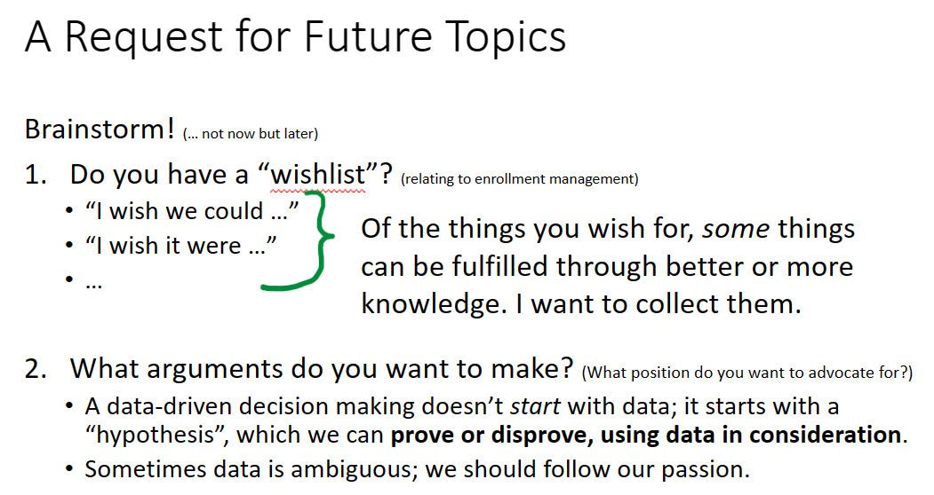  A. Park commented on Slide 6 and solicited input for possible topics data coaching sessions should cover.  Wishlist items and questions discussed at the meeting:  - Listing intersession classes for enrollment later in the semester, rather than at the start of the semester which competes with enrollments in regular session classes.  - Q: how much more do we make as a college for regular semester vs. 14-week? (A: short-term classes lose apportionment when classes don’t meet due to holidays; regular session classes get those days credited as if they met. It’s a balancing exercise of how many more enrollment (benefit) we get in a late-start class vs. the FTES counting less (cost) for apportionment. A class that would fill to capacity in regular session should be offered in regular session.)  Participated in discussion: Jane McKenna, C. Carmichael, S. Altenbach, J. Fowler, A. Park, … among others.  Summary of #3  Olga Fish shared the Spring 2023 ZTC Taskforce Achievements.  Credit to Jayne Smithson, Trish Nelson, Vanson Nguyen, Khalilah Beal-Uribe, and others.  - Collected and maintained updated ZTC course spreadsheets  - Successfully recruited faculty for ZTC course conversion.  - Provided vital support and resources to faculty.  - Conducted Flex Day, and Professional Day presentations.  - Fostered collaboration with ZTC leads in other colleges.  - Identified faculty using ZTC and low-cost instructional materials.  - Held meetings weekly.  - Identified pathways and Certificates for ZTC conversion: Anthropology, Math, CalGETC.  - Fculty within these pathways presented research results on gaps for ZTC conversion (Faculty Names: Erdenbaatar, Goldstein, Quezada, Burgess, Sandhu, Peterson-Guada).  - … and other achievements.  Fall 2023 ZTC Taskforce Goals:  - We’re seeking an additional grant of $320,000 to support our initiatives.  - A crucial deadline is approaching – we need to file a budget of $180,000 in NOVA by November 15, 2023.  - We must ensure we’re in compliance with XB12 coding (out of 42 disciplines only 6 not in compliance as of now)  - Our primary goal is to recruit faculty for ZTC course conversion  - Provide faculty support, resources, and collaboration with ZTC-experienced faculty.  - Compile, organize, and create ZTC-related resources and spreadsheets.  - Present findings to key groups, including Flex Day presentations.  - Meet every Tuesday and ensure compliance with ZTC program requirements and deadlines.  - Pursue external funding through grant applications.  - Stay updated on Chancellor’s Office resources and attend monthly ZTC Office Hours.  Please reach out to Olga Fish (ofish@peralta.edu) if interested.
Officer Reports | Vice President: Nothing to report.  Treasurer: Nothing to report.  Secretary: Nothing to report.  President: District ESC met last Friday, looking at 2024-2025 FTEF allocations. PBC will also take up the same proposal for consideration. Please submit comments on the Budget Focus Group website. ASCCC Area Meeting next week.
Announcements | None beyond those in president’s report.
Motion to extend the meeting by 5 minutes.
First: J. Campbell
Second: A. Park
M.S.U.
DAS Updates/Announcements | Jayne Smithson – Budgeting and Planning Calendar will be presented next week at PBC. It is a public meeting; please attend.  District is working on improving delays on independent contractor and consultants process.  Chancellor finalists’ forum next week; soliciting public questions. VC of Finance search is suspended until the selection of the chancellor.
Public Comment | None other than “hi” from Coach Linda.
Proposed agenda items for next meeting Thursday, Nov. 2, 2023 | Call for additional proposed agenda items (beyond those noted above) was made.  Please email J. Fowler for any other agenda items.
Adjournment at 1:25 pm | Meeting adjourned at 1:25 p.m. with all agenda items having been addressed.

