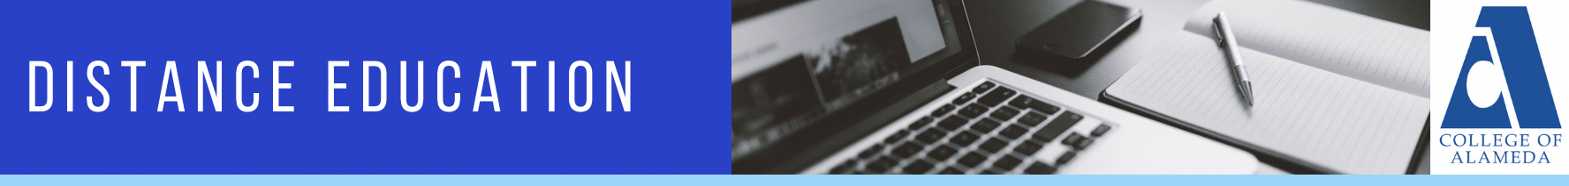

MINUTES
College of Alameda Distance Education Committee
Wednesday, October 25, 2023
12:30p – 1:30p
Location: Zoom

Members: Place X in box adjacent to name when present.

X | Cady Carmichael |  | Khalilah Beal-Uribe |  | Robert Brem
X | Richard Kaeser |  | Brielle Erike |  | Stefanie Ulrey
 | Anthony Villegas |  | David Leitner

Guests: List full name below. Place X in box adjacent to name when present.

Brandon Wu

AGENDA ITEM | DISCUSSION | FOLLOW UP ACTION
- Call to order: Approval of Agenda – (5 minutes) |  | No quorum
- Minutes from Previous Meeting – (5 minutes) |  | No quorum
- District DE Updates – (5 minutes) | No updates
- Action Items – (5 minutes)  - Approval of Minutes from 4/19/23  - Nomination and Election of Committee Chair |  | No quorum
- Discussion Items – (35 minutes)  - Committee Members Update  - Committee Goals for 2023/2024  - Observations of and Response to AI plagiarism Patterns (R. Brem) | Items will be pushed to next meeting.
- Announcements – (5 minutes)
- Adjournment

Abbreviations:
- COA – College of Alameda
- DE – Distance Education
- CVC-OEI – California Virtual Campus – Online Education Initiative
- POCR – Peer Online Course Review
- PCCD – Peralta Community College District
- AP – Administrative Procedure
- BP – Board Policy

