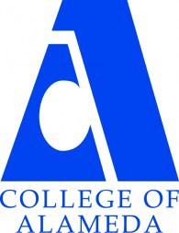
COLLEGE OF ALAMEDA
Institutional Effectiveness Committee
AGENDA

Thursday, October 12, 2023

2:00 – 3:30 pm

H-280 and via ZOOM

Co-Chair - Admin, Vacant
Co-Chair - Faculty, Andrew Park
Co-Chair - Classified, Kawanna Rollins

1. Approval of the Agenda | Action | Co-Chairs
2. Approval of the Minutes | Action | Co-Chairs
3. CurriQunet META Pilot | Informational | Acting VPI Jones
4. Program Review Validation Training | Discussion | Andrew Park
5. Other Items
6. Adjournment | Action | Co-Chairs
Next meetings –
Program Review Validation at,
Thursday, October 19, 2023, 2-3:30 p.m. in
A-building computer lab; and
Regular Meeting: Thursday, November 9, 2-3:30 p.m.

Our Mission
The Mission of College of Alameda is to serve the educational needs of its diverse community by providing comprehensive and flexible programs and resources that empower students to achieve their goals.

