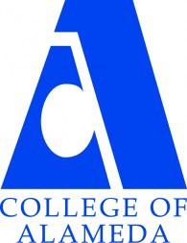
COLLEGE OF ALAMEDA
Institutional Effectiveness Committee
MINUTES

Thursday, September 14, 2023

2:00 – 3:30 pm
Via ZOOM

https://peralta-edu.zoom.us/j/89760332449

Co-Chair - Admin, Dominique Benavides
Co-Chair - Faculty, Andrew Park
Co-Chair - Classified, Kawanna Rollins

Committee Members Present: Didem Ekici, Dominique Benavides, Andrew Park (note-taker), Maurice Jones, Kawanna Rollins, and Natay Meyers

Guest(s) Present: Drew Burgess

Meeting called to order at 2:06 p.m.

1. Approval of the Agenda  Motion to approve the agenda by A. Park, seconded by K. Rollins.  Brief comment confirming that co-chairs can make and second motions, per last year’s change.  M.S.U. | Action | Chairs
2. Approval of the Minutes  May meeting minutes shared by D. Benavides. Motion to approve the minutes by D. Ekici, seconded by N. Meyers.  Note on correcting document heading to say “minutes” not “agenda”.  M.S.U. | Action | Chairs
3. Committee Membership  D. Benavides started item, summarizing the change in committee membership since last year. Current committee members are:  Admin – Maurice Jones and Dom Benavides (one vacant).  Classified – Kawanna Rollins and Louie Martirez y McFarland (one vacant position being held for new curriculum specialist)  Faculty – Didem Ekici, Khalilah Beal-Uribe, and Andrew Park  ASCOA – Natay Meyers  Still waiting for a new admin appointee. | Informational | Chairs
4. Meeting Modality  A. Park started the item with the reminder of last year’s discussion.  Motion by A. Park to continue IEC meetings 100% online for AY 2023-2024. Seconded by D. Ekici. Some discussion followed, in which M. Jones, K. Rollins, and D. Benavides participated. A. Park withdrew the motion with the leave of the committee.  New motion: “to hold IEC meetings in AY 2023-2024 in person on campus with online accommodation, preferably in H-280”. Moved by M. Jones. Seconded by A. Park. Some discussion followed, including online committee members counting for quorum (IEC is not a Brown-Act committee).  M.S.U.  M. Jones confirmed reserving H-280 for second Thursdays, 2-3:30 p.m. with the help of Marivic. | Action | Chairs
5. COA Shared Governance webpages – Update  A. Park gave the update on keeping the committee websites updated. All committee websites looked good, most just needing end-of-year updates with new information for AY 2023-2024. Andrew will send an email blast to committee chairs asking for end-of-year updates and AY 2023-2024 info. | Informational | Andrew Park
6. Program Review Timeline  D. Benavides started the presentation (similar presentation presented to department chairs on Tuesday). All the steps are scheduled to be completed by early November, with Oct. 16-30 scheduled for review validation.  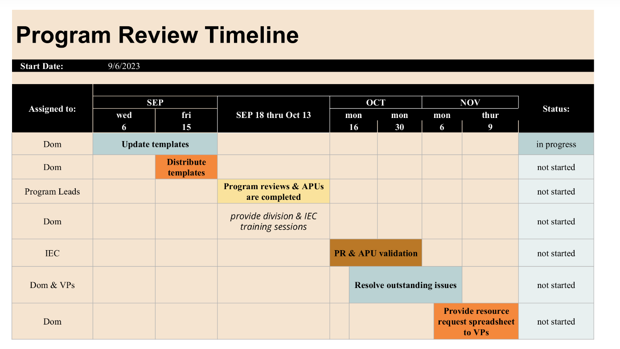  At the October IEC meeting (Oct. 12), we will hold a training session for program review validation. D. Ekici and A. Park participated in the discussion.  Q: Will we invite help and participation from other faculty?  A: Let’s set a validation meeting time that works for all IEC members and send out an invitation to CoA – All. Also, LRC tutors helped last year; their help again this year would be welcome.  After some discussion about schedule availability, Oct. 19, 2-3:30 p.m. was set for validation meeting. List of programs undergoing comprehensive program review was shared.  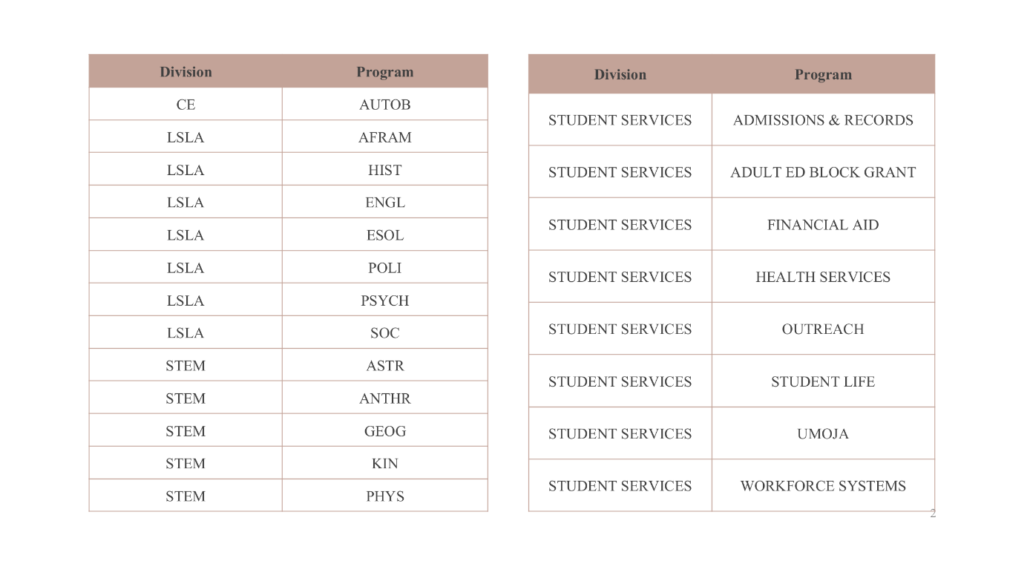 | Informational | Dominique Benavides
7. Program Review Validation Rubric  D. Benavides shared the revised validation rubric and started the presentation. Similar rubrics will be developed for student service areas. Andrew would like to provide the list of SLOs and PLOs to program leads along with the program review templates.  Motion to adopt the presented revised rubric for AY 2023-2024, by A. Park. Seconded by K. Rollins. M.S.U.  Will talk about service area rubrics at the next meeting. | Action | Dominique Benavides
8. CurriQunet META Pilot  D. Benavides started the item, sharing that sister colleges are already using program review module for CurriQunet META. CoA needs volunteers to test the customized interface for CoA.  Volunteers: K. Rollins and Drew Burgess. | Action | Dominique Benavides
9. Other Items

Discussion of potential future agenda items:
- Guided Pathways: will be developing program maps for part-time students (M. Jones / D. Ekici)
- Program review validation training (D. Benavides)

PD chair Drew Burgess asked about suggestions for October flex day (Oct. 18); some suggestions:
- Guided Pathways workshop (maybe afternoon breakout session)
- Announcing program review validation taking place on Oct. 19
- SLO workshop (Andrew will put something together)

10. Adjournment  Motion to adjourn by K. Rollins, seconded by D. Ekici. M.S.U.  Meeting adjourned at 2:49 p.m. | Action | Chairs
Next meeting – Thursday, October 12, 2-3:30 p.m., in H-280 and online

Our Mission
The Mission of College of Alameda is to serve the educational needs of its diverse community by providing comprehensive and flexible programs and resources that empower students to achieve their goals.

