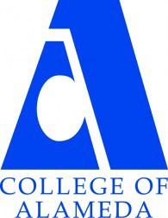
COLLEGE OF ALAMEDA
Institutional Effectiveness Committee
AGENDA

Thursday, December 14, 2023

2:00 – 3:30 pm

H-280 and via ZOOM

Co-Chair - Admin, Vacant
Co-Chair - Faculty, Andrew Park
Co-Chair - Classified, Kawanna Rollins

1. Approval of the Agenda | Action | Co-Chairs
2. Approval of the Minutes / Discussion on Nov. 9  meeting notes | Action | Co-Chairs
3. Committee Membership Updates | Informational | Co-Chairs
4. Feedback on Fall 2023 Program Review Cycle | Discussion | Andrew Park
5. ACCJC Accreditation Standards | Discussion | Andrew Park
6. Institutional Effectiveness Website | Discussion | Andrew Park
7. Other Items
8. Adjournment | Action | Co-Chairs
Next meeting –
Regular Meeting: Thursday, February 8, 2-3:30 p.m.

Our Mission
The Mission of College of Alameda is to serve the educational needs of its diverse community by providing comprehensive and flexible programs and resources that empower students to achieve their goals.

