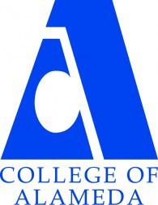
COLLEGE OF ALAMEDA
Institutional Effectiveness Committee
AGENDA

Thursday, February 8, 2024

2:00 – 3:30 pm

H-280 and via ZOOM

Co-Chair - Admin, Maurice Jones
Co-Chair - Faculty, Andrew Park
Co-Chair - Classified, Kawanna Rollins

1. Approval of the Agenda | Action | Co-Chairs
2. Approval of the Minutes | Action | Co-Chairs
3. Committee Membership Updates | Informational | Co-Chairs
4. ACCJC Mid-Term Report | Discussion | VPSS Mildred Lewis
5. Institutional Effectiveness Website | Discussion | Andrew Park
6. Enrollment Taskforce Update | Discussion | Andrew Park / Maurice Jones
7. Updates on Past Discussions: AY24-25 program review  and Institution Set Standards | Discussion | Co-Chairs
8. Other Items
9. Adjournment | Action | Co-Chairs
Next meeting –
Regular Meeting: Thursday, March 14, 2-3:30 p.m.

