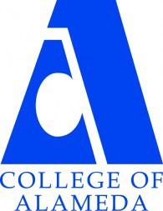
COLLEGE OF ALAMEDA
Institutional Effectiveness Committee
AGENDA

Thursday, March 14, 2024

2:00 – 3:30 pm

H-280 and via ZOOM

Co-Chair - Admin, Vacant
Co-Chair - Faculty, Andrew Park
Co-Chair - Classified, Kawanna Rollins

1. Approval of the Agenda | Action | Co-Chairs
2. Approval of the Minutes | Action | Co-Chairs
3. Welcoming New Committee Members | Informational | Co-Chairs
4. Employee Voice Survey | Discussion | Co-Chairs
5. Institution Set Standards | Discussion | Andrew Park
6. ILO Assessment | Discussion | Andrew Park
7. Various Updates: Institutional Effectiveness Website;  Enrollment Taskforce | Informational | Andrew Park
8. Upcoming Items: AY24-25 Program Review;  ACCJC Mid-Term Report | Discussion | Co-Chairs
9. Other Items
10. Adjournment | Action | Co-Chairs
Next meeting –
Regular Meeting: Thursday, April 11, 2-3:30 p.m.

