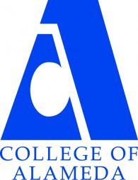
COLLEGE OF ALAMEDA
Institutional Effectiveness Committee
AGENDA

Thursday, April 11, 2024

2:00 – 3:30 pm

H-280 and via ZOOM

Co-Chair - Faculty, Andrew Park

1. Approval of the Agenda | Action | Co-Chairs
2. Approval of the Minutes | Action | Co-Chairs
3. Employee Voice Survey | Action | Drew Burgess
4. AY24-25 Program Review and APU Templates: Instructional | Discussion | Andrew Park
5. ACCJC Mid-Term Report (Standing Agenda Item) | Informational | Mildred Lewis
6. Various Updates: Institutional Set Standards, ILO Assessment, Institutional Effectiveness Website Updates | Informational | Andrew Park
7. Other Items | Discussion | Co-Chairs
8. Adjournment
Next meeting –  Regular Meeting: Thursday, May 9, 2-3:30 p.m. | Action | Co-Chairs

