**College of Alameda**

2020-21 Program Review – African American Studies

**Program Overview**

Please provide your program’s mission statement.

|  |
| --- |
| The discipline of African American Studies at the College of Alameda will give you a deep appreciation and understanding of the impact that people of African descent have had on the ancient and modern worlds. You will draw from multiple academic disciplines, including history, sociology, communication, literature, art, dance, anthropology, and political science. Through these academic lenses you will gain a broader understanding of the African diasporic experience in the U.S. and beyond as you will critically analyze the struggles, triumphs, and rich traditions both past and present. You will learn from instructors who are active in the community and their areas of academic specialization. Students in African American Studies at the College of Alameda can elect to study in Africa during the summer session through our study abroad program to Accra Ghana. Future study abroad opportunities within the African diaspora will include Mexico, Cuba, Haiti, Jamaica, and Brazil. |

List your program faculty and/or staff

|  |
| --- |
| Jody L. Campbell  Hillary Walker  Robert McKnight |

List your program goals from your most recent Program Review or APU. Then, provide an update on the status of the goal. Has your program achieved the goal? Have any of your goals been revised or any still in progress? Lastly, make sure to discuss which College or District goal your program goal aligns to.

If no program goals exist or if this is your first program review, work to create 2-3 goals and align them with a College or District goal.

|  |  |
| --- | --- |
| **Program Goal** | **Which college or district goal is aligned with your program goal?** |
| Solve problems and make decisions in life and work using critical thinking, quantitative reasoning, community resources, and civil engagement. | Institutional Goal# 1, 3, and 4. |
| Engage in respectful interpersonal communications, acknowledging ideas and values of diverse individuals that represent different ethnic, racial, cultural, and gender expressions. | Institutional Goal# 1, 3, and 4. |
|  |  |

Describe your current utilization of facilities, including labs and other space

|  |
| --- |
| We are currently offering all classes online as of 3/20 |

**Enrollment Trends**

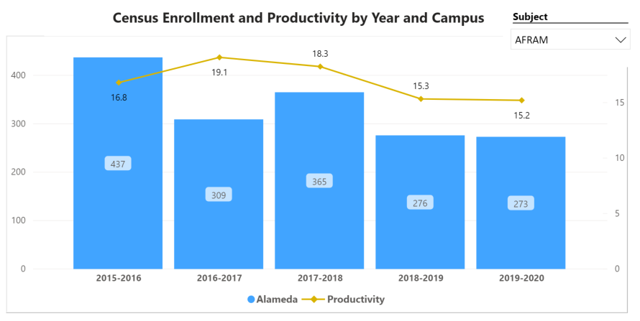

*Consider the most recent 3 to 5 years when answering the questions below.*

[**Enrollment Trends Dashboard link**](https://app.powerbi.com/view?r=eyJrIjoiNWJlOWZmYTEtNTY0MC00MDhkLWE5OTAtYmJjZjIxNzJiNWViIiwidCI6ImVlYTE2YTE2LTQ4YWYtNDc3Yi05MTEzLTA1YjFjMDExMjNmZiIsImMiOjZ9&pageName=ReportSection86d6f65e2fb41a73da4d)

Discuss enrollment trends over the past three years

*For additional analysis, click on the Enrollment Trends Dashboard, set the filters to Alameda and your discipline*

|  |
| --- |
| Enrollment overall has been in a slight decline 2017, however with more course offerings and dual enrollment acquisitions, I anticipate a rise in overall productivity which is why I would like to request an additional 1.0 (faculty). Our rise in dual enrollment requests and intercession courses will further our growth and development as a department. |

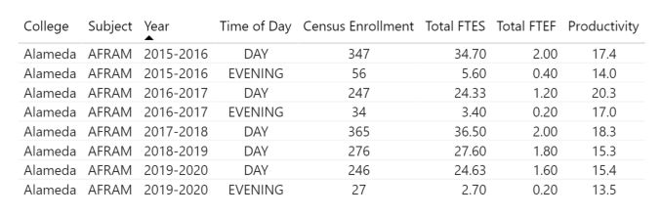

In the enrollment dashboard, set the filter to consider whether the time of day each course is offered meets the needs of students.

Are courses scheduled in a manner that meets student needs and demands? How do you know?

|  |
| --- |
| We are offering dual enrollment courses as well as a number of online options. |

Describe effective and innovative teaching strategies used by faculty to increase student learning and engagement.

|  |
| --- |
| Faculty has completed trainings in canvas in order to be more proficient online instructors. |

How is technology used by the discipline, department?

|  |
| --- |
| Technology is used on a daily basis to connect with students via canvas and zoom. |

How does the discipline, department, or program maintain the integrity and consistency of academic standards with all methods of delivery, including face to face, hybrid, and Distance Education courses?

|  |
| --- |
| Faculty has completed all required trainings and continues to attend a variety of workshops designed to improve methods of educational delivery. |

**Curriculum**

Please review your course outlines of record in Curriqunet to determine if they have been updated or deactivated in the past three years

[](https://peralta.curricunet.com/)

**https://peralta.curricunet.com/**

Specify when your department will update each one, within the next three years.

|  |
| --- |
| The department is current and has several updates in progress including several new courses. |

Please summarize curriculum plans and improvements for your discipline, department and or program of study.

|  |
| --- |
| The AFRAM department will be offering 3 new courses starting Fall 2021. |

**Student Learning Outcomes Assessment**

List your Student Learning Outcomes

|  |  |  |  |  |  |
| --- | --- | --- | --- | --- | --- |
| |  | | --- | | Examine the impact of post WWII politics in the Black community.  Explore the philosophy on Black feminism in the 20th century.  Research the origins of the modern Civil Rights Movement in the U.S.  Identify the genesis of the Black Power Movement.  Examine the historical significance of the extraordinary events which led to the election of the 44st President of the U.S. Barack Obama. | |  | |  | |  | |  | |

Were there any obstacles experienced during assessment? What worked well? (Mainly based on evidence in the report, attach other evidence as necessary)

|  |
| --- |
| No obstacles experienced. |

What percent of your programs have been assessed? (mainly based on evidence in the report, attach other evidence as necessary; note: a complete program assessment means all Program Learning Outcomes (PLOs) have been assessed for that program)

|  |
| --- |
| 100% |

How has your dept worked together on assessment (planning together)? Describe things that went well or obstacles. What aspects of assessment work went especially well in your department and what improvements are most needed?

Planning Process

|  |
| --- |
| Regular meetings with colleagues, department chairs, and committees. |

Collaboration

|  |
| --- |
| Guided pathways, curriculum committee, dual enrollment and UMOJA. |

Leadership Roles

|  |
| --- |
| Vice chair of the curriculum committee. |

Data Analysis

|  |
| --- |
| Guided pathways. |

What were the most important things your department learned from assessment? Did implementation of your action plans result in better student learning? In other words, how has your department used the results of assessment to improve student learning and/or curriculum? Please be as detailed as possible.

|  |
| --- |
| That we need the data to help guide our strategies and plans of action. |

Does your department participate in the assessment of multidisciplinary programs? If Yes, describe your department's participation and what you learned from the assessment of the program that was applicable to your own discipline.

|  |
| --- |
| We are currently working on the development of a multi discipline Ethnic Studies program. |

College of Alameda Institutional Learning Outcomes (ILOs) were created to guide educational programs and services. They include:

* **Problem Solving:** Solve problems and make decisions in life and work using critical thinking, quantitative reasoning, community resources, and civil engagement.
* **Communication and Technology:** Use technology and written and oral communication to discover, develop, and relate critical ideas in multiple environments.
* **Creativity:** Exhibit aesthetic reflection to promote, participate and contribute to human development, expression, creativity, and curiosity.
* **Diversity:** Engage in respectful interpersonal communications, acknowledging ideas and values of diverse individuals that represent different ethnic, racial, cultural, and gender expressions.
* **Civic Responsibility:** Accept personal, civic, social and environmental responsibility in order to become a productive local and global community member.

How does your department participate in assessing the Institutional Learning Outcomes (ILOs)? If your department has not participated, how will you plan to incorporate these outcomes within your department?

|  |
| --- |
| We meet with our department chair/s regularly regarding ILO assessments. |

What support does your department need from administrators, assessment coordinators and/or your campus assessment committee to continue to make progress in assessment of outcomes and implementation of action plans?

|  |
| --- |
| Trainings, workshops, and seminars. |

**Course Completion**

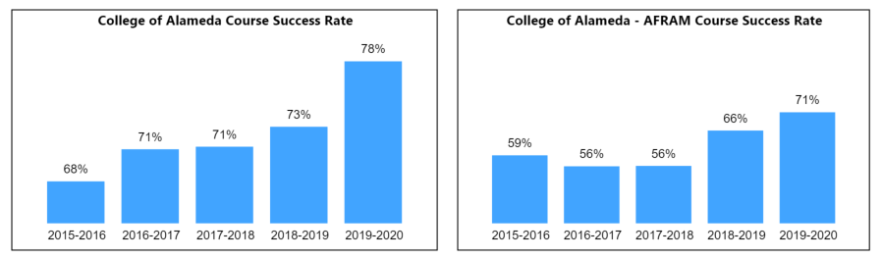

Consider your course completion rates over the past three to five years (% of student who earned a grade of "C" or better).

[**Course Completion Dashboard link**](https://app.powerbi.com/view?r=eyJrIjoiNjc2MDhiNTEtNTJhZi00MDM0LTk5NDItNTRiY2EzMGI1NTZiIiwidCI6ImVlYTE2YTE2LTQ4YWYtNDc3Yi05MTEzLTA1YjFjMDExMjNmZiIsImMiOjZ9&pageName=ReportSection86d6f65e2fb41a73da4d)

How do the course completion rates for your program or discipline compare to your college's Institution-Set Standard for course completion of **67%**?

|  |
| --- |
| We are at 71% |

How do the department's Hybrid course completion rates compare to the college course completion standard? Use the course completion dashboard to disaggregate.

|  |
| --- |
| N/A |

Are there substantial differences in course completion rates between face to face and Distance Education/hybrid courses? If so, how does the discipline, department, or program address this? How do you assess the overall effectiveness of Distance Education/hybrid course?

|  |
| --- |
| N/A |

Are there substantial differences in course completion rates between courses taught during the day compared to evening course? If so, how does the discipline, department, or program address this?

|  |
| --- |
| No |

If your program offers dual enrollment courses, examine the data, and discuss the course completion rates compared to the overall program rate.

|  |
| --- |
| The data reflects that we meet expectations of 67% |

On average the course retention rate (number of students are retained in the course) for College of Alameda has been **85%** for the past three years. Examine the course retention rates for your program over the last three years. How does your program or discipline course retention rates compare to the college?

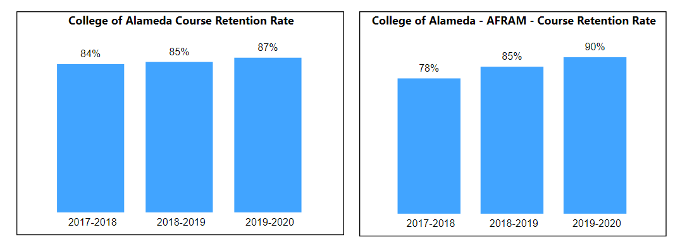

|  |
| --- |
|  |

College of Alameda continues to focus on access, equity, and success. The goal is to create an inclusive environment where all students can thrive and meet their education and career goals.

To address equity gaps and work towards achieving equity in educational outcomes, examine your program data for evidence of disproportionate impact (DI). When disaggregating course success rates, are there any groups whose course completion rate falls more than 3 percentage points below the discipline average? If so, identify them and explain what your department is doing to address the disproportionate impact for the group.

*Note: The tables reflected use 2018-19 program data to calculate DI. Groups with 10 students or less are excluded from the analysis.*

**Ethnicity and Gender**



|  |
| --- |
|  |

**Students with Disabilities (DSPS), First Generation, Foster Youth, Low Income or Veterans**



|  |
| --- |
|  |

**Age Range**



|  |
| --- |
|  |

What has the discipline, department, or program done to improve course completion and retention rates?

|  |
| --- |
| Study the presented data, adjust, and attend relevant trainings. |

**Degrees & Certificates Conferred**

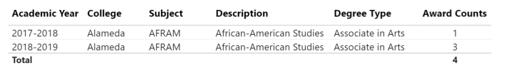

Since the last program review, what has the discipline, department, or program done to improve the number of degrees and certificates awarded?

|  |
| --- |
| By offering more courses and updating the degree requirements. |

For more information on awards: [**Degrees & Certificates Dashboard link**](https://app.powerbi.com/view?r=eyJrIjoiZjU2M2M5MzItOTcwZi00Y2U1LWJmODUtYTc0YjlhZGI2ZDhjIiwidCI6ImVlYTE2YTE2LTQ4YWYtNDc3Yi05MTEzLTA1YjFjMDExMjNmZiIsImMiOjZ9&pageName=ReportSectionde32556e136b0a8caccd)

Increasing the number of students who complete a certificate or degree is a shared goal across CoA’s Ed Master Plan Goals, PCCD Goals, the Chancellor’s Office Vision for Success, the Student-Centered Funding Formula, and Guided Pathways. What is planned for the next 3 years to increase the number of certificates and degrees awarded?

|  |
| --- |
| By promoting the program in a more visible and culturally relevant way. |

**Engagement**

Discuss how faculty and staff have engaged in institutional efforts such as committees, presentations, and departmental activities. Please list the committees that full-time faculty participate in.

|  |
| --- |
| Curriculum and Academic Senate. |

Discuss how faculty and staff have engaged in community activities, partnerships and/or collaborations.

|  |
| --- |
| By participating in community activities, and working with other campus programs like UMOJA and the BSU. |

Discuss how adjunct faculty members are included in departmental training, discussions, and decision-making.

|  |
| --- |
| Adjunct faculty is included in all major decisions relevant to the program as they are a critical component to our overall success. |

**Prioritized Resource Requests Summary**

In the boxes below, please add resource requests for your program. If there are no resource requested, leave the boxes blank.

|  |  |  |  |  |
| --- | --- | --- | --- | --- |
| **Resource Category** | **Description/Justification** | **Estimated Annual Salary Costs** | **Estimated Annual Benefits Costs** | **Total Estimated Cost** |
| Personnel: Classified Staff |  |  |  |  |
| Personnel: Student Worker |  |  |  |  |
| Personnel: Part Time Faculty |  |  |  |  |
| Personnel: Full Time Faculty |  |  |  |  |

|  |  |  |
| --- | --- | --- |
| **Resource Category** | **Description/Justification** | **Total Estimated Cost** |
| Professional Development: Department wide PD needed | Trainings and seminars workshops, guest lecturers. | 3,000.00 |
| Professional Development: Personal/Individual PD needed | Travel, and Registration. | 1,000.00 |

**Prioritized Resource Requests Summary - Continued**

|  |  |  |
| --- | --- | --- |
| **Resource Category** | **Description/Justification** | **Total Estimated Cost** |
| Supplies: Software | Teachers need the latest in software developments to stay current in our increasingly digital world. | 500.00 |
| Supplies: Books, Magazines, and/or Periodicals | Teachers need access to the latest materials in the field in order to stay relevant and current. | 500.00 |
| Supplies: Instructional Supplies | Teachers need supplies in order to perform their daily tasks. | 500.00 |
| Supplies: Non-Instructional Supplies | Educators need instructional supplies so that they can better serve the student population without disruption. | 500.00 |
| Supplies: Library Collections | Teachers would like to be able to put our text on reserve in the library for students that can’t afford their materials. | 500.00 |

|  |  |  |
| --- | --- | --- |
| **Resource Category** | **Description/Justification** | **Total Estimated Cost** |
| Technology & Equipment: New | Teachers occasionally need to upgrade their hardware to better serve students. | 1,000 |
| Technology & Equipment: Replacement | When equipment becomes dated or worn, educators should be able to “refresh’ or replace their equipment. | 2,000 |

**Prioritized Resource Requests Summary - Continued**

|  |  |  |
| --- | --- | --- |
| **Resource Category** | **Description/Justification** | **Total Estimated Cost** |
| Facilities: Classrooms | Maps/ Charts / Graphs/ Audio Visual equipment. | 500.00 |
| Facilities: Offices | Proper furniture that will facilitate a healthy and safe work environment and avoid short and long-term injury/disability. | 1,000 |
| Facilities: Labs | N/A |  |
| Facilities: Other | N/A |  |

|  |  |  |
| --- | --- | --- |
| **Resource Category** | **Description/Justification** | **Total Estimated Cost** |
| Library: Library materials | Reserve text books. | 500.00 |
| Library: Library collections | Historical films and books. | 500.00 |

|  |  |  |
| --- | --- | --- |
| **Resource Category** | **Description/Justification** | **Total Estimated Cost** |
| Other |  |  |