**College of Alameda**

2021-22 Annual Program Update - ADAM

**Program Overview**

Please provide your program’s mission statement and program’s learning outcomes

|  |
| --- |
| The Apparel Design and Merchandising Program (ADAM) provides educational training that prepares students with the knowledge and skills needed to successfully secure a career in the vast fields of apparel design and manufacturing. The ADAM Program fosters a well-balanced educational environment which promotes professionalism, integrity, and a high standard of performance as they relate to the everyday operations in the apparel industry. |

List your program faculty and/or staff

|  |
| --- |
| OJ Roundtree, Department Chair, Contract Faculty  Derek Piazza, Contract Faculty |

Describe your current utilization of facilities, including labs and other space

|  |
| --- |
| The ADAM Program moved to the newly constructed Liberal Arts Building H at the College of Alameda campus mid-August 2020. The new ADAM facilities consist of three new classrooms plus a state-of-the-art computer lab. Included, are new fashion equipment, office furnishings, technical electronics and computer equipment and software.  Concern issues over inadequate power outlets in both the ADAM sewing room lab (H305) and computer lab (H322) have yet to be addressed by Roebbelen Contracting, Inc., Peralta District, and/or COA administration. Additionally, there are not enough network connection outlets for internet access in the ADAM Lab H322. **This is urgent issue since it will greatly limit instruction for Spring 2021 for our courses if a solution is not reach ASAP. SEE PRIORITIZED RESOURCE REQUESTS.**  Due to the PCCD COVID-19 shelter in place protocol polices and building code difficulties, the new facility space is not available for occupancy to date. ADAM has been conducting all instruction via zoom sessions from remote home locations and its old facility space in Building D, Room D310. ADAM was just grant full access to new space (Build H) at the beginning of the Fall 2021 semester.  This has been challenging since most of ADAM’s instruction equipment, supplies, and resources were moved to the new facility and only accessible with extremely limited access. However, with the assistance of the following COA administration and personnel, ADAM was able to purchase and acquire the equipment, supplies and resources needed to make the transition success for our students and us as instructors. We are grateful for their excellent leadership and continuous support of the ADAM Program and College of Alameda.  A soft RTC for the Peralta District is to occur for Spring 2022. ADAM is scheduled to instruct all its second-year courses face-to-face in the new space as required to meet the 35-40% return to campus request for Spring 2022. ADAM has expressed concern this could cause a decline in enrollment for Spring 2022; just the opposite outcome District would expect. |

List your program goals from your most recent Program Review or APU. Then, provide an update on the status of the goal. Has your program achieved the goal? Have any of your goals been revised or any still in progress? Lastly, make sure to discuss which College or District goal your program goal aligns to.

If no program goals exist or if this is your first program review, work to create 2-3 goals and align them with a College or District goal.

|  |  |
| --- | --- |
| **Program Goal** | 1) Start to evaluate ADAM course curriculum.  2) Revise ADAM courses with 4 units to 3 units to better align for credit/unit transfer. |
| Status: In-Progress or Complete? | 1) Discussed Fall 2021 – schedule has been mapped out.  2) Discussed Fall 2021 – proposal planned |
| Which college or district goal is aligned with your program goal? | The Mission of College of Alameda to serve the educational needs of its diverse community by providing comprehensive and flexible programs and resources that empower students to achieve their goals. Academic Excellence |

|  |  |
| --- | --- |
| **Program Goal** | 1. Continue high standards of instruction and integrity within classroom but open to improvement. 2. Decrease withdrawal rates and increase retention rates, particularly during fall semesters. |
| Status: In-Progress or Complete? | 1) Continuing on-going |
| Which college or district goal is aligned with your program goal? | COA Mission  Academic Excellence  PCCD Goal |

|  |  |
| --- | --- |
| **Program Goal** | 1. ADAM has discussed the idea of starting a fashion club on campus to increase student engagement and activities outside the classroom. |
| Status: In-Progress or Complete? | 1) On hold due to COVID-19 |
| Which college or district goal is aligned with your program goal? | Engage in respectful interpersonal communications, acknowledging ideas and values of diverse individuals that represent different ethnic, racial, cultural, and gender expressions. Institutional Learning Outcomes |
| **Program Goal:** Professional Development, Institutional and Professional Engagement, and Partnerships | 1. Form partnerships with businesses 2. Increased awareness of the ADAM Program in the community. 3. Increase membership in the ADAM Advisory Board |
| Status: In-Progress or Complete? | 1. On-going in all three areas above |
| Which college or district goal is aligned with your program goal? | Community engagement – COA and PCCD |

|  |  |
| --- | --- |
| **Program Goal:** Other Program Improvement Objectives | 1. Plan for future faculty and staff needs. |
| Status: In-Progress or Complete? | 1. On hold due to COVID-19 |
| Which college or district goal is aligned with your program goal? | Budgetary COA and PCCD |

|  |  |
| --- | --- |
| **Program Goal:** Other Program Improvement Objectives | 1. Increase marketing to community. 2. Continue an established link with CTE advisory council and Strong Workforce |
| Status: In-Progress or Complete? | 1. On-going in both areas |
| Which college or district goal is aligned with your program goal? | Budgetary COA and PCCD |

**Program Update**

Using the dashboards, review and reflect upon the data for your program.

[**Course Completion and Retention Rates – Instructional Dashboard**](https://app.powerbi.com/view?r=eyJrIjoiNjc2MDhiNTEtNTJhZi00MDM0LTk5NDItNTRiY2EzMGI1NTZiIiwidCI6ImVlYTE2YTE2LTQ4YWYtNDc3Yi05MTEzLTA1YjFjMDExMjNmZiIsImMiOjZ9&pageName=ReportSection86d6f65e2fb41a73da4d)

[**Course Completion and Retention Rates – Student Services Dashboard**](https://app.powerbi.com/view?r=eyJrIjoiNjk3NDJjOTItNzI5MS00MDhjLWJhN2EtZjcxNzU4OTBiZDBjIiwidCI6ImVlYTE2YTE2LTQ4YWYtNDc3Yi05MTEzLTA1YjFjMDExMjNmZiIsImMiOjZ9&pageName=ReportSection86d6f65e2fb41a73da4d)

[**Enrollment Trends and Productivity Dashboard**](https://app.powerbi.com/view?r=eyJrIjoiNWJlOWZmYTEtNTY0MC00MDhkLWE5OTAtYmJjZjIxNzJiNWViIiwidCI6ImVlYTE2YTE2LTQ4YWYtNDc3Yi05MTEzLTA1YjFjMDExMjNmZiIsImMiOjZ9&pageName=ReportSection86d6f65e2fb41a73da4d)

[**Degrees and Certificates Dashboard**](https://app.powerbi.com/view?r=eyJrIjoiZjU2M2M5MzItOTcwZi00Y2U1LWJmODUtYTc0YjlhZGI2ZDhjIiwidCI6ImVlYTE2YTE2LTQ4YWYtNDc3Yi05MTEzLTA1YjFjMDExMjNmZiIsImMiOjZ9&pageName=ReportSectionde32556e136b0a8caccd)

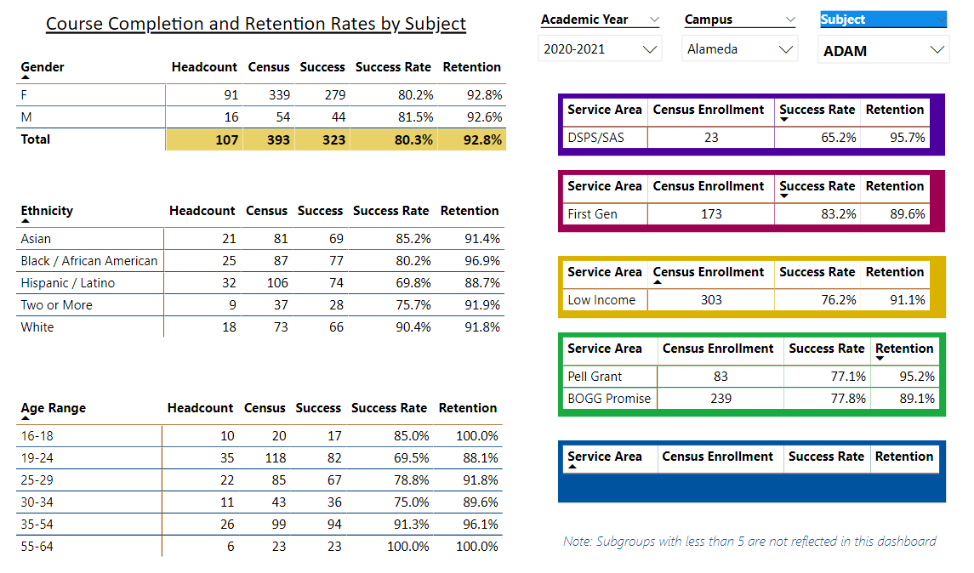

Describe any significant changes and discuss what the changes mean to your program. Consider whether performance gaps exist for disproportionality impacted students by using filters to disaggregate the data. Focus upon the most recent year and/or the years since your last comprehensive program review. Cite data points to support your reflection.

**ADAM SUMMARY STATEMENT**

Data supports ADAM continues to be a strong viable CE program even during the two-year crisis of Covid-19. With the support of administration and additional funding ADAM was able to make the transit from face-to-face to an all-online platform during the past two-years with only slight loss of completion and retention rates. Compared to the College of Alameda and the District, the ADAM Program is still well above the averages. Awarding of ADAM Degrees and Certificates are also in alignment with the flow for the College of Alameda and District over the years as well as with the Covid-19 crisis.

ADAM had a strong Fall 2021 enrollment considering this was the second year of the Covid-19 crisis. However, as we approached mid-semester retention dropped possibly do to 1) students becoming online “zoom” fatigued burnt-out”, 2) financial responsibility (need to work), 3) sickness (Covid-19), 4) waiting for face-to-face environment, 5) other reasons. Considering this and the announcement of the District’s RTC for Spring 2022, ADAM is looking at a reduced enrollment for Spring 2022. However, this is the norm for ADAM, a slightly lower enrollment in the spring since our courses are sequential and rotate on a yearly cycle.

The ADAM Program is proud to say it was able adapt and survive the Covid-19 crisis which is not an easy transit for CE education. Two other fashion institutions closed their doors in the SF/Bay Area during this crisis as well as others across the nation, but ADAM was able to successfully transition to online and still give our students the quality education they desired during these challenging times.

|  |  |
| --- | --- |
| **Overall Completion and Retention Rates**  **2017 – 2018 ADAM Comparison Rates = CR 88% and RR 91% (well above average)**  Consistent with the slight increase overall on most campuses  **Overall Completion and Retention Rates**  **2019 – 2020**  **Chart, bar chart  Description automatically generated**  **ADAM Comparison Rates = CR 81% and RR 90% (well above average)**  These ratings reflect some of the effects from the COVID-19 Spring 2020 online transition and crisis. However, the campuses did well particularly in the areas of retention. ADAM was able to hold on to its above average rates in both areas.  **Fall 2020**  **Chart, bar chart  Description automatically generated**  **ADAM Comparison Rates = CR 80% and RR 93% (well above average**  Retention rates were expected to have fallen due to continued COVID-19 crisis. However, it well above the college and District average. ADAM has adapted and met the online requirements to successfully maintain its completion and retention rates during this challenging crisis and new educational environment.  **DEGREES AND CERTIFICATES**  A picture containing line chart  Description automatically generated  The number of ADAM AA Degrees have been consistent over the years. However, the number of Certificate of Achievements have fluctuated. This does seem to fit the overall pattern of enrollment for the program and the enrolment trend of COA and the District as a whole. However, it is something ADAM will continue to monitor. Naturally, given the number of students that enroll for the two-year program each year, ADAM would like to see degree and certificate numbers increase. |  |

Describe the department's progress on Student Learning Outcomes (SLOs) and/or Service Area Outcomes (SAOs) since the last Program Review/APU.

|  |
| --- |
| ADAM Student Learning Outcomes are evaluated at the end of each current semester for current courses being taught (See CurriQunet). All Program Learning Outcomes are current in CurriQunet. ADAM is current in all areas. |

Describe the outcomes and accomplishments from previous year’s funded resource allocation request.

|  |  |  |  |
| --- | --- | --- | --- |
| **Brief description of funded request** | **Source (any additional award outside your base allocation)** | **Total Award Amount** | **Outcome/Accomplishment** |
| Funds requested for new software and workstations to setup CLO3D | Funding from the H Build Project | $31,675.00 | Completed Fall 2021 |
|  |  |  |  |
|  |  |  |  |

**Prioritized Resource Requests Summary**

In the boxes below, please add resource requests for your program. If there are no resource requested, leave the boxes blank.

|  |  |  |  |  |
| --- | --- | --- | --- | --- |
| **Resource Category** | **Description/Justification** | **Estimated Annual Salary Costs** | **Estimated Annual Benefits Costs** | **Total Estimated Cost** |
| **Personnel: Classified Staff** | 1 ADAM .5 contract staff employees as TAs, office duties, recruitment, placement, internships, etc. | $42,000 |  | $42,000.00 |
| **Personnel: Student Worker** | 2 Student TA positions each semester – 20 hrs. each per week.  Supports strong % rates for completion and retention in ADAM Program | $16,960 |  | $16,960.00 |
| **Personnel: Part Time Faculty** |  |  |  |  |
| **Personnel: Full Time Faculty** | 1 Full-time Contract Faculty – with in the next 1-2 years to replace retiring faculty | $81,700 |  | $81,700.00 |

|  |  |  |
| --- | --- | --- |
| **Resource Category** | **Description/Justification** | **Total Estimated Cost** |
| **Professional Development: Department wide PD needed** |  |  |
| **Professional Development: Personal/Individual PD needed** |  |  |

**Prioritized Resource Requests Summary - Continued**

|  |  |  |
| --- | --- | --- |
| **Resource Category** | **Description/Justification** | **Total Estimated Cost** |
| **Supplies: Software** | 3 - WordPerfect Software (upgrade for ADAM office computers) | $750.00 |
| **Supplies: Books, Magazines, and/or Periodicals** |  |  |
| **Supplies: Instructional Supplies** |  |  |
| **Supplies: Non-Instructional Supplies** |  |  |
| **Supplies: Library Collections** |  |  |

|  |  |  |
| --- | --- | --- |
| **Resource Category** | **Description/Justification** | **Total Estimated Cost** |
| **Technology & Equipment: New** | 2 - Printer/Copier/Fax for ADAM Office  1 – 12.9” iPad Pro Wi-Fi 128 GB  1 – USB C Charger Cable (2m)  1 - 30w USB C Power Adapter  1 – AirPods Pro  2 – Tripp Lite 6’ Lighting USB Apple Charge Cable  3 – Tripp Lite 4’ USB Connector USB Cable Data Transfer | $1,000.00  $1,099.00  $19.00  $49.00  $24.00  $51.78  $65.97 |
| **Technology & Equipment: Replacement** |  |  |

**Prioritized Resource Requests Summary - Continued**

|  |  |  |
| --- | --- | --- |
| **Resource Category** | **Description/Justification** | **Total Estimated Cost** |
| **Facilities: Classrooms** |  |  |
| **Facilities: Offices** |  |  |
| **Facilities: Labs**  **This has been a request since the building was under construction** | **PRIORTIY FOR SPRING INSTRUCTION 2022**  **Inadequate electrical outlet issue addressed and corrected in both ADAM H305 and ADAM H322.**  **Inadequate network connections for internet access issue addressed and corrected in ADAM H322.** | Undetermined  $$$$$$$$$$$  Undetermined  $$$$$$$$$$$ |
| **Facilities: Other** |  |  |

|  |  |  |
| --- | --- | --- |
| **Resource Category** | **Description/Justification** | **Total Estimated Cost** |
| **Library: Library materials** |  |  |
| **Library: Library collections** |  |  |

|  |  |  |
| --- | --- | --- |
| **Resource Category** | **Description/Justification** | **Total Estimated Cost** |
| **OTHER** |  |  |