**College of Alameda**

2021-22 Annual Program Update - AFRAM

**Program Overview**

Please provide your program’s mission statement and program’s learning outcomes

|  |
| --- |
| The discipline of African American Studies at the College of Alameda will give you a deep appreciation and understanding of the impact that people of African descent have had on the ancient and modern worlds. You will draw from multiple academic disciplines, including history, sociology, communication, literature, art, dance, anthropology, and political science. Through these academic lenses you will gain a broader understanding of the African diasporic experience in the U.S. and beyond as you will critically analyze the struggles, triumphs, and rich traditions both past and present. You will learn from instructors who are active in the community and their areas of academic specialization. Students in African American Studies at the College of Alameda can elect to study in Africa during the summer session through our study abroad program to Accra Ghana. Future study abroad opportunities within the African diaspora will include Mexico, Cuba, Haiti, Trinidad and Tobago, Jamaica, and Brazil. |

List your program faculty and/or staff

|  |
| --- |
| Jody L. Campbell  Hillary Walker  Robert McKnight |

Describe your current utilization of facilities, including labs and other space

|  |
| --- |
| We are currently 100% on line. |

List your program goals from your most recent Program Review or APU. Then, provide an update on the status of the goal. Has your program achieved the goal? Have any of your goals been revised or any still in progress? Lastly, make sure to discuss which College or District goal your program goal aligns to.

If no program goals exist or if this is your first program review, work to create 2-3 goals and align them with a College or District goal.

|  |  |
| --- | --- |
| **Program Goal** | Solve problems and make decisions in life and work using critical thinking, quantitative reasoning, community resources, and civil engagement. |
| Status: In-Progress or Complete? | Complete. |
| Which college or district goal is aligned with your program goal? | Institutional Goal# 1, 3, and 4. |

|  |  |
| --- | --- |
| **Program Goal** | Engage in respectful interpersonal communications, acknowledging ideas and values of diverse individuals that represent different ethnic, racial, cultural, and gender expressions. |
| Status: In-Progress or Complete? | Complete. |
| Which college or district goal is aligned with your program goal? | Institutional Goal# 1, 3, and 4. |

|  |  |
| --- | --- |
| **Program Goal** | Use technology and written and oral communication to discover, develop, and relate critical ideas in multiple environments. |
| Status: In-Progress or Complete? | Complete. |
| Which college or district goal is aligned with your program goal? | Institutional Goal# 1, 3, and 4. |

**Program Update**

Using the dashboards, review and reflect upon the data for your program.

[**Course Completion and Retention Rates – Instructional Dashboard**](https://app.powerbi.com/view?r=eyJrIjoiNjc2MDhiNTEtNTJhZi00MDM0LTk5NDItNTRiY2EzMGI1NTZiIiwidCI6ImVlYTE2YTE2LTQ4YWYtNDc3Yi05MTEzLTA1YjFjMDExMjNmZiIsImMiOjZ9&pageName=ReportSection86d6f65e2fb41a73da4d)

[**Course Completion and Retention Rates – Student Services Dashboard**](https://app.powerbi.com/view?r=eyJrIjoiNjk3NDJjOTItNzI5MS00MDhjLWJhN2EtZjcxNzU4OTBiZDBjIiwidCI6ImVlYTE2YTE2LTQ4YWYtNDc3Yi05MTEzLTA1YjFjMDExMjNmZiIsImMiOjZ9&pageName=ReportSection86d6f65e2fb41a73da4d)

[**Enrollment Trends and Productivity Dashboard**](https://app.powerbi.com/view?r=eyJrIjoiNWJlOWZmYTEtNTY0MC00MDhkLWE5OTAtYmJjZjIxNzJiNWViIiwidCI6ImVlYTE2YTE2LTQ4YWYtNDc3Yi05MTEzLTA1YjFjMDExMjNmZiIsImMiOjZ9&pageName=ReportSection86d6f65e2fb41a73da4d)

[**Degrees and Certificates Dashboard**](https://app.powerbi.com/view?r=eyJrIjoiZjU2M2M5MzItOTcwZi00Y2U1LWJmODUtYTc0YjlhZGI2ZDhjIiwidCI6ImVlYTE2YTE2LTQ4YWYtNDc3Yi05MTEzLTA1YjFjMDExMjNmZiIsImMiOjZ9&pageName=ReportSectionde32556e136b0a8caccd)

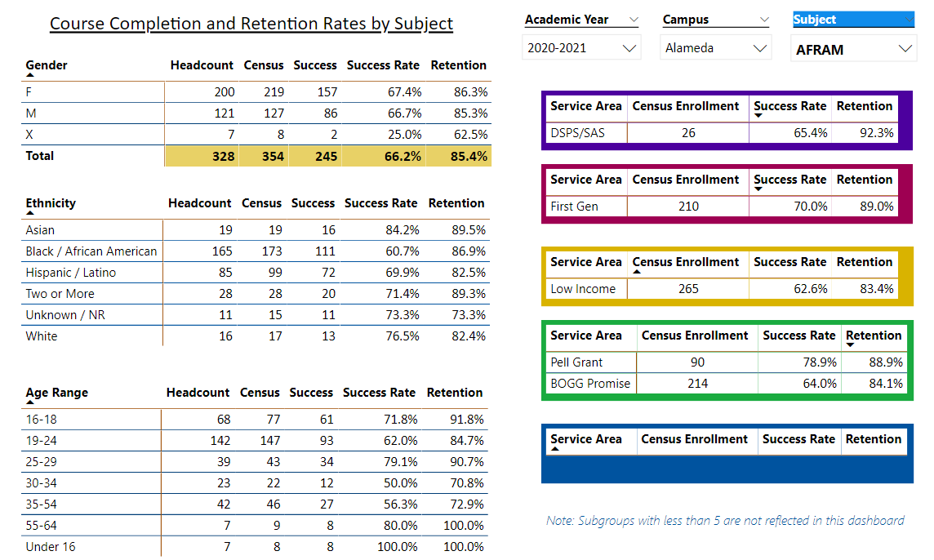

Describe any significant changes and discuss what the changes mean to your program. Consider whether performance gaps exist for disproportionality impacted students by using filters to disaggregate the data. Focus upon the most recent year and/or the years since your last comprehensive program review. Cite data points to support your reflection.

|  |
| --- |
| Enrollment overall has been in a slight decline since 2021, however, with more course offerings and dual enrollment acquisitions we anticipate an increase in enrollment in the coming academic year. Our rise in dual enrollment requests and intercession courses, will further our growth and development as a department.  According to the data there appears to be a relatively high success rate among Pale grate recipients (78.0%) compared to DSPS/SAS students (65.4%). Also, retention rates appear to be up, compared to previous years. Rates range from roughly (84.1- 92.3%). In all, numbers for AFRAM enrollment and retention appear to be trending in the right direction. Course retention and completion rates have been on the rise since 2018. |

Describe the department's progress on Student Learning Outcomes (SLOs) and/or Service Area Outcomes (SAOs) since the last Program Review/APU.

|  |
| --- |
| SLO assessment in progress for AFRAM courses. |

Describe the outcomes and accomplishments from previous year’s funded resource allocation request.

|  |  |  |  |
| --- | --- | --- | --- |
| **Brief description of funded request** | **Source (any additional award outside your base allocation)** | **Total Award Amount** | **Outcome/Accomplishment** |
|  |  |  |  |
|  |  |  |  |
|  |  |  |  |

**Prioritized Resource Requests Summary**

In the boxes below, please add resource requests for your program. If there are no resource requested, leave the boxes blank.

|  |  |  |  |  |
| --- | --- | --- | --- | --- |
| **Resource Category** | **Description/Justification** | **Estimated Annual Salary Costs** | **Estimated Annual Benefits Costs** | **Total Estimated Cost** |
| **Personnel: Classified Staff** |  |  |  |  |
| **Personnel: Student Worker** |  |  |  |  |
| **Personnel: Part Time Faculty** |  |  |  |  |
| **Personnel: Full Time Faculty** |  |  |  |  |

|  |  |  |
| --- | --- | --- |
| **Resource Category** | **Description/Justification** | **Total Estimated Cost** |
| **Professional Development: Department wide PD needed** | Trainings and seminars workshops, guest lecturers. | 3,000 |
| **Professional Development: Personal/Individual PD needed** | Travel, transportation, and registration. | 1,500 |

**Prioritized Resource Requests Summary - Continued**

|  |  |  |
| --- | --- | --- |
| **Resource Category** | **Description/Justification** | **Total Estimated Cost** |
| **Supplies: Software** | Teachers need the latest in software developments to stay current in our increasingly digital world. | 500.00 |
| **Supplies: Books, Magazines, and/or Periodicals** | Teachers need access to the latest materials in the field in order to stay relevant and current. | 500.00 |
| **Supplies: Instructional Supplies** | Teachers need supplies in order to perform their daily tasks. | 500.00 |
| **Supplies: Non-Instructional Supplies** | Teachers need supplies in order to perform their daily tasks. | 500.00 |
| **Supplies: Library Collections** | Teachers would like to be able to put our text on reserve in the library for students that can’t afford their materials. | 500.00 |

|  |  |  |
| --- | --- | --- |
| **Resource Category** | **Description/Justification** | **Total Estimated Cost** |
| **Technology & Equipment: New** | Teachers occasionally need to upgrade their hardware to better serve students. | 1,000 |