**College of Alameda**

2021-22 Annual Program Update - ANTHR

**Program Overview**

Please provide your program’s mission statement and program’s learning outcomes

|  |
| --- |
| Anthropology courses at College of Alameda offer students the opportunity to study humankind from biological, historic, prehistoric and cultural perspectives. Anthropology introduces students to ways to investigate and understand humanity in ways that are personally enriching and have practical application in their lives.  Program Learning Outcomes for Anthropology ADT and A.A. are:  1) Explain core concepts of Anthropology, including biological, socio-cultural and archaeological aspects of the discipline.  2) Demonstrate an understanding of the scientific methods (skills) used by contemporary anthropologists.  3) Apply holistic perspective to discuss appreciation for the genetic and cultural diversity of humans in the past and present, around the world. |

List your program faculty and/or staff

|  |
| --- |
| Jayne Smithson, lead faculty (F/T)  Nicole Buyagawan (P/T)  David Leitner (P/T)  Karen Oeh (P/T)  Iolani Sodhy-Gereben (P/T) |

Describe your current utilization of facilities, including labs and other space

|  |
| --- |
| Until the end of September 2021, the Anthropology Program at CoA used a complex of rooms in the C building on the main campus: C-102 (Physical Anthropology prep room for labs and storage for lab specimens), C-103 (Archaeology field lab and program-wide specimens and equipment storage) and C-104 (primary lecture and lab room). The Anthropology Instructors office is housed in C-103.  C-Building was declared to be “unsafe” by CoA Administration towards the end of September 2021. On Oct. 10, 2021, final word was received from Peralta Legal via CoA Acting VPI Bajrami that no instruction or office meetings can be conducted in the C-building. The Anthropology Program currently (as of 11/6/2021) is without permanent teaching or office facilities, although a potentially permanent laboratory classroom has been identified (D-115) and limited storage might be available in D-115A (which is currently being used as the SAS storage room). A nearby lecture room still needs to be identified, as lecture rooms in the H-Building are not appropriately set up for lectures in Physical Anthropology. A potential office space in D-116A has been identified, but that space is currently being used by another faculty member. Acting VPI Bajrami is working diligently on securing permanent space for the Anthropology Program in the above-mentioned locations, for which we are very grateful. |

List your program goals from your most recent Program Review or APU. Then, provide an update on the status of the goal. Has your program achieved the goal? Have any of your goals been revised or any still in progress? Lastly, make sure to discuss which College or District goal your program goal aligns to.

If no program goals exist or if this is your first program review, work to create 2-3 goals and align them with a College or District goal.

|  |  |
| --- | --- |
| **Program Goal** | **Integrate a robust and thriving Anthropology Program into the curriculum at CoA.** |
| Status: In-Progress or Complete? | This goal has been achieved. CoA now offers an Associate of Arts in Anthropology transfer degree and a local Associate of Arts degree. Physical Anthropology and Physical Anthro Laboratory courses are specified as satisfying the biological science transfer requirements in 30 programs at CoA. Cultural Anthropology is recommended as a course to satisfy social science requirements in multiple programs. Archaeology, Magic, Religion and Witchcraft, Sex and Gender and Forensic Anthropology satisfy local degree, IGETC and CSU GE Breadth requirements. Anthropology classes have high enrollment and retention rates, which further solidify the position of this program as an integral part of CoA curriculum. |
| Which college or district goal is aligned with your program goal? | The College of Alameda Vision Statement centers on   * Academic Excellence * Budgetary Competence, and * Community Engagement   All of these ideals are reflected throughout the Anthropology Program, particularly in Community Engagement, where “a coherent and integrated pattern of learning experiences (to) prepare students (as) educated persons with a broad range of knowledge to evaluate and appreciate the physical environment, the culture, and the society in which they live; to be able to examine the values inherent in proposed solutions to major social problems; and to be able to participate effectively in their resolution.” |

|  |  |
| --- | --- |
| **Program Goal** | **Engage students in lively discussions (in-class and online) about course materials and applications of course content in real-life situations.** |
| Status: In-Progress or Complete? | This is an ongoing goal of the CoA Anthropology Program. Classes include in-person and online discussion components that encourage robust conversations that often carry on outside of class time and after course instruction has ended, according to numerous reports from current and former students. |
| Which college or district goal is aligned with your program goal? | Institutional Learning Outcomes include  4. Engage in respectful interpersonal communications, acknowledging ideas and values of diverse individuals that represent different ethnic, racial, cultural, and gender expressions. |

|  |  |
| --- | --- |
| **Program Goal** | **Provide interdisciplinary cross-over learning opportunities and dialog to strengthen and support student success.** |
| Status: In-Progress or Complete? | This is an ongoing goal of the CoA Anthropology Program. Anthropology faculty and students continue to engage with other disciplines on campus as part of the Anthropology tenets of applying holistic perspective and cultural relativism to all studies. |
| Which college or district goal is aligned with your program goal? | The College of Alameda Vision Statement expands to include areas that are addressed in the Anthropology Program at CoA:   * Foundational Knowledge and Learning – college courses that prepare people for transfer to higher levels of education or simply to understand our place in the world and the world in and of itself * Critical Thinking and Applied Skills – an overall set of life “survival” skills necessary to be a productive, employed, and effective citizen including applied learning in the areas of Career and Technical Education (CTE) * Personal Enrichment and Efficacy – college courses that develop the life skill sets for pursuing well-being and an enhanced quality of life |

**Program Update**

Using the dashboards, review and reflect upon the data for your program.

[**Course Completion and Retention Rates – Instructional Dashboard**](https://app.powerbi.com/view?r=eyJrIjoiNjc2MDhiNTEtNTJhZi00MDM0LTk5NDItNTRiY2EzMGI1NTZiIiwidCI6ImVlYTE2YTE2LTQ4YWYtNDc3Yi05MTEzLTA1YjFjMDExMjNmZiIsImMiOjZ9&pageName=ReportSection86d6f65e2fb41a73da4d)

[**Course Completion and Retention Rates – Student Services Dashboard**](https://app.powerbi.com/view?r=eyJrIjoiNjk3NDJjOTItNzI5MS00MDhjLWJhN2EtZjcxNzU4OTBiZDBjIiwidCI6ImVlYTE2YTE2LTQ4YWYtNDc3Yi05MTEzLTA1YjFjMDExMjNmZiIsImMiOjZ9&pageName=ReportSection86d6f65e2fb41a73da4d)

[**Enrollment Trends and Productivity Dashboard**](https://app.powerbi.com/view?r=eyJrIjoiNWJlOWZmYTEtNTY0MC00MDhkLWE5OTAtYmJjZjIxNzJiNWViIiwidCI6ImVlYTE2YTE2LTQ4YWYtNDc3Yi05MTEzLTA1YjFjMDExMjNmZiIsImMiOjZ9&pageName=ReportSection86d6f65e2fb41a73da4d)

[**Degrees and Certificates Dashboard**](https://app.powerbi.com/view?r=eyJrIjoiZjU2M2M5MzItOTcwZi00Y2U1LWJmODUtYTc0YjlhZGI2ZDhjIiwidCI6ImVlYTE2YTE2LTQ4YWYtNDc3Yi05MTEzLTA1YjFjMDExMjNmZiIsImMiOjZ9&pageName=ReportSectionde32556e136b0a8caccd)

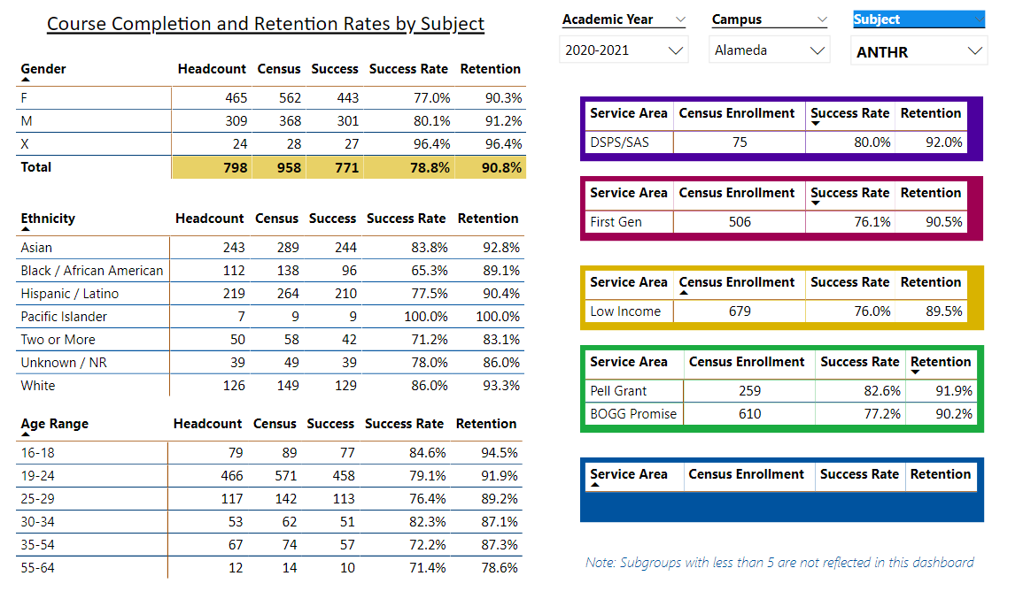

Describe any significant changes and discuss what the changes mean to your program. Consider whether performance gaps exist for disproportionality impacted students by using filters to disaggregate the data. Focus upon the most recent year and/or the years since your last comprehensive program review. Cite data points to support your reflection.

|  |
| --- |
| The Anthropology program at CoA continues to have high levels of student success in terms of course completion and course retention across genders, ages, ethnicities, and across all service areas noted in the reporting dashboards. Success rate percentages provided for this APU tend to be within 2% higher or lower than reported last year, indicating that there have been no significant changes or performance gaps compared with the information from the full program review conducted last year.  There is a somewhat lower success rate for Black/African American females and Black/African American males compared to other reported ethnicities in Anthropology courses (as reported last year as well), but it is unclear what may be causing or contributing to this observation. Conversations with students are warranted to gain insight on this phenomenon.  Overall success rates in Anthropology for all reporting categories tend to outpace the average rates for College of Alameda. The CoA Anthropology program has the second-highest level of productivity at College of Alameda, closely following Sociology in terms of enrollment, retention and student success.  A comparison of all reporting categories for Anthropology courses at all four colleges in the Peralta District shows that there are no significant differences in student success rates throughout the discipline, in spite of extenuating circumstances of COVID-19 over the past 18-20 months. |

Describe the department's progress on Student Learning Outcomes (SLOs) and/or Service Area Outcomes (SAOs) since the last Program Review/APU.

|  |
| --- |
| All Anthropology courses at CoA are assessed every semester in which they are offered, continuing the practice that we have followed for the past three years in CurriQunet and for several years prior to that in Taskstream. Course SLOs have been and continue to be assessed twice per academic year in which they are offered in a three-year cycle.  The assessment sequence has started over in 2021-2022 by assessing SLO 1 in all courses offered in fall 2021 and again in spring 2022 to quantify improvements that result from fall 2021 assessment feedback. SLO 2 will be assessed in all Anthropology courses offered in the academic year 2022-2023, once in fall and again in spring. SLO 3 will be assessed in all Anthropology courses offered in the academic year 2023-2024, once in fall and again in spring. |

Describe the outcomes and accomplishments from previous year’s funded resource allocation request.

|  |  |  |  |
| --- | --- | --- | --- |
| **Brief description of funded request** | **Source (any additional award outside your base allocation)** | **Total Award Amount** | **Outcome/Accomplishment** |
| One faculty intern as part of the Peralta Faculty Diversity Internship Program (FDIP) | None. Costs were borne by FDIP |  | Successful completion of Faculty Diversity Internship resulted in hiring our intern as a part-time faculty member. |
| Instructional Supplies |  | $4,857.62 “lottery” funds | Replacement specimens and supplies purchased as required for Anthropology Lab exercises. |
| Technology & Equipment: New | On loan from CoA IT |  | Portable Zoom/hybrid large-screen computer that integrates in-person teaching with online teaching as a prototype for post-COVID classroom instruction. |
| Facilities repairs | District Office of Risk Management |  | The previously inoperable sink in C-103 was repaired in August 2021 for an approximate cost of $5,000 |

**Prioritized Resource Requests Summary**

In the boxes below, please add resource requests for your program. If there are no resource requested, leave the boxes blank.

|  |  |  |  |  |
| --- | --- | --- | --- | --- |
| **Resource Category** | **Description/Justification** | **Estimated Annual Salary Costs** | **Estimated Annual Benefits Costs** | **Total Estimated Cost** |
| **Personnel: Classified Staff** |  |  |  |  |
| **Personnel: Student Worker** |  |  |  |  |
| **Personnel: Part Time Faculty** |  |  |  |  |
| **Personnel: Full Time Faculty** |  |  |  |  |

|  |  |  |
| --- | --- | --- |
| **Resource Category** | **Description/Justification** | **Total Estimated Cost** |
| **Professional Development: Department wide PD needed** |  |  |
| **Professional Development: Personal/Individual PD needed** | American Association of Biological Anthropologists 91st annual meeting: March 23-26, 2022 in Denver, CO. | $1,000 |

**Prioritized Resource Requests Summary - Continued**

|  |  |  |
| --- | --- | --- |
| **Resource Category** | **Description/Justification** | **Total Estimated Cost** |
| **Supplies: Software** |  |  |
| **Supplies: Books, Magazines, and/or Periodicals** |  |  |
| **Supplies: Instructional Supplies** | New and replacement osteological elements and specimens required for Anthropology Lab exercises. Current assemblage is in need of specific specimen replacements and new purchases (itemized list and cost-breakdown available). | $5,000 |
| **Supplies: Non-Instructional Supplies** |  |  |
| **Supplies: Library Collections** |  |  |

|  |  |  |
| --- | --- | --- |
| **Resource Category** | **Description/Justification** | **Total Estimated Cost** |
| **Technology & Equipment: New** | Secure storage cabinets to house program specimens and equipment, additional osteometric boards, hand-held calculators, calipers, and large world maps for classroom use. | $1000 |
| **Technology & Equipment: Replacement** | Smart-classroom repairs as needed to restore the new Anthropology Laboratory (D-115) to working order no later than fall 2022 for in-person classroom instruction.  D-115 is currently (11/4/2021) being used as a storage room for extra IT equipment, large photocopiers, and extra desks/chairs. D-115 may need repairs and/or smart-classroom updates, but it is not possible to ascertain what is needed until the room is emptied and cleaned. | unknown |

**Prioritized Resource Requests Summary - Continued**

|  |  |  |
| --- | --- | --- |
| **Resource Category** | **Description/Justification** | **Total Estimated Cost** |
| **Facilities: Classrooms** | Need: a large-capacity classroom in close proximity to D-115 to be used as the ANTHR 1 classroom on MTWTh 9:30 a.m. – 10:45 a.m. for fall 2022. Preferred classroom: D-119. We could use D-115 as the lecture classroom, but that would restrict lecture class enrollment to 35 students maximum. Lecture classroom needs to be outfitted with smart-classroom technology, internet access and sufficient tables for specimens displays. | unknown |
| **Facilities: Offices** | Need: full-time faculty office, ideally D-116A (as soon as the space is vacated by the retired current occupant). | unknown |
| **Facilities: Labs** | Need: D-115 laboratory classroom to be cleared, cleaned and brought up to laboratory teaching standards before fall 2022, including water and large sink access, smart-classroom technology, internet access, and additional specimens display stations for lab observations. **(Not included in original APU: also need 35-40 high stools as student seats at lab tables in D-115).** | unknown |
| **Facilities: Other** | Need: D-115A dedicated storage and specimens prep room with water and large sink facilities, plus room for 6-8 large (6-foot X 4-foot X 2-foot) locking cabinets for specimens, plus storage area for 40 banker-boxes of archaeological specimens, archaeological equipment and at least three 6-foot open racks of specimens. | unknown |

|  |  |  |
| --- | --- | --- |
| **Resource Category** | **Description/Justification** | **Total Estimated Cost** |
| **Library: Library materials** |  |  |
| **Library: Library collections** | Canvas access to Films on Demand for students. | unknown, ongoing |

|  |  |  |
| --- | --- | --- |
| **Resource Category** | **Description/Justification** | **Total Estimated Cost** |
| **OTHER** |  |  |