**College of Alameda**

2021-22 Annual Program Update - ASTR

**Program Overview**

Please provide your program’s mission statement and program’s learning outcomes

|  |
| --- |
| The mission of the Astronomy Department at College of Alameda is to introduce students to the Universe and insight into its mysteries. Students will learn how observations have shaped theories of basic astronomical phenomena and the evolution of the Universe.  We provide comprehensive and flexible programs that empower students to achieve their goals through offering of online and face-to-face sections of introductory astronomy. |

List your program faculty and/or staff

|  |
| --- |
| Andrew Park  Andrew Fittingoff  Dietmar Krauss-Varban |

Describe your current utilization of facilities, including labs and other space

|  |
| --- |
| Any lecture demos useful for Astronomy are stored in Physics stockroom (ATLAN 101). Astronomy lecture classes are scheduled according to campus-wide classroom availability. |

List your program goals from your most recent Program Review or APU. Then, provide an update on the status of the goal. Has your program achieved the goal? Have any of your goals been revised or any still in progress? Lastly, make sure to discuss which College or District goal your program goal aligns to.

If no program goals exist or if this is your first program review, work to create 2-3 goals and align them with a College or District goal.

|  |  |
| --- | --- |
| **Program Goal** | Increase ASTR 1/10 offering |
| Status: In-Progress or Complete? | In-Progress |
| Which college or district goal is aligned with your program goal? | College Goal 1: Student Access |

|  |  |
| --- | --- |
| **Program Goal** | Continue to maintain supplies and equipment for ASTR lecture demos |
| Status: In-Progress or Complete? | In-Progress |
| Which college or district goal is aligned with your program goal? | College Goal 6: Teaching and Learning |

|  |  |
| --- | --- |
| **Program Goal** | Regular online ASTR/PHYS faculty meeting during semester |
| Status: In-Progress or Complete? | In-Progress |
| Which college or district goal is aligned with your program goal? | College Goal 6: Teaching and Learning |

|  |  |
| --- | --- |
| **Program Goal** | Retain our astronomy instructors through a few assessment cycles, so that results of assessments may lead to improvement of pedagogy and improved assessments |
| Status: In-Progress or Complete? | In-Progress |
| Which college or district goal is aligned with your program goal? | College Goal 6: Teaching and Learning |
| **Program Goal** | Provide opportunities for students to participate in astronomical observations |
| Status: In-Progress or Complete? | In-Progress |
| Which college or district goal is aligned with your program goal? | College Goal 6: Teaching and Learning |

**Program Update**

Using the dashboards, review and reflect upon the data for your program.

[**Course Completion and Retention Rates – Instructional Dashboard**](https://app.powerbi.com/view?r=eyJrIjoiNjc2MDhiNTEtNTJhZi00MDM0LTk5NDItNTRiY2EzMGI1NTZiIiwidCI6ImVlYTE2YTE2LTQ4YWYtNDc3Yi05MTEzLTA1YjFjMDExMjNmZiIsImMiOjZ9&pageName=ReportSection86d6f65e2fb41a73da4d)

[**Course Completion and Retention Rates – Student Services Dashboard**](https://app.powerbi.com/view?r=eyJrIjoiNjk3NDJjOTItNzI5MS00MDhjLWJhN2EtZjcxNzU4OTBiZDBjIiwidCI6ImVlYTE2YTE2LTQ4YWYtNDc3Yi05MTEzLTA1YjFjMDExMjNmZiIsImMiOjZ9&pageName=ReportSection86d6f65e2fb41a73da4d)

[**Enrollment Trends and Productivity Dashboard**](https://app.powerbi.com/view?r=eyJrIjoiNWJlOWZmYTEtNTY0MC00MDhkLWE5OTAtYmJjZjIxNzJiNWViIiwidCI6ImVlYTE2YTE2LTQ4YWYtNDc3Yi05MTEzLTA1YjFjMDExMjNmZiIsImMiOjZ9&pageName=ReportSection86d6f65e2fb41a73da4d)

[**Degrees and Certificates Dashboard**](https://app.powerbi.com/view?r=eyJrIjoiZjU2M2M5MzItOTcwZi00Y2U1LWJmODUtYTc0YjlhZGI2ZDhjIiwidCI6ImVlYTE2YTE2LTQ4YWYtNDc3Yi05MTEzLTA1YjFjMDExMjNmZiIsImMiOjZ9&pageName=ReportSectionde32556e136b0a8caccd)

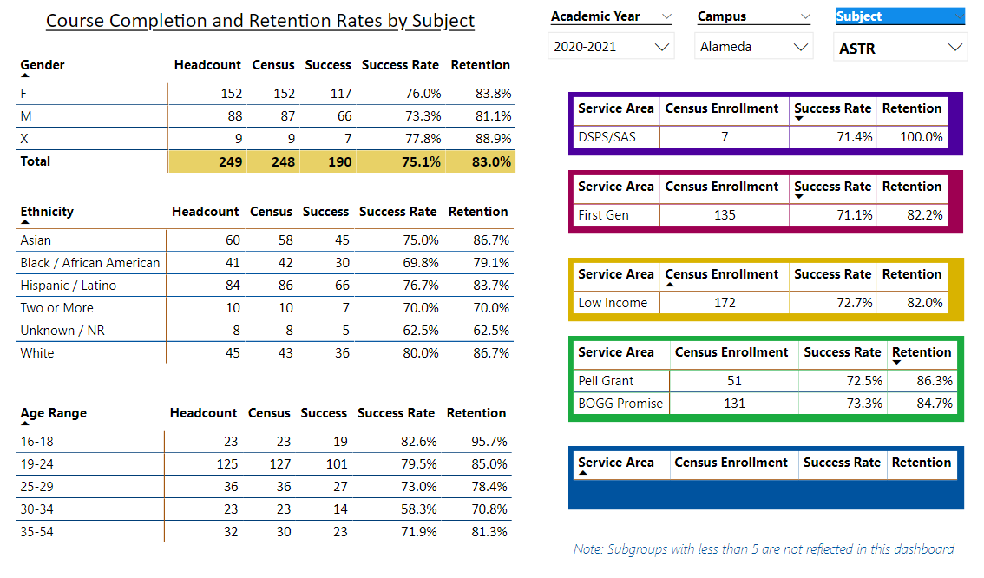

Describe any significant changes and discuss what the changes mean to your program. Consider whether performance gaps exist for disproportionality impacted students by using filters to disaggregate the data. Focus upon the most recent year and/or the years since your last comprehensive program review. Cite data points to support your reflection.

|  |
| --- |
| Patterns previously identified (lower success rate for AfrAm students – 69.8% compared against department average of 75.1%; lower success rate for 30-34 age group – 58.3%) persist.  Conversation among all three ASTR instructors is needed in identifying possible causes and how to help narrow this performance gap. |

Describe the department's progress on Student Learning Outcomes (SLOs) and/or Service Area Outcomes (SAOs) since the last Program Review/APU.

|  |
| --- |
| ASTR 1 was last assessed Fall 2019; SLOs for ASTR 10 has not yet been assessed and will be assessed in Fall 2021. (One special note for ASTR 1 and ASTR 10: these two are substantively same courses; we switched to offering ASTR 10 instead of ASTR 1 in Spring 2021, when ASTR 10 was included in our IGETC list, but we switched back for Spring 2022, because ASTR 10 is not yet approved for UC general education areas.) |

Describe the outcomes and accomplishments from previous year’s funded resource allocation request.

|  |  |  |  |
| --- | --- | --- | --- |
| **Brief description of funded request** | **Source (any additional award outside your base allocation)** | **Total Award Amount** | **Outcome/Accomplishment** |
| N/A | N/A | N/A | N/A |
|  |  |  |  |
|  |  |  |  |

**Prioritized Resource Requests Summary**

In the boxes below, please add resource requests for your program. If there are no resource requested, leave the boxes blank.

|  |  |  |  |  |
| --- | --- | --- | --- | --- |
| **Resource Category** | **Description/Justification** | **Estimated Annual Salary Costs** | **Estimated Annual Benefits Costs** | **Total Estimated Cost** |
| **Personnel: Classified Staff**  N/A |  |  |  |  |
| **Personnel: Student Worker**  N/A |  |  |  |  |
| **Personnel: Part Time Faculty**  Maintain or increase existing staffing level | Introductory astronomy courses remain a popular physical science GE option; history of successful offerings in intersession |  |  |  |
| **Personnel: Full Time Faculty**  Maintain or increase existing staffing level | Same note as above |  |  |  |

|  |  |  |
| --- | --- | --- |
| **Resource Category** | **Description/Justification** | **Total Estimated Cost** |
| **Professional Development: Department wide PD needed**  N/A | No estimated costs for informal PD that continues to take place. |  |
| **Professional Development: Personal/Individual PD needed**  N/A | Individual PD requests will go through the PD committee |  |

**Prioritized Resource Requests Summary - Continued**

|  |  |  |
| --- | --- | --- |
| **Resource Category** | **Description/Justification** | **Total Estimated Cost** |
| **Supplies: Software**  N/A | Most current needs are met through free/open-source resources |  |
| **Supplies: Books, Magazines, and/or Periodicals**  N/A | Most current needs are met through free/open-source resources. |  |
| **Supplies: Instructional Supplies**  Maintain existing lottery/IELM allocation | Existing lottery/IELM allocation is used for ongoing (small) repairs of lecture demo as well as re-stocking and purchasing trial quantities of new demos. |  |
| **Supplies: Non-Instructional Supplies**  N/A |  |  |
| **Supplies: Library Collections**  N/A | Current library collection is up to date. |  |

|  |  |  |
| --- | --- | --- |
| **Resource Category** | **Description/Justification** | **Total Estimated Cost** |
| **Technology & Equipment: New**  Maintain existing lottery/IELM allocation | Existing lottery/IELM allocation is used for ongoing (small) repairs of lecture demo as well as re-stocking and purchasing trial quantities of new demos. |  |
| **Technology & Equipment: Replacement**  Maintain existing lottery/IELM allocation | Existing lottery/IELM allocation is used for ongoing (small) repairs of lecture demo as well as re-stocking and purchasing trial quantities of new demos. |  |

**Prioritized Resource Requests Summary - Continued**

|  |  |  |
| --- | --- | --- |
| **Resource Category** | **Description/Justification** | **Total Estimated Cost** |
| **Facilities: Classrooms**  N/A | Astronomy lecture classes are scheduled within general campus availability |  |
| **Facilities: Offices**  N/A | While no office space is specifically available to Astronomy faculty (beyond the general shared spaces), where necessary, Physics office space will be shared. |  |
| **Facilities: Labs**  N/A |  |  |
| **Facilities: Other**  N/A |  |  |

|  |  |  |
| --- | --- | --- |
| **Resource Category** | **Description/Justification** | **Total Estimated Cost** |
| **Library: Library materials**  N/A | Existing resources are currently sufficient. |  |
| **Library: Library collections**  N/A | Existing resources are currently sufficient. |  |

|  |  |  |
| --- | --- | --- |
| **Resource Category** | **Description/Justification** | **Total Estimated Cost** |
| **OTHER**  N/A |  |  |