**College of Alameda**

2021-22 Annual Program Update - ATECH

**Program Overview**

Please provide your program’s mission statement and program’s learning outcomes

|  |
| --- |
| MISSION STATEMENT  **The Automotive Technology curriculum is designed to prepare students for employment as apprentice auto mechanics or to allow students to continue toward a Baccalaureate degree in other advanced schools of technology in preparation for future management and teaching careers in the automotive industry.**  **The College of Alameda ATECH program is certified by the National Automotive Technicians Education Foundation (NATEF), NATEF certification guidelines and procedures are attached (Appendix D1 and D2) The program also works with the Apprentice program to meet their training needs, as well as with the Calif Bureau of Automotive Repair (BAR) in supplying required update programs for certified California Smog Mechanics and including in the regular curriculum the material required for Calif State Smog Licenses (as well as Calif State Lamp and Brake licenses)**  Program learning outcomes  *Be ‘lifelong learners’ in the field of automotive technology, keeping up with changes in vehicles, in diagnostics and in repair procedures through a commitment to continual learning and training.  *Communicate effectively with customers, supervisors and co-workers.  *Apply critical thinking and problem solving skills in the process of diagnosing and repairing vehicles.  *Competently perform industry standard automotive repair procedures, using proper tools, procedures and diagnostic techniques, as specified in the NATEF program certification process. |

List your program faculty and/or staff

|  |
| --- |
| Contract faculty – Rick Greenspan, Rufino Ramos, Wayne Fung, John Peterson  part-time faculty – Henry Chan, Patrick Dong, Mark Christensen  staff – Candido Mejia |

Describe your current utilization of facilities, including labs and other space

|  |
| --- |
| We use all lab and most lecture spaces in the B Building, M – Fri, from 8 am to 10 pm;  occasionally we run specialized weekend classes for technicians. COA also rents out part of B Building for state Smog referee program. |

List your program goals from your most recent Program Review or APU. Then, provide an update on the status of the goal. Has your program achieved the goal? Have any of your goals been revised or any still in progress? Lastly, make sure to discuss which College or District goal your program goal aligns to.

If no program goals exist or if this is your first program review, work to create 2-3 goals and align them with a College or District goal.

|  |  |
| --- | --- |
| **Program Goal** | **Maintain quality of program** |
| Status: In-Progress or Complete? | Always in progress |
| Which college or district goal is aligned with your program goal? | Build Programs of Distinction  Advance student ... success |

|  |  |
| --- | --- |
| **Program Goal** | **Keep up with changes in industry** |
| Status: In-Progress or Complete? | Always in progress |
| Which college or district goal is aligned with your program goal? | Build Programs of Distinction  Advance student ... success |

|  |  |
| --- | --- |
| **Program Goal** | **Professional development for faculty** |
| Status: In-Progress or Complete? | Always in progress |
| Which college or district goal is aligned with your program goal? | Advance COA teaching and learning |

|  |  |
| --- | --- |
| **Program Goal** | **Continue to maintain NATEF (ASE Educational Foundtion) Master Level program certification status** |
| Status: In-Progress or Complete? | Always in progress |
| Which college or district goal is aligned with your program goal? | Build Programs of Distinction  Advance COA teaching and learning |

|  |  |
| --- | --- |
| **Program Goal** | **Update equipment, such as hybrid, direct injec on, electric and fuel cell vehicles, for student labs** |
| Status: In-Progress or Complete? | Always in progress |
| Which college or district goal is aligned with your program goal? | Build Programs of Distinction  Advance COA teaching and learning |
| **Program Goal** | **Update diagnotic equipment to match industry standards** |
| Status: In-Progress or Complete? | Always in progress |
| Which college or district goal is aligned with your program goal? | Build Programs of Distinction  Advance COA teaching and learning |

**Program Update**

Using the dashboards, review and reflect upon the data for your program.

[**Course Completion and Retention Rates – Instructional Dashboard**](https://app.powerbi.com/view?r=eyJrIjoiNjc2MDhiNTEtNTJhZi00MDM0LTk5NDItNTRiY2EzMGI1NTZiIiwidCI6ImVlYTE2YTE2LTQ4YWYtNDc3Yi05MTEzLTA1YjFjMDExMjNmZiIsImMiOjZ9&pageName=ReportSection86d6f65e2fb41a73da4d)

[**Course Completion and Retention Rates – Student Services Dashboard**](https://app.powerbi.com/view?r=eyJrIjoiNjk3NDJjOTItNzI5MS00MDhjLWJhN2EtZjcxNzU4OTBiZDBjIiwidCI6ImVlYTE2YTE2LTQ4YWYtNDc3Yi05MTEzLTA1YjFjMDExMjNmZiIsImMiOjZ9&pageName=ReportSection86d6f65e2fb41a73da4d)

[**Enrollment Trends and Productivity Dashboard**](https://app.powerbi.com/view?r=eyJrIjoiNWJlOWZmYTEtNTY0MC00MDhkLWE5OTAtYmJjZjIxNzJiNWViIiwidCI6ImVlYTE2YTE2LTQ4YWYtNDc3Yi05MTEzLTA1YjFjMDExMjNmZiIsImMiOjZ9&pageName=ReportSection86d6f65e2fb41a73da4d)

[**Degrees and Certificates Dashboard**](https://app.powerbi.com/view?r=eyJrIjoiZjU2M2M5MzItOTcwZi00Y2U1LWJmODUtYTc0YjlhZGI2ZDhjIiwidCI6ImVlYTE2YTE2LTQ4YWYtNDc3Yi05MTEzLTA1YjFjMDExMjNmZiIsImMiOjZ9&pageName=ReportSectionde32556e136b0a8caccd)

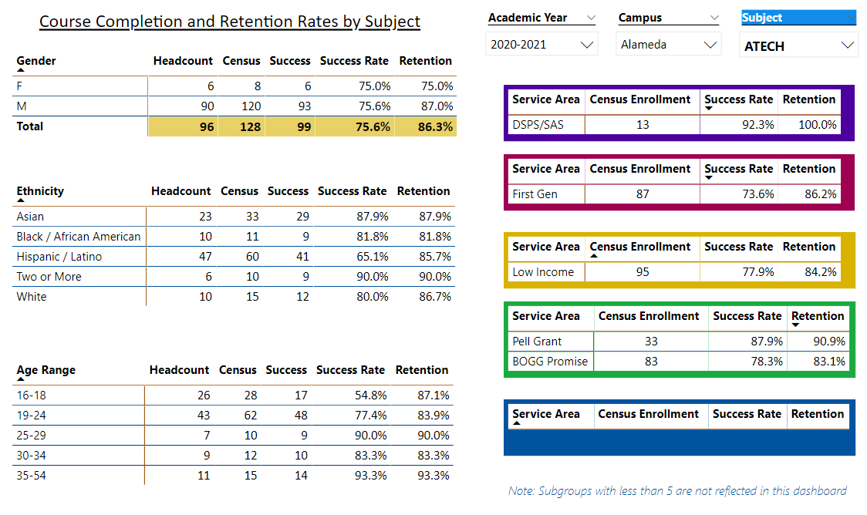

Statistics from 20-21, from the midst of the pre-vaccine pandemic, doesn’t help a lot to use as a model to plan for the future. Half our contract faculty was on “high risk of Covid” leave; no substitutes could be found, so those classes were cancelled; and enrollment was way down.

We are just now getting back to “normal”, albiet with an FTEF cap which prevents new students from enrolling in (normally large) introductory classes. We are hopeful that next year’s program review will be more meaningful than this year’s.

Describe any significant changes and discuss what the changes mean to your program. Consider whether performance gaps exist for disproportionality impacted students by using filters to disaggregate the data. Focus upon the most recent year and/or the years since your last comprehensive program review. Cite data points to support your reflection.

|  |
| --- |
| Since Atech classes require in-person labs, we had to cut class sizes to allow for social distancing. In addition, COA’s new FTEF allocation system cut the number of classes that Atech was allowed to offer. For 2021-22, we were not allowed to offer the classes that our students needed to complete their certificates/degrees. Essentially, COA’s allocation model was punishing current students by now allowing them to graduate.  Atech brought this issue to our Advisory Committee in spring, 2021, which passed the following resolution:  RESOLUTION  The COA Atech Advisory Committee urges the College of Alameda administration to allow the Atech program to offer the classes that are needed by current students to progress through and complete the program as provided in the college catalogue.  We urge that introductory Atech classes be included in the schedule each semester, so that new students can enroll in the program during the 21-22 academic year.  If the school does not have regular funds to pay for the classes which Atech students need, we urge that the COA administration explore funding the necessary classes using Parcel Tax and American Rescue Plan educational funds.  SIGNED,  Scott Jeffries, Subaru of America  Brian McKee, Hunter Engineering  Ernesto Eugenio, US Post Office  Bob Paredes, Snapon Tools  Steve Gilbert, scholarship provider  Brian Stranahan, Matco Tools  Tom Brennan, ASE Educational Foundation  Jimmy Tran, program graduate  April 15, 2021    In October, Atech brought the issue to the COA Academic Senate, which passed the following resolution  **Resolution by the College of Alameda Academic Senate re Maintaining a Schedule of Classes that Allows Students to Finish Degree and Certificate Programs**  WHEREAS, the College of Alameda (CoA), through representations in its catalog and published schedule promises students and the community that it will offer defined sequences of classes that will lead to particular degrees and certificates; and  WHEREAS, the CoA counseling department, relying on such representations and in collaboration with instructional faculty, advises students to pursue specific courses of study over a clearly defined period of time, an approach now formalized in the college’s embrace of Guided Pathways; and  WHEREAS, the East Bay community depends on CoA to deliver on its promises in a timely way to ensure that it gains all the benefits that come from having an educated population and well-trained workforce; and  WHEREAS, CoA would risk its ability to meet accreditation standards as established by the Accrediting Commission for Community and Junior Colleges (ACCJC) by failing to make available the classes necessary to award degrees and certificates (see., e.g., ACCJC Standards II.A.1 and II.C.6); and  WHEREAS, CoA and the Peralta Community College District (PCCD), despite being held harmless by the state for its apportionment through 2024-25, have announced their commitment to transitioning to the new Student-Centered Funding Formula (SCFF), which once implemented will weight the awarding of degrees and certificates in the state’s allocation of resources more heavily; and  WHEREAS, the aforementioned held-harmless status means that PCCD is collecting millions of dollars above what it would be receiving were strict enrollment-driven apportionment formulas still being applied, dollars the district could in part make available for instruction and support services at the colleges; and  WHEREAS, CoA’s not offering classes that allow students to finish their studies would be a dereliction of CoA’s declared mission “to serve the educational needs of its diverse community by providing comprehensive and flexible programs and resources that empower students to achieve their goals”;  NOW, THEREFORE, BE IT RESOLVED that the CoA Academic Senate urges the college and district administrations, however real their concerns about long-term fiscal sustainability, to schedule the courses that students need to finish the degree and certificate programs they’ve started in a timely way; and  BE IT FURTHER RESOLVED that the CoA Academic Senate invites the college and district administrations to join faculty in putting concrete educational commitments to student success and achievement above abstract business principles such as austerity and productivity, especially as reserves continue to grow and a pandemic continues to adversely affect our students’ and communities’ educational prospects.  Resolution approved October 7, 2021  I met with Dean Jenkins and VPI Bajrami in early October and the VPI was able to find funding for the classes that our continuing students needed in the spring. Those classes have now been added back into the schedule.  Essentially, it has taken Atech a full year to get our program back to offering the classes that our students need. For the last 9 months, that issue has been our priority, crowding out the things we normally work on to improve our program and offerings.  As of today, the Atech program is running all our classes in person, adhering to all current Peralta and county Covid safety protocols, and we will be offering the classes that our students need in spring 2022.  Between Covid protocols and Don Miller’s FTEF allocation cuts, we’ve spent the better part of the last year and a half fighting to get back to where we started! |

Describe the department's progress on Student Learning Outcomes (SLOs) and/or Service Area Outcomes (SAOs) since the last Program Review/APU.

|  |
| --- |
| A number of our classes were not run at all during 20-21, so we are just getting back to offering a full slate of classes this year. The classes that we did run during 20-21 were evaluated for SLOs last summer (2021). We won’t be assessing 21-22 SLOs until summer 2022. It’s hard to know how we are doing on SLOs at this point in the Fall semester. |

Describe the outcomes and accomplishments from previous year’s funded resource allocation request.

|  |  |  |  |
| --- | --- | --- | --- |
| **Brief description of funded request** | **Source (any additional award outside your base allocation)** | **Total Award Amount** | **Outcome/Accomplishment** |
| General supply and equipment | General Funds, Strong Workforce, Perkins | about $20000 | Throughout the pre-vaccination pandemic, our lecture classes were online and our labs were cut in half to maintain social distancing. This semester we are finally back to in-person lectures and labs, and beginning to bring our equipment back to an acceptable level. |
| Updating faculty desk computers  (not part of last APU) | Unknown | Unknown | All faculty desktop computers are running Windows 7, which is no longer supported by Microsoft. VPI Bajrami , Dean Jenkins and IT head Bala Sampathraj are working on replacing those computers with ones which will run Windows 10. |
|  |  |  |  |

**Prioritized Resource Requests Summary**

In the boxes below, please add resource requests for your program. If there are no resource requested, leave the boxes blank.

|  |  |  |  |  |
| --- | --- | --- | --- | --- |
| **Resource Category** | **Description/Justification** | **Estimated Annual Salary Costs** | **Estimated Annual Benefits Costs** | **Total Estimated Cost** |
| **Personnel: Classified Staff** |  |  |  |  |
| **Personnel: Student Worker** |  |  |  |  |
| **Personnel: Part Time Faculty** |  |  |  |  |
| **Personnel: Full Time Faculty** |  |  |  |  |

|  |  |  |
| --- | --- | --- |
| **Resource Category** | **Description/Justification** | **Total Estimated Cost** |
| **Professional Development: Department wide PD needed** |  |  |
| **Professional Development: Personal/Individual PD needed** |  |  |

**Prioritized Resource Requests Summary - Continued**

|  |  |  |
| --- | --- | --- |
| **Resource Category** | **Description/Justification** | **Total Estimated Cost** |
| **Supplies: Software** | Continue to update software systems | about $5000 annually |
| **Supplies: Books, Magazines, and/or Periodicals** | none | none |
| **Supplies: Instructional Supplies** | continuation of the same funding streams from general funds, Strong workforce and perkins | about $15,000 annually |
| **Supplies: Non-Instructional Supplies** | none | none |
| **Supplies: Library Collections** | none | none |

|  |  |  |
| --- | --- | --- |
| **Resource Category** | **Description/Justification** | **Total Estimated Cost** |
| **Technology & Equipment: New** | Purchase vehicles. Speficially we need a vehicle with ADAS (Advanced Driver Assistance System). We could purchase it used, but can only be a few years old | $40,000 for one vehicle  $80,000 for two |
| **Technology & Equipment: Replacement** | 1) Now that we are back to teaching in person classes, we’ll need to replace outdated diagnostic equipment (scanners, DSOs, etc.).  2) The laptops that are used as diagnostic interfaces with vehicles were all running Windows 7 (no longer supported), and didn’t have enough capacity to update to Windows 10 to run the latest versions of the diagnostic interfaces. They need to be replaced with newer laptops. | $25,000 |

**Prioritized Resource Requests Summary - Continued**

|  |  |  |
| --- | --- | --- |
| **Resource Category** | **Description/Justification** | **Total Estimated Cost** |
| **Facilities: Classrooms** |  |  |
| **Facilities: Offices** |  |  |
| **Facilities: Labs** | Upkeep and maintenance for the large equipment (vehicle lifts, brake lathes, alignment machines, etc.) in our shop areas essentially ground to a halt for 18 months. We’ll now need to bring that equipment up to industry standards. | $20,000 |
| **Facilities: Other** |  |  |

|  |  |  |
| --- | --- | --- |
| **Resource Category** | **Description/Justification** | **Total Estimated Cost** |
| **Library: Library materials** |  |  |
| **Library: Library collections** |  |  |

|  |  |  |
| --- | --- | --- |
| **Resource Category** | **Description/Justification** | **Total Estimated Cost** |
| **OTHER** |  |  |