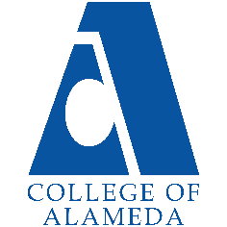College of Alameda

2021-22 Annual Program Update - CHEM

# Program Overview

Please provide your program’s mission statement.

COA chemistry offers general chemistry (Chem 1A/1B) for science majors, introductory general chemistry (Chem 30A/30B) for allied-health career track students. COA chemistry is a small program with one full time and five part time instructors. Demand for chemistry courses is high since these are prerequisite for almost any career in the sciences or health care industry.

List your program faculty and/or staff

Full Time – Peter Olds

Part Time – Jacob Schlegel, Alex Madonik, Eileen Clifford, Milt Friedman

List your program goals from your most recent Program Review or APU.

Then, provide an update on the status of the goal. Has your program achieved the goal? Have any of your goals been revised or any still in progress?

Lastly, make sure to discuss which College or District goal your program goal aligns to.

If no program goals exist or if this is your first program review, work to create 2-3 goals and align them with a College or District goal.

|  |  |
| --- | --- |
| **Program Goal**  Bring laboratory management and oversight up to minimum standards. Mitigate the historical lack of safety regulatory compliance in COA labs. | Hire or appoint a qualified Chemical Hygiene Officer (CHO).  Implement a Chemical Hygiene Plan (CHP) in COA science labs.  Turn lab management and oversight over to successful, qualified, senior and former COA chemistry students, consistently hired to work under faculty supervision. |
| Status: In-Progress or Complete? | Stalled with no progress. There is no chemical hygiene officer (CHO) in place as required by law. The CHO’s primary job is implementing a Chemical Hygiene Plan (CHP) also required by law. Faculty don’t have access to reliable inventory information. Expired chemicals and chemicals of questionable origin, identity and quality are routinely put in front of students. Faculty don’t know locations of emergency cutoff valves for tap water, DI water, gas and vacuum systems. Maintenance of these systems is neither guaranteed nor transparent. There is currently no lab  management expertise with supervisory authority at COA. |
| Which college or district goal is aligned with your program goal? | Advance student access, equity and success. |

|  |  |
| --- | --- |
| **Program Goal**  Refurbish and bring up to satisfactory standards the abandoned D-109 main campus chemistry lab plus D-105 stockroom area. | This includes reinstallation of hoods, laboratory furniture, and a complete plumbing upgrade. Similarly refurbish and bring up to satisfactory standards for demos the D-119 lecturn (gas and water) and D-119 chem demo prep area. As of 9-26-2017 four hoods and bench faucets had been reinstalled. Another  hood is needed for the Chem/Demo prep area in addition to shelving and lab bench re-installation. Dry chemical storage area also needs earthquake-proof shelving replacement. |
| Status: In-Progress or Complete? | Stalled with no progress. Alternate tentative plans for a new science building were just announced. But faculty have not yet been consulted regarding space, equipment and/or facilities  needs and allocations. |
| Which college or district goal is aligned with your program goal? | Advance student access, equity and success. |

|  |  |
| --- | --- |
| **Program Goal** | Obtain a scanning electron microscope (SEM) with an EDS elemental analysis attachment for shared use between chemistry, physics, biology, and earth sciences. Hire a second additional FT faculty member whose responsibilities include instruction on using and maintenance of this facility.  Coordinate with COA's CTE dean (and SEM manufacturer) to develop a SEM operator plus maintenance training program with this equipment modelled after San Joaquin Delta College’s program:  <https://www.deltacollege.edu/program/electron-microscopy> |
| Status: In-Progress or Complete? | CTE department dean has been contacted and will be given a copy of this program review. This goal could be integrated with new science building plans. |
| Which college or district goal is aligned with your program goal? | Advance COA teaching and learning. Build programs of distinction. |

|  |  |
| --- | --- |
| **Program Goal** | Resume offering Chem 30B – Introduction to organic and biochemistry for allied health students. |
| Status: In-Progress or Complete? | In progress. Success is contingent on resolving laboratory issues. |
| Which college or district goal is aligned with your program goal? | Advance COA teaching and learning. Build programs of distinction. |

|  |  |
| --- | --- |
| **Program Goal** | Offer Chem 18 – Analytical instrumentation. |
| Status: In-Progress or Complete? | In progress. Piggyback off of [BCC’s existing course.](https://www.berkeleycitycollege.edu/wp/sci-biotech/classes-programs/chemistry/chem-18-analytical-instrumentation/)  Teach analytical chemistry skills to students who have successfully completed Chem 1B. |
| Which college or district goal is aligned with your program goal? | Advance COA teaching and learning. Build programs of distinction. |

Describe your current utilization of facilities, including labs and other space

Pre-pandemic: One chemistry laboratory, Room 150 at the Science annex, (with four chemical hoods) can reasonably accommodate 25 students. This single lab is presently used for all chemistry courses offered at COA. Several Science Annex rooms including 110 and 160 are used for chemistry classes. Room D-119 on the main campus is also used for Chem 1A/1B lectures and chemistry demonstrations. The partially refurbished D-109 chemistry lab is still not practically functional.

During the pandemic: Chemistry faculty have been teaching from home online with Zoom plus various online academic and virtual lab platforms since late March 2020. Lab instruction online is supported by the availability of chemistry kits that have been purchased with Chemistry Instructional Supplies budget for students with demonstrated need. Online chemistry teaching platforms, in particular Macmillan Achieve Interactive General Chemistry, Achieve Virtual Labs and Beyond Labz, facilitate state-of-the-art remote learning. Additional instructional funds are being used to increase teaching efficiency by providing large monitors and large writing tablets for chemistry faculty teaching from home.

# Program Update

Using the dashboards, review and reflect upon the data for your program. [Course Completion and Retention Rates – Instructional Dashboard](https://app.powerbi.com/view?r=eyJrIjoiNjc2MDhiNTEtNTJhZi00MDM0LTk5NDItNTRiY2EzMGI1NTZiIiwidCI6ImVlYTE2YTE2LTQ4YWYtNDc3Yi05MTEzLTA1YjFjMDExMjNmZiIsImMiOjZ9&pageName=ReportSection86d6f65e2fb41a73da4d) [Course Completion and Retention Rates – Student Services Dashboard](https://app.powerbi.com/view?r=eyJrIjoiNjk3NDJjOTItNzI5MS00MDhjLWJhN2EtZjcxNzU4OTBiZDBjIiwidCI6ImVlYTE2YTE2LTQ4YWYtNDc3Yi05MTEzLTA1YjFjMDExMjNmZiIsImMiOjZ9&pageName=ReportSection86d6f65e2fb41a73da4d) [Enrollment Trends and Productivity Dashboard](https://app.powerbi.com/view?r=eyJrIjoiNWJlOWZmYTEtNTY0MC00MDhkLWE5OTAtYmJjZjIxNzJiNWViIiwidCI6ImVlYTE2YTE2LTQ4YWYtNDc3Yi05MTEzLTA1YjFjMDExMjNmZiIsImMiOjZ9&pageName=ReportSection86d6f65e2fb41a73da4d)

[Degrees and Certificates Dashboard](https://app.powerbi.com/view?r=eyJrIjoiZjU2M2M5MzItOTcwZi00Y2U1LWJmODUtYTc0YjlhZGI2ZDhjIiwidCI6ImVlYTE2YTE2LTQ4YWYtNDc3Yi05MTEzLTA1YjFjMDExMjNmZiIsImMiOjZ9&pageName=ReportSectionde32556e136b0a8caccd)

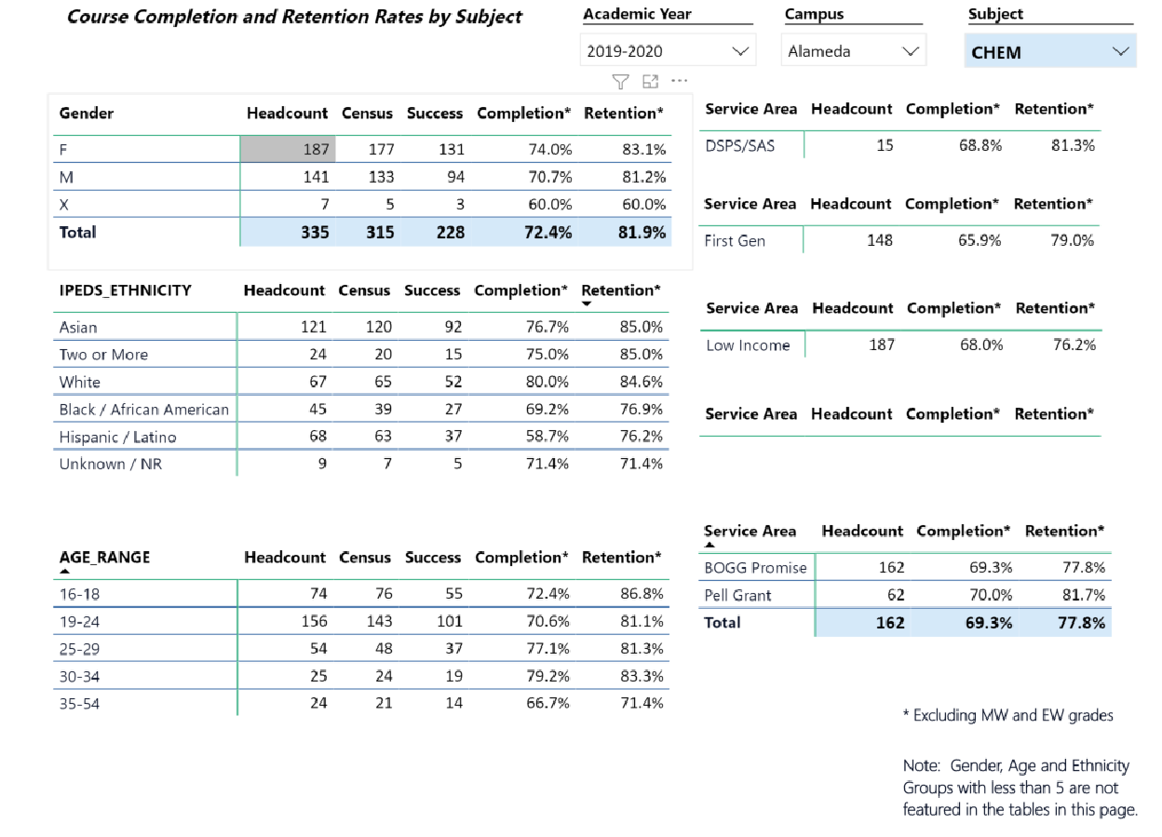

Describe any significant changes and discuss what the changes mean to your program. Consider whether performance gaps exist for disproportionality impacted students by using filters to disaggregate the data. Focus upon the most recent year and/or the years since your last comprehensive program review. Cite data points to support your reflection.

Enrollment declined in 2015-16 and more recently in 2018-19. (See data in previous program review.) These declines mirror the trend seen in general chemistry Chem 1A/1B and in 2018-19 were worsened by repeated cancellation of introductory organic and biochemistry Chem 30B. Student retention and completion rates are relatively stable. Offering enough sections to serve the available student enrollment population is a problem.

It is to be noted that Chem 1A/1B and Chem 30B require the most sophisticated laboratory experiments. So, the most recent decline in overall student enrollment may be related to administrative decision to defund hiring of high-quality student employees in lab settings during 2018-19. These student workers, when present, provided much needed support for struggling students and compensated for lack of qualified lab management.

In 2019-2020 completion and retention rates are typically in the 70-80% range except for Hispanic/Latino ethnicity and unspecified gender categories which had completion rates near 60%. The latter results are of questionable reliability due to statistics of small numbers, but the

former is cause for concern. As a result, Chemistry faculty members are in active discussions about how to improve success rates for Hispanic/Latino students. Current ideas include drawing attention Hispanic/Latino students working in classrooms and chemistry-related jobs in the community, and making more use of available CoA tutoring facilities (MESA) and classroom instructional assistants to facilitate translation of course terminology if needed.

The 70-80% completion and retention rates are systematically higher than previous years, possibly due to implementation of the Chem 30A prerequisite for Chem 1A.

Describe the department's progress on Student Learning Outcomes (SLOs) and/or Administrative Unit Outcomes (AUOs) since the last Program Review/APU. If your discipline offers a degree or certificate, please describe the department progress on Program Learning Outcomes (PLOs).

All COA Chemistry instructors use the American Chemical Society standardized exams appropriate to their particular course. This allows objective comparison of COA student performance with the rest of the nation in chemistry.

COA Chem 1A/1B students typically score well above the national average.

ACS Exam item analysis is used by instructors to monitor and determine what chemistry topics need improved delivery or more instructional time and attention.

Describe the outcomes and accomplishments from previous year’s funded resource allocation request.

|  |  |  |  |
| --- | --- | --- | --- |
| **Brief description of funded request** | **Source (any additional award outside your base**  **allocation)** | **Total Award Amount** | **Outcome/Accomplishment** |
| I don’t have access to this data, but there are no funded requests that I know about. Chemistry supplies budget is typically small,  well under $10,000 and subject to availability of “Lottery” funds. |  |  |  |
| A new science building has just been announced. According to the VPI, funding exists. Faculty have not yet been consulted regarding space, equipment and  facilities allocations for chemistry. |  |  |  |

# Prioritized Resource Requests Summary

In the boxes below, please add resource requests for your program. If there are no resource requested, leave the boxes blank.

|  |  |  |  |  |
| --- | --- | --- | --- | --- |
| **Resource Category** | **Description/Justification** | **Estimated Annual Salary Costs** | **Estimated Annual Benefits**  **Costs** | **Total Estimated Cost** |
| **Personnel: Classified Staff Chemistry/Physical Sciences laboratory coordinator.**  **Instructional Assistant for Gen Chem.** | Establish and maintain regulatory compliance including: hazardous materials inventory implementation and maintenance, chemical hygiene plan implementation, both responsibilities of the chemical hygiene officer (CHO). Remediate and establish safe storage, use and disposal of hazardous chemicals. Set up experiments, maintain equipment, improve and expand laboratory facilities, purchase chemicals,  equipment and supplies. All of the above in close collaboration with and supervised by chemistry faculty.  The current FT chemistry faculty would like to teach at least one outstanding former student how to teach, including the implementation of chemistry demos, lecturing, lab supervision and grading, etc. The activities would be in  support of general chemistry lecture and lab. | $60,000  40,000 | $30,000  30,000 | $90,000  70,000 |
| **Personnel: Student Workers** | -tutoring students  -helping students in lab | 50,000 | 0 | 50,000 |

|  |  |  |  |  |
| --- | --- | --- | --- | --- |
| **3-5 chemistry student workers and/or additional Instructional Assistants to assist faculty by:** | -helping lab tech with lab setup and cleanup  -help students during review and problem solving sessions.  -help faculty with driving and field trip logistics |  |  |  |
| **Personnel: Part Time Faculty** |  |  |  |  |
| **Personnel: Full Time Faculty**  **Two new full-time chemistry faculty.** | to teach Chem 1A/1B and Chem 30A/30B. The majority of courses is taught by part-time faculty. Students and faculty both deserve stability and the benefit  of faculty experience and job security. | 200,000 | 60,000 | 260,000 |

|  |  |  |
| --- | --- | --- |
| **Resource Category** | **Description/Justification** | **Total Estimated**  **Cost** |
| **Professional Development: Department wide PD needed** | Journal subscriptions to JChemEd, Science, Nature, JACS, Geochemistry, etc.  Meetings and conferences: Faculty need to stay current in their fields of expertise and research. Travel and registration fees for these meetings should be covered  by COA. | TBD 30,000 |
| **Professional Development: Personal/Individual PD needed** |  |  |

**Prioritized Resource Requests Summary - Continued**

|  |  |  |
| --- | --- | --- |
| **Resource Category** | **Description/Justification** | **Total**  **Estimated Cost** |
| **Supplies: Software** | There is no chemical inventory system implemented at COA or Peralta in spite of documentation of this issue for over a decade. Chemistry faculty should have access and editing authority over any chemical inventory system.  An accurately maintained chemical inventory system is required by any robust chemical hygiene plan. Neither  has been implemented COA which remains out of compliance. |  |
| **Supplies: Books, Magazines, and/or Periodicals** |  |  |
| **Supplies: Instructional Supplies** | Need an ongoing and adequate budget for Chemistry instructional supplies AND adequate oversight and management of laboratory inventory, including chemical inventory management. Before the pandemic, expired and questionable chemicals were routinely provided to  students. |  |
| **Supplies: Non-Instructional Supplies** |  |  |
| **Supplies: Library Collections** |  |  |

|  |  |  |
| --- | --- | --- |
| **Resource Category** | **Description/Justification** | **Total Estimated Cost** |
| **Technology & Equipment: New** | For Chem 1A, Chem 1**B (gen chem) and Chem 18 (analytical instrumentation).** | TBD |

|  |  |  |
| --- | --- | --- |
|  | * A computer lab for analyzing data (and running simulations for gen/org chem), could be in conjunction with an expanded MESA * Lots of glassware: burets, columns (for chromatography), etc. * Another oven, more analytical balances * Ion sensitive electrodes * Cyclic voltammetry ($6k) * High performance liquid chromatograph ($20–45k?) * Gas chromatograph/mass spectrometer   o Vernier makes a pocket GC, but I don't believe it'd be useful in the course   * FTIR * Atomic absorption spectrometer | Rough estimate  $500 K. |
| **Technology & Equipment: Replacement** | ***Faculty are out of the loop regarding the DI water system, vacuum system and the natural gas system maintenance at the 860 Atlantic lab facility. Where are the cutoff valves in case of emergencies? How often are DI system ion exchange columns replaced and based on what criteria? Who maintains the***  ***vacuum and gas systems?*** |  |

**Prioritized Resource Requests Summary - Continued**

|  |  |  |
| --- | --- | --- |
| **Resource Category** | **Description/Justification** | **Total**  **Estimated Cost** |
| **Facilities: Classrooms**  **New science building TBD** | Three lecture rooms to accommodate additional chemistry classes | TBD |
| **Facilities: Offices**  **New science building TBD** | Five offices to accommodate three full time and up to four part time chemistry instructors. | TBD |
| **Facilities: Labs**  **New science building TBD** | **Three chemistry laboratories are required for program sustainability and expansion.**  Currently, one chemistry laboratory (with four chemical hoods) exists, which can reasonably accommodate 25 students and is used for all chemistry courses offered at COA. The COA chemistry program suffered neglect for many years prior to Fall 2005 resulting in a substandard classroom/laboratory environment, serious safety issues in the lab, and a tendency to attract unprepared students looking for an easy grade.  Efforts to address such issues are ongoing but are currently, and have been historically, hindered by additional challenges, including high administrator turnover rate, continued employment of chronically unqualified laboratory staff, and an unacceptably low FT/PT instructor ratio (all covered in this and previous program reviews), but bear repeating as these factors  are hindrances to lab facilities overhaul. | TBD |
| **Facilities: Other**  **New science building TBD** | Scanning Electron Microscope (SEM) room. | TBD |

|  |  |  |
| --- | --- | --- |
| **Resource Category** | **Description/Justification** | **Total Estimated Cost** |
| **Library: Library materials Journal subscriptions** | Chemistry students and faculty should have electronic access to the Journal of Chemical Education. |  |

|  |  |  |
| --- | --- | --- |
|  |  |  |
| **Library: Library collections** |  |  |

|  |  |  |
| --- | --- | --- |
| **Resource Category** | **Description/Justification** | **Total**  **Estimated Cost** |
| **OTHER** | COA science laboratories are still not compliant with regulatory code. For example, there is no chemical hygiene officer (CHO), no compliant hazardous materials inventory system accessible to faculty, and in general no chemical hygiene plan (CHP) implementation. COA management and Peralta risk management are consistently reminded of these issues by faculty (e.g. this program review), but have not achieved their mitigation. Peralta currently lacks both a risk manager and a chemical hygiene officer. COA lacks a lab manager qualified to maintain accurate chemicals inventory in addition to handling hazardous materials and overseeing laboratory equipment and facilities maintenance. |  |